
`

REPORT
Course Project

Author: Maksym Malyshkin
Course name: Databases

2025

This report documents the structure and behavior of a relational database for a hospital & service management system.

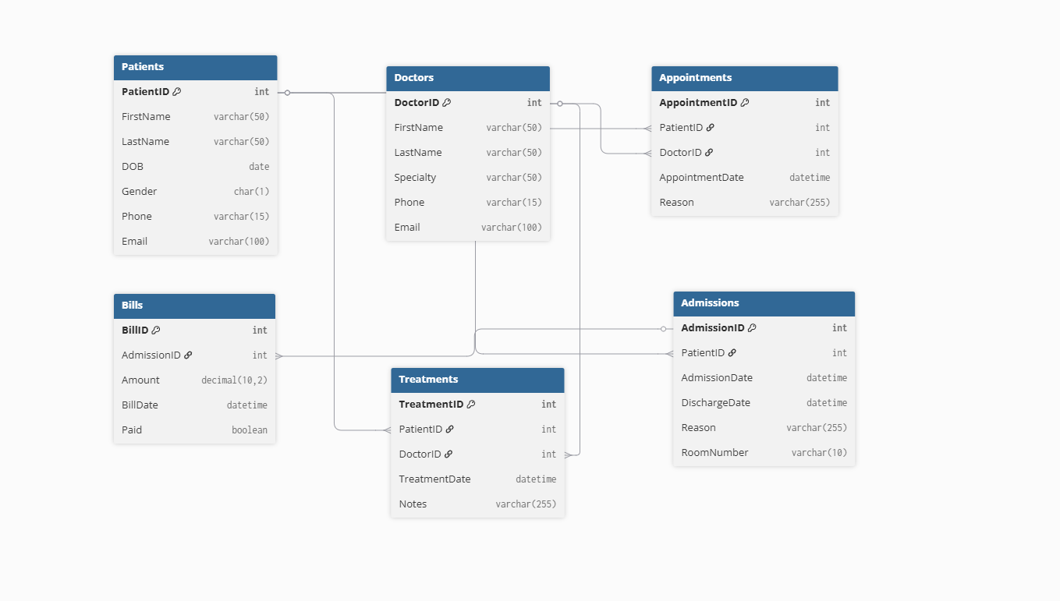

The database is visualized using: https://dbdiagram.io/
The database includes 6 tables: Patients, Doctors, Appointments, Bills, Treatments, Admission. Each table contains a primary key.

Database Project Requirements
The objective of this project is to design, implement, and manipulate a relational database using Microsoft SQL Server (or other). Throughout the project, you will gain practical experience with database concepts and SQL operations. Your database should include the following components and functionalities:
1. Database Design
- Create a Database: Design and create a database for a small business or organisation, such as an online store, or school.
- Define Tables: Identify and create tables necessary to store the required data, including:
  - Primary Key: Ensure each table has an auto-incremented primary key (PK) to uniquely identify each record.
  - Foreign Key: Define foreign key (FK) constraints to establish relationships between tables.
  - Many-to-Many Relationships: Implement at least one many-to-many relationship using a junction table.
  - Indexes: Create indexes to optimise queries. Use both unique and non-unique indexes where appropriate.
  - Data Types: Use a variety of data types (e.g., int, varchar, datetime) in your tables as appropriate to your data.
2. Data Manipulation
- Insert Operations: Insert sample data into each table to adequately populate the database. Write scripts using multi-row inserts.
- Update Operations: Write queries to update existing data in the tables, demonstrate modifying specific fields.
- Delete Operations: Write queries to remove specific records from the tables, practice with both conditional deletions and full table truncations.
3. Data Retrieval and Queries
Write a minimum of three SQL SELECT statements that meet the following requirements:
- Utilise at least three aggregate functions, such as COUNT, SUM, AVG, etc.
- One of the SELECT statements should be structured to support pagination, using clauses like OFFSET, FETCH NEXT, TOP, etc.
- Demonstrate data aggregation by grouping the results based on one or more columns, using the GROUP BY clause.
- Implement the ORDER BY clause to sort the retrieved data in both ascending and descending order.
4. Table Joins
- Join Two Tables: Write queries to retrieve combined information from two related tables using INNER JOIN, LEFT JOIN, RIGHT JOIN, etc.
- Join Three Tables: Extend queries to incorporate data combining from three related tables, showcasing more complex relationships.
- Create a View: create a view which combines 3 different tables using JOIN.
5. Procedures/Functions/Triggers
Create at least one:
- SQL Stored procedure
- SQL function
- SQL trigger
- Manual transaction
6. Presentation
- Be prepared to demonstrate the implementation of the specified requirements, including the relevant SQL queries. Ensure that you are ready to explain not only how the requirements were implemented, but also the underlying concepts. For instance, if you utilised a Primary Key, you should be able to explain its purpose.
- Create a visual representation of the database schema using a tool of your choice.
- Upload all project files to a version control system, such as GitHub or an alternative platform.
- Present the database design, key features, and queries in a structured and detailed report or presentation.

  - DATABASE DESIGN
Tables and Structure
Patients
- PatientID INT AUTO_INCREMENT PRIMARY KEY
- FirstName VARCHAR(50)
- LastName VARCHAR(50)
- DOB DATE
- Gender CHAR(1)
- Phone VARCHAR(15)
- Email VARCHAR(100)
Doctors
- DoctorID INT AUTO_INCREMENT PRIMARY KEY
- FirstName VARCHAR(50)
- LastName VARCHAR(50)
- Specialty VARCHAR(50)
- Phone VARCHAR(15)
- Email VARCHAR(100)
Appointments
- AppointmentID INT AUTO_INCREMENT PRIMARY KEY
- PatientID INT FOREIGN KEY REFERENCES Patients(PatientID)
- DoctorID INT FOREIGN KEY REFERENCES Doctors(DoctorID)
- AppointmentDate DATETIME
- Reason VARCHAR(255)
Admissions
- AdmissionID INT AUTO_INCREMENT PRIMARY KEY
- PatientID INT FOREIGN KEY REFERENCES Patients(PatientID)
- AdmissionDate DATETIME
- DischargeDate DATETIME
- Reason VARCHAR(255)
- RoomNumber VARCHAR(10)
Bills
- BillID INT AUTO_INCREMENT PRIMARY KEY
- AdmissionID INT FOREIGN KEY REFERENCES Admissions(AdmissionID)
- Amount DECIMAL(10,2)
- BillDate DATETIME
- Paid BOOLEAN

  - Database Creation

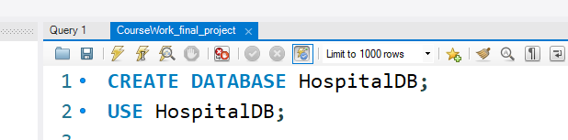

We must first build a database on our server or use one that already exists.
Then we create each table one by one.
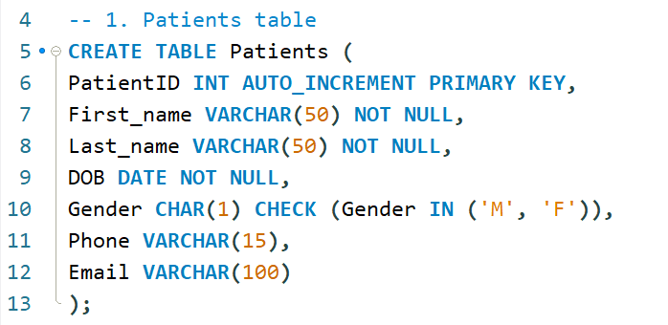
To enhance query performance, we include indexes.

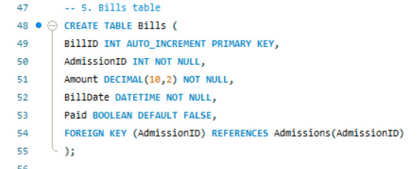
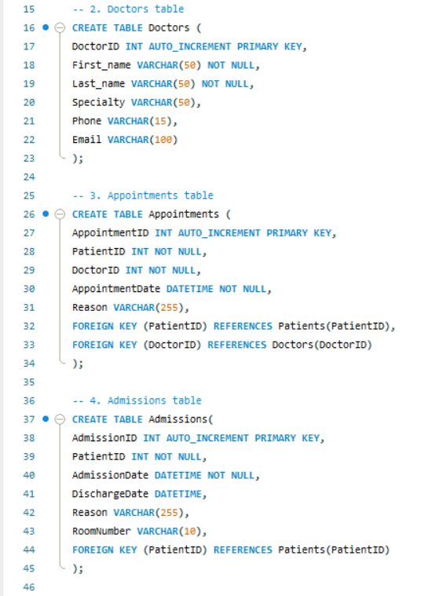

The Appointment Parts table implements a many-to-many relationship as required.

  - Data manipulation
We insert sample data.

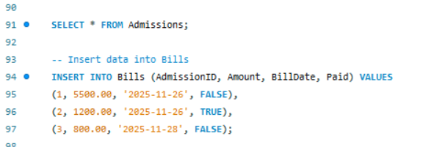
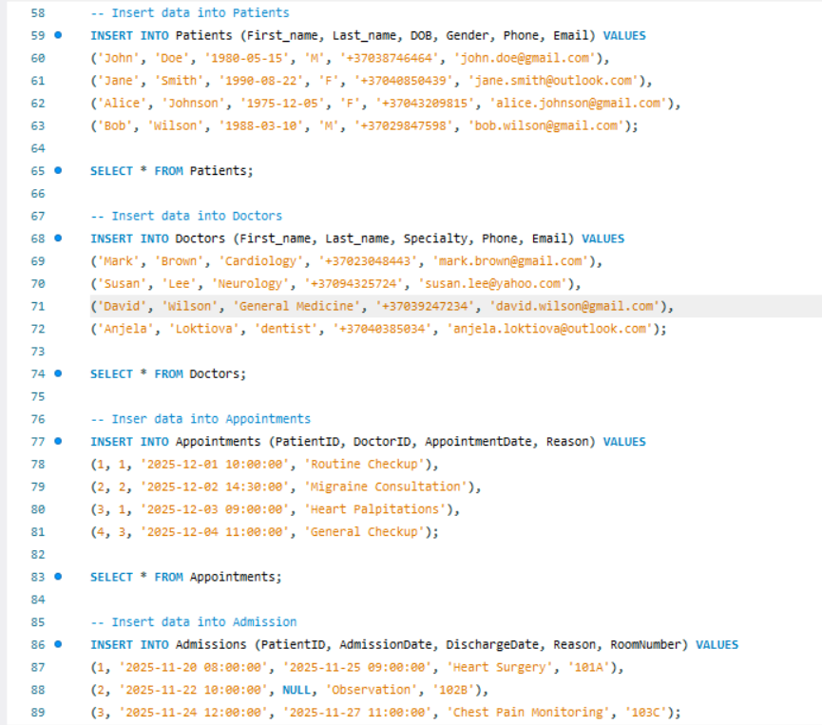

Using the following query, we can update the number of patient.
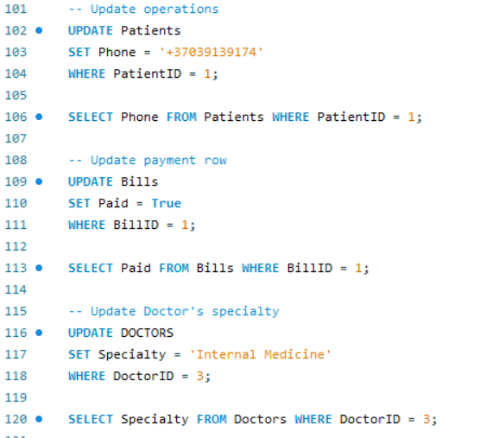

Using the following query, we can delete the appointment with id = 4.

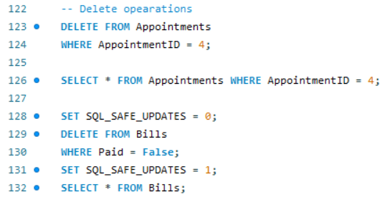
  - Data retrieval
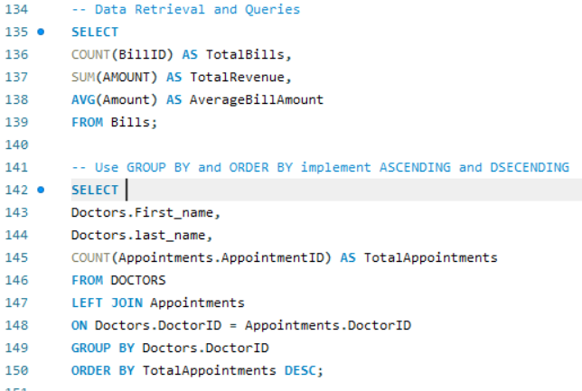
Using pagination, we may divide the necessary information into pages. We can specify the initial row by editing the Offset parameter. Fetch Next allows us to specify the number of rows to display.
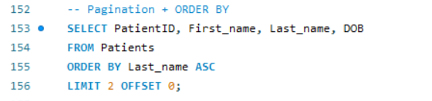

  - Joins
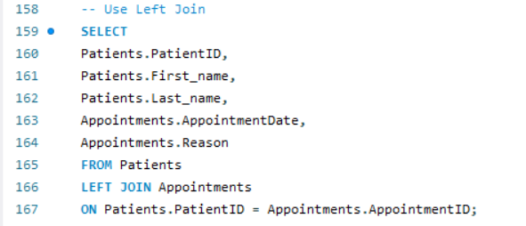

This is a query to show all of patients and appointment date.
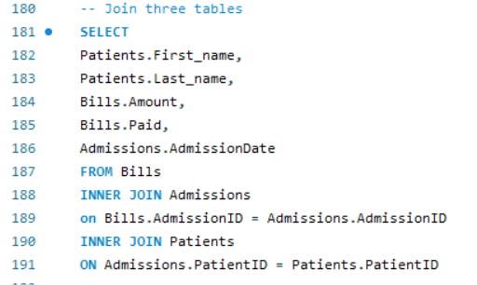

Moving forward we will create a view on three tables.

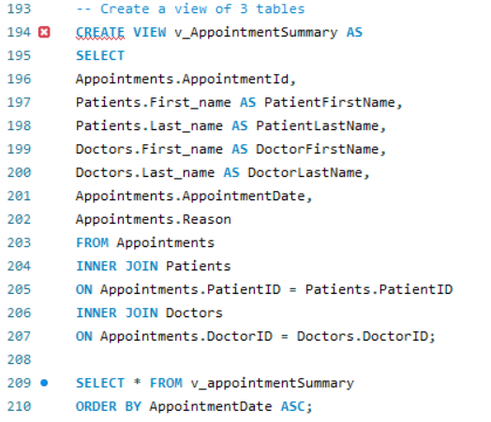

Result:

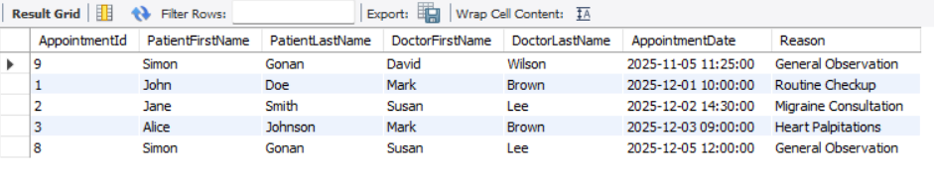

  - Triggers/Stored Procedures

Next, a stored procedure is created to insert a new patient into the system and return the newly generated patient ID.
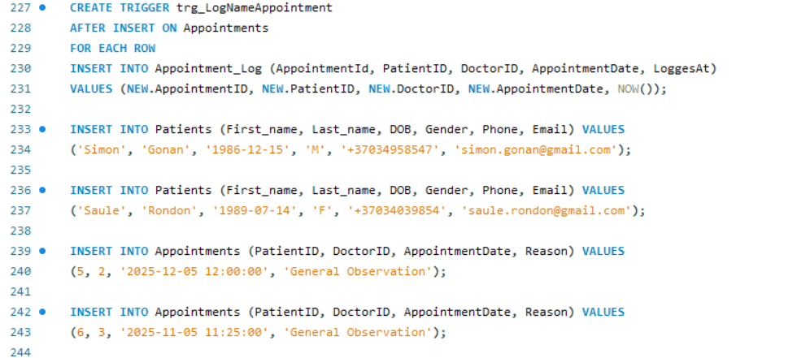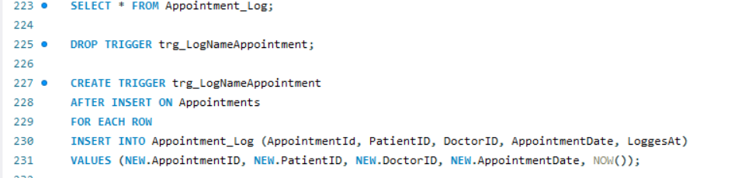

Result:
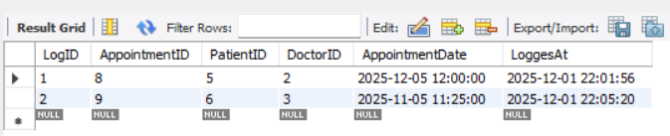

  - Conclusion

The Hospital Database Project successfully delivers a fully functional, relational database system supporting patient care operations. It demonstrates strong SQL implementation, including table design, data manipulation, joins, indexes, triggers, views, and stored procedures.
The system ensures reliability, data integrity, and efficient querying. The design is scalable and suitable for real-world hospital workflow management.

