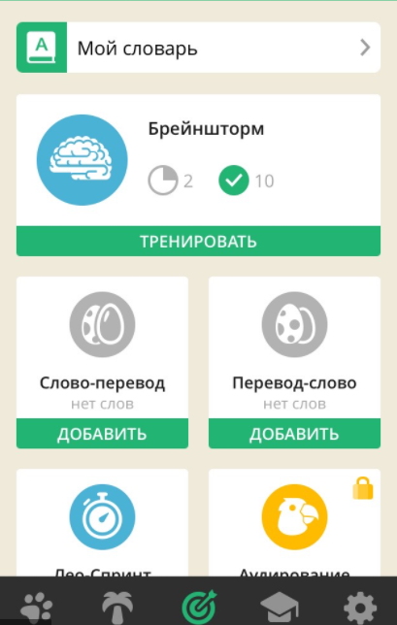

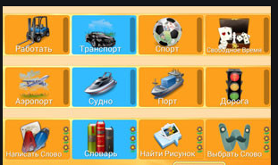

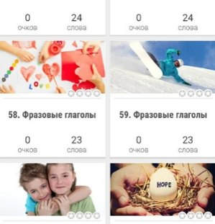

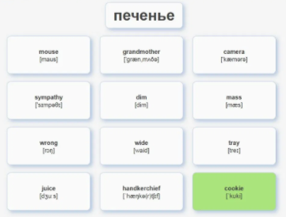

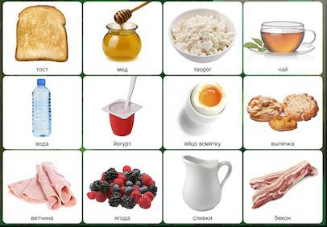

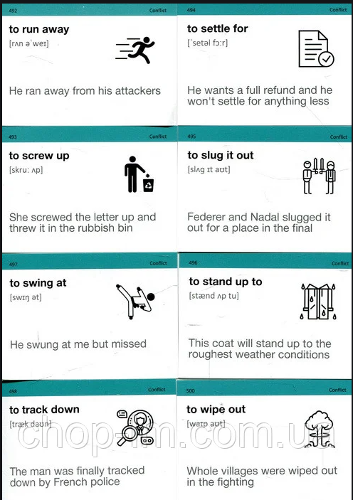

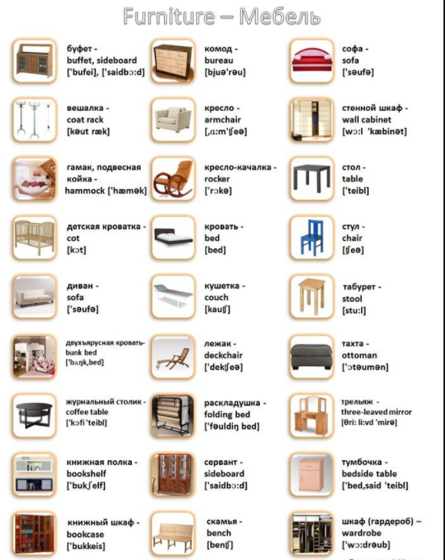



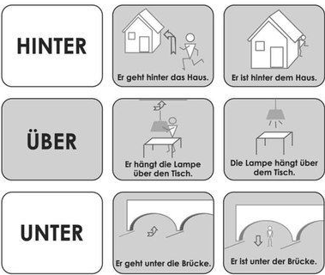

List:[

{

Id:’1’,

word:’Hinter’,

cardsDataList:[

{

src:’dsfsdfsdf’,

title:’sdfdf’

},

{

src:’dsfsdfsdf’,

title:’sdfdf’

},

]

},

//------------------------

{

Id:’2’,

word:’uber’,

cardsDataList:[

{

src:’dsfsdfsdf’,

title:’sdfdf’

},

{

src:’dsfsdfsdf’,

title:’sdfdf’

},

]

},

]