**Question**

How to represent a sequence of numbers like x[n] = {1, 2, 3, 4, …} which has the length of M with impulse function?

**Answer**

First let’s describe what is an impulse function:

A unit sample sequence, also known as an impulse sequence or delta sequence, is a discrete sequence that consists of a single sample with the value of 1 at a specific index, and all other samples are zero. It is commonly represented as a discrete-time impulse function or delta function. The unit sample response assumes input sample sequence u(n)= 1,0,0,0... or more formally u(n)=1 if n=0, u(n)=0 for other integer n values.

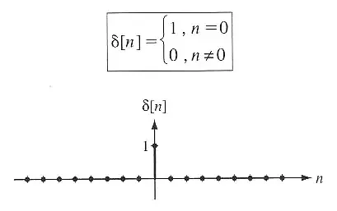

Now let’s represent every item like:

x[n] = {1, 2, 3, 4, …} = {1*u[n-0], 2*u(n-1), 3*u(n-2), …}

Which can be represented like:

x[n] = 1*u[n-0] + 2*u(n-1) + 3*u(n-2), …

Which gives us this formula:

x[n] = $\sum_{k=0}^{M}{x[k]u(n-k)}$

The codes and resources can be found in this repository:

<https://github.com/maktoobgar/image_processing>