**TASK-3** : Created a file max-temp.txt and inserted records

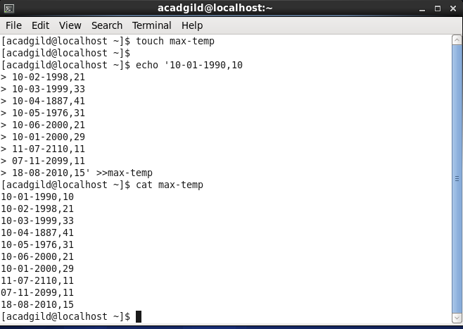

**Moved the file to /user/acadgild/hadoop.**

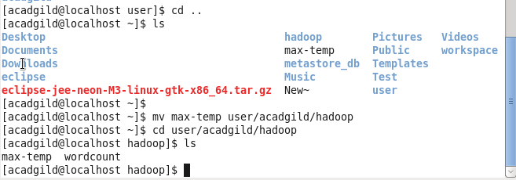

**TASK 4: Changed permissions of the file**

