1. Created a /user/acadgild /hadoop directory

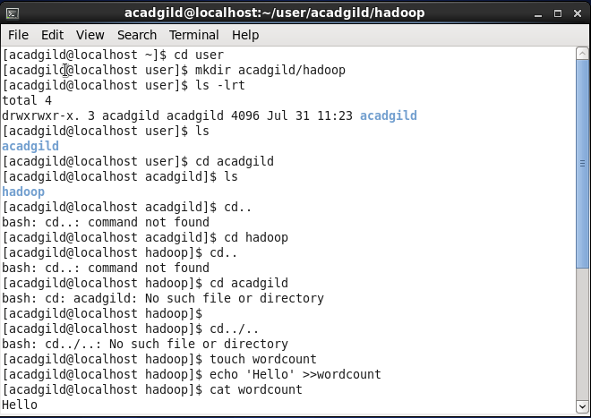

Whatever we type on screen should get appended to the file.

Try to type (on screen) few lines from any online article or textbook.