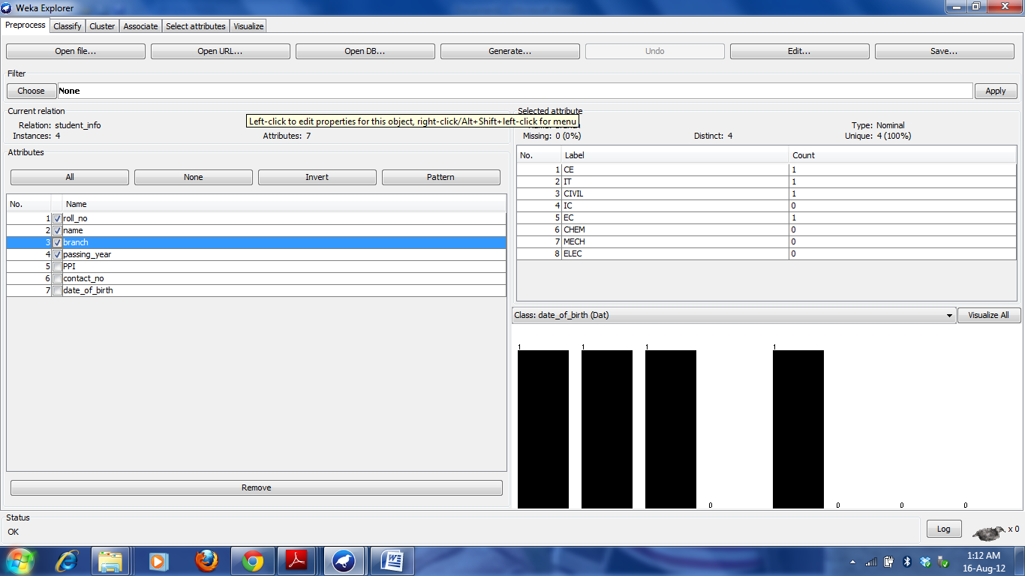
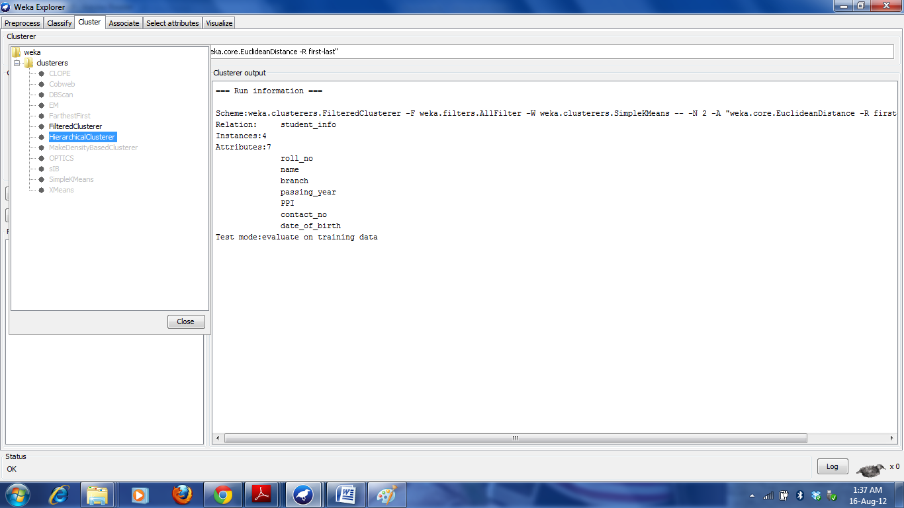
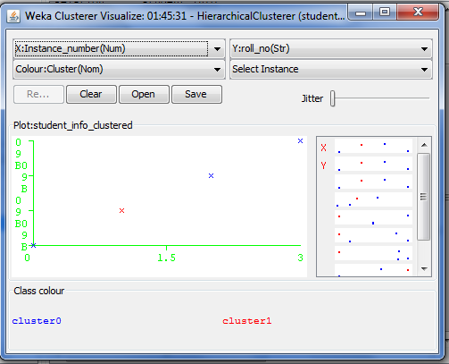
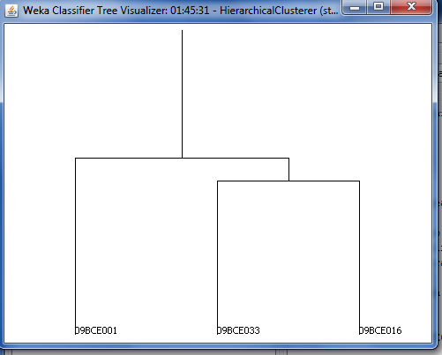
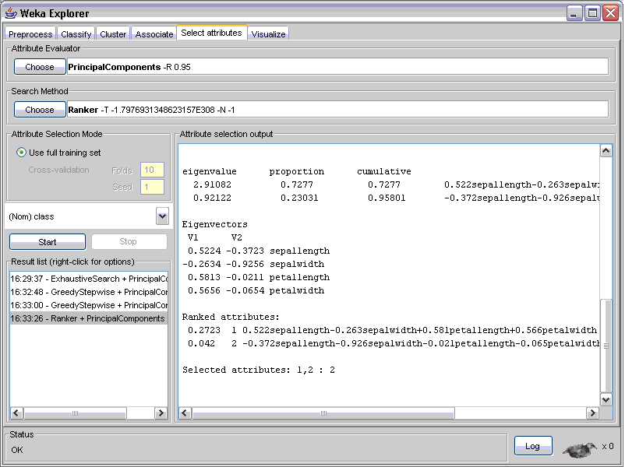
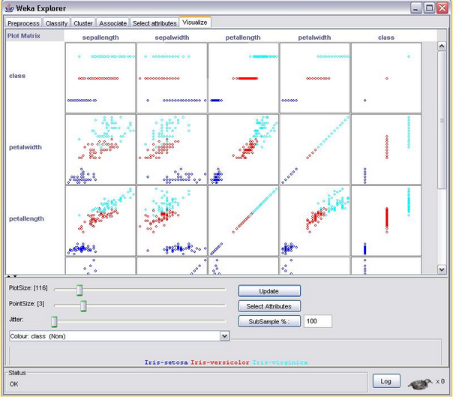
Practical-2:
Introduction to weka tool

Weka is a tool comprising of numerous machine learning algorithms that can be applied to Data Mining Problems. Weka was developed at the University of Waikato, New Zealand. It is an open source software issued under the GNU General Public License. Input in problem domain can be given directly to Weka or the Weka Algorithms can be called from Java code. The machine learning algorithms in Weka have themselves been developed in Java.

- Weka Input:

Input to Weka is given as a data set. Weka permits the input data set to be in numerous file formats like CSV (comma separted values: *.csv), Binary Serialized Instances (*.bsi) , attribute relation file format (arff).

Fig-1:Input file in weka

- Preprocess:

Once the input file is opened, certain preprocess analysis is done by Weka. All attributes
in the input file are shown in the Attributes Window. Properties of the selected attribute like the attribute name, Attribute Type, number of missing values etc are displayed in the “Selected attribute” window.

Fig-2:Weka preprocessing

- Classify:

we can validate the algorithm that is being used to find the predicted value. This is done using the “Classify” option in Weka and by selecting an appropriate Classifier. We select a classifier J48.

Fig-3: Classifier J48 selected for input data set classification

The classifier checks values of all attributes for input records and compares those values with the values predicted by the preprocess filter using its algorithm. After the classification is complete Weka outputs the statistics. For example: Percentage of correctly classified Instances, Incorrectly Classified Instances etc. The Classifier output can also be viewed in the form of a tree which may give a clearer idea of the classifier model and algorithm.

Fig-4: Classifier Output Statistics

Fig-5: Classifier Tree Visualizer

- Cluster:
The clustering option is very similar to the classification described above, with a few differences regarding the options you select. For instance, there is an easy way to discard undesired attributes. We can choose clustering algorithm from given list e.g. FilteredClusterer, HierarchicalClusterer etc.

Fig-6:choosing clustering algorithm

We can see Weka Clusterer Visualize window by right clicking the result list item and selecting Visualize cluster assignments..

Fig-7:Visualize window

We can also get tree visualize window by right clicking the result list item and selecting Visualize tree option.
Fig-8 : visualize tree.

- Select Attributes:

Weka also provides techniques to discard irrelevant attributes and/or reduce the dimensionality of your dataset. After loading a dataset, click on the select attributes tag to open a GUI which will allow you to choose both the evaluation method (such as Principal Components Analysis for example) and the search method (f. ex. greedy or exhaustive search). Depending on the chosen combination, the actual time spend on selecting attributes can vary substantially and can also be very long, even for small datasets such as the Iris data with only five features (including the class attribute) for each of the 150 samples. The picture below shows the results for a sample application. It is also important to note that not all evaluation/search method combinations are valid, watch out for the error message in the Status bar. There's also a problem using Discretize while in the preprocessing mode, which leads to false results. If you need to use this filter, you can work around this by using the FilteredClassifier option in the classify menu.

Fig-9:Attribute selection output
- Visualize:
There is also a tab called called VISUALIZE. Clicking on that will open the scatterplots for all attribute pairs:

Fig-10:Visualize window

From these scatterplots, we can infer a number of interesting things. For example, in the picture above we can see that in some examples the clusters (for now, think of clusters as collections of points that are physically close to each other on the screen) and the different colors correspond to each other such as for example in the plots for class/(any attribute) pairs and the petalwidth/petallength attribute pair, whereas for other pairs (sepalwidth/sepallength for example) it's much hader to separate the clusters by color.

