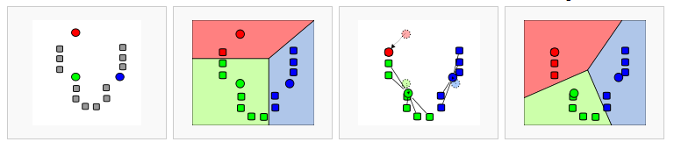
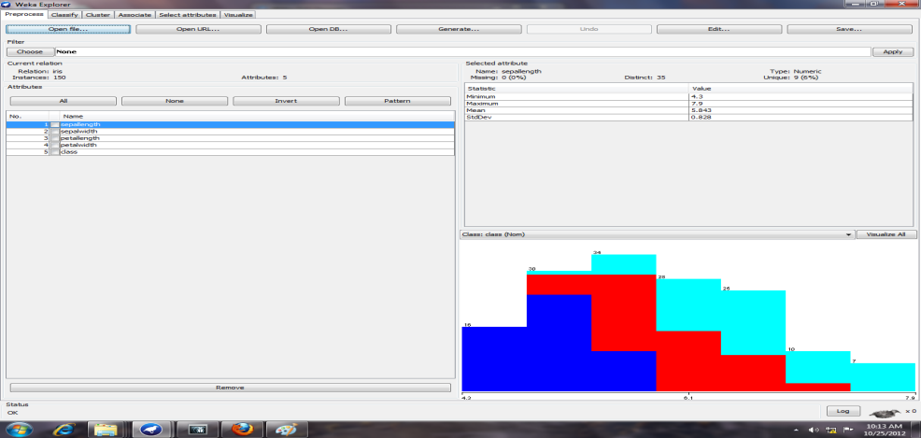
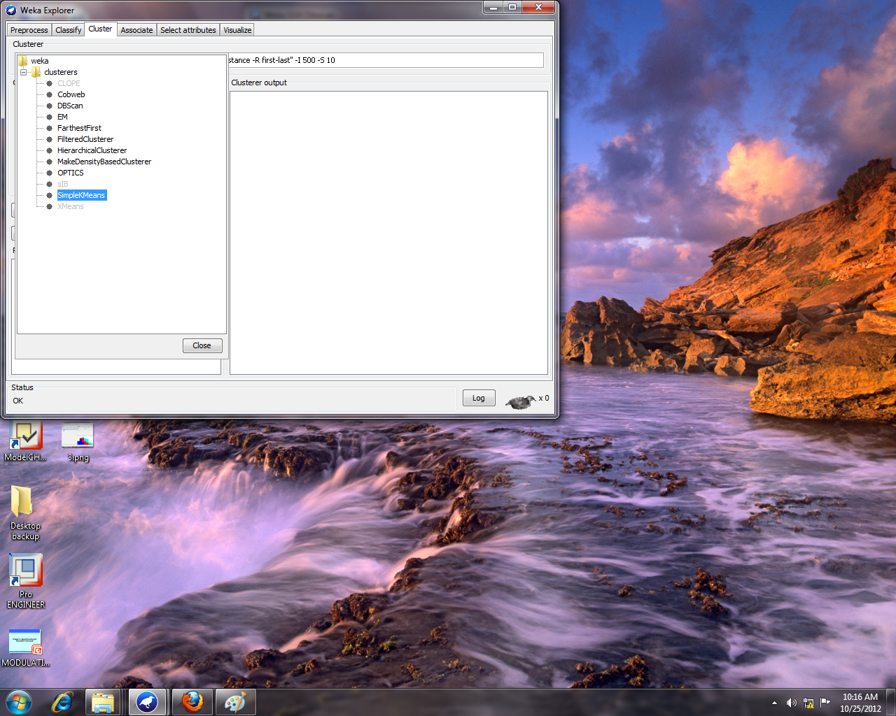
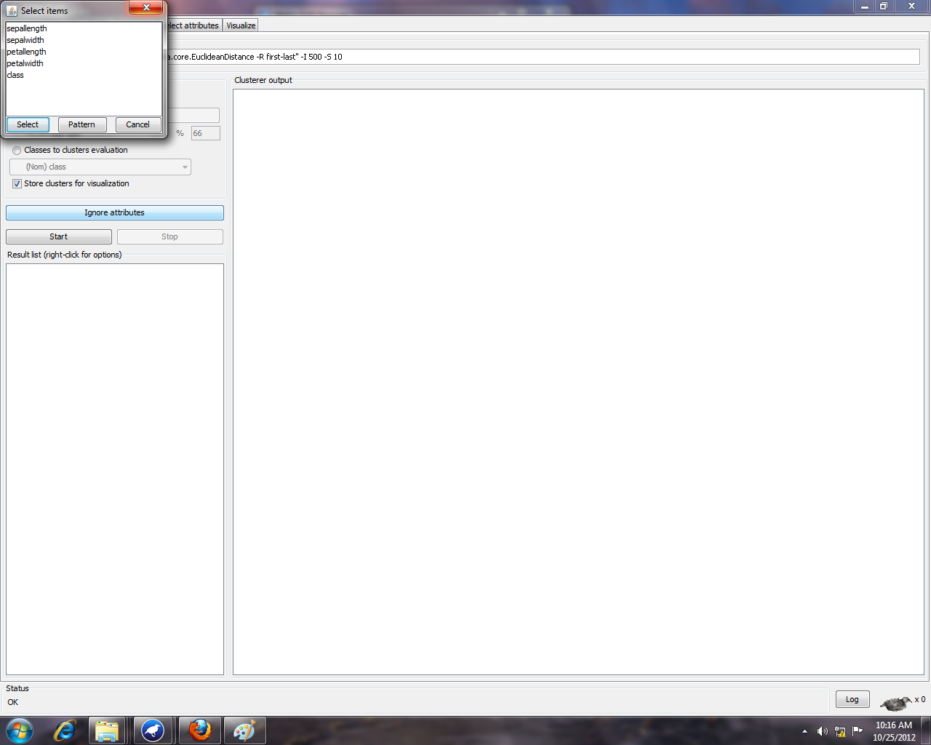
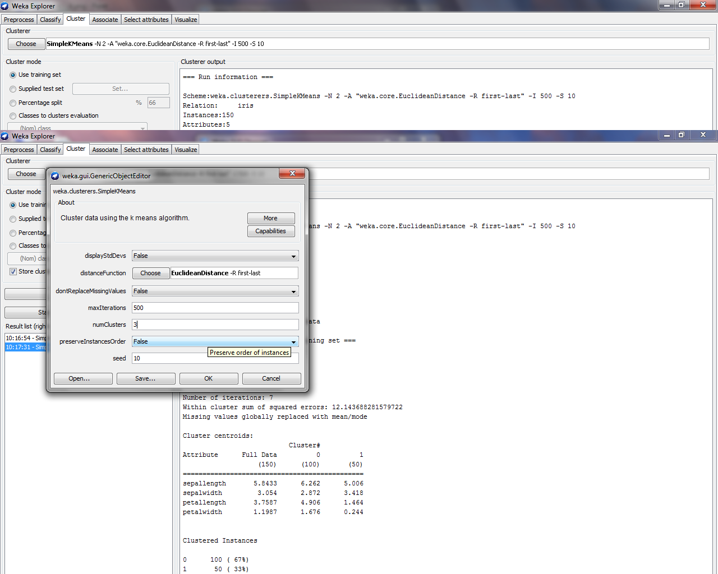
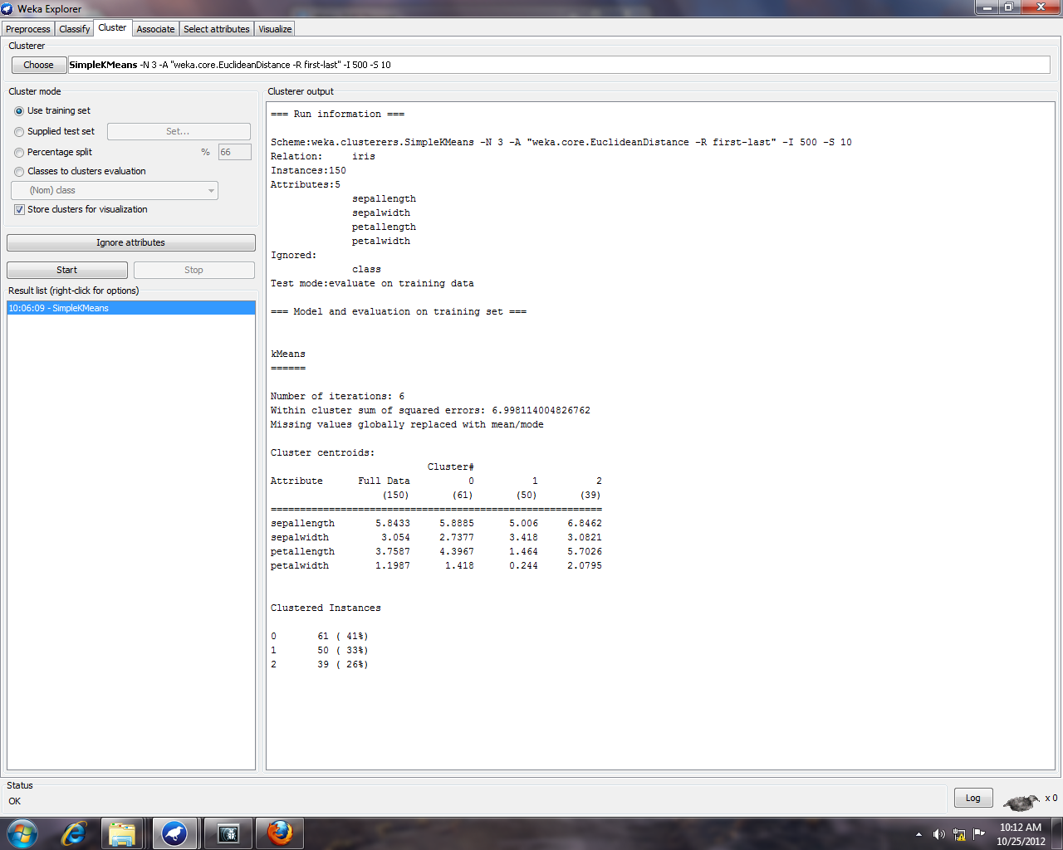
Practical 9
Aim : Study of K Means Algorithm in WEKA
Roll No : 09BCE026
Theory :
K Means is a clustering Algorithm.It follows following steps
1. k initial "means" are randomly generated within the data domain .Fig1
2. k clusters are created by associating every observation with the nearest mean. Fig2
3. The centroid of each of the kclusters becomes the new mean
4. Steps 2 and 3 are repeated until convergence has been reached.

Fig1 Fig2 Fig3 Fig4

Using weka tool we can easily implement it .For Iris Dataset we gave made our kmeans algorithm in which we use to divide data into 3 clusters.
Steps are as follows.
1.First Load data (Iris data set into weka )

2.In weka select Cluster Tab to perform clustering(k clustering ) Algorithm.Select Simple kmeans algorithm.

After this select Ignore Attribute (Class Attribute) for clustering.

And the Last Step is in weka generi cobject editor we can specify type of distance we are interested to find as well as No of Clusters we want make.
In our case we have specified Euclidien Distance as Distance measure and 3 as No of Clusters .
Other details will remain same.
And The final outcome our data set will be classified into 3 clusters using k means algorithm.

