**MCS Overview:**

The "MCS" is a such project by which we can view high volume website visitor history by implementing "Kafka Queue system" & NoSql like "Mongodb"

for history storage. All the components developed with Java 8 & Spring boot 2.

There are 4 components in the project:

1. website (with login logout facility)
2. Kafka producer
3. Kafka consumer
4. History Viewer UI

**Prerequisites:**

Below softwares should installed or configured with machine which would be used for application run.

1. Java 8
2. Kafka Server
3. MongoDB

**DEV Tools**

The Application developed with dev components:

1. Spring Boot 2
2. Java 8
3. Maven
4. Kafka server
5. Mongodb

**Instructions:**

1. Navigate to Repo for clone project source code: <https://github.com/mal1pro2/mcs-kafka-demo.git>
2. Clone application source code via GIT command : clone <https://github.com/mal1pro2/mcs-kafka-demo.git>
3. Go to application directory & install dependencies using maven: `mvn install`
4. Go to the target directories of each projects & run applications server via maven: `mvn spring-boot:run` or via java command: `java -jar ***.jar`

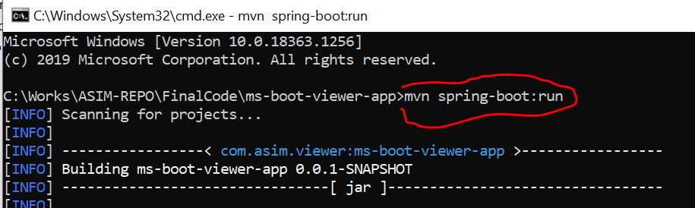

Same command would be used for other apps.

1. Open browser & hit Website url : “<http://localhost:8081/registration>” :

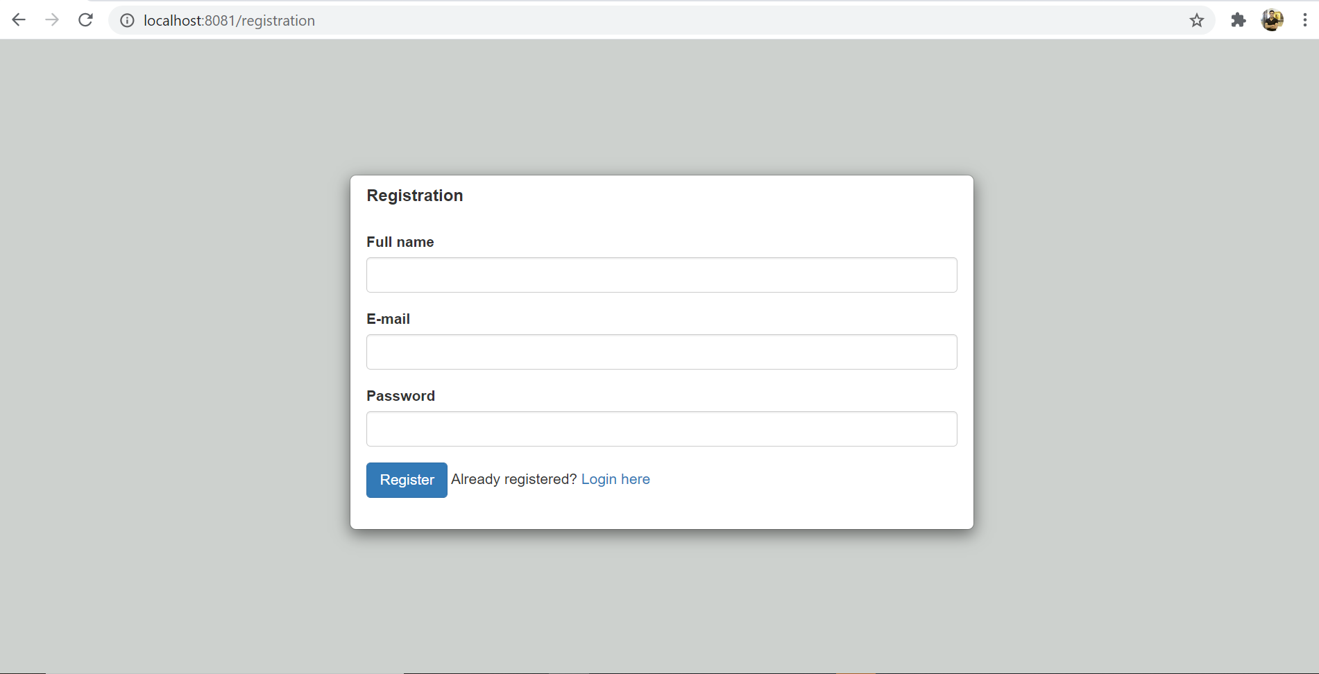

First need to register user on the website after that visit to login link “Login Here”

Use register username or password.

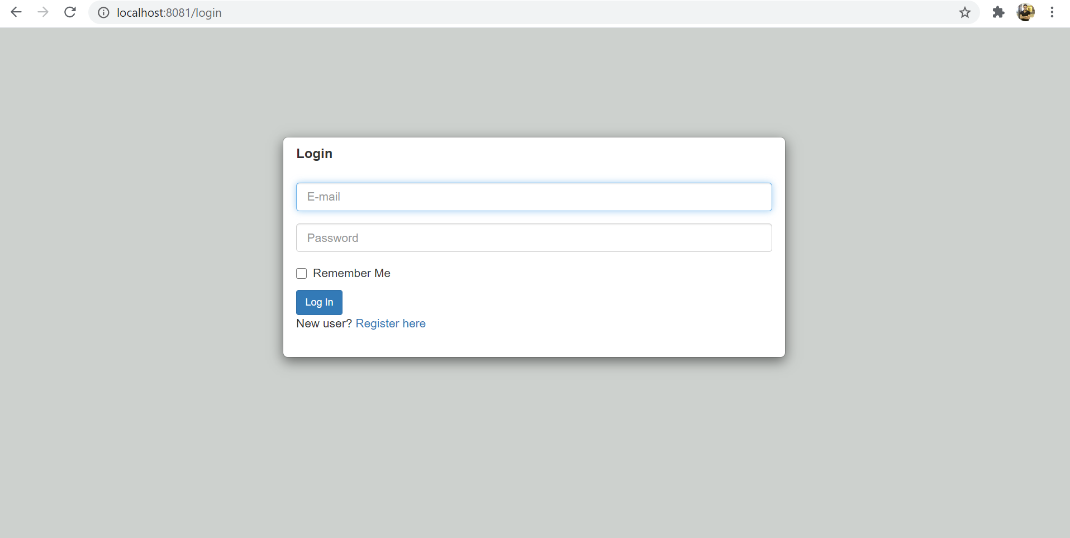

After successful login index page:

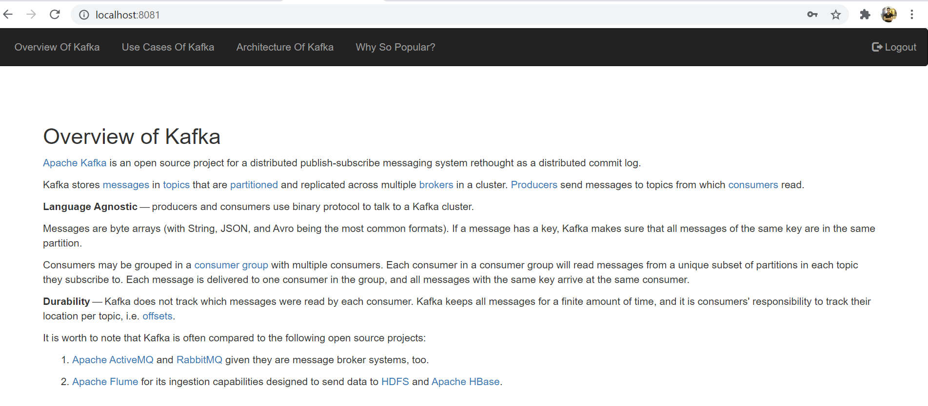

1. Website visitor history viewer app, please hit URL: <http://localhost:8084/> or <http://localhost:8084/history/page/3> on browser.

