**WEBSITE TRAFFIC ANALYSIS**

**INTRODUCTION :**

In this project, website traffic data will be analyzed to learn more about user behavior, popular sites, and traffic sources. It seeks to equip website owners with useful knowledge to improve user experiences and boost performance. The analysis's goals are clearly stated, and they include figures for page views, unique visitors, and referral sources. Insights are carefully gathered from data to ensure their quality and depth. Data is visualized using IBM Cognos, which transforms complex data into understandable visual representations.

**ABOUT PHASE 3:**

The phase 3 is all about data preprocessing of the given csv file for the purpose of performing various operations such as analysis, exploratory data analysis and visualizing of the dataset.

**IBM COGNOS:**

* In order to visualize data from files, including csv files and other files, analysis is done using the IBM Cognos tool.
* Line charts, scatter plots are displayed in these various charts.

**LINE CHARTS:**

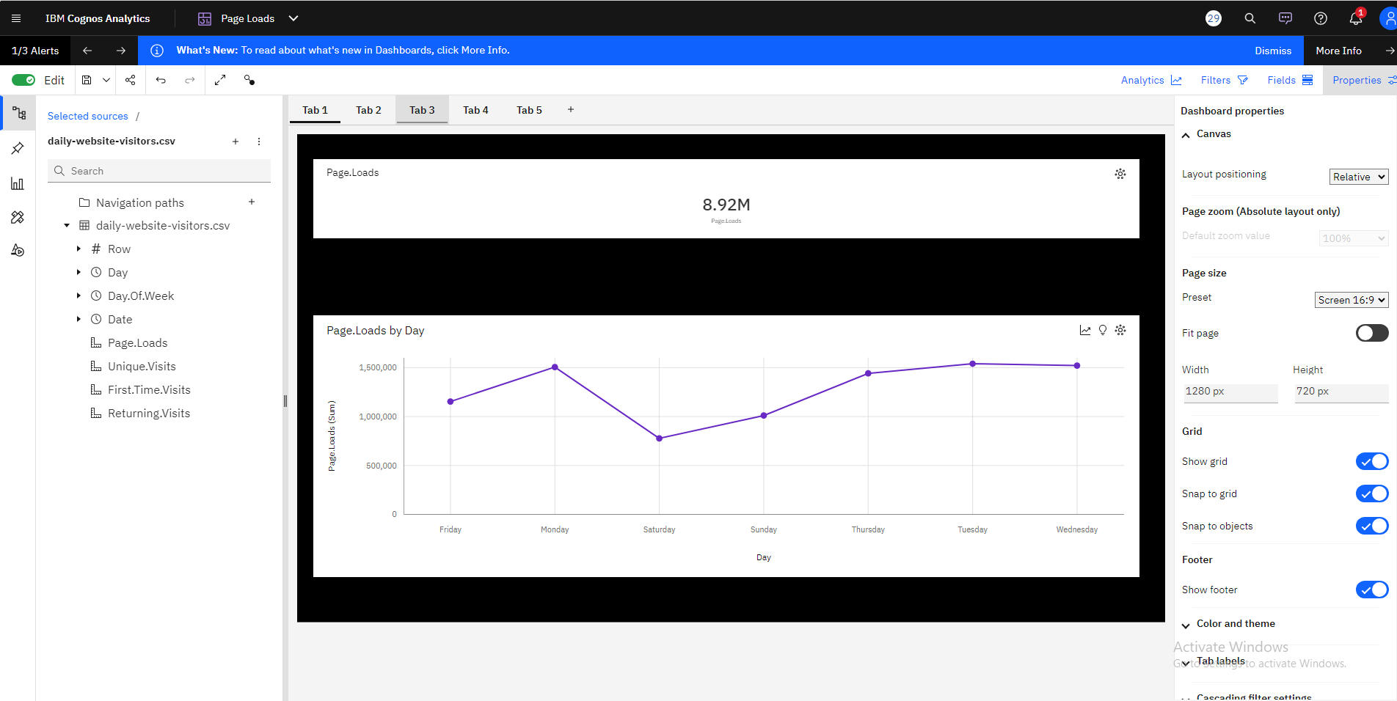

* Page Loads Show How Frequently Visitors To Your Website View Or Load Specific Pages.
* The Independent variable and Dependent variable used here are Day and Page Loads(sum) respectively.
* Page.Loads are unusually low when Day is Saturday.
* For Page.Loads, the most significant values of Day are Tuesday, Wednesday, Monday, Thursday, and Friday, whose respective Page.Loads values add up to over 7.1 million, or 80.1 % of the total.

**SCATTER PLOT:**

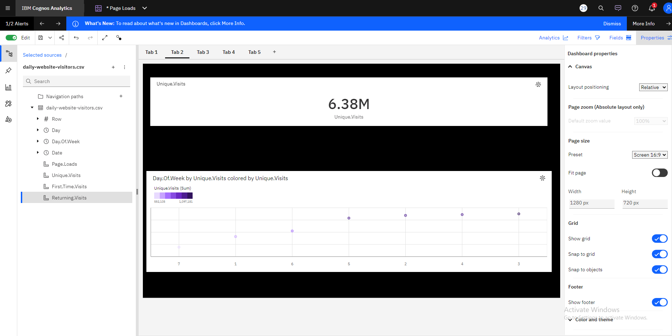

* You may see the link between the days of the week and the number of unique visits to your website by making a scatter plot using "Days of the Week" on the x-axis and "Unique Visits" on the y-axis.
* Based on the current forecasting, Unique.Visits may reach almost 481 thousand by Day.Of.Week 9.
* For Unique.Visits, the most significant values of Day.Of.Week are 3, 4, 2, 5, and 6.