The Mark Experiment

Introduction

Mark 1:1-8

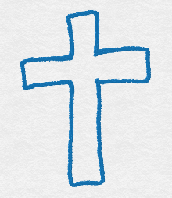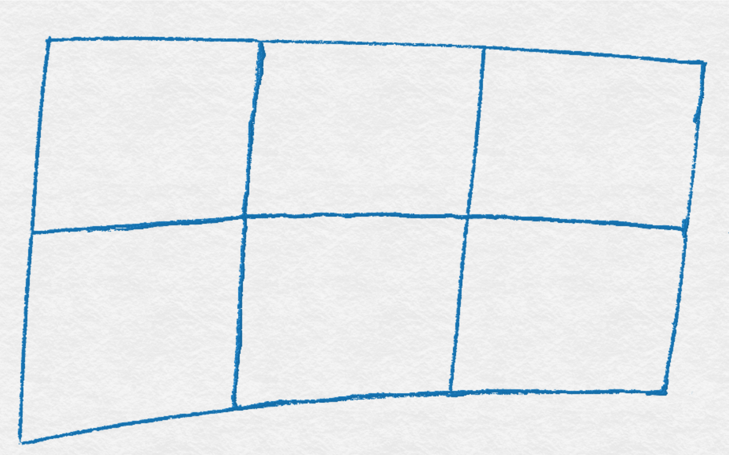

# Introduction

## 1:1-8

|  |  |  |
| --- | --- | --- |
| **a** | 1:1 | Mark’s witness to Jesus |
| **b** | 1:2-3 | The Old Testament prophets’  witness to Jesus |
| **c** | 1:4-5 | The baptism of John creates  great interest |
| **b'** | 1:6 | John is like an Old Testament prophet |
| **a'** | 1:7-8 | John’s witness to Jesus |

## 

## Section titles

Section 1: The Message (Mark 1:9-3:12)

Section 2: The Power (Mark 3:13-6:6)

Section 3: The Training (Mark 6:7-8:30)

Section 4: The Cost (Mark 8:31-10:52)

Section 5: The Judgement (Mark 11:1-13:37) 

Section 6: The Love (Mark 14:1-16:8)

# Tips for memorising

## Look, Cover, Write, Check

Look at the sentences you need to memorise, cover it up so that you can no longer see it, write it out on a piece of paper and then check what you wrote against the original. Do this a few times until you can write it out without needing to look first.

## Tell someone

Ask a friend or family member if they could help you to memorise the sentences. Give them a copy of the sentences and then try to tell them what they are. Do this a few times and maybe with different people too, until you can remember them all.

## Paraphrasing

Try writing or saying the sentences in your own words.

## Symbols

Either draw the symbols given and remember which sentence each symbol represents, or if you are feeling creative why not make up your own symbols to remember for each sentence.

## Read the passages

Reading the passages is a great way to help you remember each section as well as helping you to develop your understanding on each passage.

# Monday

## Read

Read Mark 2:1-12 from section 1 today.

## Memorise

Today we’ll be learning Mark’s introductions. Take 5 minutes to memorise it (tips on how to do this are at the start of this book!) then have a go at the activity below.

## 1:1-8

|  |  |  |
| --- | --- | --- |
| **a** | 1:1 | Mark’s witness to Jesus |
| **b** | 1:2-3 | The Old Testament prophets’ witness to Jesus |
| **c** | 1:4-5 | The baptism of John creates great interest |
| **b'** | 1:6 | John is like an Old Testament prophet |
| **a'** | 1:7-8 | John’s witness to Jesus |

## Activity

Below are the sentences again, but this time the spaces are in the wrong places. Cover up the sentences above and see if you can put the spaces back in the right places, then check how you done.

|  |
| --- |
| Ma rk’swit nes stoJ esus  _________________________________________________ |
| T he Ol dTest am entpro phe ts’wi tnesst oJe sus  _________________________________________________ |
| Th ebap ti sm ofJohncr eat esg reati nte rest  _________________________________________________ |
| Jo hnis li kean O ldT es tame ntpr op het  _________________________________________________ |
| J ohn ’swi tn es stoJ es us  _________________________________________________ |

# Tuesday

## Read

Take a look at Mark 4:35-5:20 from section 2 today.

## Memorise

Let’s see how much you remember from yesterday and try to memorise it again. Work at it for a few minutes, then cover them up and try the activity below.

## 1:1-8

|  |  |  |
| --- | --- | --- |
| **a** | 1:1 | Mark’s witness to Jesus |
| **b** | 1:2-3 | The Old Testament prophets’ witness to Jesus |
| **c** | 1:4-5 | The baptism of John creates great interest |
| **b'** | 1:6 | John is like an Old Testament prophet |
| **a'** | 1:7-8 | John’s witness to Jesus |

## Activity

Try to figure out the code below by filling in the sentences to find out which letter and number correspond.

CODE

|  |  |  |  |  |  |  |  |  |  |  |  |  |  |  |  |  |  |  |  |  |  |  |  |  |  |
| --- | --- | --- | --- | --- | --- | --- | --- | --- | --- | --- | --- | --- | --- | --- | --- | --- | --- | --- | --- | --- | --- | --- | --- | --- | --- |
| A | B | C | D | E | F | G | H | I | J | K | L | M | N | O | P | Q | R | S | T | U | V | W | X | Y | Z |
|  |  |  |  | 22 |  |  |  |  |  |  |  | 17 |  |  |  | 18 |  | 25 |  |  | 20 |  | 2 | 14 | 1 |

1

|  |  |  |  |  |  |  |  |  |  |  |  |  |  |  |  |  |  |  |  |  |  |  |
| --- | --- | --- | --- | --- | --- | --- | --- | --- | --- | --- | --- | --- | --- | --- | --- | --- | --- | --- | --- | --- | --- | --- |
| M |  |  |  | ‘ | S |  |  |  |  |  | E | S | S |  |  |  |  |  | E | S |  | S |
| 17 | 12 | 16 | 24 |  | 25 |  | 8 | 19 | 5 | 15 | 22 | 25 | 25 |  | 5 | 4 |  | 9 | 22 | 25 | 11 | 25 |

2

|  |  |  |  |  |  |  |  |  |  |  |  |  |  |  |  |  |
| --- | --- | --- | --- | --- | --- | --- | --- | --- | --- | --- | --- | --- | --- | --- | --- | --- |
|  |  | E |  |  |  |  |  |  | E | S |  |  | M | E |  |  |
| 5 | 10 | 22 |  | 4 | 23 | 3 |  | 5 | 22 | 25 | 5 | 12 | 17 | 22 | 15 | 5 |

|  |  |  |  |  |  |  |  |  |  |  |  |  |  |  |  |  |  |  |  |  |  |  |  |  |  |
| --- | --- | --- | --- | --- | --- | --- | --- | --- | --- | --- | --- | --- | --- | --- | --- | --- | --- | --- | --- | --- | --- | --- | --- | --- | --- |
|  |  |  |  |  | E |  | S | ‘ |  |  |  |  |  | E | S | S |  |  |  |  |  | E | S |  | S |
| 13 | 16 | 4 | 13 | 10 | 22 | 5 | 25 |  |  | 8 | 19 | 5 | 15 | 22 | 25 | 25 |  | 5 | 4 |  | 9 | 22 | 25 | 11 | 25 |

3

|  |  |  |  |  |  |  |  |  |  |  |  |  |  |  |  |  |  |  |
| --- | --- | --- | --- | --- | --- | --- | --- | --- | --- | --- | --- | --- | --- | --- | --- | --- | --- | --- |
|  |  | E |  |  |  |  |  |  | S | M |  |  |  |  |  |  |  |  |
| 5 | 10 | 22 |  | 7 | 12 | 13 | 5 | 19 | 25 | 17 |  | 4 | 6 |  | 9 | 4 | 10 | 15 |

|  |  |  |  |  |  |  |  |  |  |  |  |  |  |  |  |  |  |  |  |  |  |
| --- | --- | --- | --- | --- | --- | --- | --- | --- | --- | --- | --- | --- | --- | --- | --- | --- | --- | --- | --- | --- | --- |
|  |  | E |  |  | E | S |  |  |  | E |  |  |  |  |  |  | E |  | E | S |  |
| 26 | 16 | 22 | 12 | 5 | 22 | 25 |  | 21 | 16 | 22 | 12 | 5 |  | 19 | 15 | 5 | 22 | 16 | 22 | 25 | 5 |

4

|  |  |  |  |  |  |  |  |  |  |  |  |  |  |  |  |  |  |  |
| --- | --- | --- | --- | --- | --- | --- | --- | --- | --- | --- | --- | --- | --- | --- | --- | --- | --- | --- |
|  |  |  |  |  |  | S |  |  |  |  | E |  |  |  |  |  |  |  |
| 9 | 4 | 10 | 15 |  | 19 | 25 |  | 23 | 19 | 24 | 22 |  | 12 | 15 |  | 4 | 23 | 3 |

|  |  |  |  |  |  |  |  |  |  |  |  |  |  |  |  |  |
| --- | --- | --- | --- | --- | --- | --- | --- | --- | --- | --- | --- | --- | --- | --- | --- | --- |
|  | E | S |  |  | M | E |  |  |  |  |  |  |  |  | E |  |
| 5 | 22 | 25 | 5 | 12 | 17 | 22 | 15 | 5 |  | 13 | 16 | 4 | 13 | 10 | 22 | 5 |

5

|  |  |  |  |  |  |  |  |  |  |  |  |  |  |  |  |  |  |  |  |  |  |  |
| --- | --- | --- | --- | --- | --- | --- | --- | --- | --- | --- | --- | --- | --- | --- | --- | --- | --- | --- | --- | --- | --- | --- |
|  |  |  |  | ‘ | S |  |  |  |  |  | E | S | S |  |  |  |  |  | E | S |  | S |
| 9 | 4 | 10 | 15 |  | 25 |  | 8 | 19 | 5 | 15 | 22 | 25 | 25 |  | 5 | 4 |  | 9 | 22 | 25 | 11 | 25 |

# Wednesday

## Read

We’re going to read through Mark 8:27-30 from section 3 today.

## Memorise

Now it’s time to memorise the section titles we will be covering over this series. Take 5 minutes to learn them now, then have a go at the activity below.

## Section titles

Section 1: The Message (Mark 1:9-3:12)

Section 2: The Power (Mark 3:13-6:6)

Section 3: The Training (Mark 6:7-8:30)

Section 4: The Cost (Mark 8:31-10:52)

Section 5: The Judgement (Mark 11:1-13:37)

Section 6: The Love (Mark 14:1-16:8)

## Activity

Hidden in the word search below are all of the section titles, can you spot them all?

|  |  |  |  |  |  |  |  |  |  |  |  |  |  |  |
| --- | --- | --- | --- | --- | --- | --- | --- | --- | --- | --- | --- | --- | --- | --- |
| E | X | S | N | X | B | S | O | B | B | M | A | H | P | J |
| E | T | T | P | J | X | K | G | R | U | N | T | W | H | Z |
| K | D | U | O | P | N | K | R | H | P | N | V | P | D | I |
| A | C | Q | W | A | R | L | C | O | E | M | S | D | W | L |
| K | M | Q | E | F | G | T | Q | M | D | X | Y | X | H | W |
| Z | H | E | R | X | C | H | E | Q | E | O | G | X | B | Y |
| C | M | H | S | Q | B | G | R | R | W | U | R | M | E | X |
| N | L | C | C | S | D | T | R | A | I | N | I | N | G | B |
| N | N | O | F | U | A | X | Q | I | G | O | R | Q | O | G |
| Y | S | A | J | W | E | G | Y | A | D | R | R | I | W | P |
| T | Q | J | M | A | U | W | E | C | Z | A | F | I | T | O |
| K | S | E | X | R | Y | H | Y | J | U | J | E | T | W | U |
| E | V | O | L | H | L | W | R | C | W | E | J | O | A | I |
| L | C | L | D | T | D | Q | W | X | A | K | Q | T | B | Q |
| E | O | U | N | T | U | Q | M | H | T | T | B | C | G | A |

# Thursday

## Read

Today let’s read Mark 8:31-9:1 from section 4.

## Memorise

How much can you remember from yesterday? Take 5 minutes to memorise them again before doing the activity below.

## Section titles

Section 1: The Message (Mark 1:9-3:12)

Section 2: The Power (Mark 3:13-6:6)

Section 3: The Training (Mark 6:7-8:30)

Section 4: The Cost (Mark 8:31-10:52)

Section 5: The Judgement (Mark 11:1-13:37)

Section 6: The Love (Mark 14:1-16:8)

## Activity

Cover up the sentences above and see if you can you link the section number and titles together.

|  |  |
| --- | --- |
| SECTION 1 | THE JUDGEMENT |
| SECTION 2 | THE TRAINING |
| SECTION 3 | THE MESSAGE |
| SECTION 4 | THE LOVE |
| SECTION 5 | THE COST |
| SECTION 6 | THE POWER |

# Friday

## Read

Today we are going to read Mark 11:1-25 from section 5.

## Memorise

Today we are going to memorise everything from this week. Take 5 minutes to remember this, then do the activity below.

## 1:1-8

|  |  |  |
| --- | --- | --- |
| **a** | 1:1 | Mark’s witness to Jesus |
| **b** | 1:2-3 | The Old Testament prophets’ witness to Jesus |
| **c** | 1:4-5 | The baptism of John creates great interest |
| **b'** | 1:6 | John is like an Old Testament prophet |
| **a'** | 1:7-8 | John’s witness to Jesus |

## Section titles

Section 1: The Message (Mark 1:9-3:12)

Section 2: The Power (Mark 3:13-6:6)

Section 3: The Training (Mark 6:7-8:30)

Section 4: The Cost (Mark 8:31-10:52)

Section 5: The Judgement (Mark 11:1-13:37)

Section 6: The Love (Mark 14:1-16:8)

## Activity

Hide the sentences above and see if you can fill in all the blanks.

|  |  |
| --- | --- |
| 1:_ | ____ witness __ Jesus |
| _:_-3 | The ___ Testament prophets’ ______ to Jesus |
| 1:4-_ | ___ baptism of ____ creates _____ interest |
| _:6 | ____ is ____ an Old __________ prophet |
| 1:7-_ | _______ witness __ Jesus |

Section _: The Power

Section 1: The _______

Section 6: The ____

Section _: The Training

Section _: The Judgement

Section 4: The ­­­____

# Saturday

## Read Mark 15:16-16:8

Our final passage is from section 6; Mark 15:16-16:8.

## Memorise

We’ve learned everything now! Hurrah! See what you can remember already without checking, and put it in the list below. Fill in the rest by looking back to the front page.

## 1:1-8

|  |  |  |
| --- | --- | --- |
| **a** | 1:1 | ______________________________________ |
| **b** | 1:2-3 | ______________________________________ |
| **c** | 1:4-5 | ______________________________________ |
| **b'** | 1:6 | ______________________________________ |
| **a'** | 1:7-8 | ______________________________________ |

## Section titles

Section 1: ______________________________________

Section 2: ______________________________________

Section 3: ______________________________________

Section 4: ______________________________________

Section 5: ______________________________________

Section 6: ______________________________________

## Activity

Can you fill in the crossword without looking at the section names?

|  |  |  |  |  |  |  |  |  |  |  |
| --- | --- | --- | --- | --- | --- | --- | --- | --- | --- | --- |
|  |  |  |  |  |  | 1 |  |  |  |  |
|  |  |  |  |  | 2 |  |  |  |  |  |
|  |  |  |  |  |  |  |  |  |  | 3 |
| 4 |  |  |  |  |  |  |  | 5 |  |  |
|  |  |  |  |  |  |  |  |  |  |  |
|  |  |  |  | 6 |  |  |  |  |  |  |
|  |  |  |  |  |  |  |  |  |  |  |
|  |  |  |  |  |  |  |  |  |  |  |
|  |  |  |  |  |  |  |  |  |  |  |
|  |  |  |  |  |  |  |  |  |  |  |
|  |  |  |  |  |  |  |  |  |  |  |

DOWN

1. Section 6

3. Section 2

5. Section 3

ACROSS

2. Section 4

4. Section 5

6. Section 1