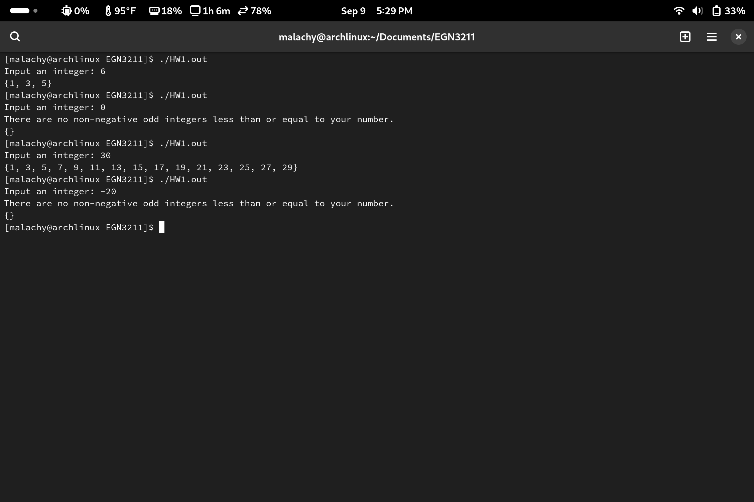Code:  
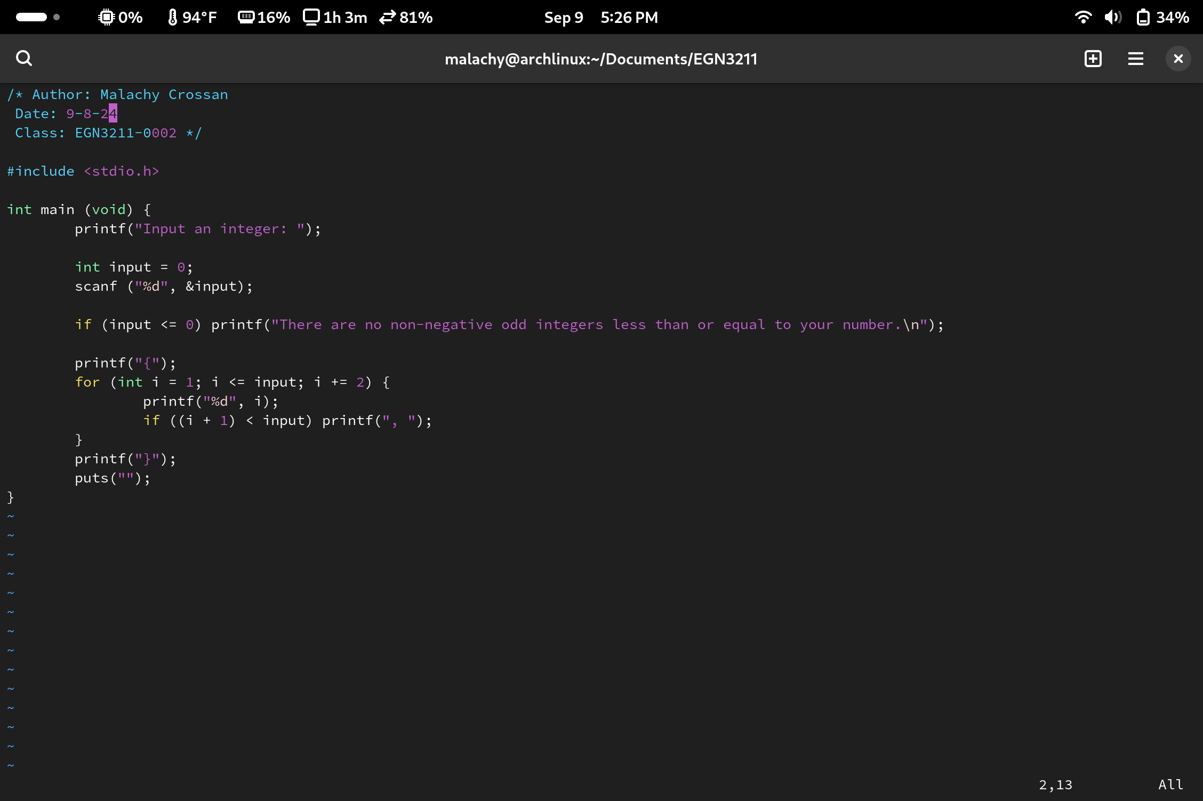/\* Author: Malachy Crossan

Date: 9/8/24

Class: EGN3211-0002 \*/

#include <stdio.h>

int main (void) {

printf("Input an integer: ");

int input = 0;

scanf ("%d", &input);

if (input <= 0) printf("There are no non-negative odd integers less than or equal to your number.\n");

printf("{");

for (int i = 1; i <= input; i += 2) {

printf("%d", i);

if ((i + 1) < input) printf(", ");

}

printf("}");

puts("");

}