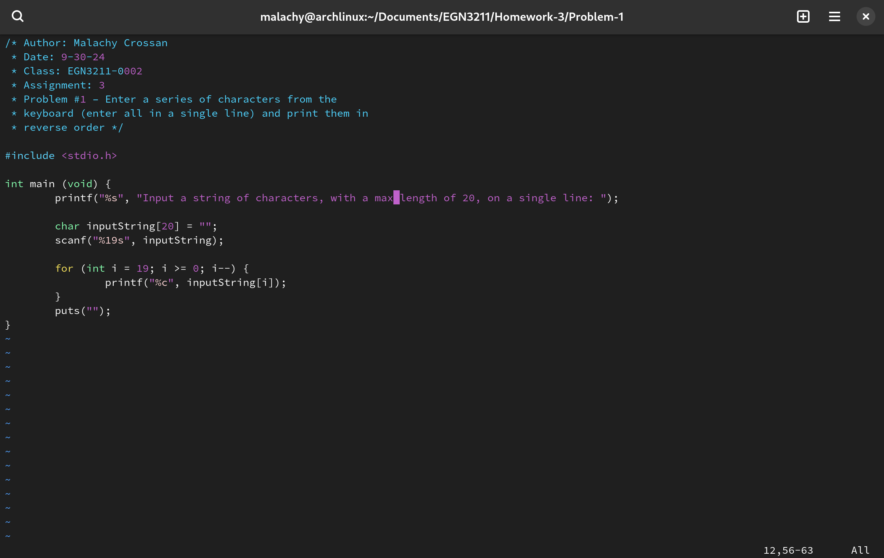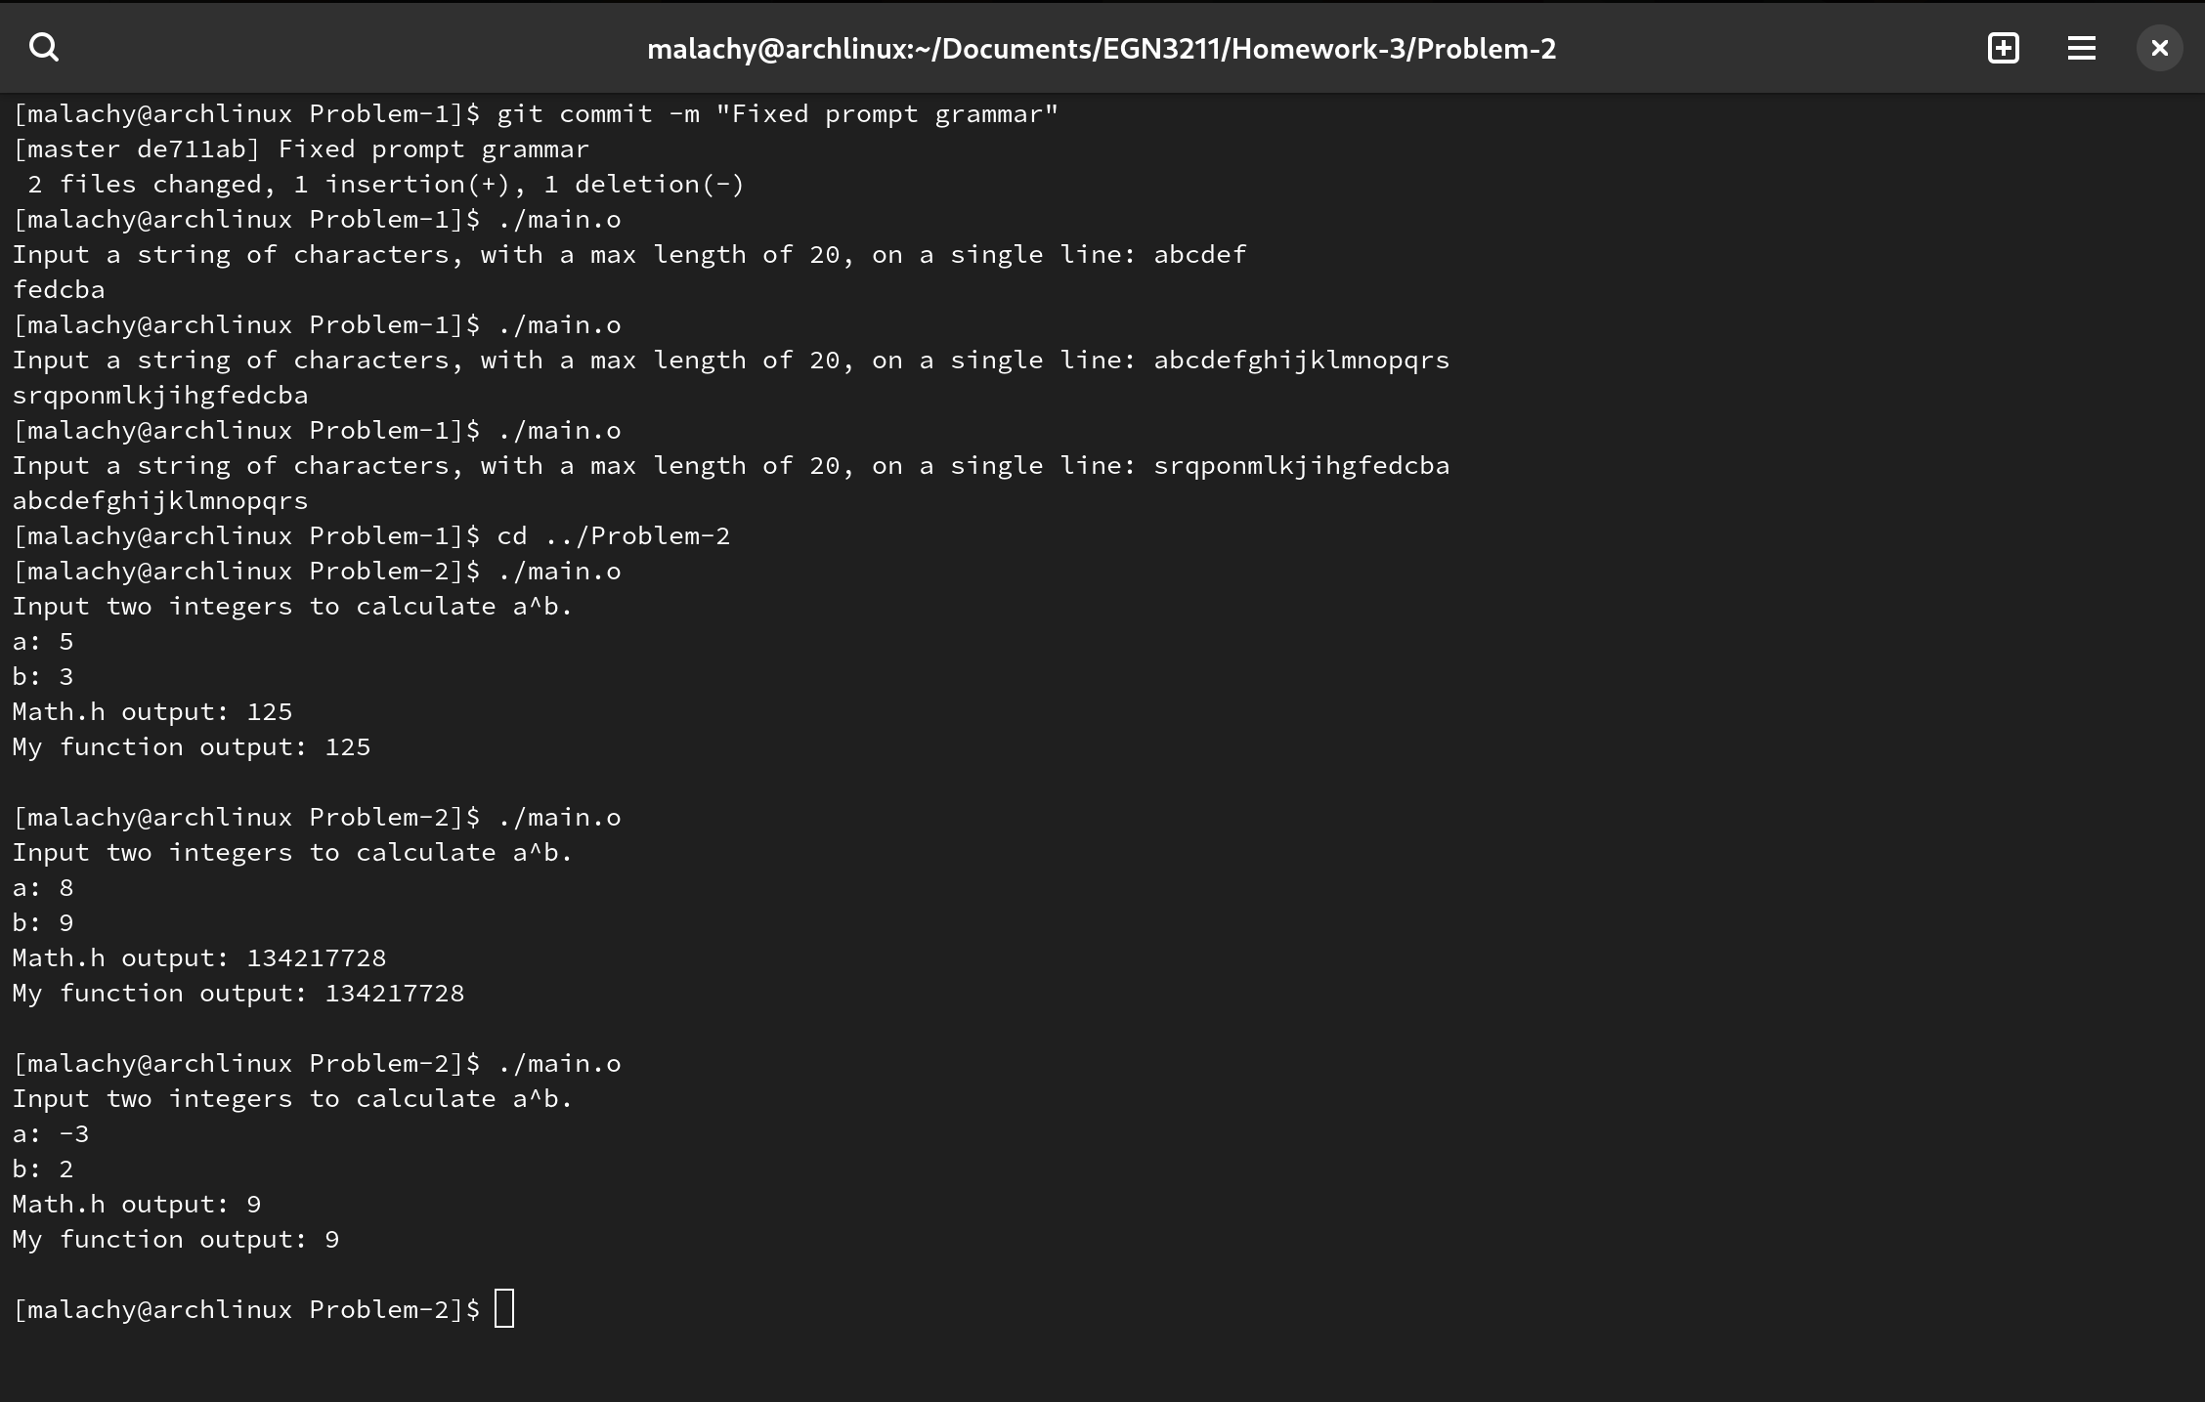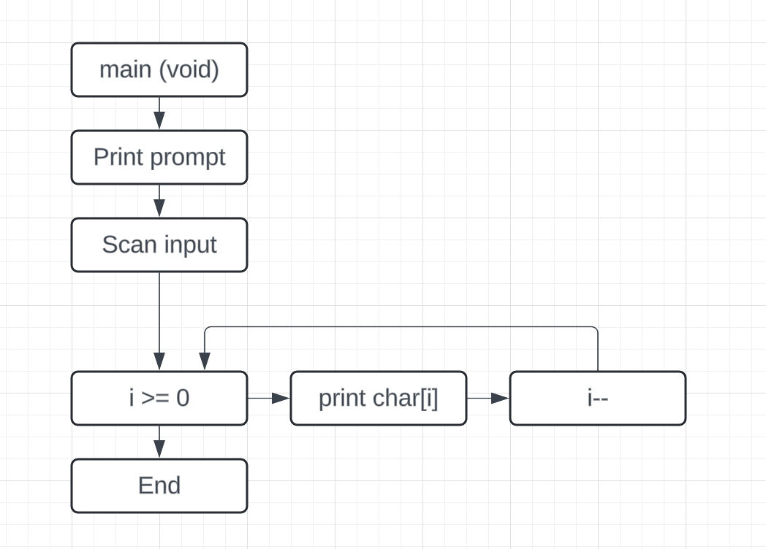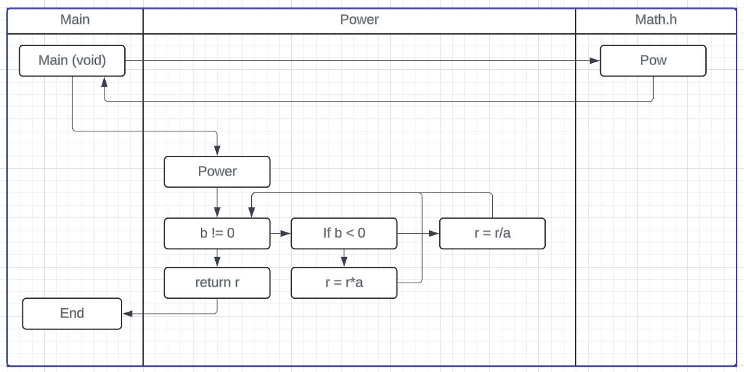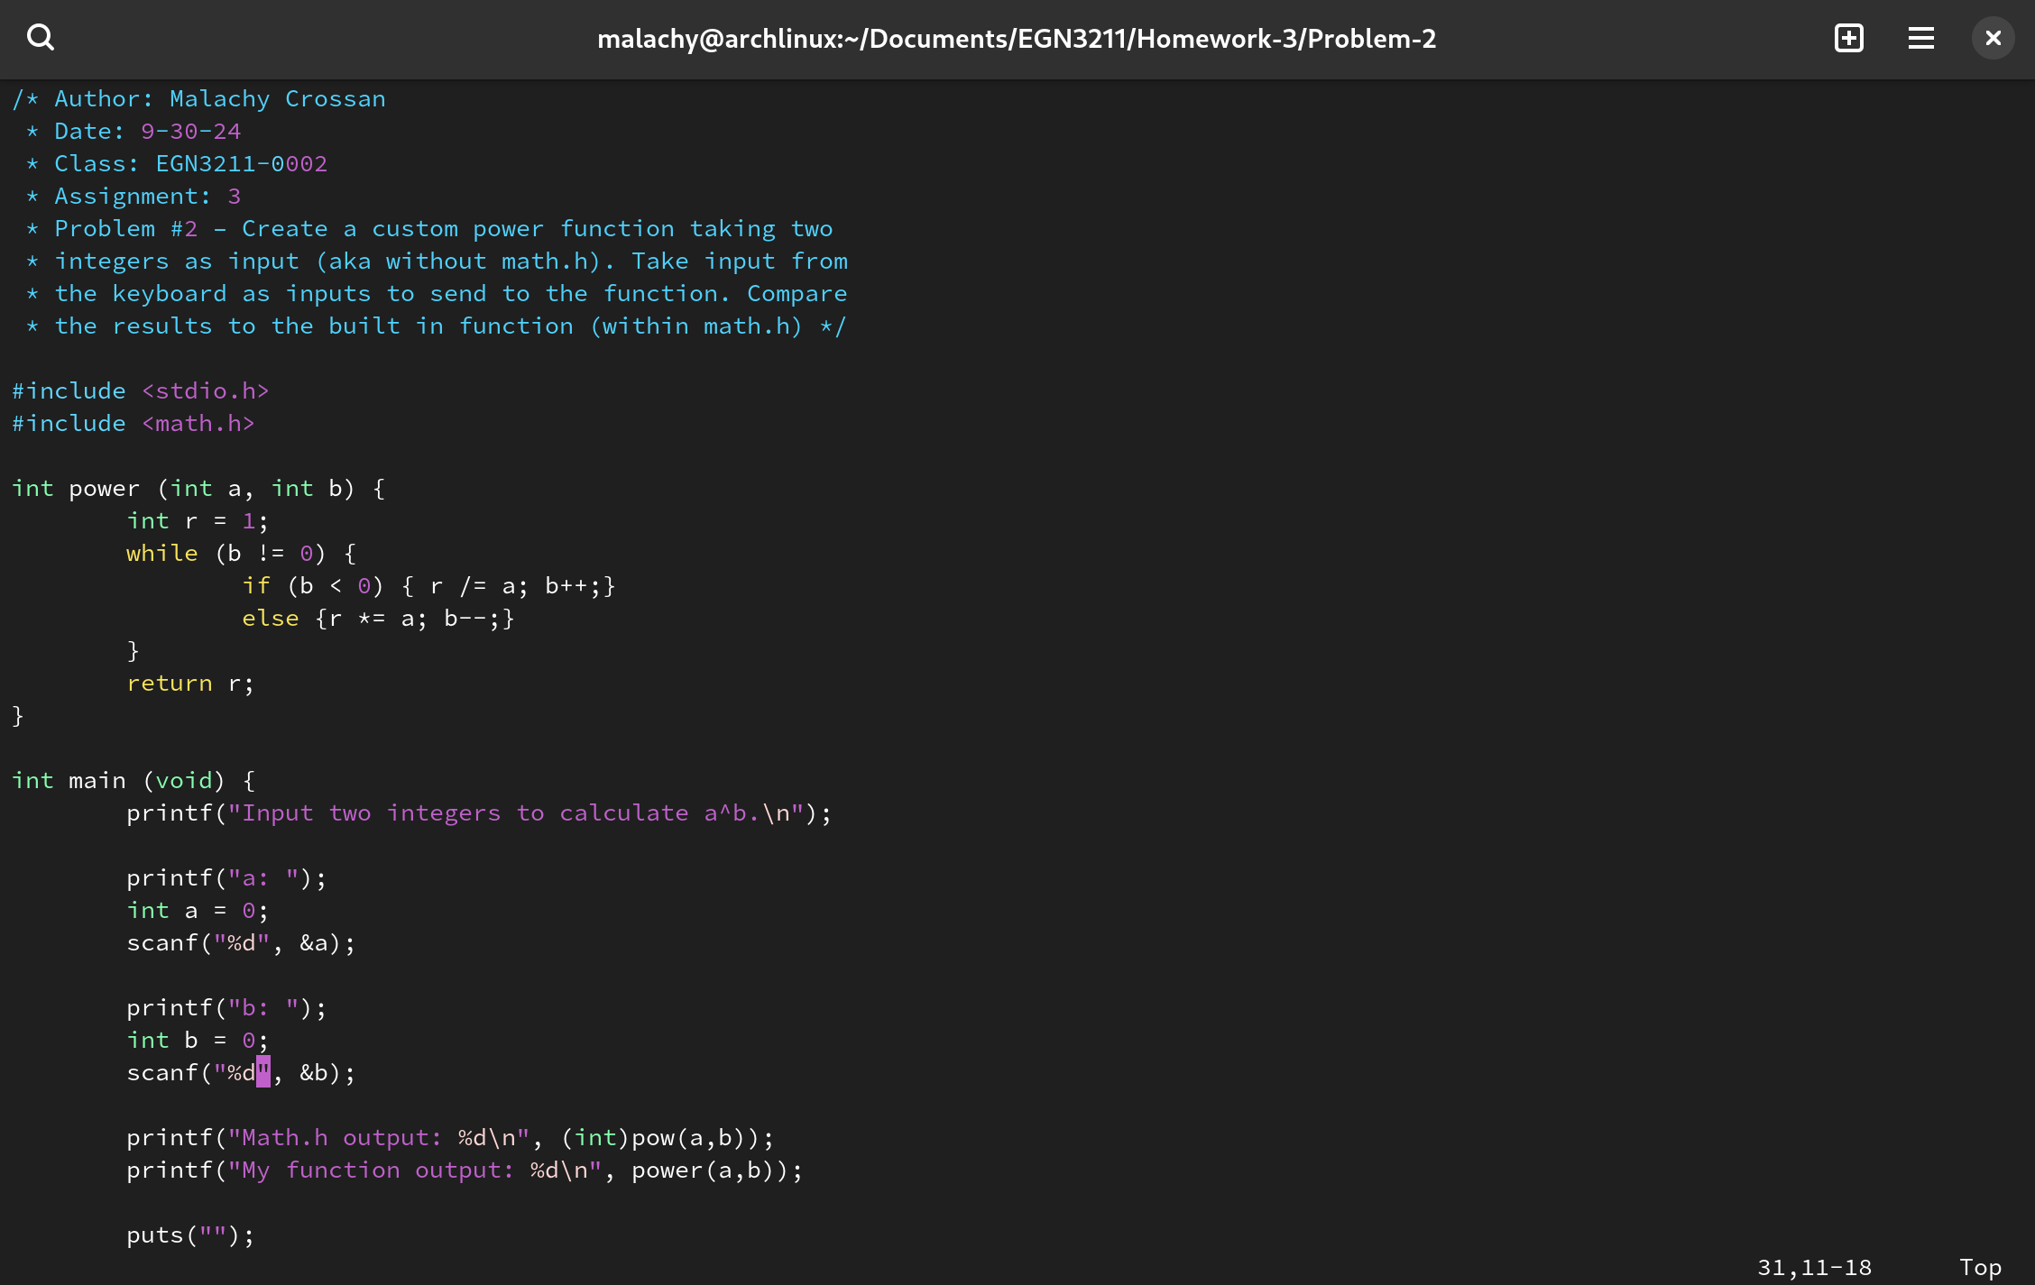/\* Author: Malachy Crossan

\* Date: 9-30-24

\* Class: EGN3211-0002

\* Assignment: 3

\* Problem #1 – Enter a series of characters from the

\* keyboard (enter all in a single line) and print them in

\* reverse order \*/

#include <stdio.h>

int main (void) {

printf("%s", "Input a string of characters, with a max length of 20, on a single line: ");

char inputString[20] = "";

scanf("%19s", inputString);

for (int i = 19; i >= 0; i--) {

printf("%c", inputString[i]);

}

puts("");

}

Problem 2:

/\* Author: Malachy Crossan

\* Date: 9-30-24

\* Class: EGN3211-0002

\* Assignment: 3

\* Problem #2 – Create a custom power function taking two

\* integers as input (aka without math.h). Take input from

\* the keyboard as inputs to send to the function. Compare

\* the results to the built in function (within math.h) \*/

#include <stdio.h>

#include <math.h>

int power (int a, int b) {

int r = 1;

while (b != 0) {

if (b < 0) { r /= a; b++;}

else {r \*= a; b--;}

}

return r;

}

int main (void) {

printf("Input two integers to calculate a^b.\n");

printf("a: ");

int a = 0;

scanf("%d", &a);

printf("b: ");

int b = 0;

scanf("%d", &b);

printf("Math.h output: %d\n", (int)pow(a,b));

printf("My function output: %d\n", power(a,b));

puts("");

}