Project title: Team-up: A Collaborative Study & Team Planning Hub
Team ID: 6
Team members: Malaika Farooq (1002311562), Aditi Vishal (1002387938), Amogh Dhole (1002055522), Krishan Lnu (1002306864)
Submission date: September 27, 2026

1. Project Overview
Teamup is a web-based collaborative study and team planning tool that helps students to organize study sessions, class projects, and recurring group work. This platform also allows users to create their own profile with the skills and courses they are good at to find study groups or study partners to study with using the AI feature of teammate matching, making it easier to find suitable study groups for targeted courses. It also allows students/users to organize study sessions based on the collaborated calendar, so users can find a perfect time to meet up to study. Students can create or join teams through invitations or requests, schedule meetings using a shared calendar, and manage responsibilities through a task board with assignments, deadlines, and status tracking. The application also provides shared notes, links, file references, notifications, and a progress dashboard so every team member can stay updated. Overall, the system provides one centralized workspace for student collaboration, communication, scheduling, and productivity.

1.1 SMART Goals
Specific: Developing a web-based collaboration platform for students that supports profile creation, an AI-based teammate matching feature, team creation, shared calendars, task management, shared resources, notifications, and progress tracking.
Measurable: The project will be considered successful when users can create profiles and teams, receive teammate recommendations, schedule study sessions, assign and track tasks, share resources, and view team progress through the dashboard.
Achievable: The system will be developed using React.js and TypeScript, database tools such as PostgreSQL, APIs, and AI-based matching techniques, with project responsibilities divided among team members.
Relevant: Teamup addresses common student collaboration problems such as finding compatible study partners, coordinating schedules, organizing responsibilities, and keeping project information in one centralized location.
Time bound: The major Teamup features will be designed, developed, tested, and integrated within the Fall 2026 project schedule, with functionality delivered incrementally across planned development sprints.

2. Scope and requirements
2.1 Project Scope

In Scope | Out of Scope
User profiles (courses, skills, weekly availability) | Native mobile apps (iOS/Android)
Group creation with invite and taskboard-approved workflow | Built-in video/voice calling/messaging
Owner/member permission levels | Payment or subscription features
Availability-overlap meeting scheduler | Real-time collaborative document editing
Shared notes & resource links per group | Google/Outlook calendar sync
In-app notifications (task, deadline) | Plagiarism/academic-integrity checks
Progress dashboard (tasks and deadlines) | Multi-language / localization support
AI Teammate Matching (skills + availability based) | Offline mode / offline data access

2.2 Functional Requirements

ID | Functional Requirement | Priority
FR-01 | The system shall allow a user to register, sign in, and manage a profile containing enrolled courses, skills, and weekly availability. | Must
FR-02 | The system shall allow a user to create a team and invite others and allow other users to request to join, with the team owner able to approve or deny each request. | Must
FR-03 | The system shall allow team members to create and view meetings in a shared calendar and shall highlight overlapping member availability to suggest common meeting times. | Must
FR-04 | The system shall allow team members to create tasks, assign owners, set due dates, and update task status (To Do / In Progress / Done) on a shared board. | Must
FR-05 | The system shall allow team members to create shared notes and add links and file references that are visible to their group. | Must
FR-06 | The system shall send in-app notifications to users about invitations, task assignments, and meeting changes. | Should
FR-07 | The system shall display a progress dashboard showing task completion, overdue work, and recent group activity. | Must
FR-08 | The system shall suggest potential teammates or group sessions based on a user's profile, skills, availability, and workload using the AI Teammate Matching feature and shall let the user accept or decline each suggestion. | Should
FR-09 | The system shall enforce owner and member permission levels on all group actions and shall display clear error messages and user guidance in the main workflows. | Must
FR-10 | The system shall allow a user to filter the task view by owner, due date, and status. | Should

2.3 Nonfunctional Requirements
ID | Category | Measurable Nonfunctional Requirement
NFR-01 | Performance | 95% of task board and dashboard page loads shall complete within 2 seconds under 50 concurrent users.
NFR-02 | Security | All user passwords shall be stored using JWT token hashing, and all API endpoints shall require authenticated session tokens.
NFR-03 | Usability | A new user shall be able to create a profile and join or create their first group within 5 minutes without external guidance.
NFR-04 | Reliability | The system shall maintain 99% uptime during the semester testing period, with any AI-matching failure gracefully falling back to manual skill search.
NFR-05 | Scalability | The system's database schema shall support at least 100 concurrent user profiles and a minimum of 50 active groups without requiring architectural changes.

2.4 Required AI-enabled Feature
Feature | Input and Output | Evaluation and Limitation
AI Teammate Matching suggests compatible study partners or teammates based on a user's profile, skills, availability, and current workload. | Input: user's enrolled courses, listed skills, self-reported weekly availability, current task load  Output: a ranked list of suggested teammates or study groups, each with a brief rationale (e.g., "shares Calc III, free Tue 4pm, complementary skill set") | Metric: user acceptance rate: the percentage of AI-suggested matches that a user actually invites, joins, or accepts  Limitation: cold-start problem for new users with incomplete profiles; suggestion quality depends entirely on accuracy of self-reported data (skills/availability aren't verified); risk of bias toward users who fill out more profile fields, making them appear as "better" matches more often

2.5 Use of AI/Tools
Tool: Claude (Anthropic).

Purpose/input: Drafted the scope table, functional requirements FR-01 to FR-10, non-functional requirements, AI-feature description (Section 2), the testing plan (Section 7), and the WBS table (Section 4.4). Cross-checked the requirements against the sprint backlog PB-01 to PB-10.

Output accepted as-is: scope table and non-functional requirement wording.

Output changed or to validate: The functional requirements were revised to map one-to-one to the backlog, and the testing plan was reviewed and refined (tool names, pass-rate target). Numeric targets (50 users, 99% uptime) are planning assumptions and must be checked against the final tech stack.

Tools Used: React Testing Library, Cypress, k6, and Jira.

3. Technical approach and resources
Architecture and major components | Architecture is based on a React web app, and the backend is a TypeScript server function on the Lovable cloud that will check permissions and log activity. The database is Postgres, which has permissions on row-level security so that data is only accessible to the right members. Client server calls are secured using JWT token authentication.
Technology stack | The frontend is built in React.js, the backend is in TypeScript, and the database is a PostgreSQL SQL database. Authentication is JWT token-based for log-in and sign-up.
External resources | Supabase Authentication is used to handle password hashing and session tokens using JWT. Supabase Row Level Security for enforcing owner permissions and access control, an AI/LLM API called from a Supabase Edge Function for the Teammate Matching feature.
Constraints and assumptions | Our team consists of four members splitting the work for frontend, backend, database, and cloud, which is a constraint since we need to divide the work throughout 4 sprints. Assuming every team member completes the task assigned to them.

4. Agile delivery plan
Item | Plan
Method and justification | The method we are using is Scrum. The application can be delivered in small and usable increments, which will allow students and the instructor to provide feedback after each sprint. Regular reviews will help the team improve usability and manage changing requirements.
Sprint length and number | Four two-week sprints, covering eight weeks.
Ceremonies | Sprint planning at the beginning of each sprint and a 15-minute daily stand-up on working days. Weekly backlog refinement; a sprint review and retrospective at the end of each sprint.
Definition of done | Acceptance criteria should be met, and code reviewed and merged. Relevant unit and integration tests passing. Access permissions verified for various users. Documentation updated, feature deployed to the shared test environment, and no unresolved critical defects.

4.1 Initial product and sprint backlog
ID | Epic or user story | Priority | Estimate | Target sprint
PB-01 | As a student, I can register, sign in, and manage a profile containing my courses, skills, and availability. | Must | 8 | Sprint 1
PB-02 | As a student, I can create a team, invite others, request to join a group, and approve requests when I am the team owner. | Must | 8 | Sprint 1
PB-03 | As a team member, I can create and view meetings in a shared calendar using members’ availability. | Must | 8 | Sprint 2
PB-04 | As a team member, I can create tasks, assign owners, set due dates, and update task status on a shared board. | Must | 5 | Sprint 2
PB-05 | As a team member, I can create shared notes and add links and file references accessible to my group. | Must | 5 | Sprint 3
PB-06 | As a team member, I receive in-app notifications about invitations, task assignments, and meeting changes. | Should | 5 | Sprint 3
PB-07 | As a team member, I can view a progress dashboard showing task completion, overdue work, and recent activity. | Must | 8 | Sprint 4
PB-08 | As a team member, I can receive suggested teammates or group sessions based on my profile, skills, availability, and workload. | Should | 8 | Sprint 4
PB-09 | As a student, I can complete the main workflows in the release version with verified permissions, clear error messages, and user guidance. | Must | 5 | Sprint 5
PB-10 | As a student, I can filter my task view by owner, due date, and status. | Should | 3 | Sprint 6

4.2 PERT Chart and Table
Using the PERT formula, we calculated the below table:
Activity | Optimistic (O) | Most Likely (M) | Pessimistic (P) | PERT Duration
User Profile | 3 days | 5 days | 7 days | 5 days
Create/Join Teams | 3 days | 5 days | 7 days | 5 days
Shared Calendar | 4 days | 6 days | 9 days | 6.17 days
Shared Notes | 4 days | 6 days | 9 days | 6.17 days
Task Board | 3 days | 5 days | 8 days | 5.17 days
Activity History | 5 days | 7 days | 10 days | 7.17 days
AI Feature | 5 days | 7 days | 12 days | 7.50 days
Wireframe | 2 days | 4 days | 6 days | 4 days
API Designing | 2 days | 4 days | 7 days | 4.17 days
DB setup | 3 days | 5 days | 8 days | 5.17 days
Hosting on Cloud | 2 days | 4 days | 7 days | 4.17 days
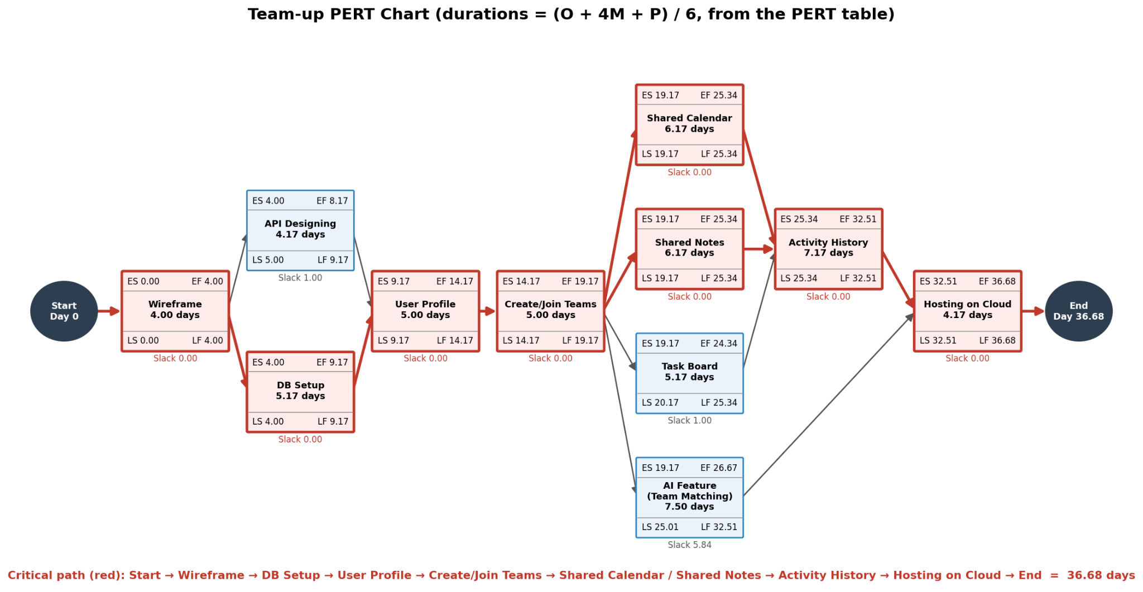
4.3 Gantt Chart
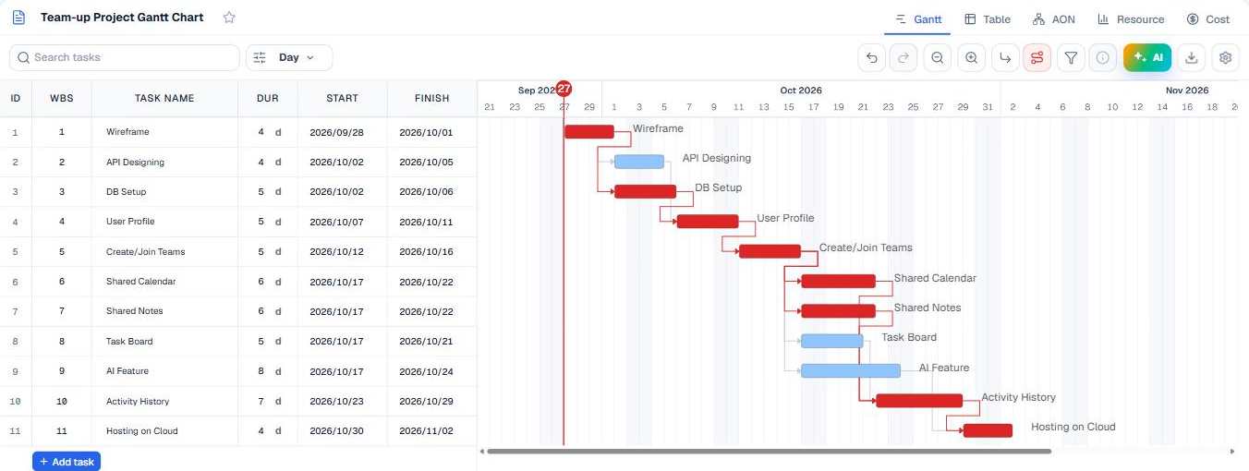
4.4 Work Breakdown Structure (WBS)
Attached is the link to see the full WBS
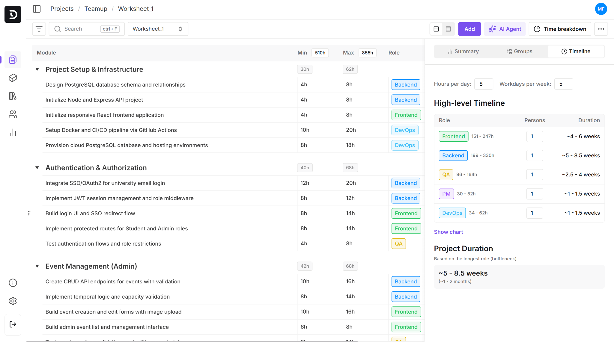
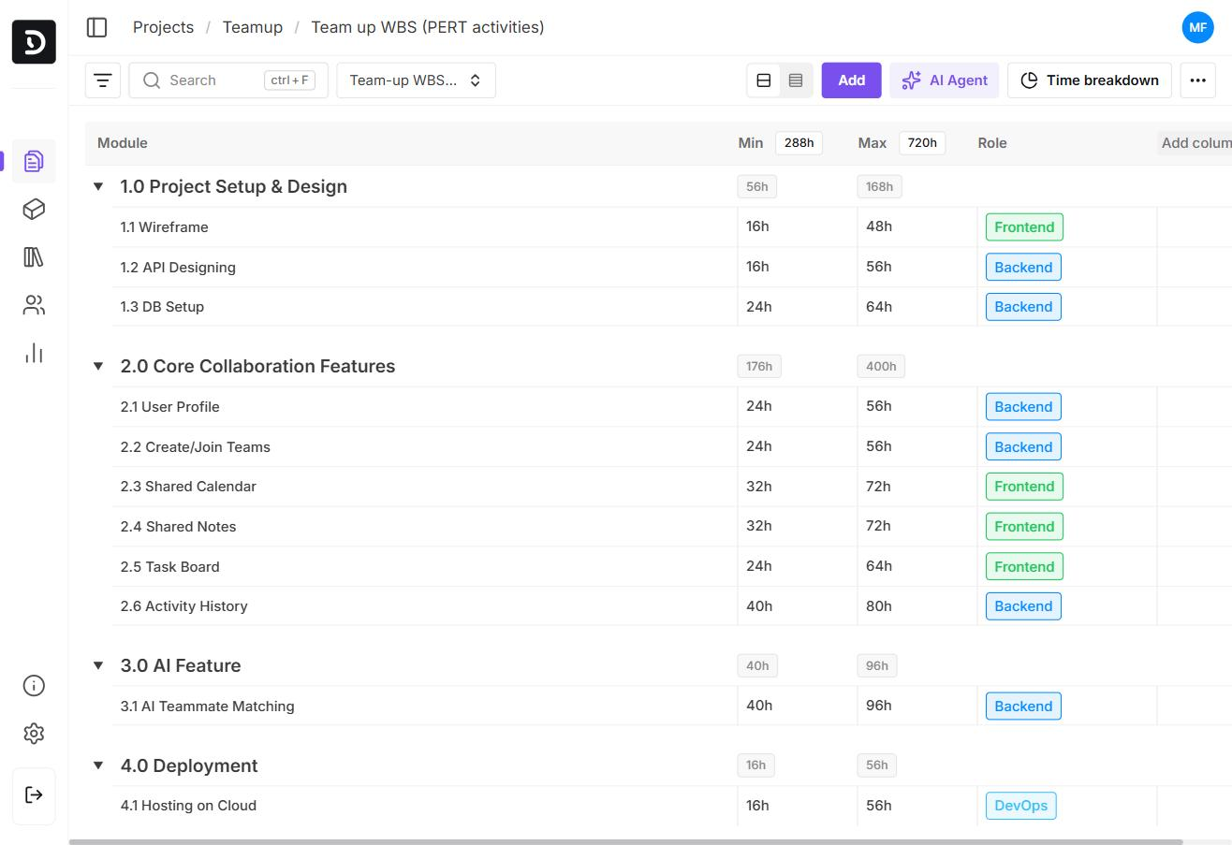
Work Breakdown Structure built in Devtimate (worksheet “Team-up WBS (PERT activities)”). 4 work packages, 11 tasks matching the PERT table; Min = optimistic days x 8 h, Max = pessimistic days x 8 h; total 288-720 person-hours.

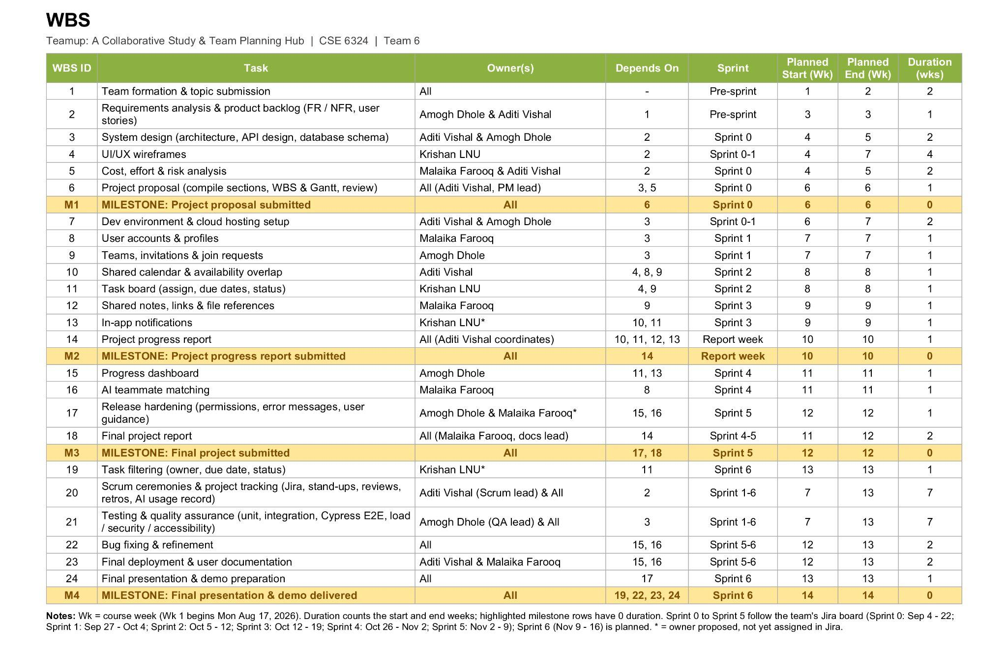4.5 Burndown Chart
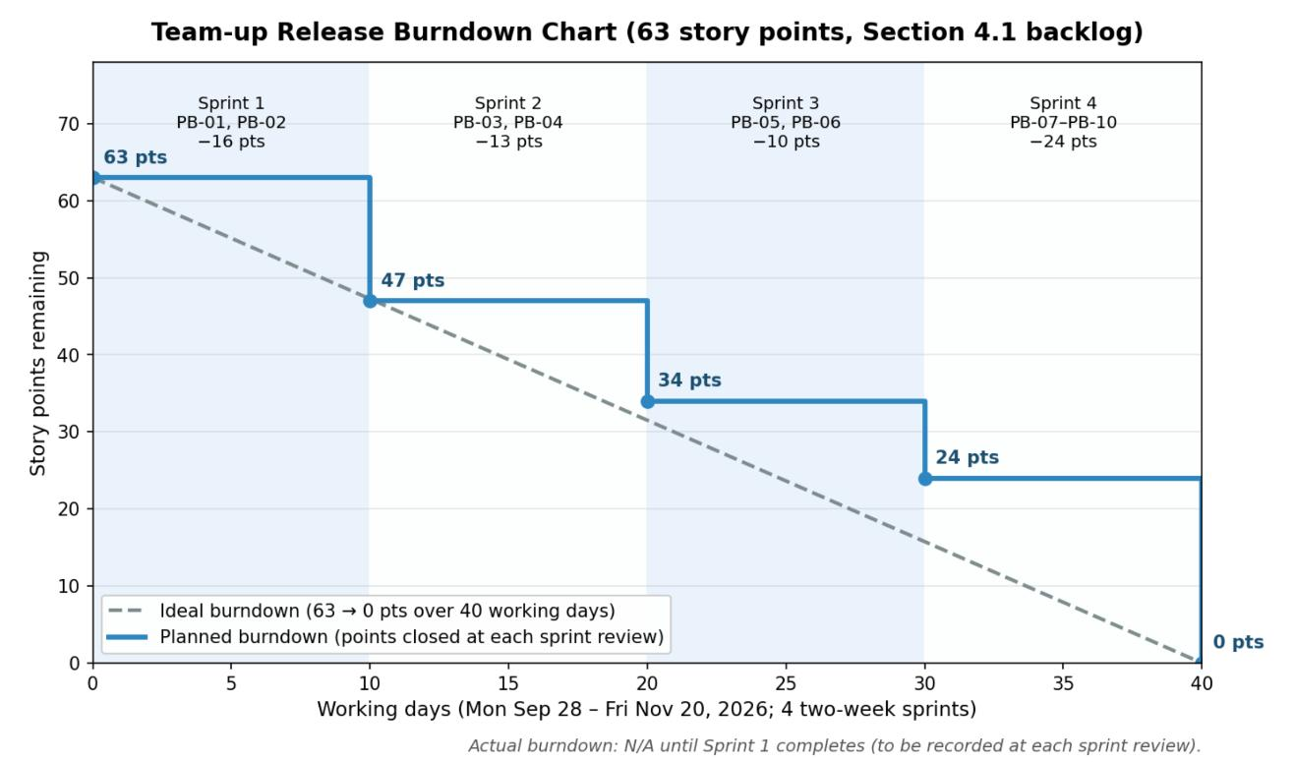
.
4.6 Scrum Board
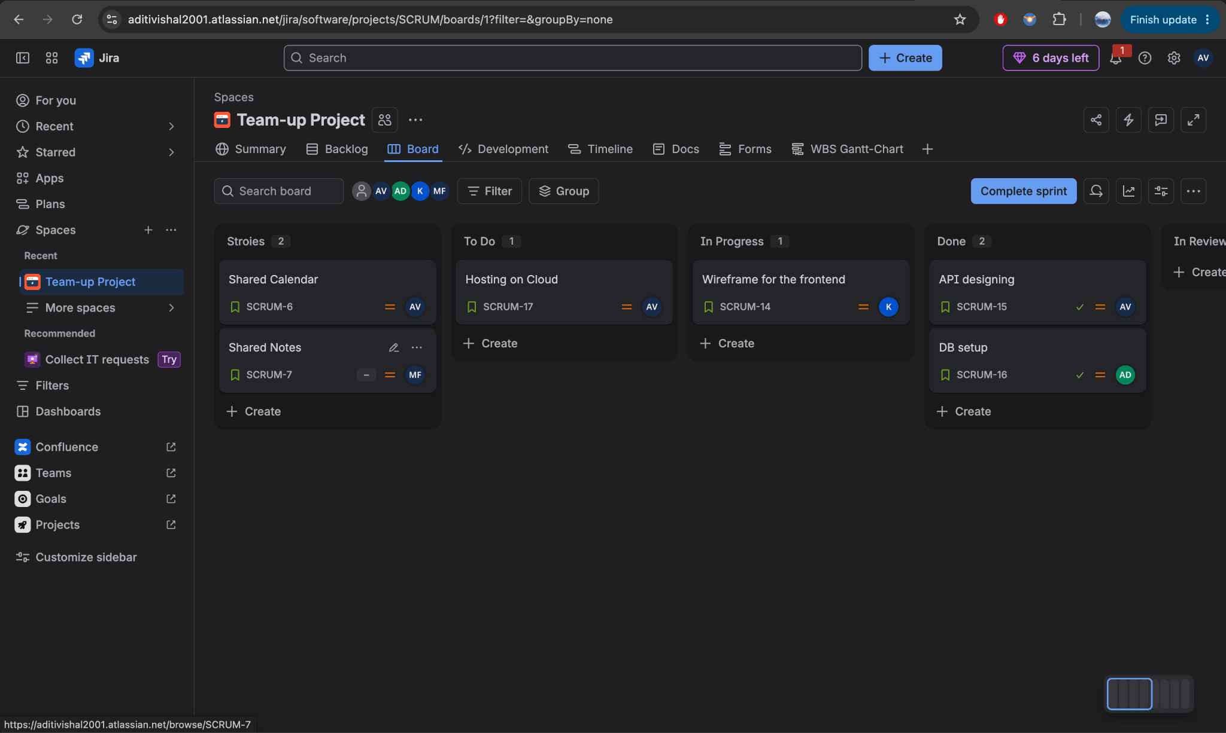
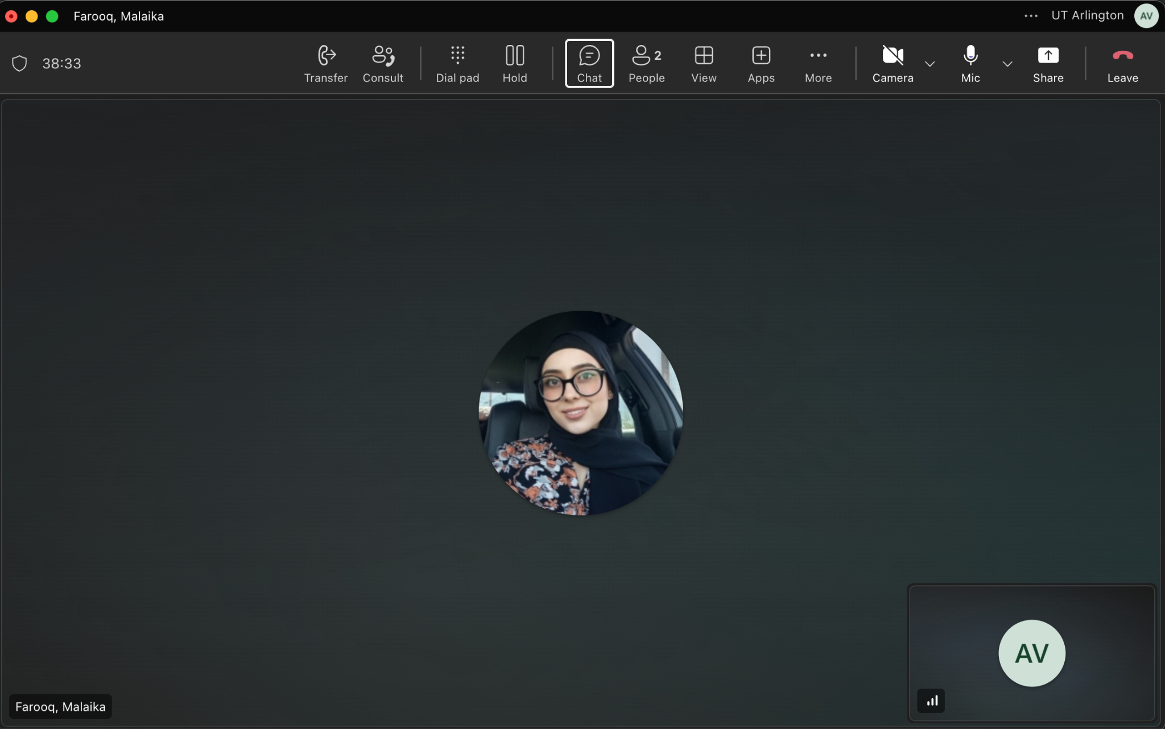
Scrum stand-up meeting on teams.
4.7 AI/Tools Used
Tools used for this section: Lucidchart, AI Gantt Generator, Devtimate
Purpose: Confirmed that the PERT chart was according to the table on the Lucidchart AI tool. The AI Gantt generator was used as a reference to the Jira Gantt chart created and exported as an Excel sheet. Devtimate was used for WBS.
The output team must still validate or correct: The team must validate the output of charts according to the Jira scrum board. Furthermore, AI was used to divide the workload for Jira to work on the Gantt, PERT, and WBS.

5. Effort and Cost Estimation
Method | Inputs and assumptions | Estimated result
A: Historical analogy | Size: 189 AFP Productivity/rate: 2.5-3.75 hrs/FP from three analogous student projects (assumed profile); $20/hr notional rate | Effort: ≈591 person-hours (473-709)  Schedule: ≈9.9 weeks at 4 x 15 hrs/week  Cost: ≈$11,820 (notional; team unpaid)
B: Decomposition, story points | Size: 63 story points (PB-01 to PB-10)  Productivity/rate: 4 person-hours per point (planning assumption until Sprint 1 velocity); $20/hr notional rate | Effort: 252 person-hours (240-480 capacity-derived)  Schedule: 12 weeks (6 two-week sprints)  Cost: $5,040 (notional)
C + D: Function points to Basic COCOMO, organic mode | Size: 189 AFP x 30 LOC/FP = 5.67 KLOC  Productivity/rate: Boehm constants a = 2.4, b = 1.05, c = 2.5, d = 0.38 [1]; 152 hrs/PM; $20/hr notional rate | Effort: ≈14.8 person-months (≈2,256 person-hours)  Schedule: ≈7.0 months (≈30 weeks)  Cost: ≈$45,120 (notional)
C + D2: Intermediate COCOMO with cost drivers | Size: 5.67 KLOC  Productivity/rate: a = 3.2, b = 1.05, EAF = 0.77 from Table 5.7a [1]; 152 hrs/PM; $20/hr notional rate | Effort: ≈15.2 person-months (≈2,306 person-hours)  Schedule: ≈7.0 months (≈30 weeks)  Cost: ≈$46,120 (notional)
D2: COCOMO II with maintenance, softwarecost.org | Size: 5,670 SLOC  Productivity/rate: scale drivers Nominal; RELY, APEX, PVOL Low; TOOL High; SCED Very Low; $3,040/PM notional; maintenance 850 ESLOC/year for 1 year (assumed) | Effort: 22.5 person-months (≈3,420 person-hours)  Schedule: 6.6 months (≈29 weeks)  Cost: $68,267 development + $9,594 per year maintenance (notional)
5.1 Approach
This section applies four estimation methods: historical analogy, decomposition by story points, decomposition by function points, and the COCOMO empirical model (Basic, plus Intermediate with cost drivers in Section 5.5.1) rather than a single method. Running independent methods side by side and comparing where they agree and disagree (Section 5.6) gives the team direct evidence about which numbers to trust, instead of a single unverified figure.
5.2 Method A: Historical Analogy
Historical analogy bases the estimate on similar projects that have already been completed and scales their effort to the new project. Because the team has no completed project of its own with recorded hours, three typical one-semester student web apps are used as analogs. Each analog is a subset of Teamup’s own features, so its size is measured with exactly the same function-point counts as Teamup (Section 5.4), which makes the sizes directly comparable. Analog effort is assumed from the course-project profile shown (team size × weeks × 10–15 hours per student per week) and should be replaced with real hours if the team or instructor can provide them.
Analogous project | Features (Teamup equivalent) | Size (FP) | Team | Duration | Effort (person-hours, at 10–15 hrs/week each) | Productivity (hrs/FP)
A1: Team task tracker | Accounts and profiles, teams and invitations, task boards, notifications, filtered task view (PB-01, 02, 04, 06, 10) | 115 | 4 students | 8 weeks | 320–480 | 2.8–4.2
A2: Study-group scheduler | Accounts and profiles, groups and invitations, shared calendar with availability overlap (PB-01, 02, 03) | 93 | 3 students | 8 weeks | 240–360 | 2.6–3.9
A3: Class notes-sharing app | Accounts and profiles, groups, shared notes and files, progress dashboard, notifications (PB-01, 02, 05, 06, 07) | 112 | 4 students | 6 weeks | 240–360 | 2.1–3.2
Average of analogs |  | 107 |  |  |  | 2.5–3.75 (midpoint ≈ 3.13)
Teamup (scaled by analogy) | All PB-01 to PB-10, including AI teammate matching | 189 | 4 students | See Table 5.1. | ≈ 473–709 (most likely ≈ 591) | 2.5–3.75

5.3 Method B: Decomposition (Story Points)
Backlog used for this estimate
ID | Epic or user story | Priority | Pts
PB-01 | As a student, I can register, sign in, and manage a profile containing my courses, skills, and availability. | Must | 8
PB-02 | As a student, I can create a team, invite others, request to join a group, and approve requests when I am the team owner. | Must | 8
PB-03 | As a team member, I can create and view meetings in a shared calendar using members’ availability. | Must | 8
PB-04 | As a team member, I can create tasks, assign owners, set due dates, and update task status on a shared board. | Must | 5
PB-05 | As a team member, I can create shared notes and add links and file references accessible to my group. | Must | 5
PB-06 | As a team member, I receive in-app notifications about invitations, task assignments, and meeting changes. | Should | 5
PB-07 | As a team member, I can view a progress dashboard showing task completion, overdue work, and recent activity. | Must | 8
PB-08 | As a team member, I can receive suggested teammates or group sessions based on my profile, skills, availability, and workload. | Should | 8
PB-09 | As a student, I can complete the main workflows in the release version with verified permissions, clear error messages, and user guidance. | Must | 5
PB-10 | As a student, I can filter my task view by owner, due date, and status. | Should | 3
 | Total |  | 63

Method | Inputs and assumptions | Estimated result
Decomposition  Story Points | Backlog: 10 items (PB-01–PB-10), 63 total story points; see itemized backlog table above.  Sizing method: relative sizing during backlog grooming, following Cohn’s planning-poker approach [4].  Conversion rate: 1 story point ≈ 4 person-hours, a planning assumption, not a measured rate, since the team has no velocity history yet. Cohn [4] recommends treating this as provisional until Sprint 1 data is available.  Schedule basis: Six two-week sprints (Section 4).  Labor rate: $20/person-hour, an assumed academic planning rate (not an actual wage; team members are unpaid, so the cost below is a notional value only). | Effort:  63 × 4 = 252 person-hours  Schedule:  8 weeks  Cost:  252 × $20 = $5,040

5.4 Method C: Decomposition (Function Points)
Step 1: Unadjusted Function Points, mapped to backlog items
Component | Mapped to backlog item(s) | Count | Weight [2] | Subtotal
External Inputs (EI) | PB-01 register/sign-in/edit-profile (3) · PB-02 create-team/invite/request/approve (4) · PB-03 create-meeting (1) · PB-04 create-task/assign/update-status (3) · PB-05 create-note/add-link (2) · PB-08 acts on a suggested match (1) | 14 | 4 | 56
External Outputs (EO) | PB-06 notification feed (1) · PB-07 dashboard (1) · PB-03 highlighted common-availability result (1) · PB-08 ranked teammate-match suggestions (1) | 4 | 5 | 20
External Inquiries (EQ) | PB-01 view profile · PB-02 view members · PB-03 view calendar + meeting detail (2) · PB-04 view board · PB-05 view notes · PB-06 view notifications · PB-08 request match suggestions · PB-10 filtered view | 9 | 4 | 36
Internal Logical Files (ILF) | Profiles, Teams, Invitations, Meetings, Tasks, Notes, Notifications | 7 | 10 | 70
External Interface Files (EIF) | Matching/recommendation service (PB-08) | 1 | 7 | 7
Unadjusted Function Points (UFP) |  | 189
Step 2: General System Characteristics and Value Adjustment Factor
# | General System Characteristic | Rating [0–5] | Justification
1 | Reliable backup and recovery | 1 | Course project; no formal backup infrastructure planned
2 | Data communications | 4 | Web client-server architecture plus an external matching/AI service call
3 | Distributed processing | 0 | Single monolithic backend; no distributed components
4 | Performance critical | 1 | No hard real-time requirement
5 | Heavily used operational environment | 0 | Light, classroom-scale usage
6 | Online data entry | 5 | Nearly all data (profile, tasks, notes) is entered live.
7 | Input over multiple screens | 3 | Team creation/invite flow spans several steps.
8 | Master files updated online | 5 | All entities are live CRUD.
9 | Complex inputs, outputs, or inquiries | 4 | Ranked match-suggestion output adds nontrivial complexity.
10 | Complex internal processing | 5 | Availability-overlap scheduling logic plus teammate-matching algorithm
11 | Designed for reuse | 2 | Some shared components planned (forms, notification system)
12 | Ease of installation | 1 | Standard web deployment; no special install effort
13 | Designed for multiple installations | 0 | Single deployment for this course, not multi-tenant
14 | Facilitates change / ease of use | 4 | PB-09 explicitly requires clear errors and user guidance.
Sum of ratings (ΣFᵢ) | 35 | VAF = 0.65 + 0.01(35) = 1.00
Step 3: Result
Method | Inputs and assumptions | Estimated result
Decomposition: Function Points | UFP = 189, counted per IFPUG standard average-complexity weights [2]; see the itemized component table above, with each transaction/file traced to a specific backlog item.  VAF = 1.00, from the 14 General System Characteristics rated above (ΣFᵢ = 35).  AFP = 189 × 1.00 = 189 FP  LOC/FP conversion: 30 LOC per FP, a mid-to-low value from Jones’ backfiring tables [3] for modern high-level/framework-based languages. | Size:  189 AFP  ≈ 5.67 KLOC

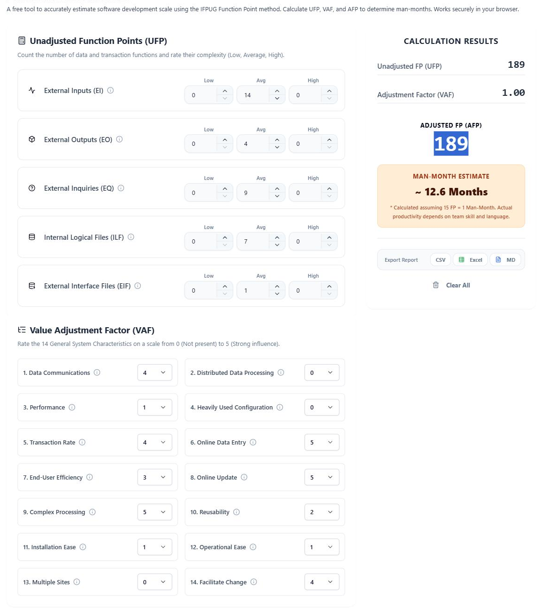5.5 Method D: Empirical Model (COCOMO Basic)
Method | Inputs and assumptions | Estimated result
Empirical Model: COCOMO Basic (Organic Mode) | Size: 5.67 KLOC (from Method C).  Mode: small team, familiar web-application domain, no embedded or hard real-time constraints [1].  Effort constants: a = 2.4, b = 1.05 (Boehm’s published organic-mode values [1], not tuned or estimated).  Schedule constants: c = 2.5, d = 0.38 [1].  Calculation: E = 2.4 × (5.67)^1.05 ≈ 14.8 person-months. T = 2.5 × (14.8)^0.38 ≈ 7.0 months. | Effort:  ≈ 14.8 person-months  (≈ 2,256 person-hours at 152 hrs/PM [1])  Schedule:  ≈ 7.0 months  (≈ 30 weeks)

Method D2: COCOMO II Cross-check and Maintenance Cost
As a cross-check on Methods D and D2 (COCOMO I), the same size was run through the COCOMO II calculator. Inputs: 5,670 new SLOC (5.67 KLOC from Method C); all five scale drivers Nominal; RELY Low, APEX (application experience) Low, PVOL (platform volatility) Low, TOOL High, SCED Very Low, all other cost drivers Nominal labor rate: $3,040 per person-month ($20/hr x 152 hrs, notional). TURN and MODP from Table 5.7a: N/A, because they are not cost drivers in COCOMO II. Maintenance inputs (assumptions): annual change size 850 ESLOC (about 15% of 5,670 SLOC changed per year), maintenance duration 1 year, software understanding 30%, unfamiliarity 0.4.

Results: development effort = 22.5 person-months (about 3,420 person-hours), schedule = 6.6 months, EAF = 1.13, notional development cost = $68,267. Annual maintenance effort = 3.2 person-months, annual maintenance cost = $9,594 (total for 1 year = $9,594). COCOMO II agrees with COCOMO I that required effort is far above the team’s 480-hour capacity, which supports risk R-01. Actual maintenance cost to the team: N/A (unpaid course project with no planned post-semester maintenance; the figures are notional).
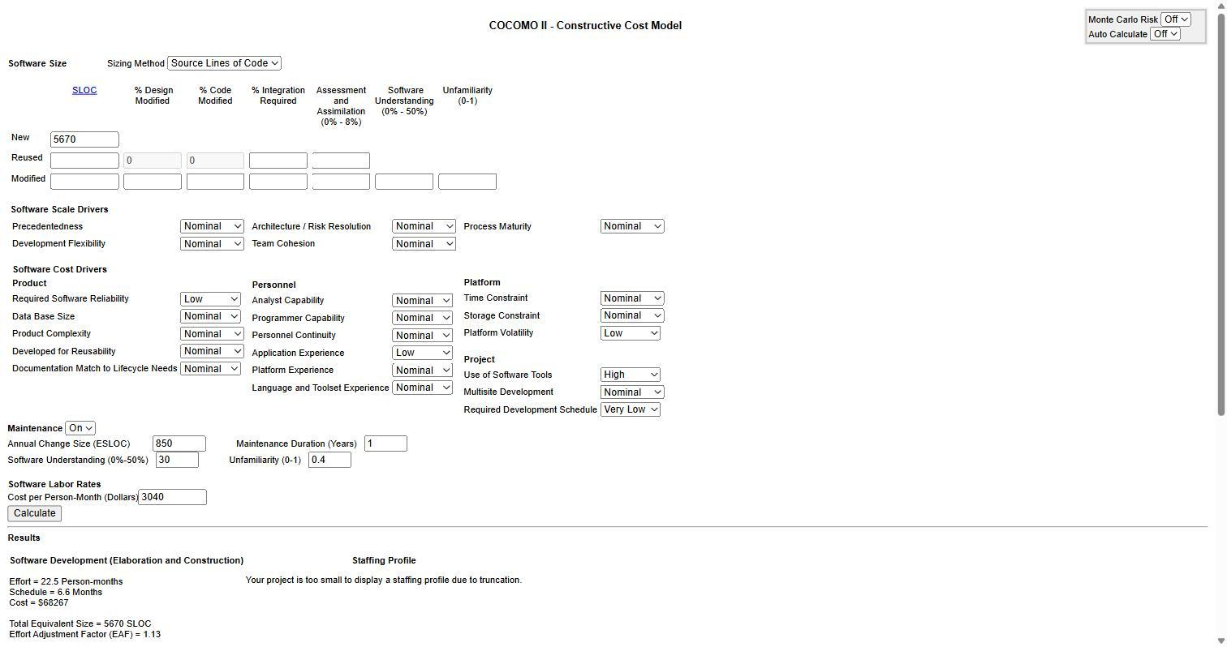
- Cocomo Calculator Cost Estimation

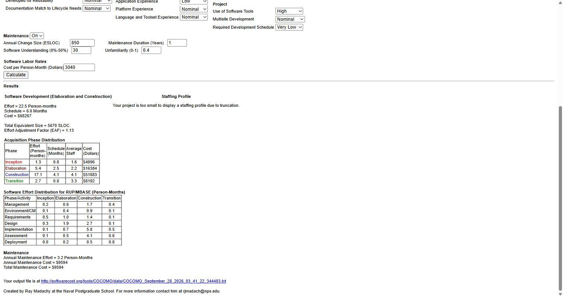
- Cocomo Calculator Cost Estimation

5.6 Comparison Across Methods
The table below compares total effort across all methods. Scaled from three analogous student projects, historical analogy (≈ 591 person-hours) falls between the story-point estimate (252-480) and function-point-to-COCOMO (≈ 2,256). Methods A, C+D, and C+D2 all start from the same 189 AFP, so they are not independent of each other; the story-point estimate is the only independent method (Table 5.8a). This gap is treated as a finding, not an error to hide.

5.7 Expanded Comparison Across Methods

This table replaces the effort-only comparison with size inputs, effort in both units, schedule, notional labor value (the team is unpaid), and whether each method is independent of the function-point count.
Method | Size input | Effort (person  hours) | Effort (person  months, 152 hrs/PM) | Schedule | Notion value at $20/hr (unpaid) | Independent of FP count? | Relative to FP→COCOMO
A: Historical analogy (analogous projects; range from Table 5.1) | 189 AFP | 591 (473-709) | 3.9 | - | $11,820 | No; uses the same 189 AFP | ≈ 0.26 times
B; Story points (as sized, 4 hrs/pt) | 63 points | 252 | 1.7 | 8 weeks | $5,040 | Yes. | ≈ 0.11  times
B; Story points (capacity-derived, Table 5.3a) | 63 points | 240-480 | 1.6-3.2 | 8 weeks | $4,800  -9,600 | Yes. | ≈ 0.11–0.21  times
C + D; FP → Basic COCOMO | 5.67 KLOC | 2,256 | 14.8 | 7.0 months | $45,120 | Baseline | 1.00 times
C + D2; FP → Intermediate COCOMO | 5.67 KLOC, EAF 0.77 | 2,306 | 15.2 | 7.0 months | $46,120 | No; same FP/KLOC input | ≈ 1.02 times
Table 5.8a: Expanded comparison across all methods.

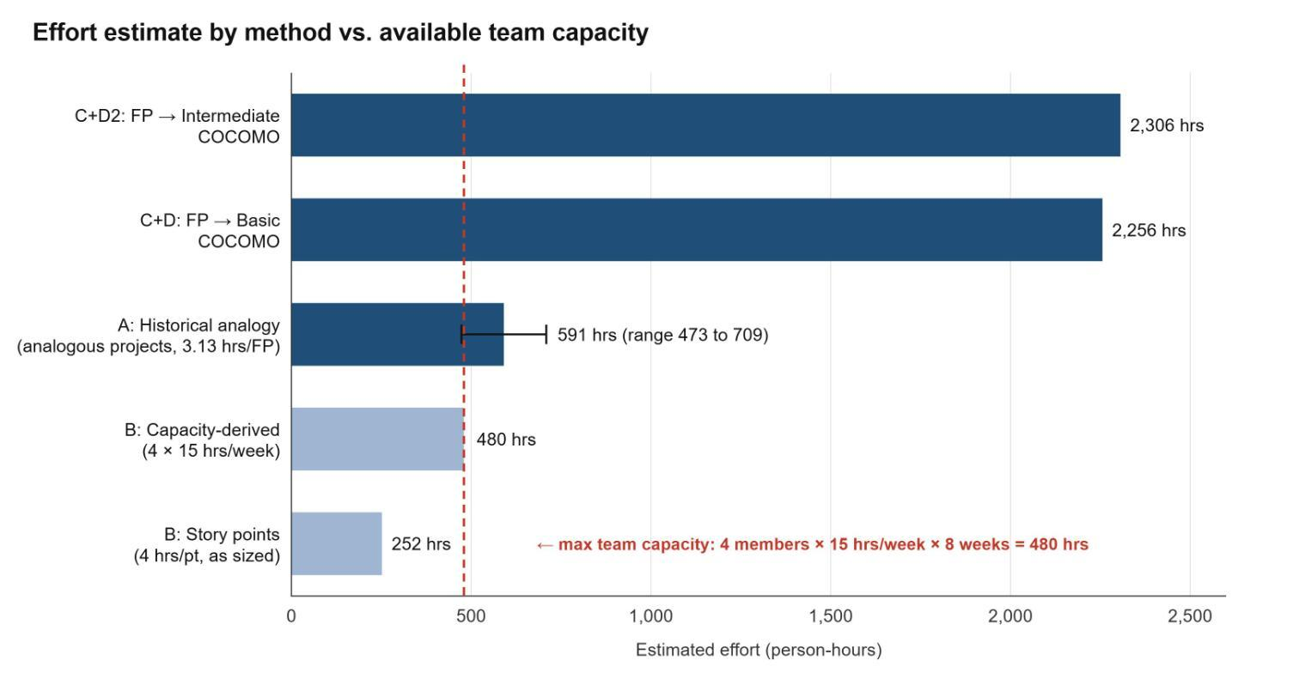
Figure 5.1: Estimated effort by method against the maximum available team capacity (4 members × 15 hrs/week × 8 weeks = 480 hours).
Using analogous projects, the estimates spread widely: about 250-480 hours from story points, about 470-710 hours from historical analogy (Table 5.1), and about 2,260-2,310 hours from COCOMO. Historical analogy and COCOMO share the same 189 AFP, so their gap comes entirely from the rate: the analogs’ 2.5–3.75 hrs/FP versus the roughly 12 hrs/FP that COCOMO implies at this size. Sprint 1 velocity will show which end is realistic for this team.
Two explanations are plausible, and both are worth stating rather than picking one without evidence. First, the story points assigned to PB-01 to PB-10 may understate true complexity: availability-overlap scheduling and AI-based matching are the kind of features new teams commonly under-size relative to more familiar CRUD work. Second, COCOMO’s organic-mode constants [1] were calibrated on professional teams from the 1970s–80s and may overestimate effort for a small team using modern frameworks and AI-assisted development tools. The team will treat Sprint 1’s actual velocity as the tie-breaker: once real hours-per-point data exists, the 4-hours-per-point assumption in Method B will be revised to match it, and the size of the remaining gap to Methods A/C+D will indicate which model was closer.
Capacity check against the 8-week schedule
Team size | Available hours (8 weeks) | Required (FP→COCOMO) | Gap
4 members × 10 hrs/week | 320 hours | 2,256 hours | ≈ 7.0 times
4 members × 15 hrs/week | 480 hours | 2,256 hours | ≈ 4.7 times

Even under the more generous assumption (4 members at 15 hours/week), required effort exceeds available capacity by roughly 4.7 times. This quantifies the risk already identified as R-01 in Section 6: the team’s planned mitigation/prioritizing must-priority items and deferring should-priority items (PB-06, PB-08, PB-10, totaling 16 points) if needed is the primary lever for closing this gap, alongside correcting the Method B assumption once Sprint 1 data is available.

5.8 Cost
This is an assignment project, and team members are not paid, so the actual labor cost is zero. Table 5.10a still shows a notional labor value at the $20/person-hour planning rate, only so the methods can be compared in one unit; it is not money the team spends. The project’s real cost is the out-of-pocket spending on software tools and services in Table 5.10b.

5.8.1 Labor Cost by Method

Team members are unpaid, so the actual labor cost is zero for every method. The notional value column uses the $20/person-hour planning rate only to compare effort in one unit. The real out-of-pocket cost is the tool and service spending in Table 5.10b, which is the same whichever effort estimate turns out to be right.
Method | Effort (person-hours) | Actual labor cost (unpaid team) | Notional labor value @ $20/hr (reference only)
A: Historical analogy (analogous projects, most likely) | 591 | 0 | $11,820
A: Historical analogy (PERT range, Table 5.1) | 473–709 | 0 | $9,460–14,180
B: Story points (as sized) | 252 | 0 | $5,040
B; Story points (capacity-derived, Table 5.3a) | 240–480 | 0 | $4,800–9,600
C + D; FP → Basic COCOMO | 2,256 | 0 | $45,120
C + D2; FP → Intermediate COCOMO | 2,306 | 0 | $46,120

5.8.2 Out-of-Pocket Tool and Service Costs

Because the team is unpaid, the only real spending is on software subscriptions and usage-based services. The estimate covers the 8-week build (about two monthly billing cycles) for four team members.
Item | Plan / assumption | Unit price | Quantity | 8-week cost | Notes
Claude (AI assistant for coding and documentation) | Pro plan, monthly billing, one seat per member | $20 per seat per month | 4 seats × 2 months | $160 | Drops to about $40 if only one member subscribes [6]
Lovable (app builder and hosting) | Pro plan, one shared workspace | $25 per month | 1 workspace × 2 months | $50 | Hosting, backend, and in-app AI draw on the same monthly credit balance. [7]
Lovable extra credits | Only if the 100 monthly Pro credits run out | ≈ $0.25 per credit | ≈ 100 credits (buffer) | ≈ $25 | Heavy prompting or app usage can exhaust credits [7].
AI matching API for PB-08 | Claude Haiku 4.5 API, if the feature calls an external model | 1 USD per million input tokens; 5 USD per million output tokens | ≈ 4M input + 1M output tokens during development and testing | ≈ $9 | Approximately 100 dollars on Lovable credits [6]
Jira (project tracking) | Free plan | $0 (up to 10 users) | 4 users | $0 | -
Version control (e.g., GitHub) | Free plan | $0 | n/a | $0 | -
ChatGPT | Free plan assumed | $0 | n/a | $0 | Add about $20 per member per month if a paid plan is used
Domain name | Not required (Lovable subdomain) | Optional | n/a | $0 | Only if the team wants a custom URL
Subtotal |  |  |  | ≈ $244 | -
Contingency (15%) |  |  |  | ≈ $37 | Price changes, extra credits, or API overruns
Total out-of-pocket cost |  |  |  | ≈ $281 | ≈ $70 per member; about $100 minimum with one Claude seat and no extra credits
Other possible costs to watch (we did not include above): a paid ChatGPT or other AI plan if any member upgrades; a custom domain if the team wants its own URL; a paid database or email service if the app outgrows free tiers (for example, sending invitation or notification emails at volume); paid design assets or fonts; and printing for the final presentation or poster. None of these is required for the current scope.

5.8: Use of AI/Tools
Tools: FP Calculation, COCOMO Calculator, Claude (Anthropic), and ChatGPT
Purpose/input: Claude was used to (a) compute Function Point counts and the Value Adjustment Factor from the team’s finalized PB-01–PB-10 backlog and the AI Teammate Matching feature description in the Aug 29 topic submission, and (b) apply the published COCOMO Basic and Intermediate Organic-mode formulas and cost-driver multipliers [1], and (c) cross-check the four resulting estimates against one another and against the team’s available capacity.
Output accepted as-is: the arithmetic and formula application.
The output team must still validate or correct: (1) the LOC/FP conversion factor (30 LOC/FP) once the technology stack in Section 3 is finalized; (2) the historical-analogy rate (2.5–3.75 hrs/FP from analogous projects), which should be replaced with a real comparable project if a team member has one; (3) the story-point-to-hour ratio in Method B, which should be replaced with actual Sprint 1 velocity; and (4) the Intermediate COCOMO cost-driver ratings in Table 5.7a.

6. Risk management plan
ID | Risk Statement | Probability | Impact | PxI | Response and owner
R-01 | Since the project combines several collaboration features within 8 weeks of development, it may exceed available capacity, which could cause incomplete mandatory features or a delayed delivery date. | 4 | 4 | 16 | Mitigate: Prioritize mandatory features, review progress each sprint, and defer AI teammate matching and optional filters if necessary. Owner: Project lead.
R-02 | The team members develop connected modules separately; incompatible APIs or database changes may cause integration failures, resulting in rework and blocked workflows. | 3 | 4 | 12 | Mitigate: Agree on API contracts and the database schema early, integrate changes frequently, and run automated workflow checks. Owner: Technical lead.
R-03 | Because the system stores profiles, availability, and private group content, incorrect access-control rules may expose information to unauthorized users, resulting in privacy breaches and loss of trust. | 3 | 5 | 15 | Mitigate: Enforce server-side membership checks, minimize stored personal data, protect credentials, and test access across different accounts and groups. Owner: Backend/security lead.
R-04 | Because students have different schedules and academic commitments, team members may be unavailable for planned work, resulting in delayed tasks and uneven workloads. | 4 | 3 | 12 | Mitigate: Plan around known availability, assign backup owners to critical tasks, document work, and redistribute tasks when blockers arise. Owner: Scrum Master.
R-05 | Because AI teammate matching depends on an external service and its suggestions can be inaccurate or biased, the feature may fail or recommend poor matches, resulting in unreliable suggestions and reduced user confidence. | 3 | 3 | 9 | Mitigate: Test with representative student profiles, let users review and decline suggestions, handle service failures clearly, and keep manual team search available. Owner: AI integration lead.
6.1 Use of AI/Tools
Tools used for this section: ChatGPT
Purpose: Confirmed that the risks discussed during the team meetings were potential risks and also worked on finding solutions for them and helped us draft responses to mitigate them.
The output team must still validate or correct: The team reviewed the risk statements and the proposed mitigation responses and confirmed that each response fits its risk. The team remains responsible for the probability and impact ratings, the response strategies, and the assigned owners.
7. Quality and Testing Plan
Testing or Quality Area | Plan and Measurable Criterion
Functional testing | Unit tests for core logic are authentication, task CRUD, and availability-overlap calculation; integration tests for API endpoints are profile, team, task board, notifications); manual system testing of end-to-end workflows (create team → invite member → assign task → mark complete); and acceptance testing against each functional requirement (FR-01 through FR-10) before each sprint review.
Automated testing | Jest and React Testing Library will be used for frontend unit and component tests; Cypress for end-to-end browser tests of three critical flows: registration/sign-in (FR-01), create/join team (FR-02), and task board (FR-04). All three automated the final sprint. AI match suggestions (FR-08) are a stretch target.
Nonfunctional testing | Loading test with 50 simulated concurrent users using a tool such as k6 or Artillery to verify NFR-01; manual check of password hashing and session-token enforcement for NFR-02; keyboard-navigation and screen-reader spot-check on key pages for NFR-03; and uptime and error-log monitoring (server and browser console logs) during the testing period for NFR-04.
Quality measures | >= 90% pass rate on the automated suite before each sprint review, and 100% of critical-flow tests passing before final submission; >= 70% line coverage on core logic; every ‘must’ requirement would be tested before final submission; defects rated Critical, Major, or Minor, with all Critical defects would be resolved before delivery; AI Teammate Matching would be evaluated by manually reviewing at least 20 sample suggestions for relevance and acceptance rate.
8. Team Roles and Responsibility
Member | Role | Primary Responsibilities and Deliverables
Malaika Farooq | Backend Development  /Database  /Documentation  /Testing/Project Management. | Prepare and maintain effort and cost estimates; track project resources and workload; maintain project documentation; update  estimation assumptions as the project progresses; contribute to implementation and testing; and support the final report and presentation.
Aditi Vishal | Backend Development  /Documentation  /Testing  /Deployment | Coordinate Scrum ceremonies, sprint planning, backlog tracking, and team communication; monitor sprint progress and blockers; coordinate risk management activities; and contribute to implementation, testing, and presentation.
Amogh Dhole | Front End/  Documentation  /Testing | Prepare the quality and testing plan; develop test cases and acceptance checks; coordinate functional and integration testing; track defects and quality measures; and contribute to implementation and presentation.
Krishan Lnu | Front End/  Documentation  /Testing | Prepare the quality and testing plan; develop test cases and acceptance checks; coordinate functional and integration testing; track defects and quality measures; and contribute to implementation and presentation.
All team members will contribute to implementation, testing, documentation, and the final presentation as appropriate to ensure that project responsibilities are shared and that no major deliverable depends on only one team member.
9. References
All the information related to AI tools as well as usage of online available tools is already added at the end of each section (if used any), as every teammate worked on different sections and added the tool usage. However, few online references were used to compare and get the correct available information for context, tool pricings, and software practices as added below:

[1] Boehm, B. W. (1981). Software Engineering Economics. Prentice-Hall.
[2] International Function Point Users Group (IFPUG). Function Point Counting Practices Manual, Release 4.3.1.
[3] Jones, C. (2008). Applied Software Measurement: Global Analysis of Productivity and Quality (3rd ed.). McGraw-Hill.
[4] Cohn, M. (2005). Agile Estimating and Planning. Prentice Hall.
[5] International Software Benchmarking Standards Group (ISBSG). (2021). Practical Guide: Productivity Measurement of Software Projects. isbsg.org.
[6] Anthropic. Plans & Pricing (Claude Pro and API rates). claude.com/pricing, accessed September 2026.
[7] Totalum (2026). Lovable Pricing 2026: Plans, Credits, and What Changed in August. Totalum.app; verify on lovable.dev/pricing.
[8] Atlassian. Explore Jira Cloud plans (free plan: up to 10 users). support.atlassian.com, accessed September 2026.

