SOC INCIDENT REPORT
SSH Brute Force Attack — Credential Compromise
Home SOC Lab • Documentation • BruteForce Attack

Incident ID | INC-2026-04-19-001
Date | 19 April 2026
Time Window | 22:01:27 – 22:06:48 (UTC+5)
Analyst | Malaika Umbreen
Severity | HIGH
Attack Type | SSH Brute Force – Credential Stuffing
Tool Detected | THC-Hydra v9.6
SIEM Platform | Wazuh (Threat Hunting Module)
Status | DETECTED & CONTAINED
Summary

A brute force attack was detected targeting the SSH service (port 22) on an Ubuntu Linux server within the home SOC lab. Multiple failed authentication attempts were launched from a single source IP in rapid automated succession using THC-Hydra. The attack ultimately succeeded in cracking the target user's weak password. Wazuh SIEM detected the attack in real time, generating 28 security events including critical Rule Level 12 alerts.
Affected System

Hostname | dvwa-server
IP Address | 192.168.40.XX
Operating System | Ubuntu Linux
Exposed Service | OpenSSH – Port 22
Wazuh Agent | Installed and actively monitored

Targeted Account

Username | malaika
Account Type | Standard local user
Password Strength | Weak — numeric only ('XXXX')
Compromise | YES — password successfully cracked

Attacker Details

Source IP | 192.168.40.XX
Attacker Machine | Kali Linux (hostname: Malaika)
Attack Tool | THC-Hydra v9.6 (automated brute force)
Attack Protocol | SSH (TCP Port 22)
Method | Single username + password spraying

Evidence

5.1 Hydra Attack Commands (from Kali Linux terminal)
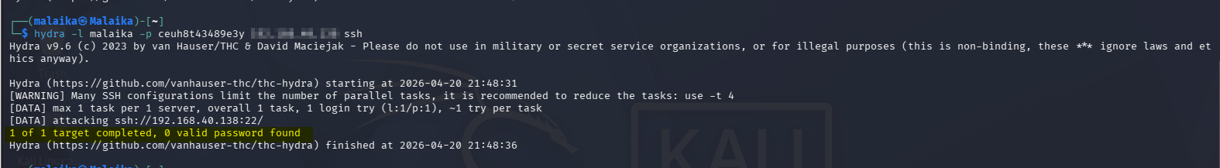

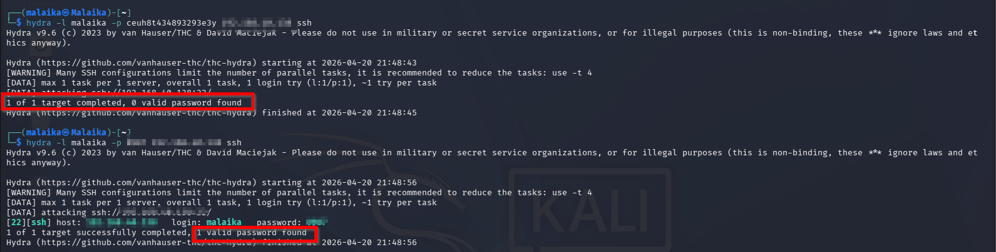

5.2 Auth Log Evidence from Victim (/var/log/auth.log)

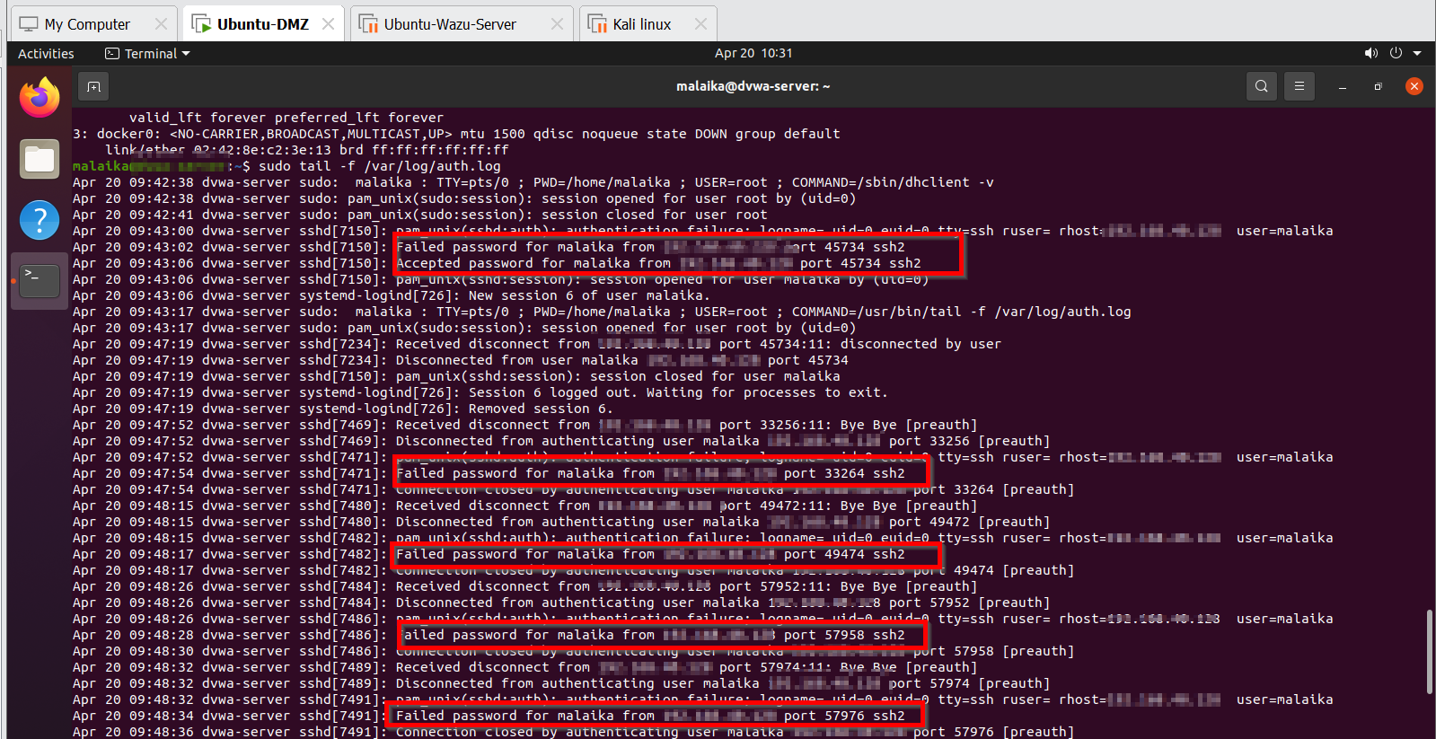

Multiple failed attempts from the same source IP within seconds, culminating in a successful login a textbook brute force signature.

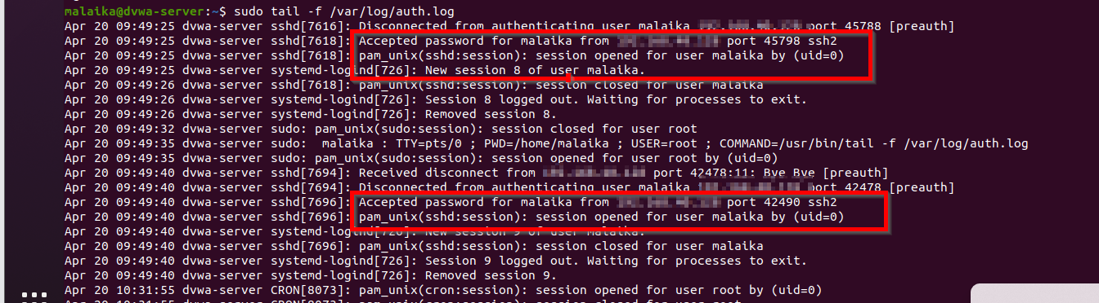

5.3 Wazuh SIEM Alerts (28 events triggered)

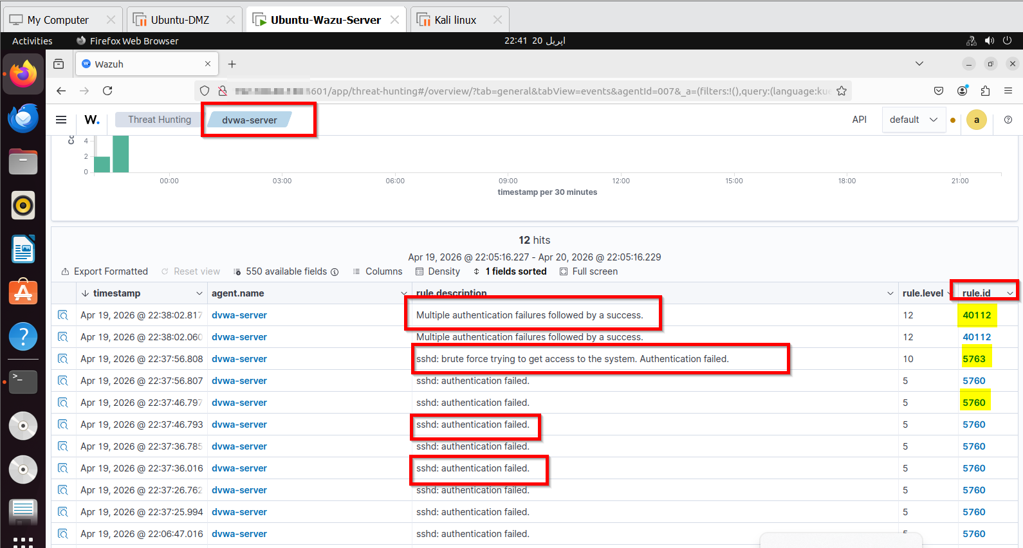

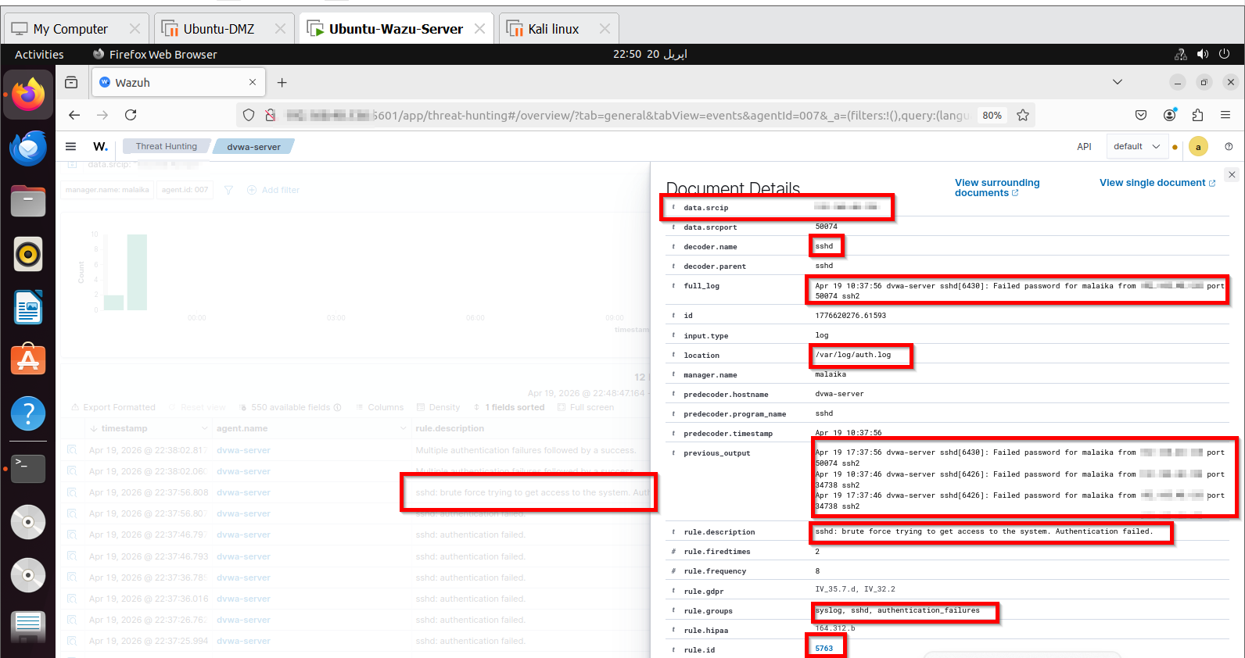

Analysis

- Multiple failed authentication attempts in rapid succession confirm automated brute force behavior.
- A single source IP (192.168.40.xx) was responsible for all attack attempts no IP rotation observed.
- The same username ('malaika') was targeted consistently throughout the attack window.
- Wazuh Rule Level 12 - the highest brute force alert was triggered, indicating failures followed by a successful login.
- The password 'XXXX' (numeric only, 4 characters) is critically weak and trivially crackable by any automated tool.
- The attack duration was under 6 minutes from first attempt to credential compromise.
- Auth log timestamps confirm rapid sequential connection attempts, a hallmark of automated credential stuffing.
Recommended Actions

- Block attacker IP (192.168.40.xx) via firewall rules immediately to prevent further access attempts.
- Enforce a strong password policy- minimum 12 characters with mixed case, numbers, and special symbols.
- Disable password-based SSH authentication entirely; switch to SSH key-pair authentication only.
- Enable account lockout after 3–5 failed login attempts using Fail2Ban or PAM tally configuration.
- Enable Multi-Factor Authentication (MFA) for all SSH-accessible accounts.
- Change the default SSH port (22) to a non-standard port to reduce exposure to automated scanners.
- Configure Wazuh Active Response to automatically block IPs upon brute force rule trigger.
- Conduct a credential audit - rotate all user passwords and enforce complexity requirements immediately.

Conclusion

The activity is confirmed as a successful SSH brute force attack. The attacker (Kali Linux, IP 192.168.40.xx) used THC-Hydra to systematically attempt passwords against the user account 'malaika' on the Ubuntu victim machine. The weak 4-digit password was cracked within minutes. The Wazuh SIEM platform demonstrated effective detection capability by generating 28 security events with escalating severity levels, culminating in a Level 12 critical alert -'Multiple authentication failures followed by a success' which directly identifies the compromise moment.

This exercise validates the end-to-end SOC workflow: attack simulation → log collection → SIEM correlation → alert triage → incident documentation. Immediate remediation is required to prevent recurrence.

FINAL VERDICT
CONFIRMED SSH BRUTE FORCE WITH SUCCESSFUL CREDENTIAL COMPROMISE
Wazuh SIEM detection was effective. Immediate password reset, IP block, and SSH hardening required.

Analyst: Malaika Umbreen
Date: 19 April 2026 | Home SOC Lab

