SSH BRUTE FORCE ATTACK
Incident Investigation Report
Home SOC Lab • Threat Detection & Analysis
Date | 19 April 2026
Analyst | Malaika Umbreen
Severity | HIGH
Attack Type | SSH Brute Force (Credential Stuffing)
Tool Used | THC-Hydra v9.6
Status | Detected & Contained

1. Introduction
This report documents a controlled SSH brute force attack conducted within a home Security Operations Center (SOC) laboratory environment. The purpose of this exercise was to simulate a real-world credential-based attack, observe the resulting indicators of compromise, and validate the detection capabilities of a deployed Wazuh SIEM. The attack was performed using THC-Hydra on a Kali Linux machine targeting an Ubuntu Linux server with SSH exposed.

2. Objectives
- To simulate a realistic SSH brute force attack in a controlled lab environment
- To validate the detection capability of the Wazuh SIEM platform
- To analyze the resulting authentication logs on the victim machine
- To assess alerting rules triggered and their respective severity levels
- To document findings and provide mitigation recommendations

3. Lab Environment

Role | Machine | IP Address | OS / Notes
Attacker | Kali Linux (Malaika) | 192.168.40.xx | Kali Linux (Hydra)
Victim | Ubuntu-DMZ (dvwa-server) | 192.168.40.xx | Ubuntu + OpenSSH
SIEM Monitor | Ubuntu-Wazuh-Server | 192.168.40.xx | Ubuntu + Wazuh SIEM

4. Attack Execution & Observations
The attack was initiated from the Kali Linux machine using THC-Hydra v9.6, targeting SSH (port 22) on the Ubuntu victim machine. Multiple password attempts were launched against the user account 'malaika'. The following commands were executed during the attack:

4.1 Hydra Commands Used
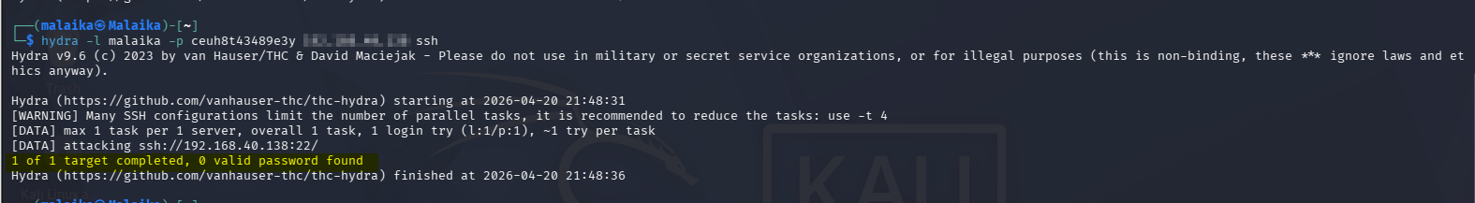

5. Wazuh SIEM Analysis
The Wazuh SIEM dashboard (Threat Hunting module) detected the attack in real time. A total of 28 security events were generated between 21:42:20 and 22:02:20 on April 19, 2026. The following key alerts were triggered on the monitored agent 'dvwa-server':

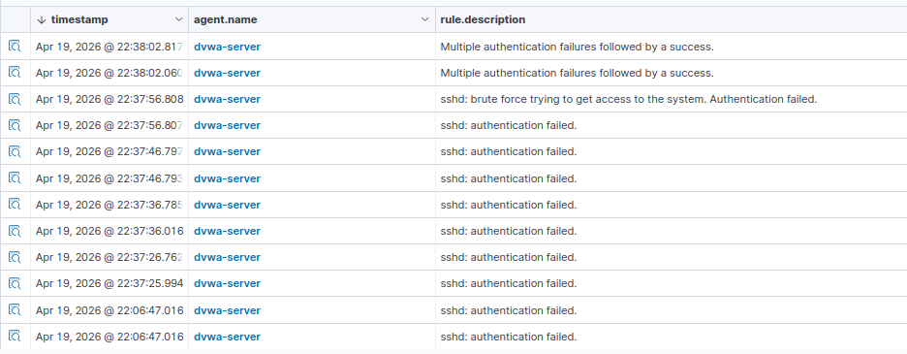

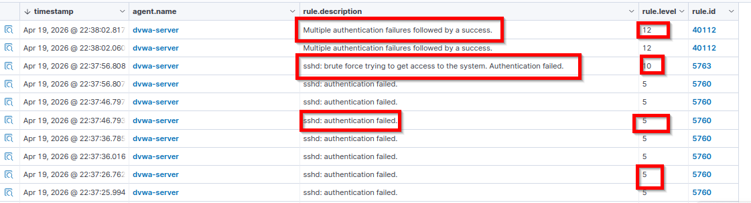

Rule Level Reference:
- Level 3: Informational – session open/close events
- Level 5: Low – individual authentication failures
- Level 10: Medium – multiple failures or brute force pattern detected
- Level 12: High – multiple failures FOLLOWED BY a successful login (critical indicator)

6. Authentication Log Analysis (auth.log)
The /var/log/auth.log file on the Ubuntu victim machine confirmed the attack activity. The following is a representative excerpt showing the brute force sequence and eventual successful login:

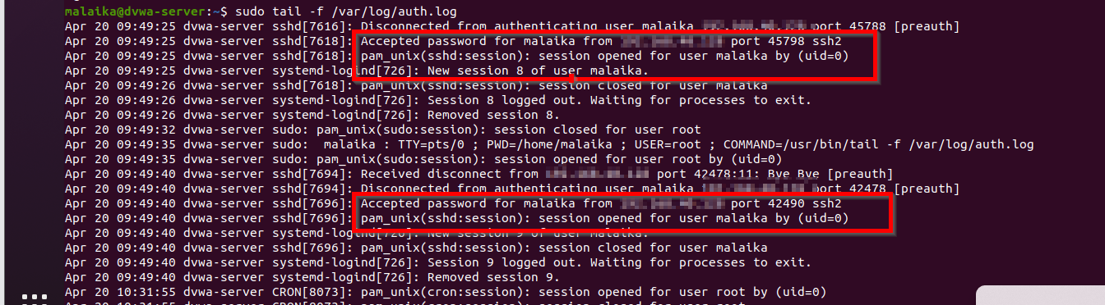

Key observations from the auth.log:
- Multiple failed SSH attempts from 192.168.xx.xx in rapid succession (every 8–11 seconds)
- All attempts targeted the same username: malaika
- The pattern of failures followed by a success is a classic brute force signature
- Session was opened and then immediately closed — indicating a credential verification

7. Final Analysis & Conclusion

Attacker IP | 192.168.xx.xx (Kali Linux – Malaika)
Victim IP | 192.168.xx.xx (Ubuntu – dvwa-server)
Targeted User | malaika
Attack Tool | THC-Hydra v9.6
Protocol Attacked | SSH (Port 22)
Total Wazuh Alerts | 28 events triggered
Highest Rule Level | Level 12 – Critical (brute force + success)
Password Cracked | Yes – credential 'xxxx' discovered
SIEM Detection | Successful – Wazuh detected brute force pattern

The attack successfully demonstrated that a simple SSH brute force using THC-Hydra can crack a weak password within seconds. The Wazuh SIEM correctly identified the attack pattern, escalating alerts from Level 5 (individual failures) to Level 12 (failures followed by success), which represents the highest-confidence brute force detection signature. The auth.log on the victim machine corroborated all SIEM findings.

8. Mitigation & Recommendations
- Enforce a strong password policy - minimum 12 characters, mixed case, numbers, and symbols. The password 'xxxx' would be cracked instantly in any real-world attack.
- Disable password-based SSH authentication entirely. Configure SSH key-based authentication only using authorized_keys.
- Implement account lockout after a defined number of failed attempts using tools such as Fail2Ban or PAM tally.
- Restrict SSH access by source IP using firewall rules. Only allow known trusted IP addresses to reach port 22.
- Enable Multi-Factor Authentication (MFA) for SSH sessions as an additional layer of defense.
- Change the default SSH port (22) to a non-standard port to reduce automated scanning exposure.
- Configure Wazuh active response to automatically block the attacker IP upon brute force detection.
- Review and rotate credentials regularly. Implement a password manager policy for all user accounts.

FINAL VERDICT
The attack is classified as a CONFIRMED SSH BRUTE FORCE with successful credential compromise. Wazuh SIEM detection was effective. Immediate remediation is strongly recommended.

