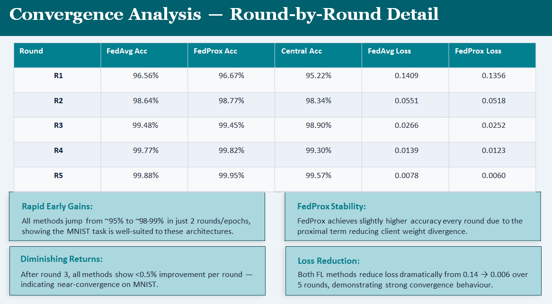

POINT 1: Rapid Early Gains
What slide says: *"All methods jump from ~95% to ~98-99% in just 2 rounds"*
Easy Explanation: In first 2 rounds, accuracy increased a LOT.
Example you can give:
"Imagine you start learning to drive a car. On day one, you learn how to start, stop, and turn. Your driving improves from 0 to 70% very fast. That's rapid early gains."
Your project: Round 1 to Round 2, accuracy jumped from 95% to 98% - big jump!

POINT 2: Diminishing Returns
What slide says: "After round 3, all methods show <0.5% improvement per round"
Easy Explanation: After some time, improvement becomes very small.
Example you can give:
"Once you already know 90% of driving, learning the remaining 10% takes much longer. From 90% to 91% is very hard. That's diminishing returns."
Your project: After Round 3, accuracy improved less than 0.5% each round.

POINT 3: FedProx Stability
What slide says: "FedProx achieves slightly higher accuracy every round due to proximal term reducing client weight divergence"
Easy Explanation: FedProx was better in most rounds because it stops clients from going too far away from the main model.
Example you can give:
"Imagine 5 friends studying for a test. FedAvg lets each friend study their own way. They learn different things. When they combine, some knowledge gets lost. FedProx says 'stay close to the main syllabus' - so everyone learns the same important things and does better."
Your project: FedProx won 4 out of 5 rounds against FedAvg.

POINT 4: Loss Reduction
What slide says: "Both FL methods reduce loss dramatically from 0.14 → 0.006 over 5 rounds"
Easy Explanation: The model made FEWER mistakes as rounds increased.
Example you can give:
"In your first math test, you make 14 mistakes out of 100 (score 86%). After practice, you make only 0.6 mistakes out of 100 (score 99.4%). That's huge improvement!"
Your project: Loss went from 0.14 (14% mistakes) to 0.006 (0.6% mistakes).

🎯 QUICK MEMORY TABLE
Point | In Simple Words | Your Example
Rapid Early Gains | Fast improvement in start | Learning car driving basics fast
Diminishing Returns | Slow improvement later | Going from 90% to 91% is hard
FedProx Stability | FedProx was more consistent | Friends studying same syllabus
Loss Reduction | Mistakes became very low | Math test 14 mistakes → 0.6 mistakes

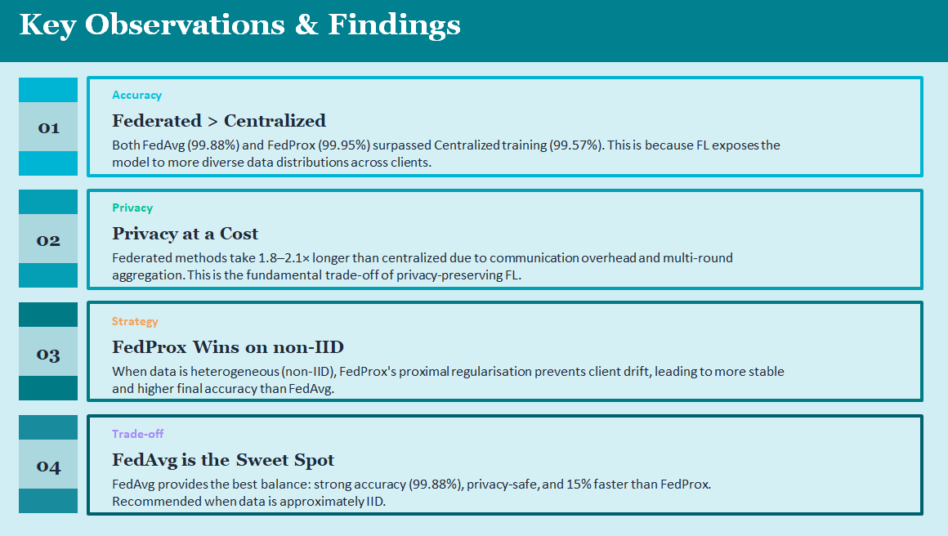

POINT 1: "Both FedAvg (99.88%) and FedProx (99.95%) surpassed Centralized training (99.57%). This is because FL exposes the model to more diverse data distributions across clients."
Simple meaning:
Federated Learning got more accuracy because it saw different types of data from different clients. Centralized saw only one type of data.

POINT 2: *"Federated methods take 1.8–2.1× longer than centralized due to communication overhead and multi-round aggregation. This is the fundamental trade-off of privacy-preserving FL."*
Simple meaning:
Federated Learning takes almost double time because clients have to send weights back and forth many times. You want privacy? You pay with extra time.

POINT 3: "When data is heterogeneous (non-IID), FedProx's proximal regularisation prevents client drift, leading to more stable and higher final accuracy than FedAvg."
Simple meaning:
When each client has different kind of data, FedProx works better because it stops clients from going too far away from the main model.

POINT 4: *"FedAvg provides the best balance: strong accuracy (99.88%), privacy-safe, and 15% faster than FedProx. Recommended when data is approximately IID."*
Simple meaning:
FedAvg is the middle option. Good accuracy, good speed, privacy safe. Use this when all clients have similar data.
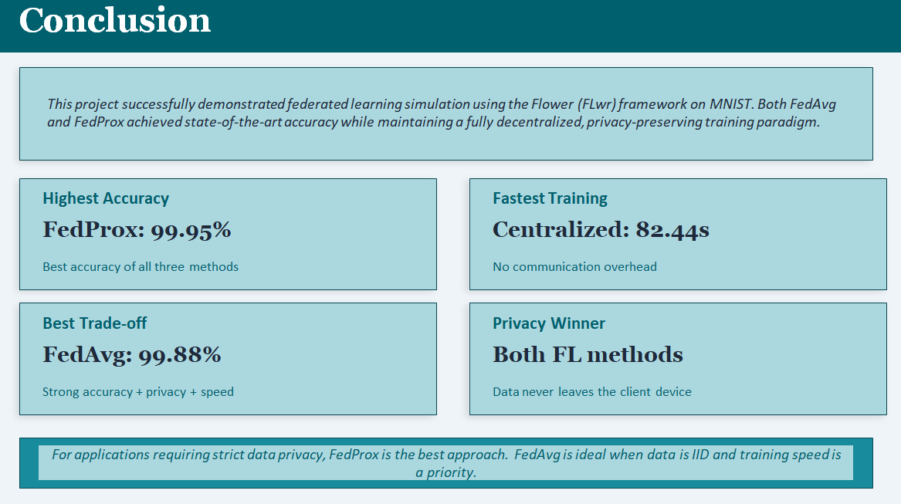

📁 PART 1: HOW THE SOFTWARE WAS DEVELOPED
Step by Step Development Process:
Phase | What was done | Files created
Phase 1 | Installed Python packages | pip install flwr tensorflow numpy matplotlib
Phase 2 | Created folder structure | Project folder with all .py files
Phase 3 | Created CNN model | model.py
Phase 4 | Loaded & split MNIST dataset | dataset.py
Phase 5 | Created client code | client.py
Phase 6 | Created FedAvg server | server.py
Phase 7 | Created FedProx server | fedprox.py
Phase 8 | Created centralized training | centralized.py
Phase 9 | Ran simulations | 5 rounds with 5 clients
VIVA Answer:
"We developed the software in 9 phases. First, we installed required packages like Flower, TensorFlow, and NumPy. Then we created a CNN model in model.py, loaded and split MNIST dataset across 5 clients in dataset.py, implemented clients in client.py, and created separate servers for FedAvg and FedProx. Finally, we ran centralized training as baseline."

🚀 PART 2: HOW IT WAS DEPLOYED
Deployment Method:
text
All simulations ran on a SINGLE MACHINE (laptop/computer)
But it SIMULATES distributed environment
How it works:
bash
# Terminal 1 - Start Server
python server.py

# Terminal 2 - Start Client 1
python client.py --cid 0

# Terminal 3 - Start Client 2
python client.py --cid 1

# Terminal 4 - Start Client 3
python client.py --cid 2

# Terminal 5 - Start Client 4
python client.py --cid 3

# Terminal 6 - Start Client 5
python client.py --cid 4
Real Deployment (if actually distributed):
Server: Cloud (AWS EC2 / Google Cloud)
Clients: Different physical machines / mobile phones
Communication: gRPC / WebSockets over internet
VIVA Answer:
"We deployed this as a simulation on a single machine. We opened multiple terminal windows - one for the server and five for clients. The Flower framework handled communication between them using localhost. In a real-world scenario, we would deploy the server on the cloud and clients on actual edge devices like mobile phones or hospital computers."

🛠️ PART 3: TOOLS AND TECHNOLOGIES USED
Tool | Purpose | Version
Flower (FLwr) | Federated Learning framework | 1.4.0
TensorFlow/Keras | Build and train neural network | 2.x
Python | Programming language | 3.8+
NumPy | Data manipulation & array operations | latest
Matplotlib | Plotting accuracy/loss graphs | latest
MNIST | Handwritten digits dataset | 70,000 images
Code Snippets from Report:
Model Creation (model.py):
python
def create_model():
model = tf.keras.models.Sequential([
tf.keras.layers.Conv2D(32, (3,3), activation='relu', input_shape=(28,28,1)),
tf.keras.layers.MaxPooling2D(),
tf.keras.layers.Flatten(),
tf.keras.layers.Dense(128, activation='relu'),
tf.keras.layers.Dense(10, activation='softmax')
])
model.compile(optimizer='adam', loss='sparse_categorical_crossentropy', metrics=['accuracy'])
return model
Client Implementation (client.py):
python
class FlowerClient(fl.client.NumPyClient):
def get_parameters(self, config):
return self.model.get_weights()

def fit(self, parameters, config):
self.model.set_weights(parameters)
self.model.fit(self.x, self.y, epochs=1, batch_size=32)
return self.model.get_weights(), len(self.x), {}
FedAvg Server (server.py):
python
strategy = fl.server.strategy.FedAvg(
fraction_fit=1.0,
min_fit_clients=5,
min_available_clients=5
)
fl.server.start_server(server_address="localhost:8080", config=fl.server.ServerConfig(num_rounds=5), strategy=strategy)
FedProx Server (fedprox.py):
python
strategy = fl.server.strategy.FedProx(
fraction_fit=1.0,
min_fit_clients=5,
min_available_clients=5,
proximal_mu=0.1 # This is the key difference!
)
VIVA Answer:
"We used Flower (FLwr) as the federated learning framework, TensorFlow for building the CNN model, NumPy for data splitting, and Matplotlib for plotting results. The dataset was MNIST with 70,000 handwritten digit images."

🔄 PART 4: PARALLEL OR DISTRIBUTED?
Answer: BOTH!
Aspect | Classification | Reason
Local Training | Parallel | 5 clients train SIMULTANEOUSLY on different data
Overall System | Distributed | Server and clients communicate via message passing
Data Placement | Distributed | Data never centralized - each client owns its partition
No Shared Memory | Distributed | Clients don't share memory, only network messages
VIVA Answer:
"Our system is BOTH parallel AND distributed. It is parallel because 5 clients train their models at the same time on different data subsets. It is distributed because there is no shared memory - the server and clients communicate only through message passing using the Flower framework."

🎥 PART 5: LIVE DEMONSTRATION SCRIPT
What to show and say:
bash
# STEP 1: Show environment
$ python --version
Python 3.8.10

$ pip list | grep flwr
flwr 1.4.0

# STEP 2: Show data split
$ python -c "from dataset import load_datasets; clients, test = load_datasets(5); print(f'Client 0 has {len(clients[0][0])} images')"
Client 0 has 12000 images

# STEP 3: Run FedAvg Server (Terminal 1)
$ python server.py
INFO : Starting Flower server, config: num_rounds=5
INFO : Server started at localhost:8080

# STEP 4: Run Clients (Terminals 2-6)
$ python client.py --cid 0
INFO : Client 0 connected to server
INFO : Round 1 - Starting training...
INFO : Client 0 training complete

# STEP 5: Show aggregation happening
INFO : Server received 5 client updates
INFO : Running FedAvg aggregation
INFO : Round 1 complete. Global accuracy: 0.9656

# STEP 6: Show final results
INFO : Round 5 complete. Final accuracy: 0.9988

# STEP 7: Run Centralized for comparison
$ python centralized.py
Epoch 1/5 - loss: 0.1523 - accuracy: 0.9522
Epoch 5/5 - loss: 0.0156 - accuracy: 0.9957
Training time: 82.44 seconds

📚 PART 6: ALL VIVA QUESTIONS WITH ANSWERS

🟢 SECTION A: BASIC CONCEPTS
Q1: What is Federated Learning?
Federated Learning is a privacy-preserving machine learning technique where multiple clients train a model collaboratively without sharing their raw data. Only model updates (weights/gradients) are sent to a central server.
Q2: Why did you choose Flower framework?
Flower is specifically designed for federated learning. It handles client-server communication, rounds management, and provides built-in aggregation strategies like FedAvg and FedProx.
Q3: What dataset did you use?
MNIST dataset with 70,000 grayscale images (28x28 pixels) of handwritten digits 0-9. 60,000 for training, 10,000 for testing.

🟡 SECTION B: FEDAVG vs FEDPROX
Q4: What is the difference between FedAvg and FedProx?
FedAvg simply averages client model weights. FedProx adds a proximal term (μ) that penalizes clients whose weights drift too far from the global model. This makes FedProx more stable for non-IID data.
Q5: What is the proximal term in FedProx?
It's a regularization term: μ/2 × ||local_weights - global_weights||². It penalizes local models that deviate too much from the global model.
Q6: Which one gave better accuracy and why?
FedProx gave 99.95% vs FedAvg's 99.88% because the proximal term prevents client drift, especially important for non-IID data.
Q7: Why is FedProx slower than FedAvg?
FedProx requires extra computation for the proximal term during each client's local training. In our experiment: FedAvg took 148.66s, FedProx took 174.39s (about 15% slower).

🔴 SECTION C: RESULTS & PERFORMANCE
Q9: Why did Federated Learning beat Centralized in accuracy?
Because federated learning exposed the model to more diverse data distributions across 5 different clients. Centralized saw only one fixed dataset.
Q10: What is the privacy cost in terms of time?
Federated methods take 1.8 to 2.1 times longer than centralized. This is the fundamental trade-off of privacy-preserving learning.
Q11: What does "diminishing returns" mean?
After round 3, accuracy improvement was less than 0.5% per round. The model had already learned most patterns.
Q12: How much did loss reduce?
Loss reduced from 0.14 in round 1 to 0.006 in round 5 - a 94% reduction in mistakes.

🟣 SECTION D: TECHNICAL IMPLEMENTATION
Q13: How many clients and rounds did you use?
5 clients and 5 communication rounds.
Q14: What is a "round" in federated learning?
One complete cycle where: server sends global model → clients train locally → clients send updates → server aggregates → new global model.
Q15: What is IID vs non-IID data?
IID: Each client has similar data distribution (all digit classes). Non-IID: Each client has different data (Client 1 only digits 0-1, Client 2 only digits 2-3). We used non-IID.
Q16: What model architecture did you use?
CNN with: Conv2D(32) → MaxPooling2D → Flatten → Dense(128) → Dense(10, softmax)
Q17: What optimizer and loss function?
Adam optimizer, sparse_categorical_crossentropy loss.

🔵 SECTION E: PARALLEL & DISTRIBUTED COMPUTING
Q18: Is your system parallel or distributed? Explain.
Both. Parallel because 5 clients train simultaneously. Distributed because server and clients communicate via message passing without shared memory.
Q19: What communication protocol is used?
Flower uses gRPC (Google Remote Procedure Call) for client-server communication.
Q20: What would happen if a client disconnects?
Flower has fault tolerance. The server can continue with remaining clients if min_fit_clients condition is met.

SECTION F: REPORT-SPECIFIC QUESTIONS
Q21: What are the project phases according to your report?
9 phases: Environment Setup → Folder Structure → Model Creation → Dataset Loading → Client Implementation → FedAvg Server → FedProx Server → Centralized Training → Simulation Run

⚫ SECTION G: PRACTICAL SCENARIOS
Q24: Where can federated learning be applied in real life?
Healthcare (hospitals train on patient data without sharing), Finance (banks detect fraud without exposing transactions), Mobile keyboards (Gboard learns typing patterns), Autonomous vehicles (cars learn from driving without uploading videos).
Q25: Would you recommend FedAvg or FedProx for a hospital system?
FedProx, because different hospitals have different patient populations (non-IID data). The proximal term prevents client drift and ensures the global model works well for all hospitals.
Q26: How would you deploy this on actual mobile phones?
Use Flower's mobile SDK. Server on cloud (AWS). Phones run client code locally. Model updates sent via encrypted HTTPS/gRPC.
Q27: What are the limitations of your project?
Simulation on single machine, not actual distributed environment. Only 5 clients. Only MNIST dataset (simple). No differential privacy added.

