City Library
Borrowing Behavior Analysis Report

1. Business Problem
How can City Library use its member and checkout data to understand borrowing behavior , identify popular books and active readers, and support better library management decisions?
The analysis addresses the following questions:
- How does borrowing activity change over time?
- Which books and authors are the most popular?
- Which genres are most popular, and how does genre preference differ across member groups?
- Who are the most active library members?
- How does borrowing behavior differ across grades, neighborhoods, and membership statuses?

2. Analysis Process
The dataset was built and prepared in four stages before analysis:
- Data Collection — consolidated data on library members, the book catalog, and standard checkout records.
- book details (genre, pages, publication year, publisher) came from a JSON file, and a separate summer-program checkout log came from an HTML export.
- Data Integration — the three sources were merged into one working table of 417 checkout records across 17 columns, combining member, book, and checkout information.
- Data Exploration — the merged dataset was profiled for duplicate rows, missing values, and inconsistent category values before any changes were made.
- Data Cleaning — the issues found during exploration were addressed where a reliable fix existed; the ones that could not be safely corrected were documented rather than altered. Details are in Section 3.

3. Data Quality Findings
Before analysis, the merged dataset was checked for completeness, consistency, and logical validity. Some issues could be corrected with confidence; others could not be resolved without access to the source systems and are reported here so management is aware of their impact on the figures below.

Issues identified and resolved
Issue | Details
Missing names | 5 checkout records had no member first/last name and could not be linked to a person; these records were removed (417 → 412 records).
Inconsistent text values | Neighborhood and membership status were entered with mixed casing and spacing (e.g. "zamalek", "NASR CITY", " Maadi"). Values were standardized to a single consistent format.
Missing grade | 41 records had no grade recorded; these were filled with the median grade so the records could still be used in the grade-level analysis.
Incorrect data types | Date fields were stored as text and ID fields as numbers; both were converted to proper date and identifier types to allow correct sorting and grouping.

Issues identified but not resolved
These issues remain in the dataset used for analysis below. They do not prevent the analysis but should be kept in mind when interpreting exact figures.
Issue | Details
Checkout dates before join date | 153 of 412 records (about 37%) show a checkout date earlier than the member's recorded join date, which is not logically possible. Neither field could be independently verified against a source system, so the records were kept as-is and flagged for the library's system administrators to investigate at the source.
Missing join dates / checkout IDs | 6 records are missing a join date and 21 are missing a checkout ID; both gaps trace back to the summer-program checkout log, which was not structured with the same fields as the main system.

4. Business Problem Analysis
4.1 How does borrowing activity change over time?
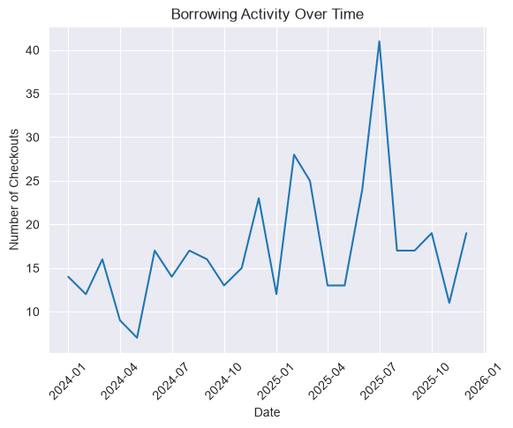
Figure 1 — Monthly checkout volume, January 2024 to December 2025
Summary:
- Borrowing has grown steadily since the start of 2024, with monthly checkouts roughly doubling by the end of the period.
- Two clear peaks stand out: December 2024 (23 checkouts) and July 2025, the highest month on record (41 checkouts).
- Activity dips slightly in the early months of most years (January–May), suggesting a seasonal pattern worth planning around for staffing and stock.
4.2 Which books and authors are the most popular?
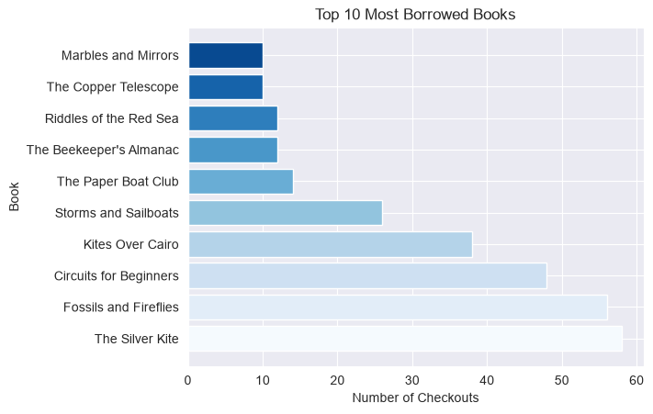
Figure 2 — Top 10 most borrowed books
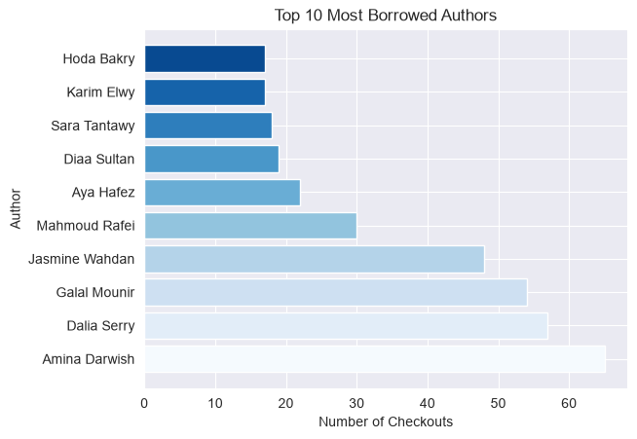
Figure 3 — Top 10 most borrowed authors
Summary:
- "The Silver Kite" (58 checkouts) and "Fossils and Fireflies" (56 checkouts) are the two most borrowed titles, well ahead of the rest of the top 10.
- Amina Darwish is the most borrowed author overall (65 checkouts), followed by Dalia Serry (57) and Galal Mounir (54).
- The top 4 authors alone account for a large share of total borrowing, indicating strong reader loyalty to a small set of writers.
4.3 Which genres are most popular, and how does genre preference differ across member groups?
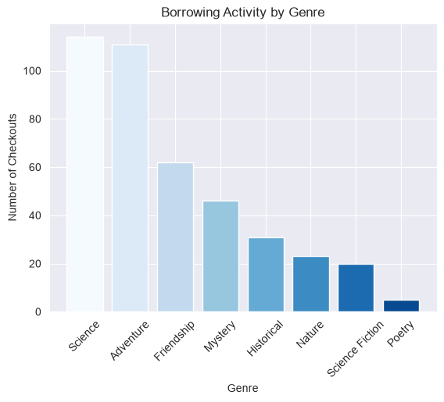
Figure 4 — Borrowing activity by genre
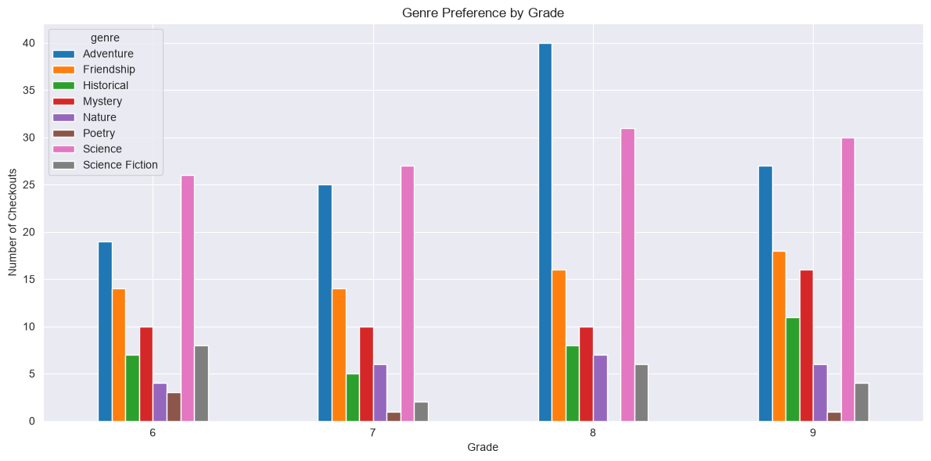
Figure 5 — Genre preference by grade
Summary:
- Science (114 checkouts) and Adventure (111 checkouts) are the two dominant genres, together making up more than half of all borrowing; Poetry is the least borrowed genre (5 checkouts).
- The preference for Science and Adventure holds consistently across grades 6–9, with Adventure notably highest among grade 8 members.
- Friendship is a strong secondary genre across all grades, while Poetry and Science Fiction remain niche interests in every grade.
4.4 Who are the most active library members?
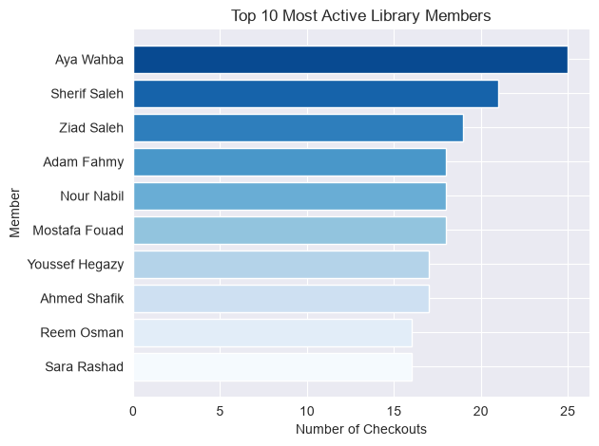
Figure 6 — Top 10 most active members by number of checkouts
Summary:
- Aya Wahba is the most active member with 25 checkouts, followed by Sherif Saleh (21) and Ziad Saleh (19).
- The top 10 members each checked out at least 16 books over the period, making them a clear target group for loyalty recognition or early access programs.
4.5 How does borrowing behavior differ across grades, neighborhoods, and membership statuses?
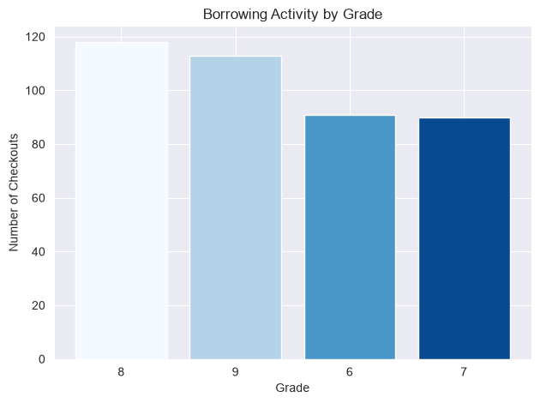
Figure 7 — Borrowing activity by grade

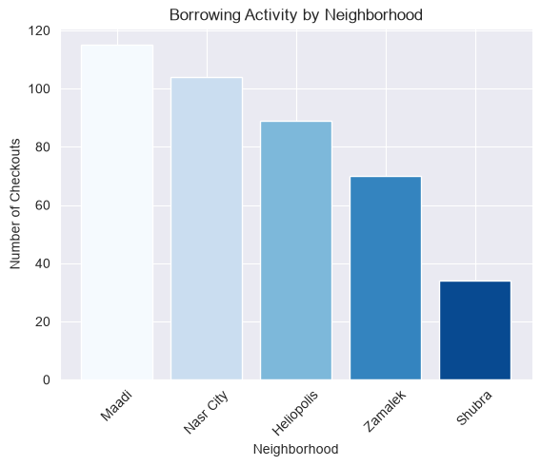
Figure 8 — Borrowing activity by neighborhood
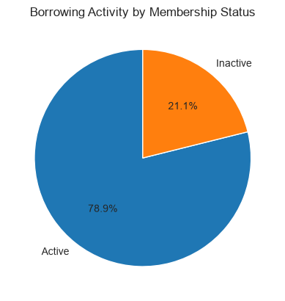
Figure 9 — Borrowing activity by membership status
Summary:
- Grades 8 and 9 borrow the most (118 and 113 checkouts) compared to grades 6 and 7 (91 and 90), though the difference across all four grades is moderate.
- Maadi (115 checkouts) and Nasr City (104) are the most active neighborhoods, while Shubra (34) trails well behind the other four areas — a potential outreach opportunity.
- Active members account for 78.9% of all borrowing versus 21.1% for inactive members, confirming that membership status is a strong indicator of engagement.

5. Conclusion
Borrowing at City Library is growing and concentrated: a small set of books, authors, and members drive a large share of activity, Science and Adventure dominate genre preference across all grades, and engagement is strongest among active members in Maadi and Nasr City. These patterns can support decisions on stock purchasing, targeted outreach in lower-activity areas such as Shubra, and recognition programs for top readers. The data quality issues in Section 3 — particularly the checkout dates that precede member join dates — should be investigated at the source system before the next reporting cycle.

