**Project - River Herring Habitat Study in Massachusetts Waters**

**GIS 5201 Advanced Spatial Analysis**

**Prof. James Armstrong**

**Malak Parmar**

**Overview**

Our study examined where river herring spawn along the Massachusetts coast. We used mapping software to visualize fish movement and identify key spawning locations. The maps display various sampling sites along the coastline, marked by colored dots. These colors represent the ease with which fish can move through these areas. Green dots indicate locations where fish passage is unobstructed, meaning they can swim freely upstream to spawn. These are crucial areas for the herring's life cycle. Conversely, red dots highlight areas where fish movement is restricted or blocked entirely. These blockages might be due to natural obstacles or human-made structures like dams or culverts. Understanding these movement patterns is essential for conservation efforts, as it allows us to pinpoint areas where fish passage needs improvement to support healthy spawning populations. The distribution of these dots provides a clear visual representation of the challenges and opportunities for river herring migration.

**Density Study**

We used computer analysis to study where river herring gather most densely during spawning season. This helped us understand which areas are most important for their reproduction. Our analysis revealed that the majority of spawning activity occurs in areas with a density value around 0.02. This means that these spots have a moderate concentration of spawning fish. We also found a strong connection between high fish density and the absence of barriers. The highest concentrations of fish were consistently observed near locations where there were no obstacles blocking their upstream migration. This highlights the negative impact of barriers on spawning activity. Furthermore, the distribution of fish density across all locations followed a normal, bell-shaped curve. This indicates that there are a few areas with very high and very low densities, while most areas have a moderate level of spawning activity. This information is critical for prioritizing conservation and restoration efforts.

**Distance Study**

We investigated how far river herring typically disperse from their primary spawning locations. This analysis helps us understand the spatial extent of the spawning habitat and the areas that need to be protected. Our findings show that a significant number of areas, approximately 470, are located within a 25-meter radius of the main spawning spots. This suggests that the immediate vicinity of these locations is crucial for successful reproduction. We also observed around 500 areas within a 50-meter radius, indicating a slightly wider zone of influence surrounding the spawning grounds. However, the number of areas extending to 100 meters was significantly smaller, only about 20. This suggests that the majority of spawning-related activity is concentrated within a relatively short distance from the primary spawning locations. These findings are important for determining appropriate buffer zones for conservation and management strategies, ensuring that the core spawning habitats and their immediate surroundings are adequately protected.

**Key Findings**

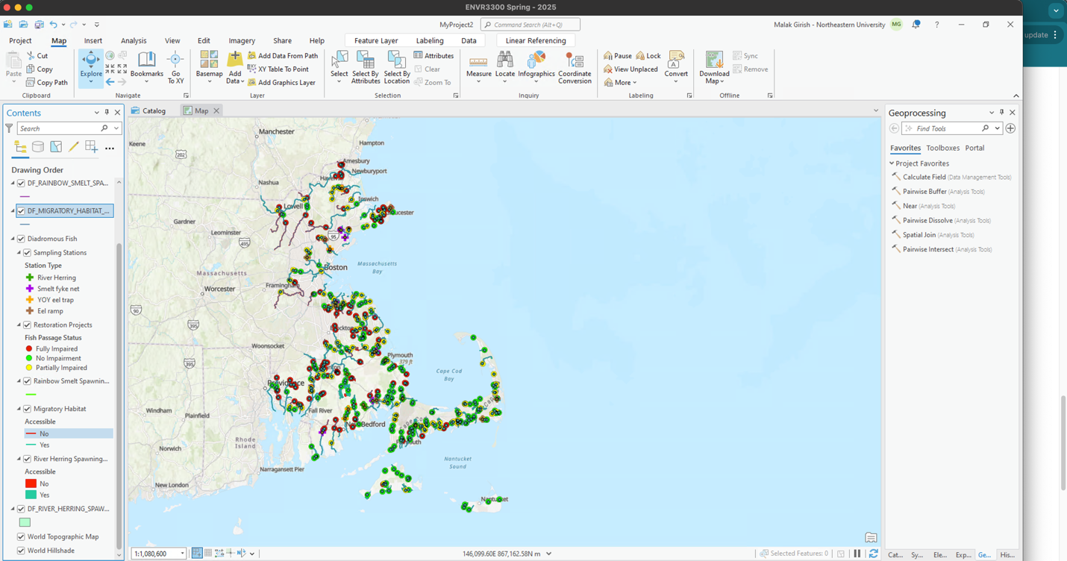

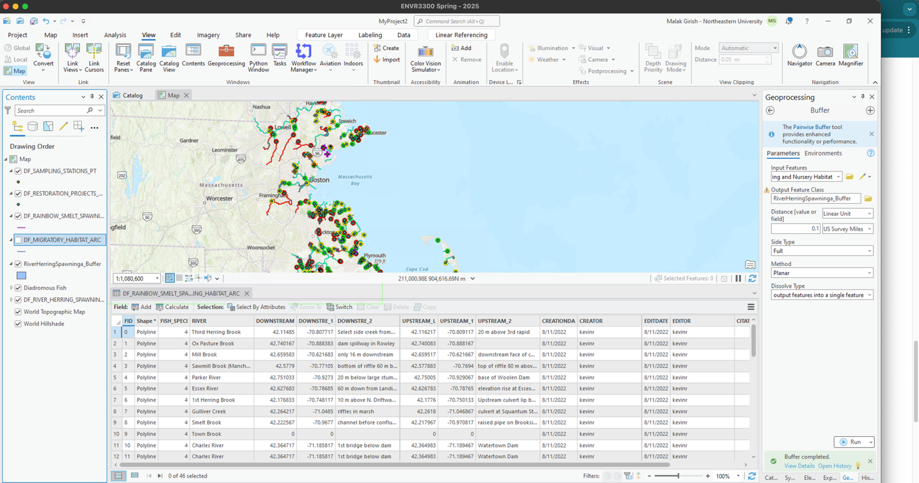

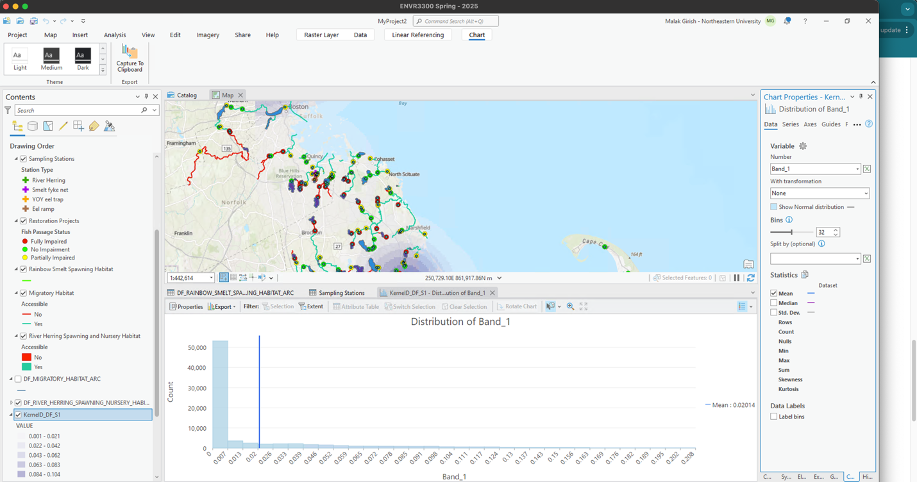

Fish prefer spots with clear paths to swim through

Most breeding happens in clusters along the coast

Areas near Boston and Cape Cod show lots of activity

Some spots need fixing to help fish move better

**What This Means**

This study helps us understand where fish breed and what stops them from reaching good spots. It shows us where we should focus on fixing barriers to help more fish reach their breeding grounds.

**Next Steps**

Fix the red-marked areas where fish can't pass

Keep watching the green areas where fish move freely

Check if fixing barriers helps more fish reach breeding spots

This information helps us protect these fish and their breeding spots better.

**References:**

Massachusetts Division of Marine Fisheries. (2022). MassGIS Data: Diadromous Fish [GIS Data]. Executive Office of Technology Services and Security (EOTSS). <https://www.mass.gov/info-details/massgis-data-diadromous-fish#downloads->

Chase, B. C. (2006). Rainbow smelt (Osmerus mordax) spawning habitat on the Gulf of Maine coast of Massachusetts (TR-30). Massachusetts Division of Marine Fisheries.

Guidelines for stream channel maintenance (2022). Massachusetts Department of Environmental Protection.

DEP/DMF stream maintenance policy (2022). Massachusetts Department of Environmental Protection.