**QUARRY 1**

Your analysis shall also include the reservation process where finance team will be interested in analyzing the company profit. Note that reservation processes can take place through multiple channels.

SELECT C.sales_channel_name, SUM(R.Total_Fare) AS total_fare

FROM Reservations R

JOIN Sales_Channel_Dim C ON R.Sales_Channel_SID = C.Sales_Channel_SID

GROUP BY C.Sales_Channel_SID, C.sales_channel_name;

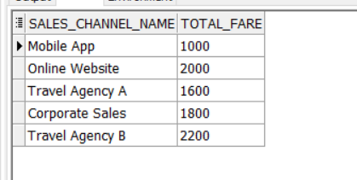

This query will return the revenue that the company gained from each channels

*************************************************************************************************************

**QUARRY 2**

In what fare basis does the the company’s frequent flyers pay

SELECT F.type, F.description, P.name

FROM RESERVATIONS R

JOIN FAIR_BASIS_DIM F

ON R.FAIR_BASIS_SID = F.FAIR_BASIS_SID

JOIN PASSENGER_DIM P

ON P.passenger_sid = R.passenger_sid

WHERE P.passenger_sid IN (

SELECT Q.passenger_sid

FROM FREQUENT_FLYER Q

);

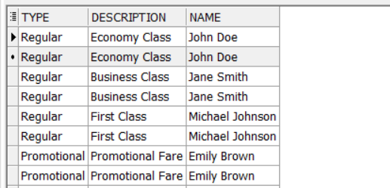

*************************************************************************************************************

**QUARRY 3**

how long the company’s frequent flyers overnight stays (OVERALL )

SELECT SUM(F.number_of_nights) AS total_nights, P.name

FROM PASSENGER_DIM P

JOIN TRAVEL_SERVICES_HOTEL_STAY F

ON F.PASSENGER_SID = P.PASSENGER_SID

WHERE P.PASSENGER_SID IN (

SELECT Q.passenger_sid

FROM FREQUENT_FLYER Q

)

GROUP BY P.name;

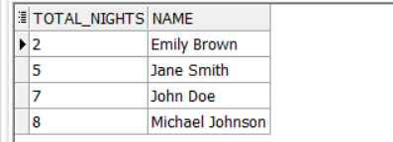

*************************************************************************************************************

**QUARRY 4**

The number of points earned and redeemed for frequent flyers

SELECT SUM(F.points_earned) AS total_points_earned, SUM(Q.POINTS_REDEEMED_) AS total_points_redeemed, P.name

FROM PASSENGER_DIM P

JOIN FLIGHT_ACTIVITY F ON P.PASSENGER_SID = F.PASSENGER_SID

JOIN FREQUENT_FLYER Q ON P.PASSENGER_SID = Q.PASSENGER_SID

GROUP BY P.name;

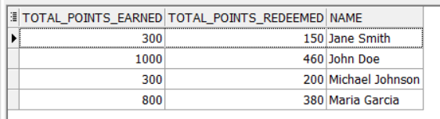

*************************************************************************************************************

**QUARRY 5**

Do frequent flyers respond to promotions ?

WITH PromotionResponse AS (

SELECT

COUNT(CASE WHEN R.promo_sid IS NULL THEN R.TICKET_ID_DD END) AS NOT_RESPONDING,

COUNT(CASE WHEN R.promo_sid IS NOT NULL THEN R.TICKET_ID_DD END) AS RESPONDING,

P.name

FROM

RESERVATIONS R

JOIN

PASSENGER_DIM P ON P.PASSENGER_SID = R.PASSENGER_SID

WHERE

P.passenger_sid IN (

SELECT Q.PASSENGER_SID

FROM FREQUENT_FLYER Q

)

GROUP BY

P.name

)

SELECT * FROM PromotionResponse;

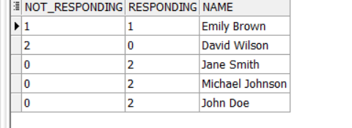

**QUARRY 6**

*************************************************************************************************************

Show all negative Feedbacks

SELECT *

FROM

CUSTOMER_CARE_FACT

where rating = 'Negative';



*************************************************************************************************************