Robotic Arm Simulation
Task 2 — 3-DOF Planar Arm: Design, Degrees of Freedom, and Pick-and-Place Motion Simulation

1. Overview
This report presents the design and simulation of a 3-degree-of-freedom (DOF) planar robotic arm with an end-effector gripper, built and animated as an interactive simulation. The model was designed to demonstrate a complete pick-and-place cycle: picking up a block from a fixed tray and placing it into a bin at a different location, using only forward kinematics driven by joint-angle keyframes.

2. Design and Degrees of Freedom
The arm is modeled as a kinematic chain of three revolute joints plus one prismatic (linear) actuator at the gripper, giving four controllable degrees of freedom in total:
- DOF 1 — Shoulder (revolute): rotates the upper arm link relative to the fixed base. Range: 0° to 180°.
- DOF 2 — Elbow (revolute): rotates the forearm link relative to the upper arm. Range: -150° to 150°.
- DOF 3 — Wrist (revolute): rotates the gripper assembly relative to the forearm, controlling the approach angle of the end-effector. Range: -90° to 90°.
- DOF 4 — Gripper (prismatic): opens and closes the two gripper fingers to grasp or release an object.
Forward kinematics for the arm are computed by chaining the link lengths and joint angles from the fixed base outward: each joint's position is calculated from the cumulative sum of all preceding joint angles, projected along the link length. This is the standard approach used for planar (2D) serial manipulators before more complex 3D or inverse-kinematics control is introduced.

3. Motion Simulation: Pick-and-Place Cycle
The simulation executes a ten-step keyframe sequence, interpolated smoothly between joint-angle targets using an ease-in-out motion profile. The sequence is as follows: the arm starts at a home position, moves above the pick tray, lowers to the block, closes its gripper to grasp the block, lifts it, transports it toward the placement bin, lowers it into the bin, opens the gripper to release the block, retracts, and returns to the home position. The screenshots below capture five key stages of this cycle.

3.1 Home Position
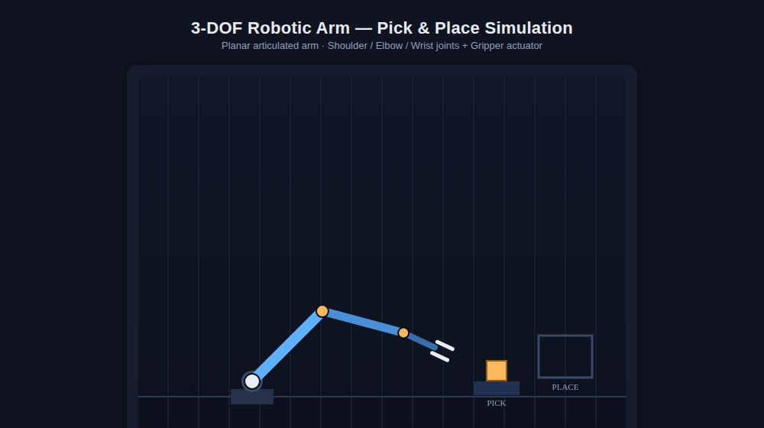
Figure 1 — Arm at home position (Shoulder 45°, Elbow -60°, Wrist -10°, Gripper open). Block rests in the pick tray on the left.

3.2 Positioned Above the Pick Tray
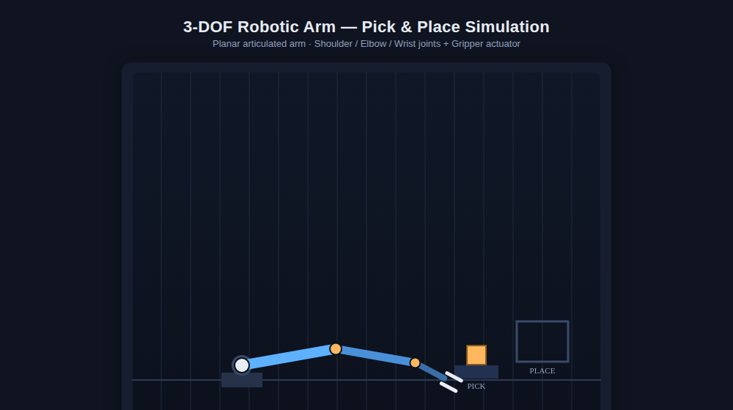
Figure 2 — Arm lowered above the block, gripper still open, ready to grasp.

3.3 Grasping the Block
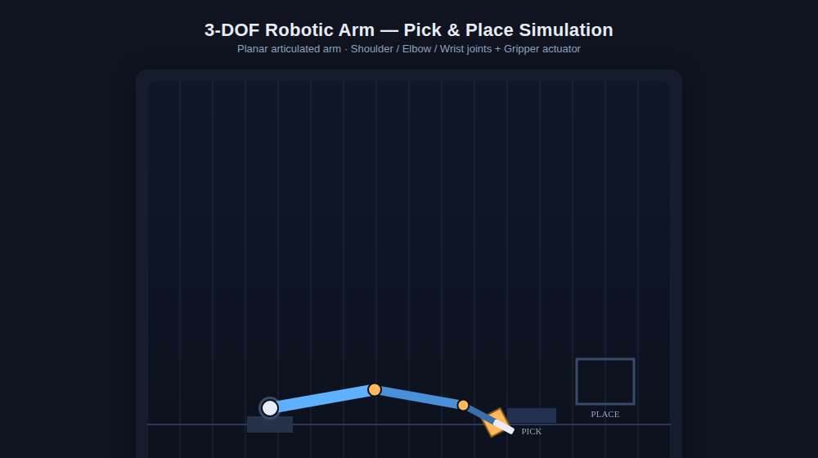
Figure 3 — Gripper closed around the block (Gripper DOF actuated from open to closed).

3.4 Transporting the Block
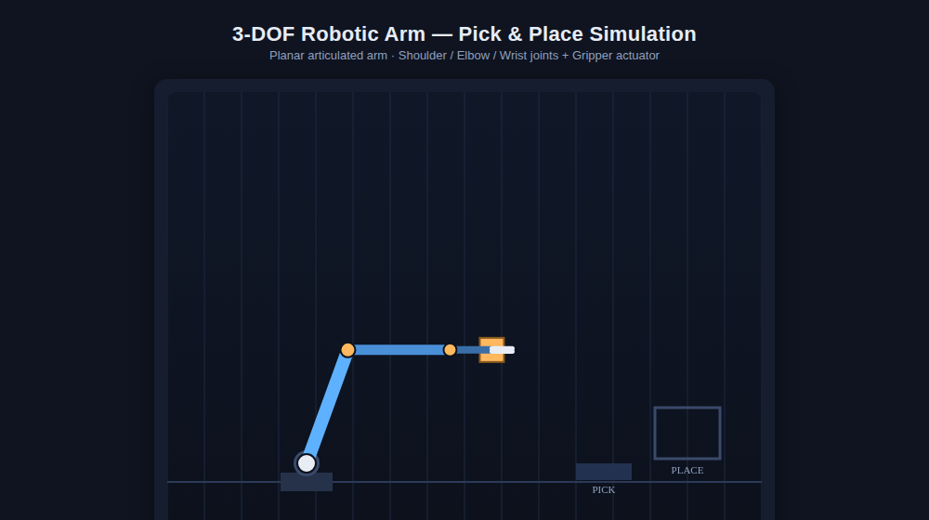
Figure 4 — Shoulder and elbow joints rotate together to carry the grasped block toward the placement bin.

3.5 Placement Complete
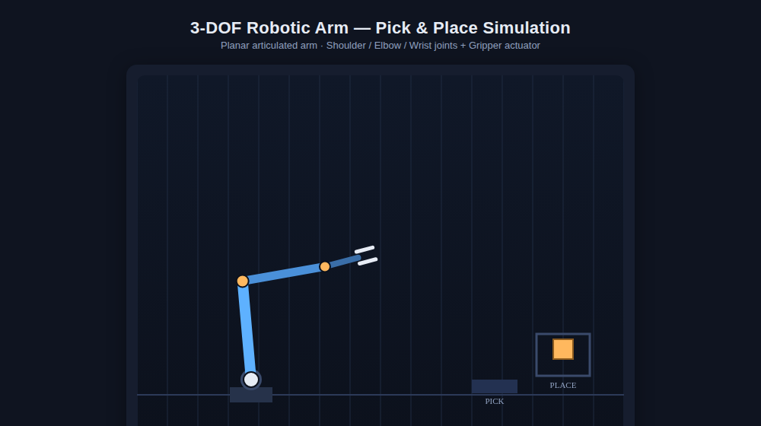
Figure 5 — Block released into the placement bin; gripper reopened, arm retracting to home.

4. Conclusion
This simulation demonstrates the core principles required for robotic pick-and-place automation: a defined kinematic chain, explicit degrees of freedom, and a coordinated joint-space motion sequence that moves an object from one location to another. While this implementation uses precomputed keyframes rather than full inverse kinematics, it accurately reflects how an industrial robotic arm's controller would sequence joint targets to execute a repeatable pick-and-place task on a factory line.

