Digital Egypt Pioneers Initiative (DEPI)
Data Analysis Track | Round 5 | Graduation Project
Project Documentation
System Analysis and Design
Project: Dollar Crisis Analysis Project – The Egyptian Pound’s Journey Against the US Dollar: Causes and Impact
Instructor | Eng. Abdelrahman El-Farsy
Track / Round | Data Analysis / Round 5
Team | Malak Emad Kamal Soltan  Romysaa Khalid Abdelmajed Asfour  Malak Ibrahim Abdelmomean Mohammed  Radwa Essam Eldin Said Hashkeel  Israa El Husseini Mohamed Al Afify  Maryam Mohammad Ebraheem Eldosoky Hegazy
Version | 1.0 – Draft for instructor review
Date | October 2026

1. Introduction
This document describes the analysis and design of the Dollar Crisis Analysis Project before implementation. The program’s documentation guidelines are written for software projects, so each item is adapted to a data analysis project. Items that do not apply to a business-intelligence project are listed with the reason.
Guideline item | Treatment in this project
Problem statement and objectives | Section 2
Use case diagram and descriptions | Section 3
Functional and non-functional requirements | Summarised in Section 4; full list in the Requirements Gathering document
Software architecture | Section 5: data pipeline architecture (sources → Python → SQL → Power BI)
Database design: ERD, logical and physical schema | Section 6: star schema
DFD and system behaviour | Section 7: DFD Level 0 and Level 1 and the analysis workflow
Sequence, state and class diagrams | Not applicable: the project has no application code or objects with behaviour. Replaced by the DFDs and the workflow in Section 7
UI/UX design: wireframes and guidelines | Section 9
Technology stack, deployment and component diagrams | Section 10; the architecture diagram serves as the component diagram
API documentation | Not applicable: no API is built
Testing and validation | Section 11
Project planning, risks and KPIs | Section 12

2. Problem Statement and Objectives

2.1 Problem statement
The shortage and rising price of the US dollar in Egypt affected the exchange rate, prices and daily life, but the information is scattered across reports and news articles, written in technical language, and hard to connect. People without an economics background find it difficult to see what drove the crisis, how the official and parallel markets differed, and how it affected prices.

2.2 Objectives
- Collect and organise public data on the exchange rate, its drivers, policy decisions and inflation.
- Clean and validate the data so that every figure is traceable to its source.
- Answer the guiding questions with light SQL analysis.
- Present the results in a four-page Power BI dashboard with plain-language insights.
- Document the project so that the work can be reviewed and reproduced.

2.3 Guiding questions
- How did the official exchange rate move, and what were the turning points?
- How large was the gap between the official and parallel rates?
- Which dollar-supply and dollar-demand indicators moved with the exchange rate?
- How did inflation and food inflation behave before and after major events?
- How did interest-rate decisions line up with inflation and the exchange rate?

3. Use Case Diagram and Descriptions
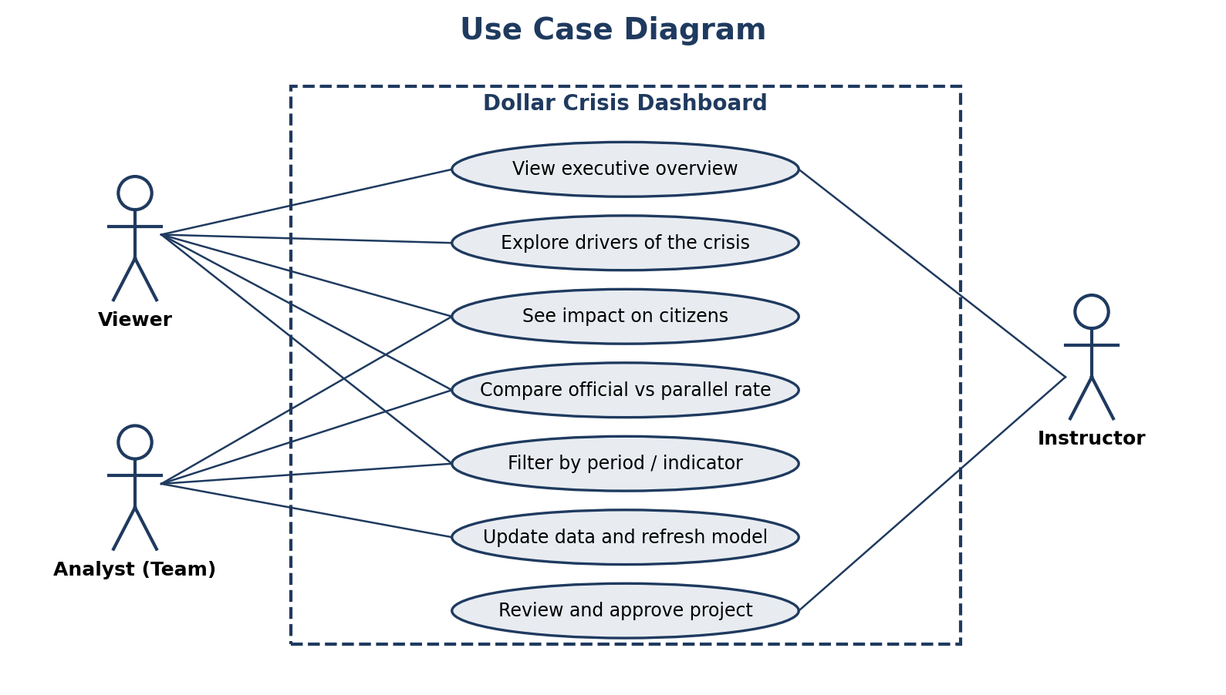
Figure 1: Use case diagram
Item | UC-01: Explore the dashboard
Actor | Viewer (peer, instructor, evaluation committee)
Goal | Understand the dollar crisis through the dashboard
Precondition | The Power BI report is open with data loaded
Main flow | 1) Open Page 1 and read the KPIs. 2) Select a period or event with a slicer. 3) Move to the Drivers, Impact or Parallel & Policy page. 4) Hover over a visual or term for an explanation. 5) Read the key takeaways text
Result | The viewer can describe what happened, why, and how it affected prices
Alternative flow | If a slicer selection returns no data, the visuals display an empty-state message and the viewer resets the filters

Item | UC-02: Update data and refresh the model
Actor | Analyst (team member)
Goal | Add or correct data and refresh the report
Precondition | Raw files and scripts are available on GitHub
Main flow | 1) Download or replace the raw file. 2) Run the Python cleaning notebook. 3) Load the cleaned files into SQL Server. 4) Refresh the Power BI model. 5) Run the validation checks and update the log
Result | The dashboard reflects the updated data, with a validation log entry
Alternative flow | If a validation check fails, the analyst corrects the cleaning step or the source file and repeats the run

4. Requirements Summary
The complete list with priorities and traceability is in the Requirements Gathering document. The key points:
Area | Summary | IDs
Dashboard structure | Four pages, KPIs, event markers, slicers, tooltips, source notes | FR-01 to FR-04, FR-10, FR-13, FR-15
Analysis content | Drivers, inflation impact, parallel market and policy views | FR-05 to FR-09
Data | Documented sources, validation, consistent frequency, data dictionary | DR-01 to DR-05
Quality | Accuracy, performance under 5 s, usability, consistency, accessibility, reproducibility | NFR-01 to NFR-08

5. Architecture
The project uses a layered data-pipeline architecture. Each layer has one responsibility and its own output, which makes errors easier to find.
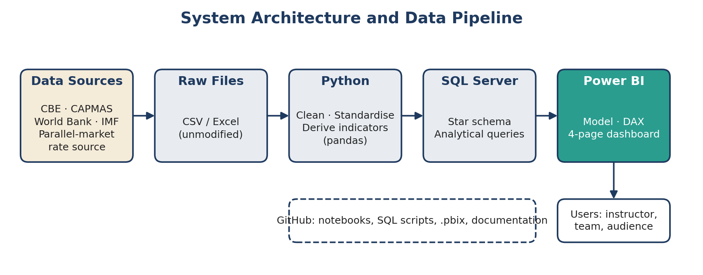
Figure 2: System architecture and data pipeline (also the component diagram)
Layer | Responsibility | Output
Data sources | Official and documented public sources: Central Bank of Egypt, CAPMAS, World Bank, IMF, and a documented market source for the parallel rate | Downloaded files
Raw files | Unmodified copies of the downloads with source, link and retrieval date | Raw data folder
Python | Clean, standardise and derive indicators | Cleaned CSV files and notebook
SQL Server | Star schema storage and analytical queries | Database and query results
Power BI | Data model, DAX measures and the four-page dashboard | .pbix file and PDF export

6. Database Design and Data Modeling
A star schema was chosen because it is the structure Power BI handles best: small dimension tables describe the context (date, year, event), and fact tables hold the measurements. Facts with different frequencies (monthly and annual) are kept in separate tables to avoid mixing time levels.
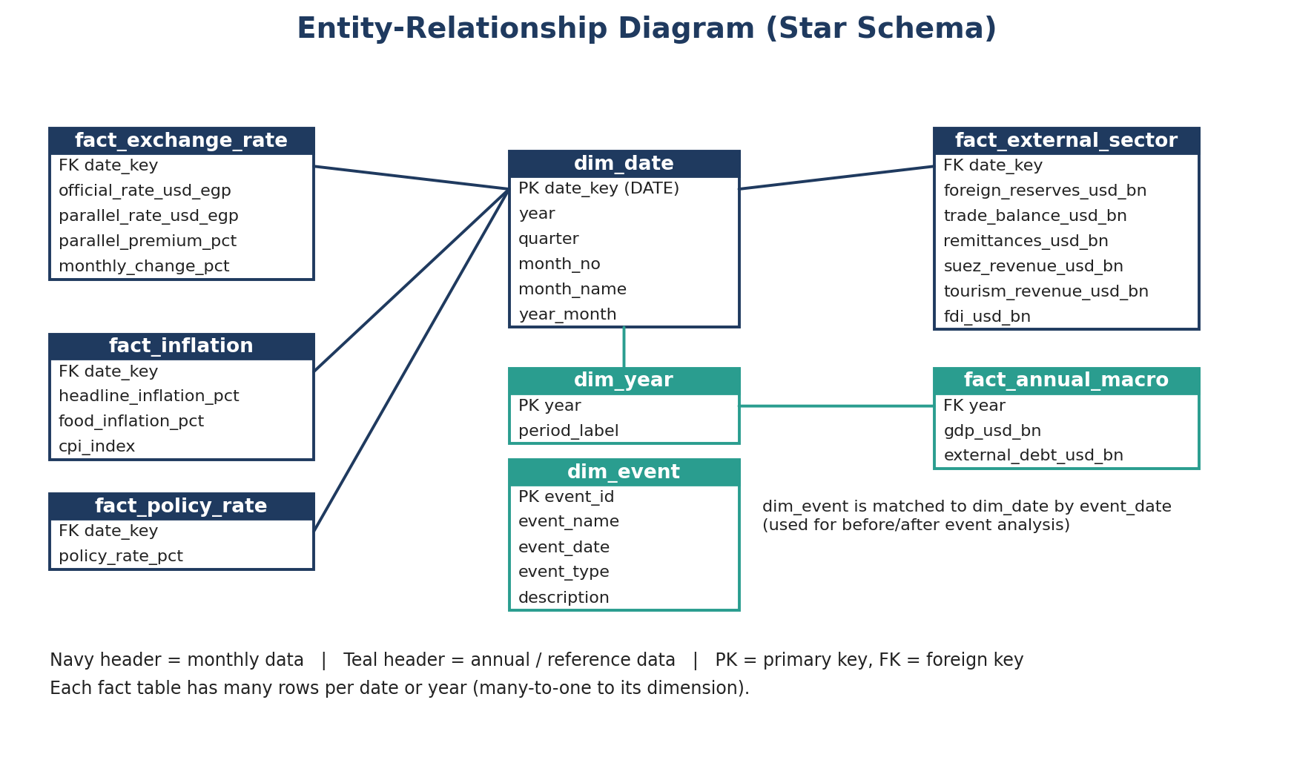
Figure 3: Entity-relationship diagram (star schema)

6.1 Logical and physical schema
Table | Columns (type) | Keys | Notes
dim_date | date_key (DATE), year (INT), quarter (INT), month_no (INT), month_name (VARCHAR), year_month (VARCHAR) | PK date_key | First day of each month
dim_year | year (INT), period_label (VARCHAR) | PK year | Links annual data
dim_event | event_id (INT), event_name (VARCHAR), event_date (DATE), event_type (VARCHAR), description (VARCHAR) | PK event_id | Floats, devaluations, IMF programmes, rate decisions, shocks
fact_exchange_rate | date_key (DATE), official_rate_usd_egp (DECIMAL), parallel_rate_usd_egp (DECIMAL), parallel_premium_pct (DECIMAL), monthly_change_pct (DECIMAL) | FK date_key | Parallel columns flagged unofficial
fact_inflation | date_key (DATE), headline_inflation_pct (DECIMAL), food_inflation_pct (DECIMAL), cpi_index (DECIMAL) | FK date_key | From CAPMAS / CBE
fact_policy_rate | date_key (DATE), policy_rate_pct (DECIMAL) | FK date_key | Carried forward between decisions
fact_external_sector | date_key (DATE), foreign_reserves_usd_bn, trade_balance_usd_bn, remittances_usd_bn, suez_revenue_usd_bn, tourism_revenue_usd_bn, fdi_usd_bn (all DECIMAL) | FK date_key | Frequency depends on source and is harmonised in Week 2
fact_annual_macro | year (INT), gdp_usd_bn (DECIMAL), external_debt_usd_bn (DECIMAL) | FK year | Annual indicators

6.2 Design considerations
- Normalisation: descriptive attributes live in dimension tables; fact tables contain keys and numeric measures only (third normal form for dimensions).
- Units: all currency values are stored in a documented unit (USD billions or EGP per USD); units are recorded in the data dictionary.
- Missing values: never filled silently. Each treatment (leave blank, carry forward, interpolate) is recorded in the cleaning log.
- Derived columns: computed in Python and verified in SQL, so the formula is visible in one place.

6.3 Planned data sources
Sources are candidates and will be confirmed in Week 1 after checking availability, frequency and terms of use.
Indicator group | Candidate source | Frequency | Note
Official exchange rate, reserves, policy rate | Central Bank of Egypt | Daily / monthly | Official statistics
Inflation and CPI | CAPMAS; Central Bank of Egypt | Monthly | Headline and food components
Parallel-market rate | Documented market-data source | Daily / monthly | Unofficial; source and method must be stated
Trade, remittances, tourism, Suez Canal, FDI | Central Bank of Egypt (balance of payments); World Bank | Quarterly / annual | Harmonise frequency
GDP and external debt | World Bank; IMF | Annual
Event dates and descriptions | IMF and Central Bank of Egypt statements | – | Verified from primary statements

7. Data Flow and Workflow
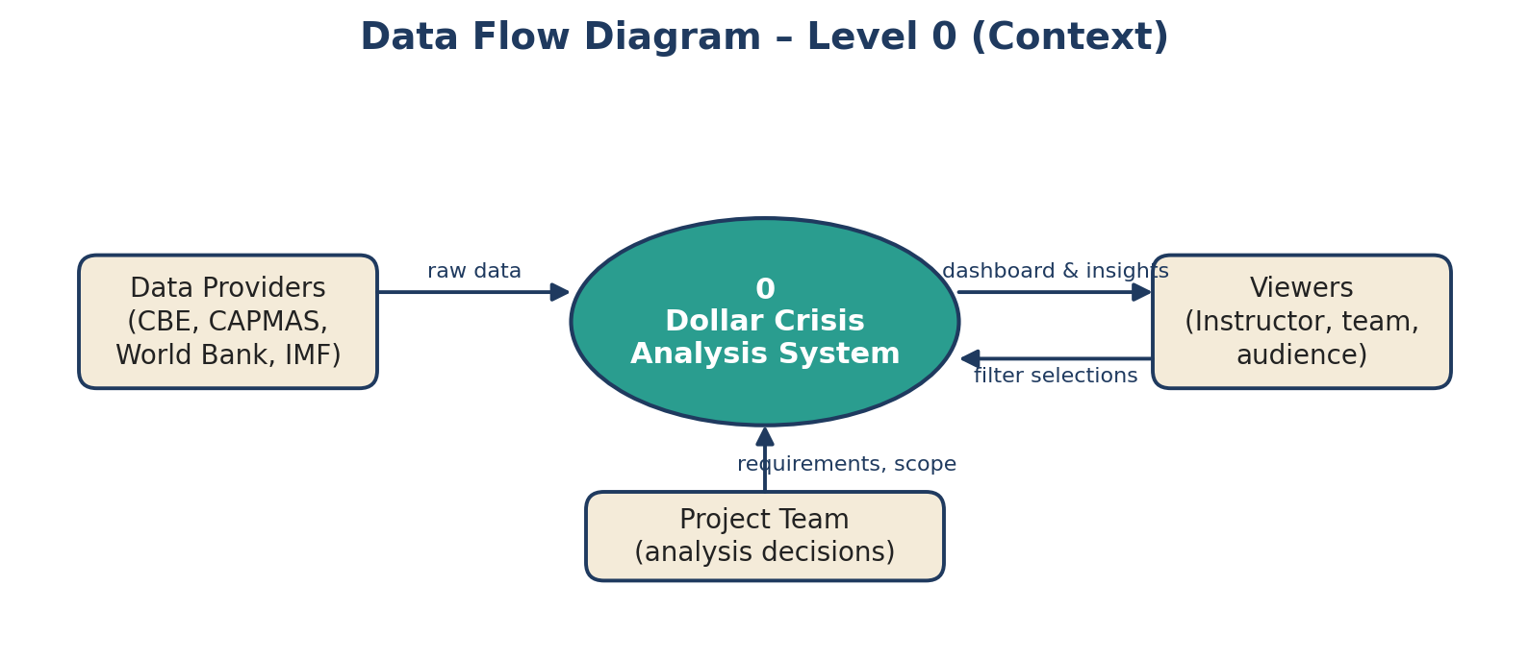
Figure 4: DFD Level 0 (context diagram)
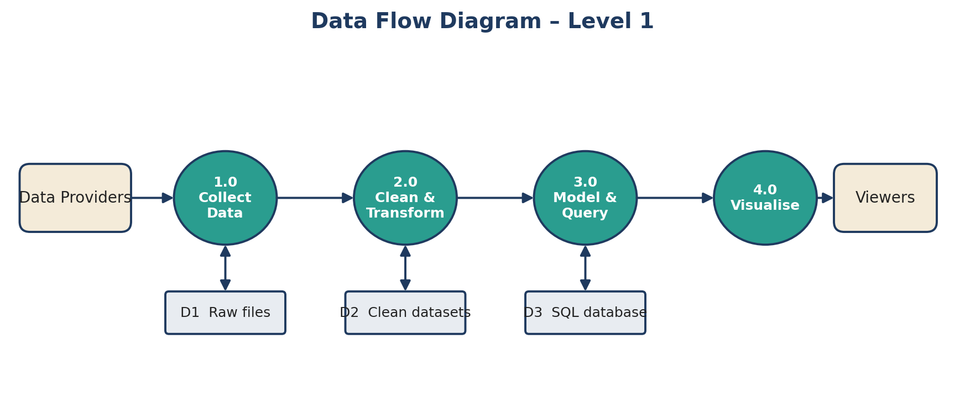
Figure 5: DFD Level 1

7.1 Analysis workflow (activity flow)
- Define the study period and indicators.
- Collect raw data and record the source, link and retrieval date.
- Inspect data quality (missing values, duplicates, date formats, units).
- Clean and standardise with Python, then derive indicators.
- Validate cleaned values against the original sources. If a check fails, return to step 3.
- Load into SQL Server and run the analytical queries.
- Build the Power BI model and the four pages.
- Test, fix, document and present.

8. Data Preparation and Analysis Plan

8.1 Python cleaning checklist
Step | Action
Standardise dates | Convert every date to the first day of the month (or to the year for annual data)
Types and units | Convert text to numbers; remove thousands separators and symbols; record the unit
Missing values | Report counts per column; decide and log the treatment
Duplicates and outliers | Remove exact duplicates; flag extreme values and check them against the source rather than deleting them
Merge | Join indicators on date_key or year; keep a row count check before and after
Export | Write cleaned CSV files with the same names as the SQL tables

8.2 Derived indicators
Indicator | Formula
monthly_change_pct | (rate this month ÷ rate previous month − 1) × 100
parallel_premium_pct | (parallel rate − official rate) ÷ official rate × 100
change_since_start_pct | (latest rate − first rate in period) ÷ first rate in period × 100

8.3 Light SQL analysis (illustrative queries)
The queries below show the planned analysis. They will be tested and adjusted on the final database in Week 2.
-- 1) Five largest monthly increases in the official rate
SELECT TOP 5 date_key, official_rate_usd_egp, monthly_change_pct
FROM fact_exchange_rate
ORDER BY monthly_change_pct DESC;

-- 2) Average inflation 12 months before and after each event
SELECT e.event_name, e.event_date,
AVG(CASE WHEN i.date_key >= DATEADD(MONTH,-12,e.event_date)
AND i.date_key < e.event_date THEN i.headline_inflation_pct END) AS avg_before_12m,
AVG(CASE WHEN i.date_key >= e.event_date
AND i.date_key < DATEADD(MONTH,12,e.event_date) THEN i.headline_inflation_pct END) AS avg_after_12m
FROM dim_event e CROSS JOIN fact_inflation i
GROUP BY e.event_name, e.event_date;

-- 3) Average parallel premium per year
SELECT d.year, AVG(f.parallel_premium_pct) AS avg_premium_pct
FROM fact_exchange_rate f JOIN dim_date d ON d.date_key = f.date_key
GROUP BY d.year ORDER BY d.year;

-- 4) Change in reserves compared with 12 months earlier
SELECT date_key, foreign_reserves_usd_bn,
foreign_reserves_usd_bn - LAG(foreign_reserves_usd_bn, 12) OVER (ORDER BY date_key) AS change_vs_12m
FROM fact_external_sector;

9. UI/UX Design and Prototyping

9.1 Design guidelines
Element | Guideline
Layout | Header with page title and navigation tabs; slicer panel on the left; KPI row at the top; main chart in the centre; key-takeaways box at the right or bottom
Colour palette | Navy #1F3A5F (titles, main lines); teal #2A9D8F (highlights and positive indicators); sand #F4EBD9 (text boxes); red #C0392B (devaluation events and warnings); light grey #F7F9FB (background)
Typography | Segoe UI: page titles 20 pt bold, visual titles 12 pt, labels and body 10–11 pt
Charts | Line charts for time series; columns for comparisons; one message per visual; no 3D, no unnecessary gridlines
Accessibility | Contrast ratio suitable for reading; do not use colour alone to carry meaning; alt text on visuals; minimum 10 pt text
Plain language | Titles state the message (for example “The pound lost value after each float”) only when the data supports it; terms are explained in tooltips
Source notes | A small footer on each page lists sources and the retrieval date

9.2 Wireframes
The wireframes show layout only. Final visuals and values will be defined after the data is cleaned.
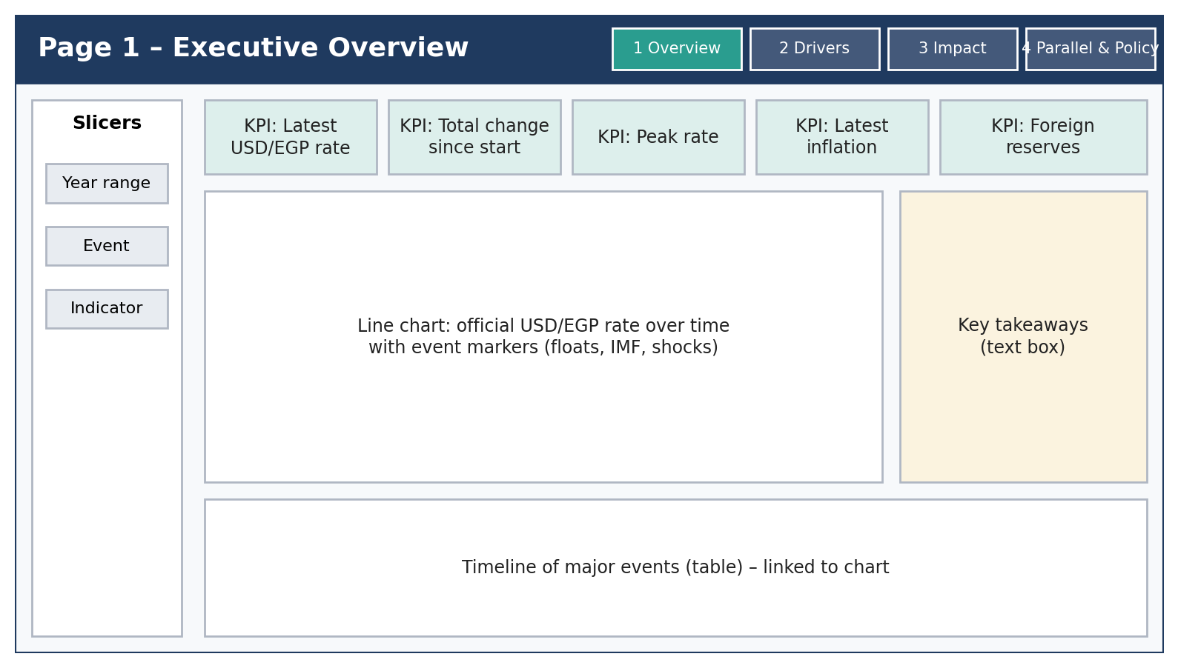
Figure 6: Page 1 – Executive Overview
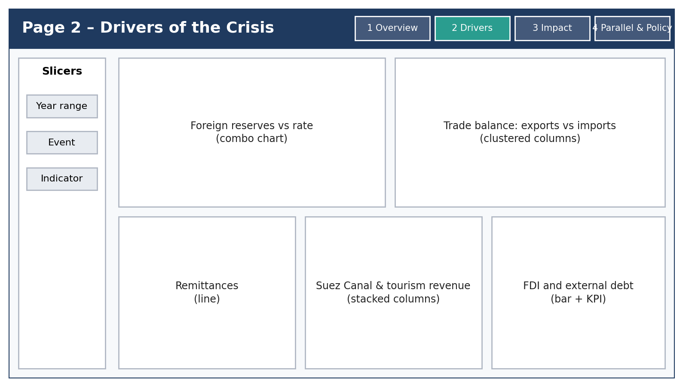
Figure 7: Page 2 – Drivers of the Crisis
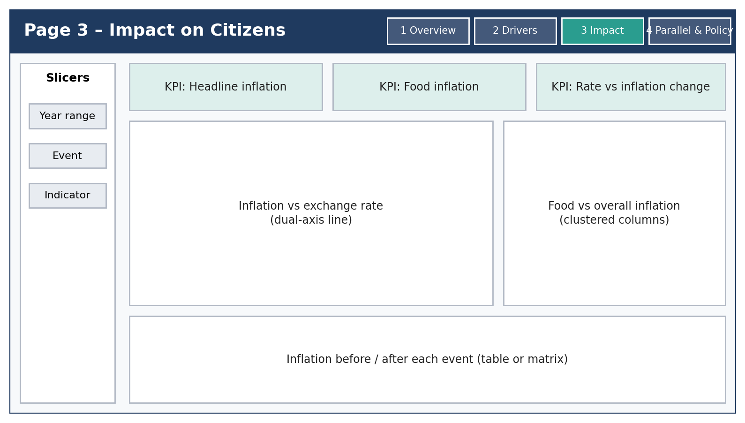
Figure 8: Page 3 – Impact on Citizens
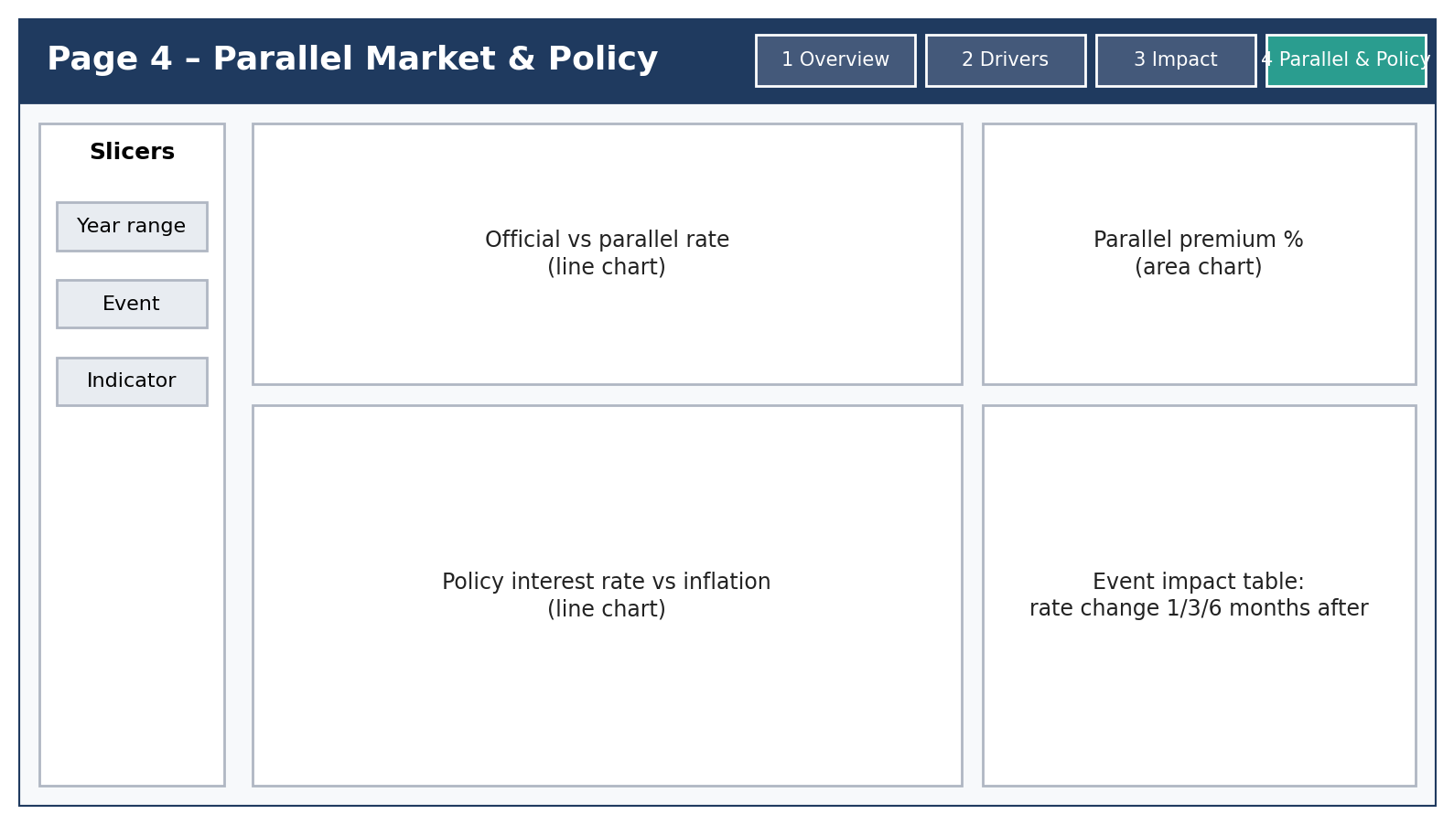
Figure 9: Page 4 – Parallel Market & Policy

9.3 Planned DAX measures
Latest Official Rate =
VAR LastDate = MAX ( fact_exchange_rate[date_key] )
RETURN CALCULATE ( MAX ( fact_exchange_rate[official_rate_usd_egp] ), fact_exchange_rate[date_key] = LastDate )

Change Since Start % =
VAR FirstDate = MIN ( fact_exchange_rate[date_key] )
VAR LastDate = MAX ( fact_exchange_rate[date_key] )
VAR FirstRate = CALCULATE ( MAX ( fact_exchange_rate[official_rate_usd_egp] ), fact_exchange_rate[date_key] = FirstDate )
VAR LastRate = CALCULATE ( MAX ( fact_exchange_rate[official_rate_usd_egp] ), fact_exchange_rate[date_key] = LastDate )
RETURN DIVIDE ( LastRate - FirstRate, FirstRate )

Parallel Premium % =
DIVIDE (
AVERAGE ( fact_exchange_rate[parallel_rate_usd_egp] ) - AVERAGE ( fact_exchange_rate[official_rate_usd_egp] ),
AVERAGE ( fact_exchange_rate[official_rate_usd_egp] )
)

10. Technology Stack and Deployment
Area | Technology | Use
Data collection and cleaning | Python 3 (pandas, NumPy), Jupyter Notebook | Collect, clean, derive indicators
Database | SQL Server (T-SQL) | Star schema and analytical queries
Business intelligence | Power BI Desktop, Power Query, DAX | Model and dashboard
Staging | Excel / CSV | Raw and cleaned files
Version control and sharing | GitHub (notebooks, SQL scripts, documentation); shared drive for the .pbix file | Collaboration and submission
Documentation and presentation | Microsoft Word, PowerPoint | Deliverables

10.1 Deployment strategy
- The final deliverable is the .pbix file plus a PDF export of the four pages.
- Publishing to the Power BI Service is optional and depends on the licence available to the team.
- The GitHub repository contains a README with the steps to rerun the cleaning notebook, load the SQL tables and refresh the report.
- Each release is tagged with a version number and the source retrieval dates.

11. Testing and Validation Plan
ID | Test | Expected result | Requirement
TC-01 | Open every page and use the navigation buttons | Four pages exist and navigation works | FR-01, FR-17
TC-02 | Compare KPI values with the source and SQL result | Values match within rounding | FR-02, DR-02
TC-03 | Check event markers and event table | Dates and descriptions match the primary statements | FR-03, FR-13
TC-04 | Compare driver charts with the source tables | Values and units match | FR-05
TC-05 | Check inflation visuals and the before/after table | Values match the SQL query results | FR-06, FR-07
TC-06 | Recalculate the premium for three sample months | DAX result equals manual calculation | FR-08, DR-03
TC-07 | Check policy rate against central bank announcements | Rates and dates match | FR-09
TC-08 | Change each slicer and check all related visuals | Visuals update consistently | FR-10
TC-09 | Hover over terms and visuals; check key-takeaway text | Tooltips and text are present and correct | FR-04, FR-11, FR-12
TC-10 | Check source notes on every page | Sources and dates are listed | FR-15
TC-11 | Measure page load and slicer response | Under 5 seconds on a standard laptop | NFR-02
TC-12 | Run the notebook and SQL scripts from raw files | Same cleaned data is produced | FR-14, DR-04, DR-05, NFR-06
TC-13 | Export the report to PDF | All four pages are exported readable | FR-16

11.1 Usability test
Five to ten non-economist peers will use the dashboard and try to answer three questions (for example: “When did the gap between the official and parallel rates close?”). The target is that at least 80% answer correctly without help (NFR-03).

11.2 Bug report template
ID | Page / table | Description | Severity | Owner | Status | Resolution
BUG-01

12. Project Management

12.1 Team and roles
No. | Member | Role
1 | Malak Emad Kamal Soltan | Team Lead & Documentation
2 | Romysaa Khalid Abdelmajed Asfour | Data Collection
3 | Malak Ibrahim Abdelmomean Mohammed | Data Cleaning (Python)
4 | Radwa Essam Eldin Said Hashkeel | SQL & Data Modeling
5 | Israa El Husseini Mohamed Al Afify | Power BI Developer
6 | Maryam Mohammad Ebraheem Eldosoky Hegazy | Research & Quality Assurance

12.2 Timeline
Week | Focus | Main deliverables
1 | Planning, research and data collection | Scope, source list, raw data, Literature Review and Requirements Gathering
2 | Data cleaning, modeling and SQL | Cleaned data, notebook, ERD, SQL scripts, data dictionary
3 | Dashboard design and development | Wireframes, .pbix with four pages, DAX measures
4 | Testing, documentation and presentation | Test report, final documentation, user manual, presentation

12.3 Risk assessment and mitigation
ID | Risk | Likelihood | Impact | Mitigation
R1 | Parallel-market data is hard to find or unofficial | High | Medium | Use a documented market source, flag it as unofficial, state the method; fall back to official-only analysis with a note
R2 | Indicators have different frequencies | High | Medium | Harmonise to monthly where possible; link annual data by year; document each choice
R3 | Misinterpretation of economic concepts | Medium | High | Team glossary, research role, instructor review, careful wording (associations, not causes)
R4 | Data errors or wrong units | Medium | High | Validation log, cross-checks against sources, test cases TC-02 and TC-04
R5 | Scope creep | Medium | Medium | MoSCoW priorities and the change-control process
R6 | Limited time (four weeks) | Medium | High | Weekly deliverables, early start of Power BI wireframes, task tracker
R7 | File conflicts in the .pbix file | Medium | Medium | One owner per page; version the file on every change; keep scripts on GitHub
R8 | Sources revise past data | Low | Medium | Record the retrieval date; do not mix versions

12.4 Key performance indicators
KPI | Target
Dashboard figures traceable to a source | 100%
Dashboard pages completed | 4 of 4
Weekly deliverables completed on time | 4 of 4 weeks
Test cases passed at submission | 13 of 13; no open critical bugs
Page load / slicer response time | Under 5 seconds
Non-economist users answering the test questions correctly | At least 80%

