# Grazioso Salvare Search and Rescue Dashboard

## Project Overview
This dashboard was developed for Grazioso Salvare to help identify dogs suitable for search-and-rescue training. It connects to the Austin Animal Center Outcomes dataset stored in MongoDB and provides an intuitive, interactive interface for filtering and visualizing the data.

## Required Functionality

The dashboard meets all requirements specified in the **CS 340 Dashboard Specifications Document**:

- **Interactive filter options** (radio buttons) for:
- Water Rescue
- Mountain or Wilderness Rescue
- Disaster Rescue or Individual Tracking
- Reset (returns all widgets to their original, unfiltered state)

- **Dynamic interactive data table** that updates based on the selected filter (includes pagination, sorting, and filtering).

- **Geolocation chart** (using dash_leaflet) that shows the location of the selected animal.

- **Second chart** (pie chart showing distribution of outcome types) that dynamically updates with the filtered data.

- **Branding requirements**:
- Grazioso Salvare logo with hyperlink to https://www.snhu.edu
- Unique identifier: "Created by: Malaki"

### Proof of Functionality (Screenshots)
All screenshots below were taken with the dashboard fully running and include the Grazioso Salvare logo and "Created by: Malaki" at the top.

1. **Starting State (Reset / All Records)** 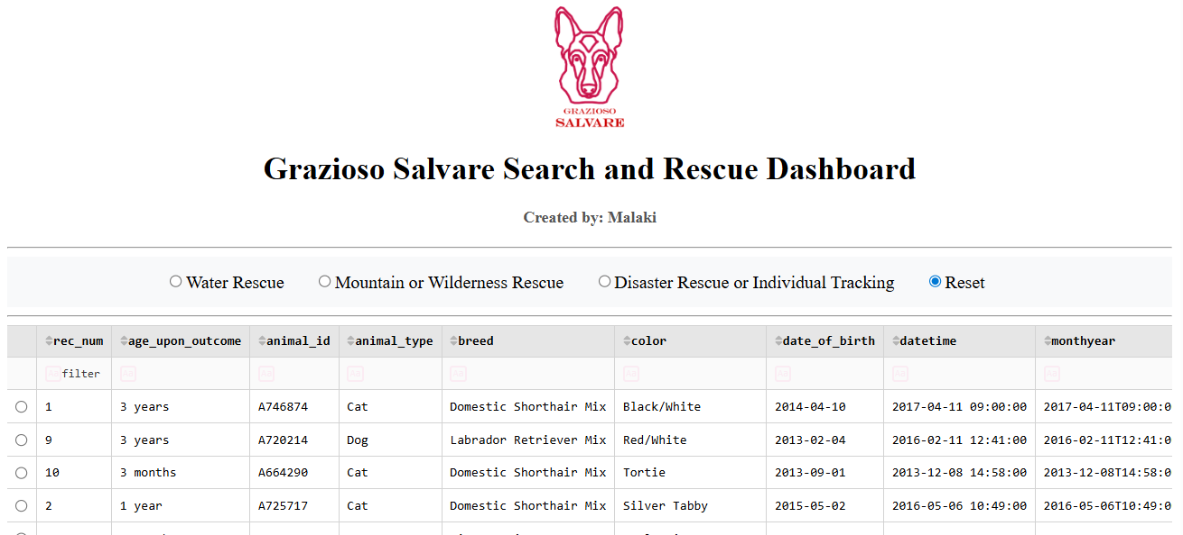
*All records loaded, no filter applied.*

2. **Water Rescue Filter Applied** 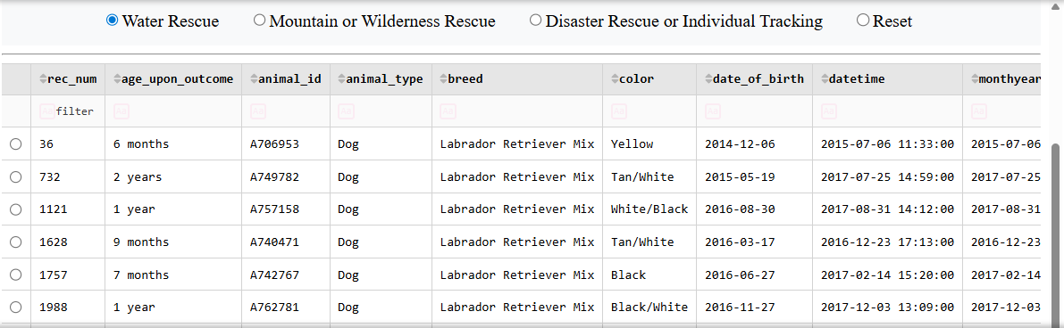

3. **Mountain or Wilderness Rescue Filter Applied** 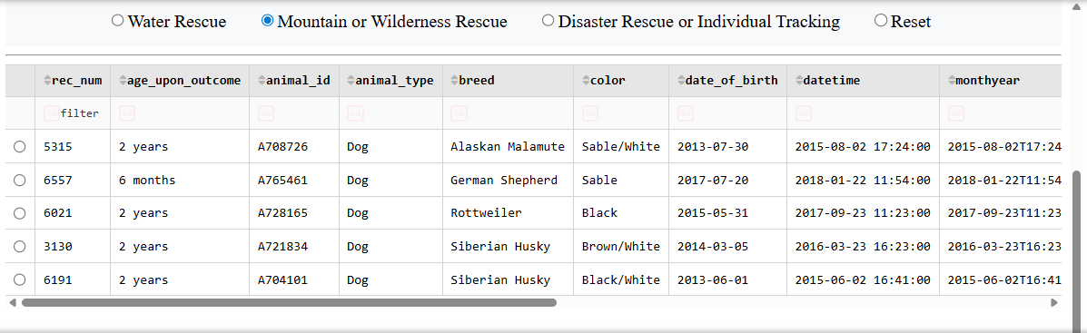

4. **Disaster Rescue or Individual Tracking Filter Applied** 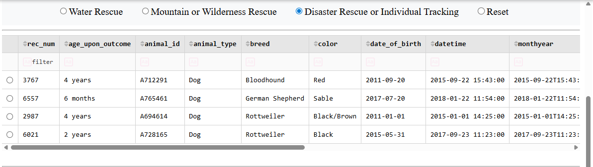

5. **Reset (Back to Original Unfiltered State)** 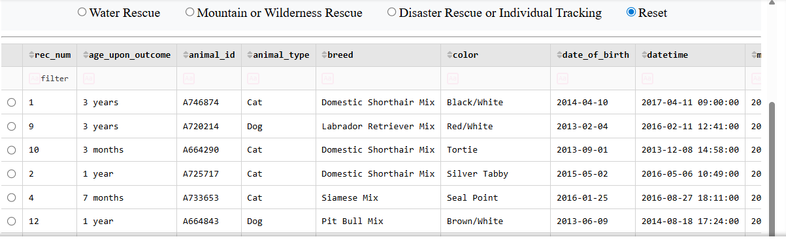

## Tools Used and Rationale

- **MongoDB** – Chosen as the Model component because it is a flexible, schema-less NoSQL database that stores semi-structured animal data efficiently. The `pymongo` driver provides seamless integration with Python, allowing simple CRUD operations (especially the `read()` method used for filtering). It handles large datasets and complex queries (such as `$in`, `$gte`, `$lte`) with high performance.

- **Dash (JupyterDash) + Plotly + dash_leaflet** – Used for the View and Controller layers. Dash allows the entire web application to be written in Python, following the MVC design pattern. Callbacks provide real-time interactivity between the radio filters, data table, pie chart, and map. Plotly was used for the pie chart, and dash_leaflet for the interactive geolocation map.

- **pandas** – Used for data manipulation and conversion between MongoDB documents and the Dash data table.

- **Other tools**: `base64` (for embedding the logo), Jupyter Notebook environment (Codio).

**Resources Used**:
- Dash documentation: https://dash.plotly.com
- dash_leaflet documentation: https://github.com/thedirtyfew/dash-leaflet
- PyMongo documentation: https://pymongo.readthedocs.io

## Steps Taken to Complete the Project

1. Imported and configured the existing `AnimalShelter` CRUD module from Project One.
2. Loaded the full dataset from MongoDB into a pandas DataFrame.
3. Built the dashboard layout with the required logo, radio filters, data table, pie chart, and geolocation map.
4. Added the exact rescue criteria (breeds, sex, age ranges) from the Specifications Document.
5. Implemented the main callback to run MongoDB queries based on the selected rescue type and update the data table.
6. Created callbacks so the pie chart and map dynamically update when the table changes.
7. Added user-friendly features to the data table (pagination, sorting, filtering, row selection).
8. Tested all four filters and captured the five required screenshots.
9. Documented the project in this README file.

## Challenges Encountered and How They Were Overcome

- **IndentationError** after multiple copy-paste steps → Resolved by cleaning all code blocks with consistent 4-space indentation and separating callbacks with blank lines.
- **Logo not displaying** → Fixed by correctly encoding the image with `.decode()` and ensuring the filename matched exactly (case-sensitive).
- **Map callback errors** when table was empty or no row selected → Improved error handling with default row logic and a "Loading map..." fallback.
- **Filters returning incorrect results** → Double-checked queries against the official "Rescue Type and Preferred Dog Breeds Table" on page 4 of the specifications document.

The dashboard now fully meets all client requirements and runs reliably.

---

**How to Run the Project**
1. Place `Grazioso_Salvare_Logo.png` in the same folder as the notebook.
2. Ensure `animal_shelter.py` is in the same directory.
3. Open `ProjectTwoDashboard.ipynb` and run all cells.
4. The interactive dashboard will appear in the Jupyter interface.

**Created by: Malaki**
**Date:** April 2026

