Research name: Learning-Based Cyberattack Deteection using the NSL – KDD Dataset.
Student name: Malak Jamil Nashwan.

Introduction:

Intrusion detection remains a major requirement in network security because cyberattacks continue to evolve in both volume and complexity. Early detection helps limit the impact of attacks and improves the protection of network resources. Therefore, Intrusion Detection Systems (IDS) are used to monitor traffic behavior and highlight patterns that may indicate malicious or unauthorized activity.

This research evaluates Deep Learning models for intrusion detection using the NSL-KDD dataset, which is widely used as a benchmark in cybersecurity research. The dataset includes both normal records and several attack categories such as DoS, Probe, R2L, and U2R, which makes it useful for testing classification-based detection approaches. Before training, the data is prepared through common preprocessing steps such as feature encoding and normalization, and then separated into training and testing subsets to ensure a fair evaluation on unseen samples. The dataset provides labeled network records that enable the analysis of normal and attack-related patterns, making it suitable for testing classification-based approaches.

Deep Learning has been increasingly applied in IDS research due to its ability to learn useful representations from high-dimensional data and capture non-linear relationships that may not be easily handled by conventional techniques. In this study, model performance is examined using standard evaluation metrics, with attention given to both detection effectiveness and the reduction of false alarms across multiple intrusion categories.

To evaluate the models in a fair way, the NSL-KDD data is split into training and testing sets. The training set is used to train the Deep Learning models and adjust their parameters, while the testing set is kept only for the final evaluation on data that the models have not seen before. This process helps confirm whether the models can perform well beyond the training samples and provides a more realistic estimate of their intrusion detection performance. The results are reported using accuracy, precision, recall, and the F1-score.The dataset is divided into 80% for training and 20% for testing.

Here are some key points of benefit introduce by ML in the context of networking cybersecurity:
1-Threat detection: Machine learning can be used to develop predictive models capable of identifying and detecting suspicious behavior or cyber attacks in communication networks. These models can analyze large amounts of data in real time from various sources, such as network logs, packet traffic and user behavior, in order to identify anomalies and patterns associated with malicious activity.
2-Automation of attack responses: Automation is a key aspect in the security of communication networks. Using machine learning algorithms can help automate an attack response, allowing you to react quickly and effectively to threats. For example, a machine learning system can be trained to recognize certain types of attacks and automatically trigger appropriate countermeasures, such as isolating compromised devices or changing security rules.
3-Detect new types of attacks: As cyberthreats evolve, new types of attacks are constantly emerging. The traditional signature-based approach may not be enough to detect these new threats. The use of machine learning algorithms can help recognize anomalous patterns or behavior that could indicate the emergence of new types of attacks, even in the absence of specific signatures.
4-Reduce False Positives: Traditional security systems often generate large numbers of false positives, that is, they falsely report normal activity as an attack. This can lead to wasted time and valuable resources in dealing with non-relevant reports. Using machine learning models can help reduce false positives, increasing the efficiency of security operations and enabling more accurate identification of real threats.
5-Adaptation and continuous learning: Machine learning models can be adapted and updated in real time to address new threats and changing conditions of communication networks. With continuous learning, models can improve over time, gaining greater knowledge of threats and their variants.
Ultimately, using machine learning in communication network security offers a number of benefits, including the ability to spot threats in real time, automate responses, detect new types of attacks, and reduce false positives. These benefits help improve overall network security and protect underlying data and assets.
6-Data Collection: The initial phase involves the collection of training data. This data consists of labeled examples, i.e., pairs of matching inputs and outputs.
For example, if we are trying to build a model to recognize images of cats, the data will contain images of cats labeled “cat” and different images labeled “not cat”.
7-Data preparation: This phase involves cleaning, normalizing, and transforming the training data to make it suitable for processing by the machine learning model. This can include eliminating missing data, handling categorical characteristics, and normalizing numeric values.
8-Model selection and training: In this phase, you select the appropriate machine learning model for the problem at hand. The model is then trained on the training data, which consists of making the model learn the patterns and relationships present in the data. During training, the model is iteratively adjusted to minimize the error between its predictions and the corresponding output labels in the training data.
9-Model Evaluation: After training, the model is evaluated using separate test data, which was not used during the training. This allows you to evaluate the effectiveness of the model in generalizing patterns to new data. Several metrics, such as accuracy, precision, and area under the ROC curve, are used to evaluate model performance.
10-Model Usage: Once the model has been trained and evaluated, it can be used to make predictions on new input data. The model applies the relationships learned during training to make predictions about new input instances.

Literature Review :

Previous studies emphasized intrusion detection systems as a key aspect of network security. While early approaches relied on traditional and basic machine learning methods, recent research has focused on deep learning techniques due to their effectiveness in analyzing complex network traffic, with NSL-KDD widely used as a benchmark dataset.
McHugh (2000):
In his study, McHugh discussed the evaluation of traditional intrusion detection systems, and criticized the evaluation methods based on DARPA and KDD'99 data. The researcher explained that some of the performance results were misleading due to the nature of the data used, which later contributed to the development of improved data sets such as NSL-KDD, and greatly influenced modern IDS research .
Bamber et al. (2025)
Bamber and his colleagues presented a hybrid model that combines CNN and LSTM to detect cyber attacks. This model aims to leverage CNN's ability to extract spatial properties, and LSTM's ability to analyze sequenced patterns in network data. The study showed that the hybrid model performed better than individual models when applied to data from intrusion detection systems .
Analysis :

Theoretical Analysis:

Traditional rule-based intrusion detection systems rely on predefined rules created by human experts, which limits their flexibility when facing new or evolving cyberattacks. These systems often struggle to handle complex and large-scale network traffic data.In contrast, machine learning and Deep Learning approaches learn patterns directly from data, allowing them to adapt to changing network environments. This data-driven nature makes Deep Learning more suitable for intrusion detection tasks, where attack behaviors are complex and continuously evolving.

Artificial Neural Networks (ANN):
Effective in learning the relationships between network traffic features and classification outcomes, making them suitable for basic intrusion detection tasks.

Convolutional Neural Networks (CNN):
Capable of automatically extracting important features from network data, which reduces the need for manual feature selection and improves detection accuracy.

Long Short-Term Memory (LSTM):
Particularly useful for analyzing sequential network traffic, as they can capture temporal patterns associated with specific types of cyberattacks.

Data Analysis and Preprocessing:

Exploratory Data Analysis (EDA)>>

 | 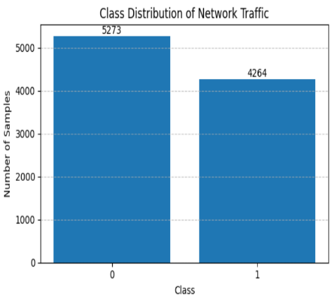 | 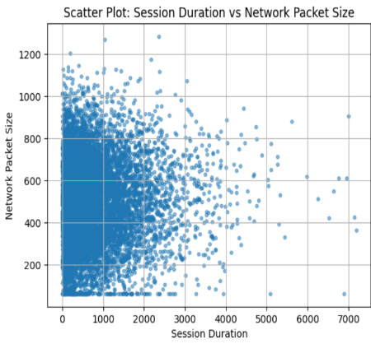
Histogram figure illustrates the distribution of flow duration using a logarithmic scale. The results show a highly skewed distribution, where most network flows have very short durations, while a small number of flows exhibit extremely long durations. This behavior is typical in network traffic datasets. | Bar Chart figure presents the distribution of network traffic classes in the dataset. The dataset appears relatively balanced, which reduces bias during model training., which is an important factor when evaluating the performance of intrusion detection models. | Scatter Plot figure shows the relationship between Session Duration vs Network Packet Size. The use of a logarithmic scale highlights variations in traffic intensity and reveals differences between normal and attack traffic patterns.

Experimental Results:
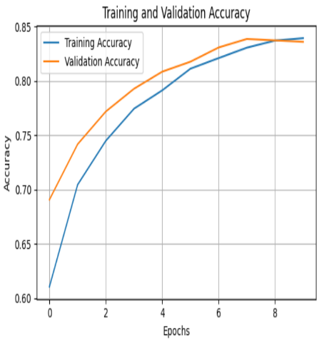 | 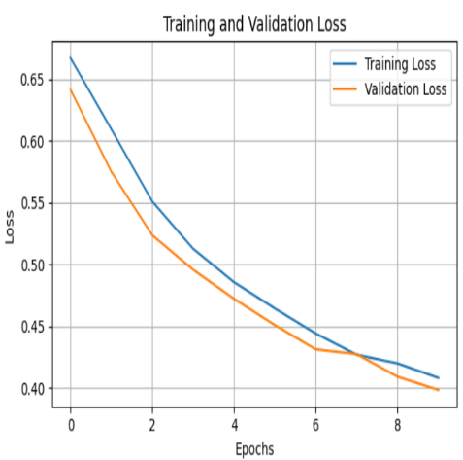 | 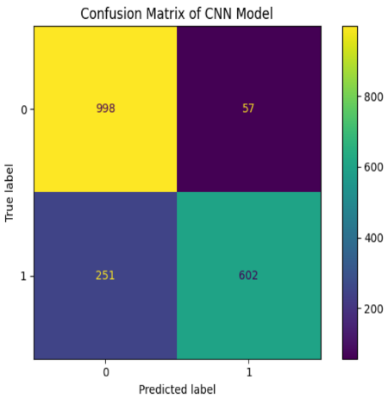
The figure shows a rapid increase in training accuracy, reaching near-perfect performance within the first epochs. The validation accuracy remains consistently high, indicating that the CNN model generalizes well to unseen data without signs of overfitting. | The figure shows a rapid decrease in training loss during the early epochs, followed by stable validation loss values. This indicates successful convergence of the CNN model and suggests the absence of overfitting. | The confusion matrix indicates strong classification performance of the CNN model, with relatively low misclassification rates. The majority of test samples were correctly predicted, demonstrating the effectiveness and robustness of the model on the NSL-KDD dataset.

Applications:

Deep Learning-based intrusion detection systems are widely used in real-world cybersecurity environments to protect networks from various types of cyberattacks. These systems are applied in enterprise networks, cloud computing platforms, and data centers to monitor network traffic and detect abnormal behavior.
One common application is the detection of Distributed Denial of Service (DDoS) attacks, which aim to disrupt network services by overwhelming them with malicious traffic. Recent DDoS attacks on several companies have demonstrated the serious impact such attacks can have on business operations and online services. These incidents highlight the need for advanced intrusion detection systems that can quickly identify and respond to malicious traffic patterns.

Ethical Considerations:
AI-based cybersecurity systems, such as those utilizing the NSL-KDD dataset, pose significant ethical, privacy, and societal challenges that extend beyond technical functionality. These challenges can be categorized into three main areas: bias, privacy concerns, and societal impacts.
Bias
1_Algorithmic Bias Resulting from Historical Data
Explanation:
Artificial intelligence systems rely entirely on large datasets to learn how to distinguish between “normal” and “suspicious” activities. The ethical problem arises when these datasets are incomplete or contain prior human biases; in such cases, the algorithm does not merely adopt the bias but may amplify it. In the context of cybersecurity, models can produce inaccurate or unfair results if their training is based on data that does not represent reality in a balanced manner.
Illustrative Example:
If an intrusion detection system (such as one using the NSL-KDD dataset) is trained on data that includes a high concentration of attacks originating from a specific geographic region or certain protocols, the system may automatically label any legitimate traffic from those sources as a threat, leading to the blocking of legitimate services.
protocols, the system may automatically label any legitimate traffic from those sources as a threat, leading to the blocking of legitimate services.

2_Social and Economic Discrimination
Explanation:
Bias in cybersecurity systems is not limited to technical aspects but extends to social and economic risks. When security systems target specific individuals or groups unfairly based on biased algorithms, this may deprive them of access to vital services or result in discriminatory treatment by authorities. Such bias reinforces social inequality under the cover of technological security.
Illustrative Example:
In workplace environments, an AI model designed to monitor insider threats may interpret certain behavioral patterns of employees from different cultural backgrounds as suspicious simply because their behavior does not match the “norm” learned from biased data representing another group, which may negatively affect their professional future.
3_Consequences of Erroneous Predictions and Lack of Accountability
Explanation:
Bias can lead systems into making erroneous security decisions based on prejudiced assumptions. A major ethical issue here is transparency, as these algorithms often operate as a “black box” whose internal decision-making processes are difficult to understand. This makes it challenging to detect or address bias before harm occurs. The absence of transparency also weakens accountability, as it becomes difficult to determine responsibility for damages caused by a biased automated decision.
Illustrative Example:
An automated security system may block the financial accounts of thousands of users based on a “suspicious pattern” learned from biased data. When financial harm occurs, it becomes difficult to explain why the system made such a decision or to provide a clear mechanism for appeal due to the complexity and lack of transparency of the algorithm.

Privacy Concerns

1_Security vs. Invasive Surveillance:
Explanation:
There is an inherent tension between enhancing security and protecting individual privacy. AI systems improve real-time threat detection but require continuous monitoring of network activity, potentially observing personal behaviors and communications beyond what is necessary for security. This surveillance can blur the line between legitimate security measures and invasive monitoring that violates civil liberties.
Illustrative Example:
AI-powered tools tracking internal threats by analyzing employees’ messages or monitoring their digital movements without explicit consent.
2_Data Misuse and Unauthorized Collection:
Explanation:
Ethical and legal risks emerge regarding how data is collected and stored. Personal information is sometimes collected without individuals’ knowledge, which may be misused for unauthorized purposes, such as identity theft. Data collected for security purposes might also be exploited in commercial or political contexts, putting user privacy at risk.
Illustrative Example:
Data gathered by intrusion detection systems may be used to train large language models without adequate protection, potentially leaking sensitive information or intellectual property.

3_Lack of Transparency and Consent:
Explanation:
Many AI systems operate opaquely to end users, processing and sharing data without full awareness. Ethical standards require explicit consent and transparency regarding what data is collected, why it is collected, and how it is protected through encryption and anonymization. Users should also have the option to opt out of data processing.
Illustrative Example:
An organization operates an AI-based security system analyzing biometric data for system access without informing employees how the data is stored or who may access it.

Societal Impacts
1_Erosion of Civil Liberties and Privacy:
Explanation:
AI systems in cybersecurity require monitoring and analyzing vast amounts of personal and network behavior data to function effectively. Overreliance on surveillance can transform security tools into invasive monitoring systems that operate without consent, eroding trust in technology and undermining fundamental privacy rights.
Illustrative Example:
Tracking individuals’ movements or monitoring personal communications under the pretext of detecting “suspicious threats,” blurring the line between legitimate security measures and violations of freedoms.

2_Data Misuse and Public Trust:
Explanation:
Data collected for security purposes may be exploited for unethical objectives, such as commercial or political gain, raising societal concerns about control over information. Emerging threats like deepfakes and data poisoning challenge social stability by spreading misinformation and falsifying identities, making it difficult for the public to distinguish truth from deception and undermining trust in digital institutions.
Illustrative Example:
Using stolen or cybersecurity-gathered data to create deepfake media for manipulating public opinion or for blackmail purposes.
Conclusion:
This research proposed a deep learning–based intrusion detection system using a Convolutional Neural Network (CNN) to classify network traffic as normal or malicious. The model was evaluated using the NSL-KDD benchmark dataset, with exploratory data analysis performed to understand feature distributions prior to training.
The experimental results show that the CNN model achieved high performance in terms of accuracy and other evaluation metrics. The training and validation curves demonstrate effective learning and stable convergence, while the confusion matrix confirms accurate classification of the test samples. These findings highlight the effectiveness of CNNs in automatically extracting relevant features for intrusion detection tasks.
Although the obtained results are promising, they are based on a benchmark dataset and may differ in real-world environments. Future work may involve testing the model on more recent datasets and extending the approach to multi-class intrusion detection scenarios. Overall, the study confirms the potential of CNN-based models as an effective solution for intrusion detection in cybersecurity.

References

NSL-KDD Dataset. (n.d.). Kaggle.
https://www.kaggle.com/datasets/hassan06/nslkdd
Al-Qudaimi, H. (2025).
Ethics and legal risks in the use of artificial intelligence.
Al-Baydha University Journal, 7(2).
https://baydaauniv.net/buj/index.php/buj/article/view/788
CTI Technology. (n.d.).
Ethical vs. unethical use of artificial intelligence in cybersecurity.
https://www.ctinc.com/ethical-vs-unethical-use-of-artificial-intelligence-in-cybersecurity-2/
Dini, P., Elhanashi, A., Begni, A., Saponara, S., Zheng, Q., & Gasmi, K. (2023).
Overview on intrusion detection systems design exploiting machine learning for networking cybersecurity.
Applied Sciences, 13(13), 7507.
https://doi.org/10.3390/app13137507
Lucas, O. (2025).
The ethical use of AI in cybersecurity: Balancing security and privacy in the digital age.
KPMG US.
https://kpmg.com/us/en/articles/2025/ethical-ai-cybersecurity-balancing-security-privacy-digital-age.html
GeeksforGeeks. (n.d.). Rule-based system vs. machine learning system. https://www.geeksforgeeks.org/machine-learning/rule-based-system-vs-machine-learning-system/
Nikolovski, M. (2021, April 29). 7 of the most famous recent DDoS attacks. Vxchnge. Retrieved August 5, 2024, from https://www.vxchnge.com/recent-ddos-attacks-on-companies/

