Project 1
Medicine inventory

Team Members
Rawda Haitham 221001727
Yossr Ashraf Eid 221001861
Malak Reda 231001933
Mariam Sayed 241001662
Yasmine Gomaa 241002181

Supervised by
Mohamed Mahmoud ElSayeh

- Introduction
This is an implementation of Medicine Inventory Database Management System using SQL. This will assist in organizing Doctors, Diseases, Medicines, Prescription, and Billing activities. In addition, this project will demonstrate the principles of Database such as table, relationship, view, trigger, and query using SQL.
The main objective of this project is to organize medicine inventory in a systematic way and relate Doctors, Patients, Prescriptions, and Medicines.

- Conceptual Design
Entities and Attributes
Doctor
- doctor_id
- name
- qualification
- specialization
Disease
- disease_id
- name
- type
Prescription
- prescription_id
- doctor_id
- issue_date
- medicines
- patient_name
Prescription_Medicine
- prescription_id
- medicine_id
- quantity
Medicine_Disease
- medicine_id
- disease_id
Bill
- bill_id
- prescription_id
- tax
- discount
- total

- Relationships Explanation
Doctor and Prescription tables are associated by doctor_id.
Prescription and Medicine tables have a many-to-many relationship which is shown by the use of Prescription_Medicine table.
Medicine and Disease tables are associated through the Medicine_Disease table.
The Bill table contains bill details for the prescriptions.

- Relational Schema
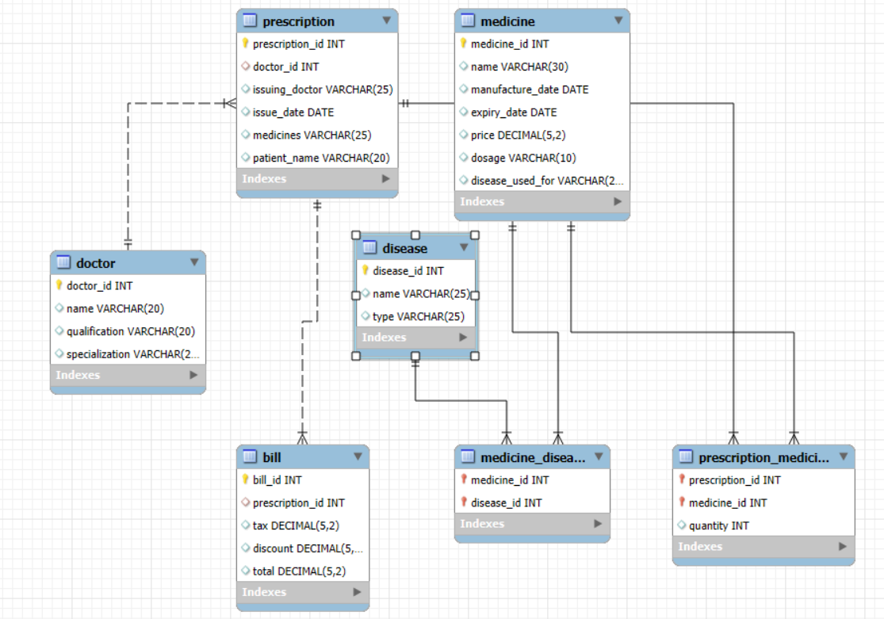
Doctor Table
CREATE TABLE Doctor (
DoctorID INT PRIMARY KEY,
DoctorName VARCHAR(120) NOT NULL,
Qualification VARCHAR(120) NOT NULL,
Specialization VARCHAR(120) NOT NULL
);
Disease Table
CREATE TABLE Disease (
DiseaseID INT PRIMARY KEY,
DiseaseName VARCHAR(120) NOT NULL,
DiseaseType VARCHAR(100) NOT NULL,
CHECK (DiseaseType IN (
'infectious diseases',
'deficiency diseases',
'genetic hereditary diseases',
'non-genetic hereditary diseases'
))
);

Medicine Table
CREATE TABLE Medicine (
MedicineID INT PRIMARY KEY,
MedicineName VARCHAR(120) NOT NULL,
ManufactureDate DATE NOT NULL,
ExpiryDate DATE NOT NULL,
Price DECIMAL(10,2) NOT NULL CHECK (Price >= 0),
Dosage VARCHAR(120) NOT NULL,
CHECK (ExpiryDate > ManufactureDate)
);
Prescription Table
CREATE TABLE Prescription (
PrescriptionID INT PRIMARY KEY,
DoctorID INT NOT NULL,
IssueDate DATE NOT NULL,
PatientName VARCHAR(120) NOT NULL,
CONSTRAINT FK_Prescription_Doctor
FOREIGN KEY (DoctorID)
REFERENCES Doctor(DoctorID)
);
Prescription_Medicine Table
CREATE TABLE Prescription_Medicine (
PrescriptionID INT NOT NULL,
MedicineID INT NOT NULL,
Quantity INT NOT NULL CHECK (Quantity > 0),
PRIMARY KEY (PrescriptionID, MedicineID),
CONSTRAINT FK_PM_Prescription
FOREIGN KEY (PrescriptionID)
REFERENCES Prescription(PrescriptionID),
CONSTRAINT FK_PM_Medicine
FOREIGN KEY (MedicineID)
REFERENCES Medicine(MedicineID)
);
Medicine_Disease Table
CREATE TABLE Medicine_Disease (
MedicineID INT NOT NULL,
DiseaseID INT NOT NULL,
PRIMARY KEY (MedicineID, DiseaseID),
CONSTRAINT FK_MD_Medicine
FOREIGN KEY (MedicineID)
REFERENCES Medicine(MedicineID),
CONSTRAINT FK_MD_Disease
FOREIGN KEY (DiseaseID)
REFERENCES Disease(DiseaseID)
);
Bill Table
CREATE TABLE Bill (
BillID INT PRIMARY KEY,
PrescriptionID INT NOT NULL UNIQUE,
Tax DECIMAL(10,2) NOT NULL DEFAULT 0,
Discount DECIMAL(10,2) NOT NULL DEFAULT 0,
Total DECIMAL(10,2) NOT NULL DEFAULT 0,
CONSTRAINT FK_Bill_Prescription
FOREIGN KEY (PrescriptionID)
REFERENCES Prescription(PrescriptionID)
);
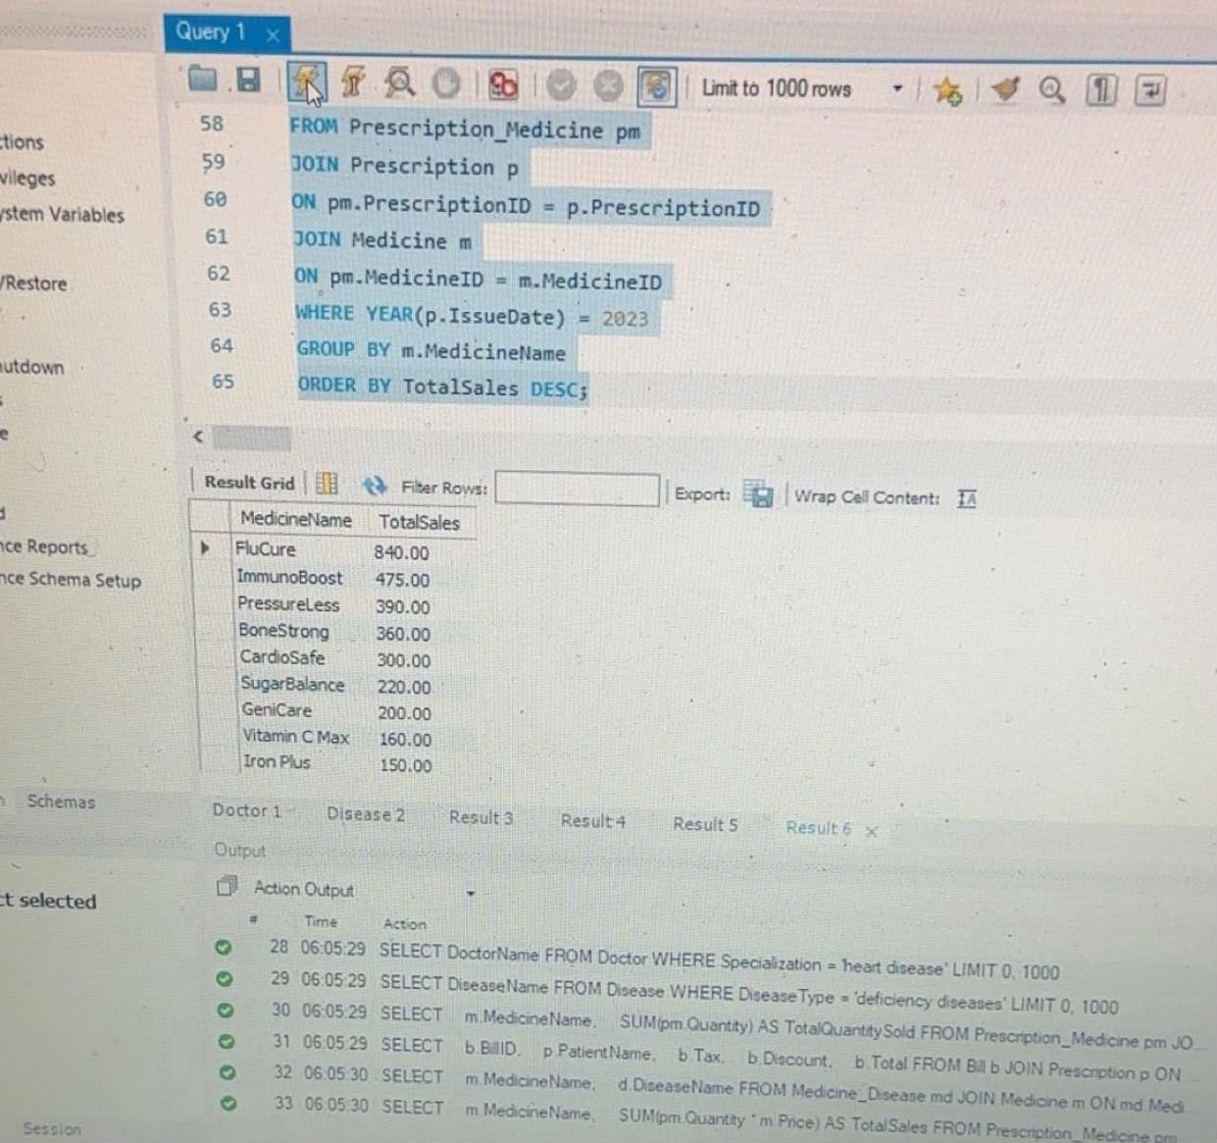
- DDL and DML
Insert into Doctor
INSERT INTO Doctor
(DoctorID, DoctorName, Qualification, Specialization)
VALUES
(1, 'Ahmed Samir', 'MBBS', 'heart disease'),
(2, 'Mona Adel', 'MD', 'nutrition'),
(3, 'Karim Tarek', 'PhD', 'infectious diseases'),
(4, 'Nourhan Ali', 'MD', 'genetics'),
(5, 'Youssef Salah', 'MBBS', 'internal medicine'),
(6, 'Sara Hassan', 'MD', 'heart disease'),
(7, 'Omar Fathy', 'PhD', 'hematology'),
(8, 'Mai Nabil', 'MBBS', 'immunology'),
(9, 'Hana Mostafa', 'MD', 'pediatrics'),
(10, 'Khaled Anwar', 'MD', 'gastroenterology');

Insert into Disease
INSERT INTO Disease
(DiseaseID, DiseaseName, DiseaseType)
VALUES
(1, 'Anemia', 'deficiency diseases'),
(2, 'Scurvy', 'deficiency diseases'),
(3, 'Influenza', 'infectious diseases'),
(4, 'Tuberculosis', 'infectious diseases'),
(5, 'Hemophilia', 'genetic hereditary diseases'),
(6, 'Color Blindness', 'genetic hereditary diseases'),
(7, 'Hypertension History', 'non-genetic hereditary diseases'),
(8, 'Diabetes Tendency', 'non-genetic hereditary diseases'),
(9, 'Coronary Disease', 'non-genetic hereditary diseases'),
(10, 'Rickets', 'deficiency diseases');
Insert into Medicine
INSERT INTO Medicine
(MedicineID, MedicineName,
ManufactureDate, ExpiryDate,
Price, Dosage)
VALUES
(101, 'Iron Plus', '2023-01-10', '2027-01-10', 50.00, '1 tablet daily'),
(102, 'Vitamin C Max', '2023-03-15', '2026-03-15', 40.00, '1 tablet twice daily'),
(103, 'FluCure', '2022-11-01', '2025-11-01', 70.00, '10 ml syrup twice daily'),
(104, 'TB Shield', '2022-05-20', '2026-05-20', 120.00, '1 capsule daily'),
(105, 'CardioSafe', '2023-02-18', '2027-02-18', 150.00, '1 tablet daily'),
(106, 'GeniCare', '2023-06-10', '2027-06-10', 200.00, '1 tablet every 12 hours'),
(107, 'SugarBalance', '2023-04-14', '2026-04-14', 110.00, '1 tablet before meal'),
(108, 'BoneStrong', '2023-07-01', '2026-07-01', 60.00, '1 tablet daily'),
(109, 'ImmunoBoost', '2023-08-11', '2026-08-11', 95.00, '1 capsule daily'),
(110, 'PressureLess', '2023-09-05', '2026-09-05', 130.00, '1 tablet daily');
Insert into Medicine_Disease
INSERT INTO Medicine_Disease
(MedicineID, DiseaseID)
VALUES
(101, 1),
(102, 2),
(103, 3),
(104, 4),
(105, 9),
(106, 5),
(106, 6),
(107, 8),
(108, 10),
(110, 7);
Insert into Prescription
INSERT INTO Prescription
(PrescriptionID, DoctorID, IssueDate, PatientName)
VALUES
(201, 1, '2023-01-05', 'Ali Hassan'),
(202, 2, '2023-02-10', 'Mariam Adel'),
(203, 3, '2023-03-15', 'Omar Mostafa'),
(204, 4, '2023-04-20', 'Huda Nabil'),
(205, 5, '2023-05-18', 'Sara Emad'),
(206, 6, '2023-06-25', 'Tamer Samy'),
(207, 7, '2023-07-14', 'Nesma Wael'),
(208, 8, '2023-08-09', 'Hassan Adel'),
(209, 9, '2023-09-03', 'Reem Yasser'),
(210, 10, '2023-10-12', 'Kareem Fathy');
Insert into Prescription_Medicine
INSERT INTO Prescription_Medicine
(PrescriptionID, MedicineID, Quantity)
VALUES
(201, 105, 2),
(201, 110, 1),
(202, 101, 3),
(203, 103, 5),
(203, 109, 2),
(204, 106, 1),
(205, 110, 2),
(206, 102, 4),
(207, 108, 6),
(208, 109, 3),
(209, 107, 2),
(210, 103, 7);
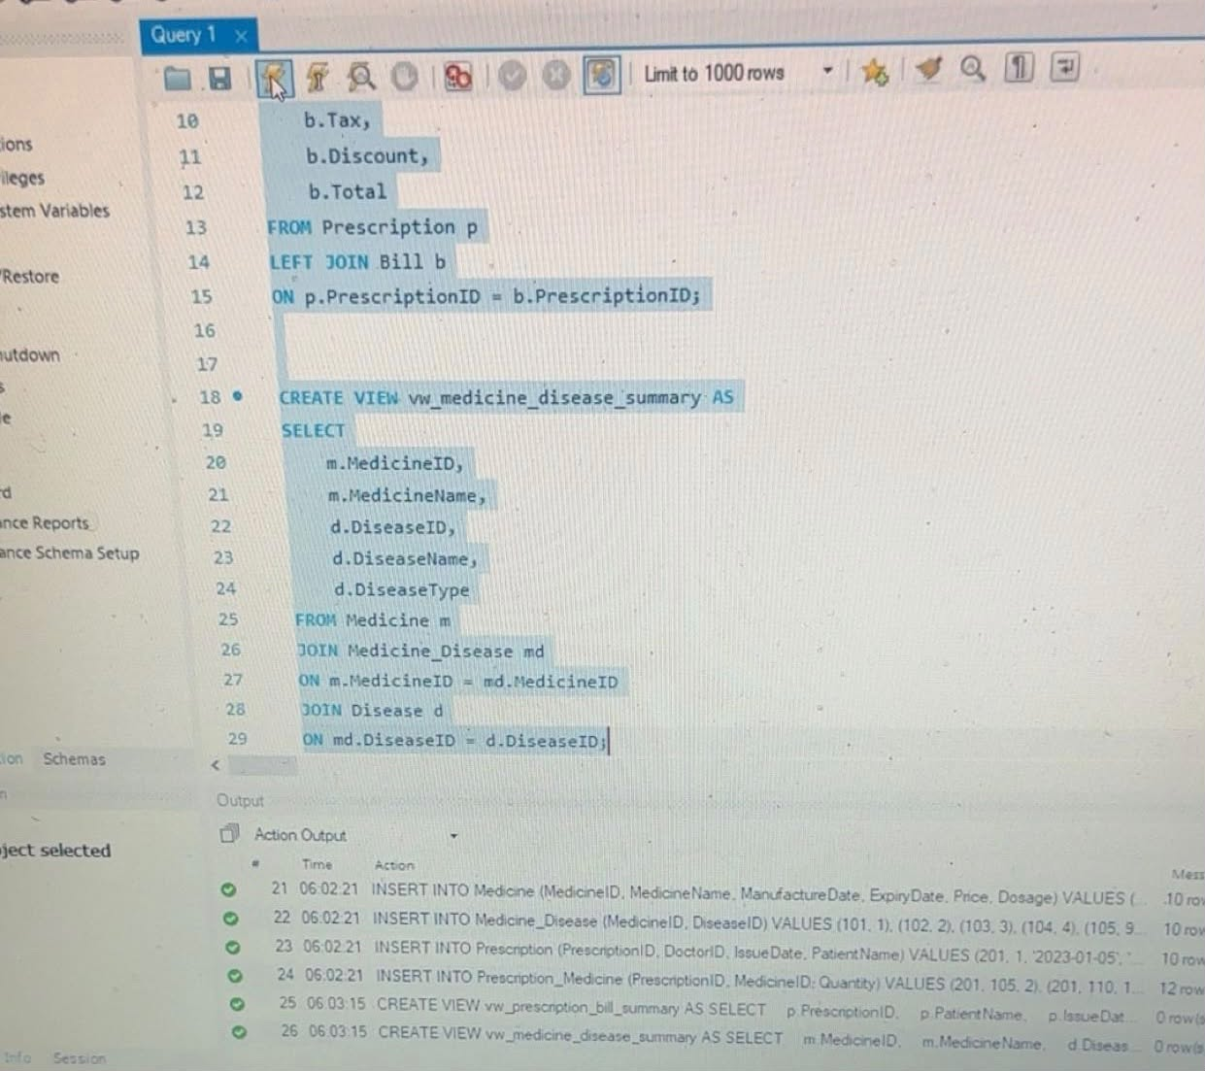
- Triggers
DELIMITER $$
CREATE TRIGGER trg_prescription_medicine_insert
AFTER INSERT ON Prescription_Medicine
FOR EACH ROW
BEGIN
DECLARE subtotal DECIMAL(10,2);
SELECT SUM(m.Price * pm.Quantity)
INTO subtotal
FROM Prescription_Medicine pm
JOIN Medicine m
ON pm.MedicineID = m.MedicineID
WHERE pm.PrescriptionID = NEW.PrescriptionID;
INSERT INTO Bill
(BillID, PrescriptionID, Tax, Discount, Total)
VALUES
(
1000 + NEW.PrescriptionID,
NEW.PrescriptionID,
subtotal * 0.10,
subtotal * 0.05,
subtotal + (subtotal * 0.10) - (subtotal * 0.05)
)
ON DUPLICATE KEY UPDATE
Tax = subtotal * 0.10,
Discount = subtotal * 0.05,
Total = subtotal + (subtotal * 0.10) - (subtotal * 0.05);
END $$
DELIMITER ;
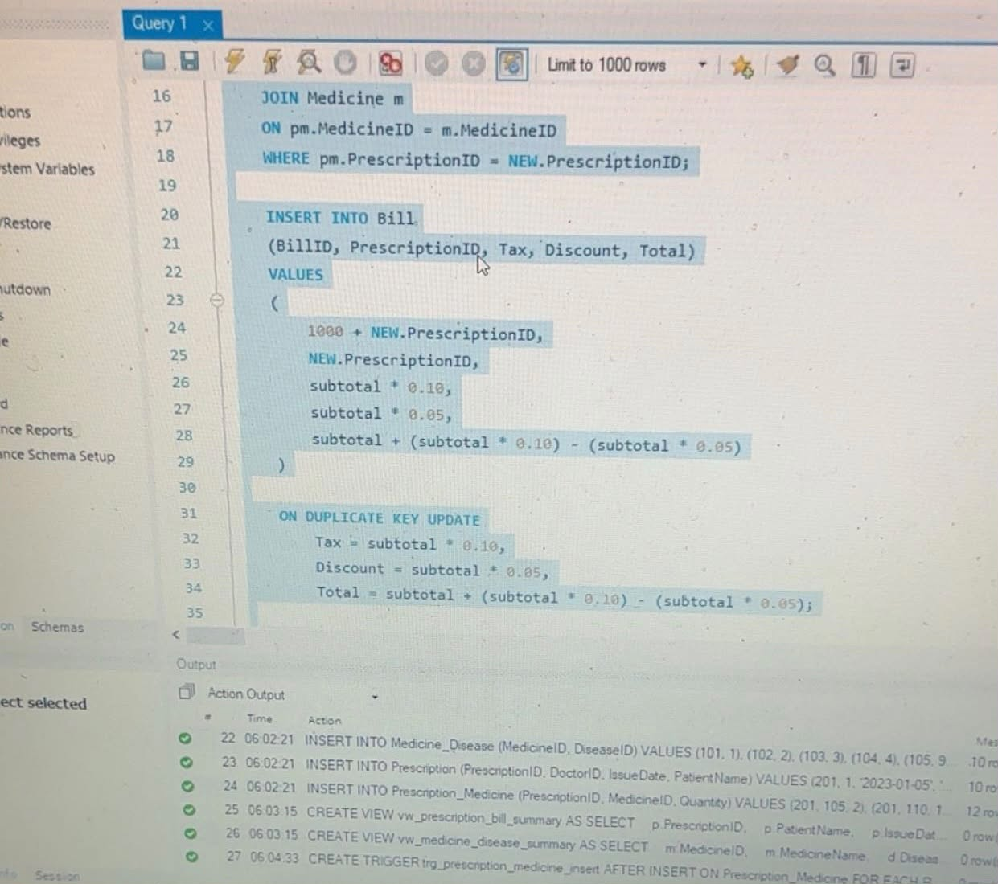
- views
Prescription Bill
CREATE VIEW vw_prescription_bill_summary AS
SELECT
p.PrescriptionID,
p.PatientName,
p.IssueDate,
b.BillID,
b.Tax,
b.Discount,
b.Total
FROM Prescription p
LEFT JOIN Bill b
ON p.PrescriptionID = b.PrescriptionID;
Medicine Disease
CREATE VIEW vw_medicine_disease_summary AS
SELECT
m.MedicineID,
m.MedicineName,
d.DiseaseID,
d.DiseaseName,
d.DiseaseType
FROM Medicine m
JOIN Medicine_Disease md
ON m.MedicineID = md.MedicineID
JOIN Disease d
ON md.DiseaseID = d.DiseaseID;
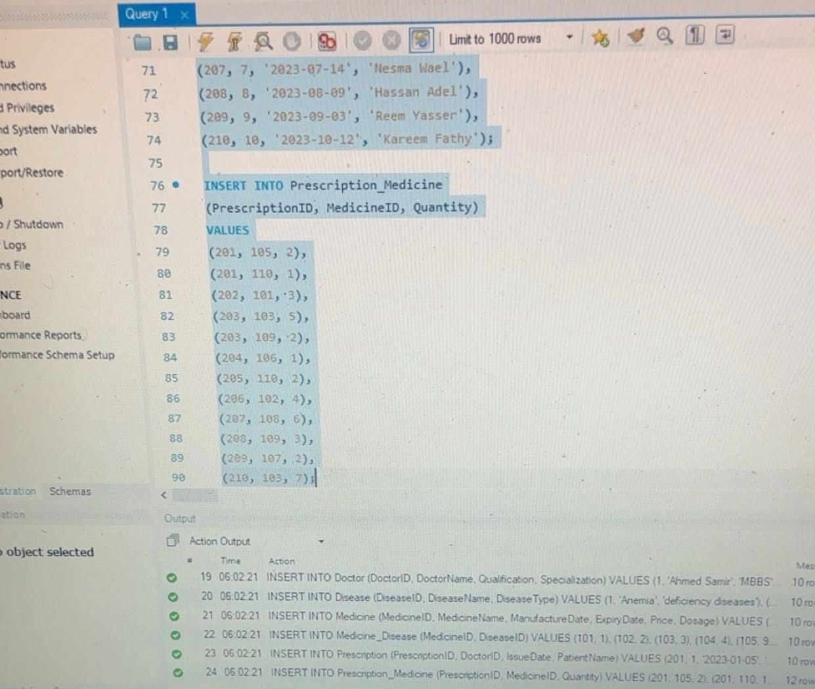
- SQL Queries
Query 1: Doctors Specialized in Heart Disease
SELECT DoctorName
FROM Doctor
WHERE Specialization = 'heart disease';
Query 2: List of Deficiency Diseases
SELECT DiseaseName
FROM Disease
WHERE DiseaseType = 'deficiency diseases';
Query 3: Most Sold Medicine in 2023
SELECT
m.MedicineName,
SUM(pm.Quantity) AS TotalQuantitySold
FROM Prescription_Medicine pm
JOIN Prescription p
ON pm.PrescriptionID = p.PrescriptionID
JOIN Medicine m
ON pm.MedicineID = m.MedicineID
WHERE YEAR(p.IssueDate) = 2023
GROUP BY m.MedicineName
ORDER BY TotalQuantitySold DESC
LIMIT 1;
Query 4: Show All Bills with Patient Names
SELECT
b.BillID,
p.PatientName,
b.Tax,
b.Discount,
b.Total
FROM Bill b
JOIN Prescription p
ON b.PrescriptionID = p.PrescriptionID;
Query 5: Medicines and Their Disease Names
SELECT
m.MedicineName,
d.DiseaseName
FROM Medicine_Disease md
JOIN Medicine m
ON md.MedicineID = m.MedicineID
JOIN Disease d
ON md.DiseaseID = d.DiseaseID;
Query 6: Total Sales per Medicine in 2023
SELECT
m.MedicineName,
SUM(pm.Quantity * m.Price) AS TotalSales
FROM Prescription_Medicine pm
JOIN Prescription p
ON pm.PrescriptionID = p.PrescriptionID
JOIN Medicine m
ON pm.MedicineID = m.MedicineID
WHERE YEAR(p.IssueDate) = 2023
GROUP BY m.MedicineName
ORDER BY TotalSales DESC;
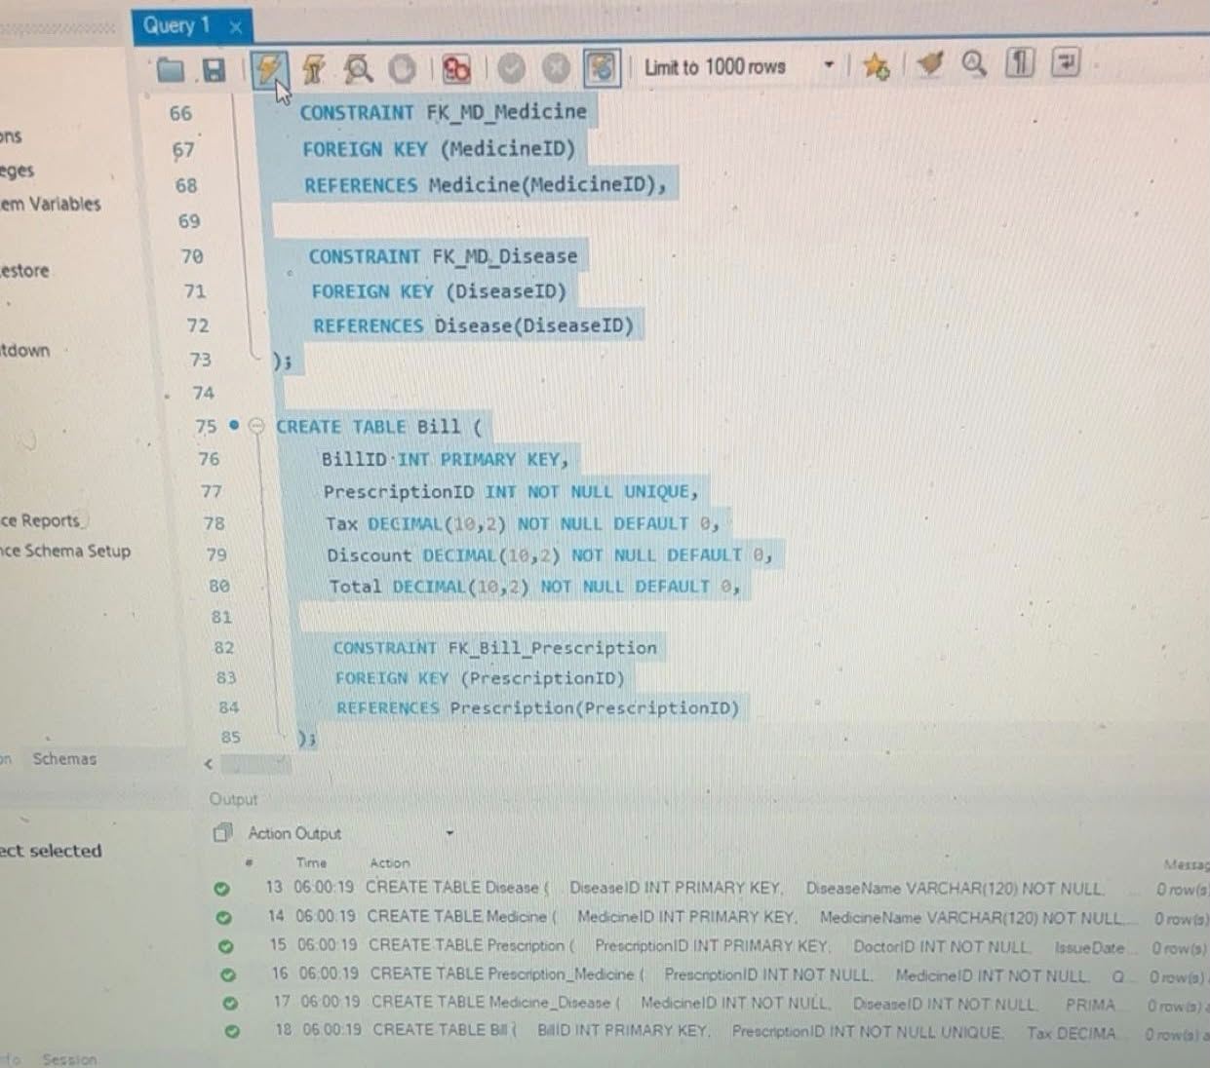
- Design Rationale and Implementation Notes
This database was created to make it easier to keep track of the medicines and maintain proper relationships between doctors, diseases, medicines, and prescriptions.
Intermediate tables like Prescription_Medicine and Medicine_Disease were utilized in case of many-to-many relationships.
Triggers were used to compute taxes, discounts, and total bill amounts on their own during any insertion, update, or deletion of prescription medicines.
Views were created for better readability of queries.

- ER Diagram and Relational Data
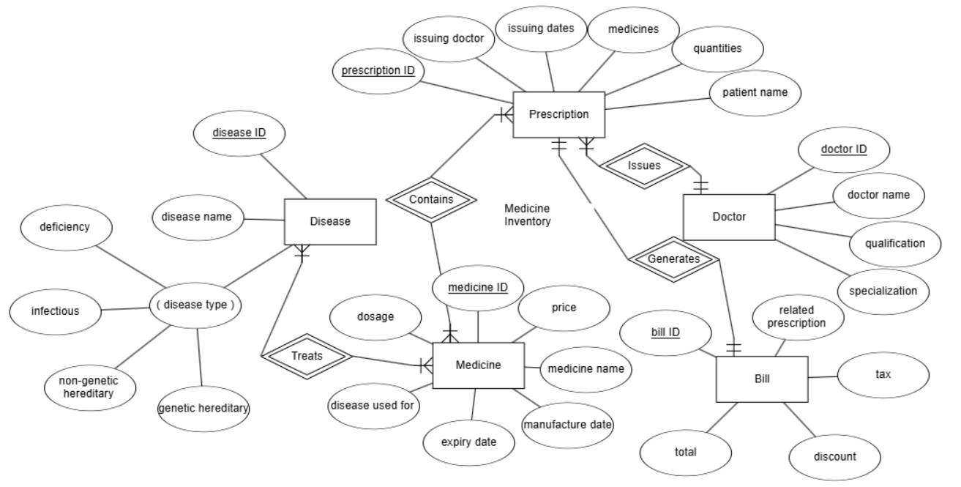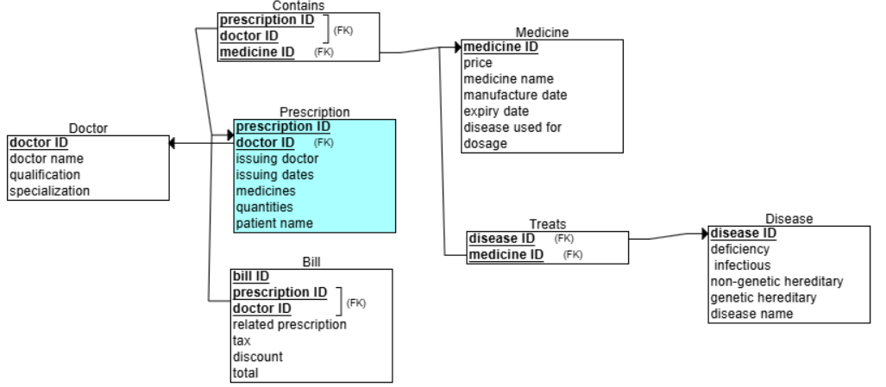
- Conclusion
The project shows the development of a total Medicine Inventory Database Management System using different features of SQL such as tables, relationships, constraints, views, triggers, and queries. This system is designed to facilitate the management of medicines, prescriptions, diseases, and bills.

