Advanced database
Assignment 1: Data Warehouse

ID | Name
20237003 | Jumanah Muhammad
20237015 | Malak Moustafa
20237020 | Basmala Mohsen
20236076 | Laila Mohamed

Database: EPL 21-22 English Premier League

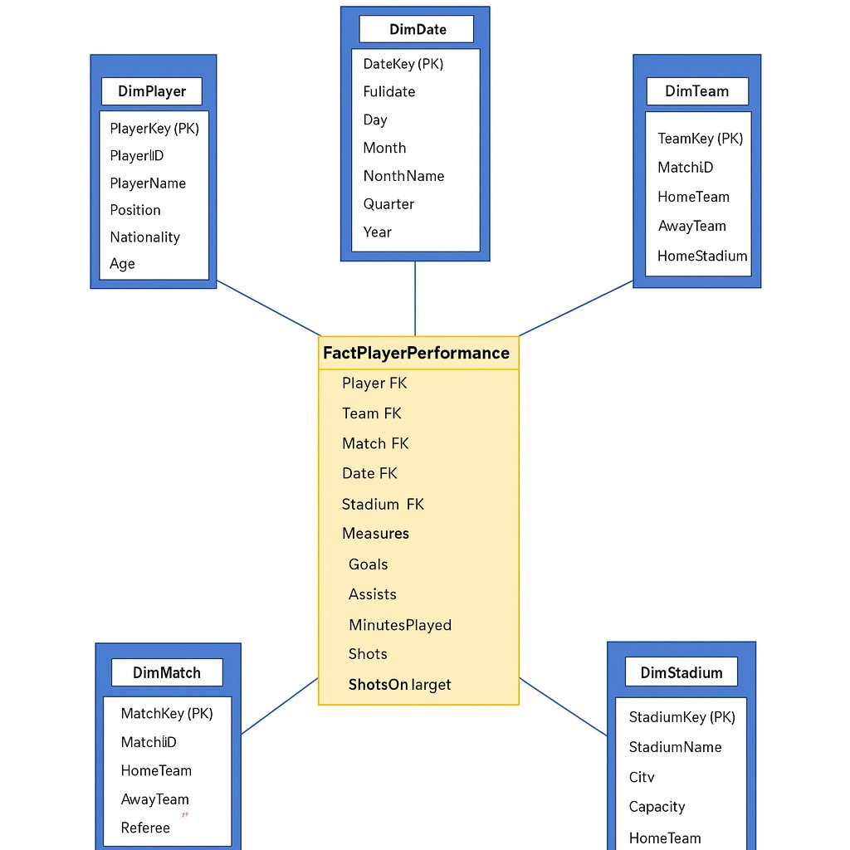

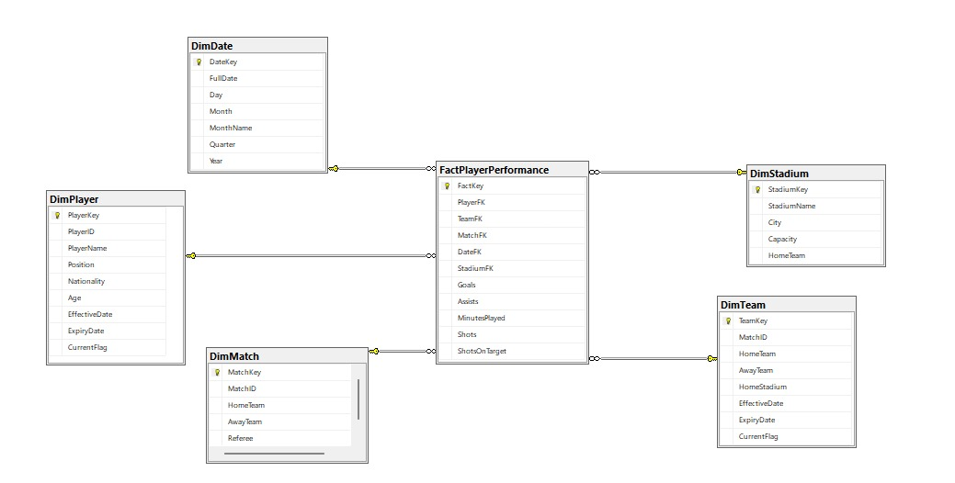

c. Motivation for creating our star schema
We are creating the EPL 2021–2022 star schema to convert the raw CSV files into a structure that supports clear and efficient performance analysis. The original datasets contain match results, player statistics, and team standings, but they are not optimized for complex analytical queries. By transforming this data into a dimensional model, we can easily slice and aggregate performance by team, player, match, and time.
This star schema allows us to answer key analytical questions when dealing with chosen dataset such as :
- Identifying team weaknesses by analyzing goals conceded, goal differences, and disciplinary issues across the season.
- Suggesting players to sell based on low appearances, weak contribution, or poor efficiency.
- Nominating the Player of the Season by aggregating goals, assists, minutes played, and performance consistency.
- Analyze home vs. away performance using stadium data
By adding DimStadium, we can analyze how playing in different stadiums affects performance, helping reveal:
  - Home advantage
  - Stadium-based weaknesses
  - Venue-specific patterns of goals, cards, or losses
Using a central FactPlayerPerformance table supported by DimPlayer, DimTeam, DimMatch, Dimstadium and DimDate, the star schema provides fast reporting , OLAP queries, accurate, and flexible analysis that would be difficult to perform directly on the raw CSV files.

Job
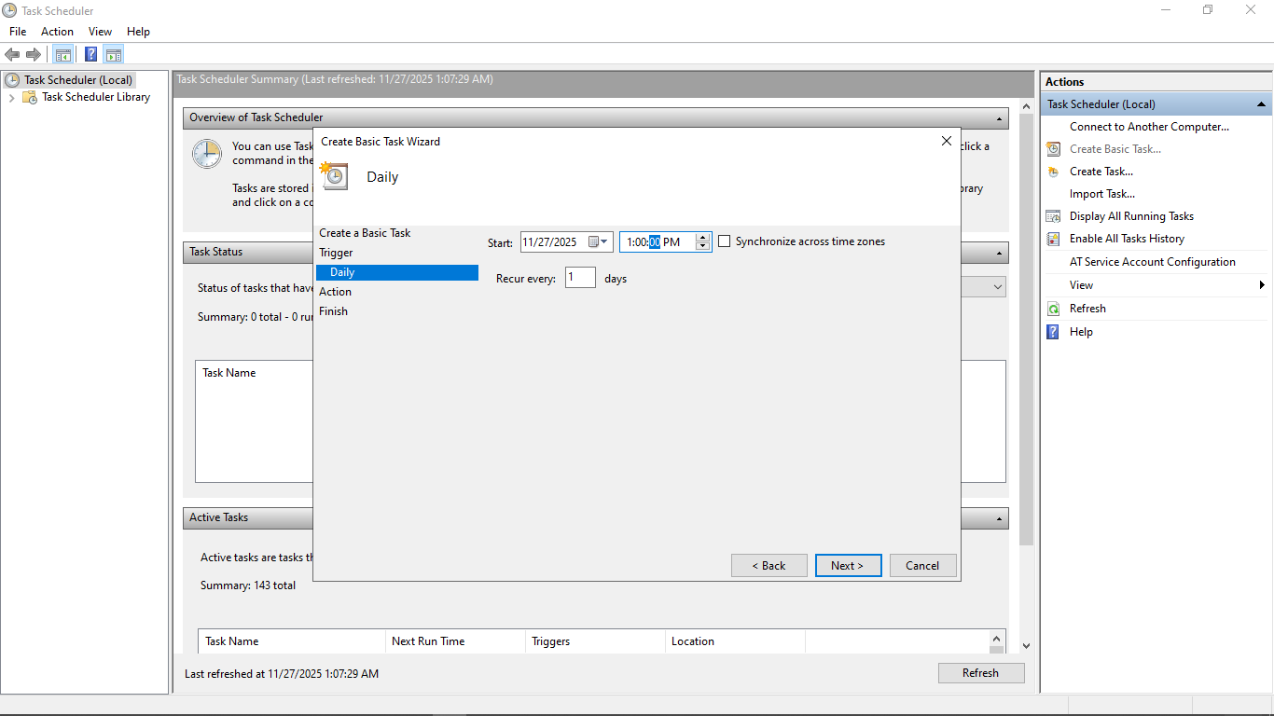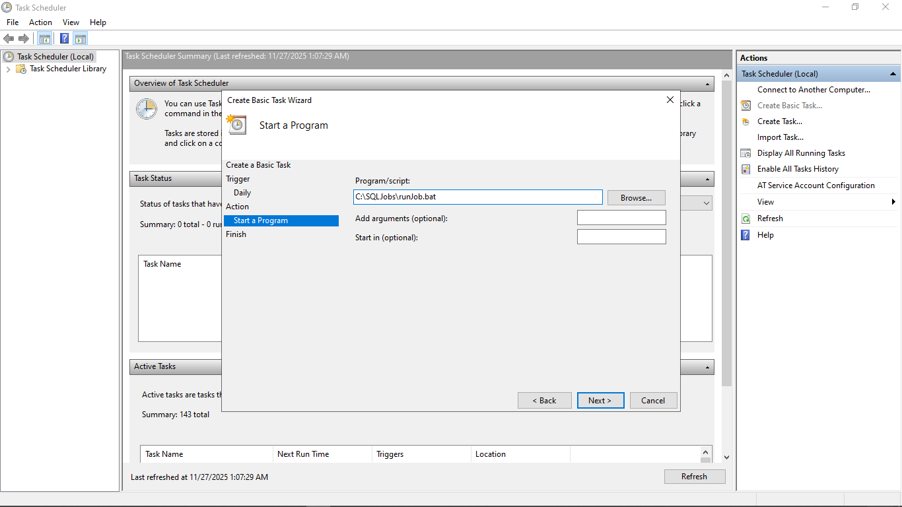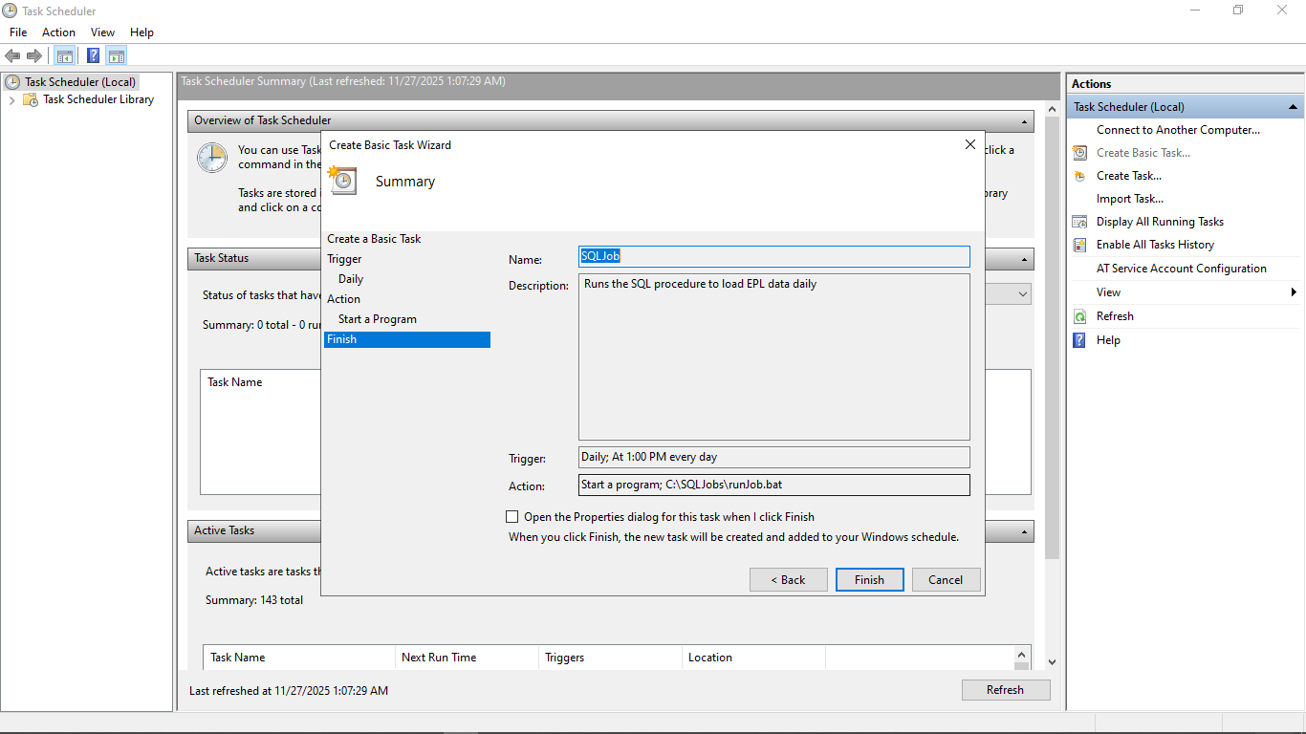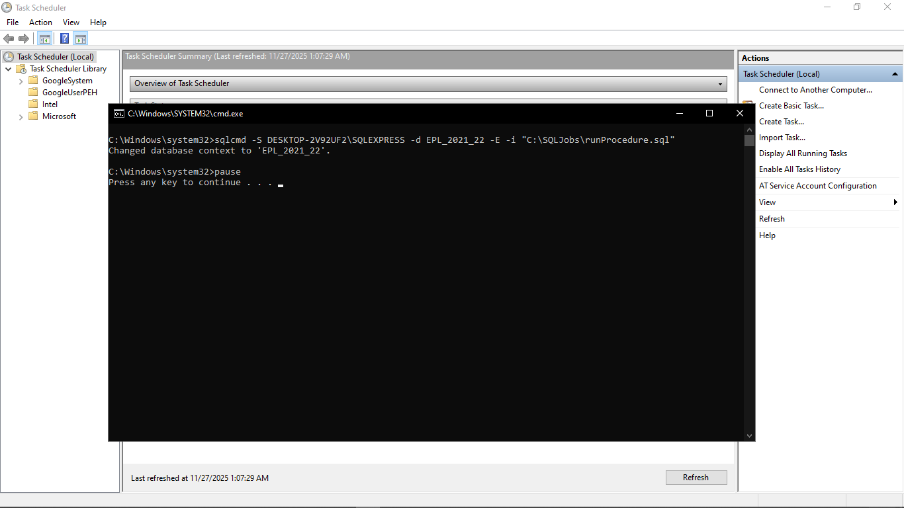

Email
