|  |
| --- |
|  |
| **DropCop** |
|  |
| **Requirements/Analysis Specification** |
| **Version 1.0**  Document Number: RAS-001 |
|  |

|  |
| --- |
|  |

**Project Team Number:** B12

**Project Team Members:**

Pavandip Singh

Justin Opraseuth

Mohammed Alam

**REVIEW AND APPROVALS**

|  |  |  |  |
| --- | --- | --- | --- |
| **Printed Name and Title** | **Function** | **Date** | **Signature** |
| Fred Strauss | Professor | 2/24/2015 | On File |
| Pavandip Singh | Author | 2/24/2015 | On File |
| Mohammed Alam | Author | 2/24/2015 | On File |
| Justin Opraseuth | Author | 2/24/2015 | On File |

**REVISION LEVEL**

|  |  |  |
| --- | --- | --- |
| **Date** | **Revision Number** | **Purpose** |
| February 24, 2014 | Version 1.0 | Initial Release |
|  |  |  |
|  |  |  |
|  |  |  |
|  |  |  |
|  |  |  |
|  |  |  |

**TABLE OF CONTENTS**

**1. INTRODUCTION ............................................................................................................................ 6**

**1.1 PURPOSE ...................................................................................................................................6**

**2. SCOPE ......................................................................................................................................... 6**

**2.1 IDENTIFICATION .........................................................................................................................6**

**2.2 BOUNDS ..................................................................................................................................... 6**

**2.3 OBJECTIVES .............................................................................................................................. 6**

**2.4 SYSTEM OVERVIEW ...................................................................................................................7**

**2.5 DOCUMENT OVERVIEW ..............................................................................................................7**

**3. REFERENCE DOCUMENTS ...........................................................................................................8**

**4. BUSINESS REQUIREMENTS .........................................................................................................8**

**4.1 TECHNOLOGY ............................................................................................................................ 8**

**4.2 ECONOMICS ...............................................................................................................................8**

**4.3 REGULATORY AND LEGAL .........................................................................................................8**

**4.4 MARKET CONSIDERATIONS .......................................................................................................8**

**4.5 RISKS AND ALTERNATIVES ....................................................................................................... 9**

**4.6 HUMAN RESOURCES AND TRAINING ......................................................................................... 9**

**5. DESCRIPTIVE FUNCTIONAL AND NON-FUNCTIONAL REQUIREMENTS …………......................... 9**

**5.1 SYSTEM’S PURPOSE .................................................................................................................9**

**5.2 FUNCTIONAL DESCRIPTIVE DETAILED REQUIREMENTS ...........................................................9**

**5.3 NON-FUNCTIONAL DESCRIPTIVE DETAILED REQUIREMENTS ...................................................9**

**5.4 CONTEXT DIAGRAM ................................................................................................................. 10**

**6. FUNCTIONAL REQUIREMENTS ANALYSIS SPECIFICATION ………..............................................10**

**6.1 SYSTEM CAPABILITY REQUIREMENTS.....................................................................................10**

**6.1.1 Capabilities ........................................................................................................................... 10**

**6.1.2 Use Case Diagrams ............................................................................................................... 11**

**6.1.3 Use Case Descriptions ........................................................................................................... 11**

**6.2 USER INTERFACE REQUIREMENTS ..........................................................................................13**

**6.3 COMPONENT ARCHITECTURE ..................................................................................................13**

**6.3.1 Component Descriptions ....................................................................................................... 13**

**6.3.2 Component Architecture Diagram ......................................................................................... 14**

**6.4 CLASS DIAGRAMS ................................................................................................................... 14**

**6.5 CLASS RELATIONSHIP/INTERACTION DIAGRAMS ................................................................... 15**

**6.6 EVENT SECTION .......................................................................................................................15**

**6.6.1 Event Dictionary .................................................................................................................... 15**

**6.6.2 Event Diagrams ..................................................................................................................... 16**

**6.7 ACTIVITY/STATE (SCENARIO) SECTION (TO BE COMPLETED IN DESIGN) .............................. 16**

**6.7.1 Activity (Scenario) Diagrams ................................................................................................. 16**

**6.7.2 Activity (Scenario) Specification ........................................................................................... 16**

**6.8 SEQUENCE DIAGRAMS .............................................................................................................17**

**6.9 COLLABORATION DIAGRAMS .................................................................................................. 19**

**6.10 DICTIONARIES ........................................................................................................................ 19**

**7. NON-FUNCTIONAL/OPERATIONAL REQUIREMENTS ……............................................................19**

**7.1 SYSTEM EXTERNAL INTERFACE REQUIREMENTS ...................................................................19**

**7.2 SAFETY REQUIREMENTS .........................................................................................................19**

**7.3 SECURITY AND PRIVACY REQUIREMENTS ...............................................................................19**

**7.4 SYSTEM ENVIRONMENT REQUIREMENTS ................................................................................19**

**7.5 COMPUTER RESOURCE REQUIREMENTS .................................................................................20**

**7.5.1 Computer Hardware Requirements ....................................................................................... 20**

**7.5.2 Computer Hardware Resource Requirements ....................................................................... 20**

**7.5.3 Computer Software Requirements ........................................................................................ 20**

**7.5.4 Computer Communications Requirements ............................................................................ 20**

**7.6 SYSTEM QUALITY FACTORS ....................................................................................................20**

**7.7 DESIGN AND CONSTRUCTION CONSTRAINTS .........................................................................20**

**7.8 PERSONNEL-RELATED REQUIREMENTS ..................................................................................20**

**7.9 TRAINING-RELATED REQUIREMENTS .......................................................................................21**

**7.10 LOGISTICS-RELATED REQUIREMENTS ...................................................................................21**

**7.11 PACKAGING REQUIREMENTS .................................................................................................21**

**7.12 PRECEDENCE AND CRITICALITY REQUIREMENTS .................................................................21**

**7.13 OTHER REQUIREMENTS .........................................................................................................21**

**8. SYSTEM TEST PLAN REQUIREMENTS .......................................................................................21**

**9. QUALIFICATION PROVISIONS .................................................................................................... 22**

**10. REQUIREMENTS TRACEABILITY ...............................................................................................22**

**11. RATIONALE .............................................................................................................................. 22**

**12. NOTES ......................................................................................................................................23**

**13. APPENDICES ............................................................................................................................23**

**13.1 DICTIONARIES ........................................................................................................................ 23**

**13.2 UML DIAGRAMS, IF NOT INCLUDED IN THE BODY OF THE DOCUMENT ..................................25**

**13.3 SCHEDULE TRACKING ............................................................................................................25**

**13.4 DEFECT TRACKING .................................................................................................................26**

**13.5 UPDATED GANTT CHART ........................................................................................................28**

**1. INTRODUCTION**

This section introduces Requirements/Analysis Specification (RAS) of the DropCop system to its readers.

**1.1 Purpose**

The purpose of this document is to layout requirements and a foundation for DropCop. We believe our intended audience will include developers, and business analysts who are the middlemen between the developers and clients, and the clients themselves.This document also will be provided to the Software Quality Assurance group. SQA will use this document to examine and test the product through its lifestyle based on given requirements. The Client will make sure that the requirements specified meet their demands. The development team will use the document to actually create the product.

**2. SCOPE**

**2.1 Identification**

To develop an application that will help not only users but vendors get in touch with each other and benefit each other mutually through group savings and sales.

**2.2 Bounds**

The application will be allowing users and vendors to continuously making polls on the items they would like to buy and vendors to post large quantities of items they will be selling. At a first glance, this application will allow users from all over the world to use. Since group discounts comes from how much the vendor would like to decrease his amount will be a heavy bound.

**2.3 Objectives**

DropCop will be an application designed to help navigate users and vendors towards each other. People that are looking for big discounts on things that they would like but can’t afford, and companies that want to sell their inventory. Many people in the world have similar taste in electronics, clothing, and many other things. This will guide the application to connect both the vendors and clients together. People won’t have to spend time looking for cheap stuff when they can check daily on what's available now on DropCop or even make a poll to get an item, getting people together for a group discount. This application is not to just save people money and get vendor’s sales it also helps the economy stabilize more. There will be an equal flow of cash to many vendors instead of just one place, of course depending on what they are selling. This application will be highly based upon user requests and we will add new features that will benefit both parties in an incremental sequence.

**2.4 System Overview**

To begin, this application will not be a stand alone system. There is a need for a working network for the clients. This application will act as an interface that will connect vendors to the clients. A general overview of the system’s functionality in relation to the various other systems is shown in the context diagram.

There will be many factors that affect the functionality of our system. Some of these include:

1. Connection Speed: The connection strength of the user’s device to the internet and to our application’s interface which is updated frequently will affect his ability to see which deals are out now. It will be on a first come, first serve basis.
2. Number of active users: The system will definitely rely heavily on the number of active users to determine how many people want that same item. Polls will be created before any vendor is contacted for group discounts. Thus if we have a low number of active users, people will definitely be missing out on great deals, poll rates will be small which means not getting the best price we can for an item.
3. Vendor precision: We will only allow companies that provide a complete list of certified documents that they are selling authentic items.
4. Device Hardware: Since this system will run on many different devices it is important to have up to date firmware and hardware. If the phone’s hardware is not good, it can cause the application to not run the way it was made to run. It could decrease the performance of the system entirely.

**2.5 Document Overview**

This document is responsible for outlining the various requirements of the application. The various requirements include the business, descriptive nonfunctional, and descriptive functional for the application. It also goes over the requirements in order to test the application as well as say how the document will be reviewed for quality. It goes into detail on how the document itself will evolve throughout the project lifecycle.

**3. REFERENCE DOCUMENTS**

“Project Proposal”, Team A12, DropCop, September 24th , 2013, Version 1

“System Requirements Specifications”, Team A12, DropCop, October 22nd , 2014, Version 2

“System Project Management Plan”, Team A12, DropCop, November 9th, 2014,

Version 1

“System Analysis Specification”, Team A12, DropCop, November 19th, 2014, Version 1

**4. BUSINESS REQUIREMENTS**

**4.1 Technology**

i. Users will need to have an Android or an iOS device to use the application

ii. Improvement in the accuracy of network is required for everyone to have a smooth experience with the interface.

iii. Integration between different smartphones to help make us sure that our application is running smooth with all its functionalities.

**4.2 Economics**

i. As prices rise for most items, more and more people will want to find cheaper products or cheaper deals on products. Vendors will most likely make deals to increase their sales with the laws of supply and demand.

ii. Getting people cheaper substitutes will make the economy more stable.

iii. Less money spent on items, means more purchasing power on other things giving people a better lifestyle.

**4.3 Market Considerations**

i. Which other systems/applications are out they that provide similar service?

ii. How many people own smartphones?(to use the app)

iii. Application might be more helpful in certain areas than others depending neighborhoods. (rich vs poor neighborhoods)

iv. Price of the item people are trying to buy/sell.

**4.5 Risks and Alternatives**

i. Users giving false information about an item. This includes fake vendors who are trying to sell either stolen or fake material. This also includes after making a deal with a vendor for selling at a certain price because we had a specific number of people who wanted that item but still won’t buy it. That would affect the price.

**4.6 Human Resources and Training**

i. Need of someone who tests the user experience of the application daily.

ii. Since everything for the application server has to be written in C/C++, knowledge needed to figure out how application on those languages work.

iii. Need to find how APIs for the Android and iOS platforms work to connect both together on a interface for polls.

**5. DESCRIPTIVE FUNCTIONAL AND NON-FUNCTIONAL REQUIREMENTS**

**5.1 SYSTEM’S PURPOSE**

The purpose of this system to provide a platform for users to share available parking locations in New York City so that those who need to find parking can conveniently do so.

**5.2 FUNCTIONAL DESCRIPTIVE DETAILED REQUIREMENTS**

1. Buy products: allow Users to buy products with simple checkout process.
2. Submit product polls: Users are able submit product polls in order to gather information on products people would like discounted.
3. Submit online deals: Allow users and vendors to submit third party deals that are noteworthy for community benefit. All third party deals go into a separate section to separate direct deals from online third party deals.

**5.3 NON-FUNCTIONAL DESCRIPTIVE DETAILED REQUIREMENTS**

* User’s Device
  + Availability of Networking
    - Networking is required to get in touch with the application and be able to refresh the page for updated deals or polls.
    - Early polls and feedback can greatly affect user base and future success of polls.
  + Operating System on user’s device
    - Our system will have an application for Android and iOS and those are the operating systems the users will need to have to use our system
* Reviews and feedback from users is something that can affect the popularity and use of our application.
* Someone can try to attack or exploit our system, and although we have no control over what others do we can try to make our system as secure as possible.
* Polls can be manipulated by small groups in order to sabotage deals that the general user base may want by creating multiple accounts and voting more than once.

**5.4 CONTEXT DIAGRAM**

DropCop

(vendors being contacted after polls),(delivery to your doorstep)

User

Vendor

Vendor

User

User

**6. FUNCTIONAL REQUIREMENTS ANALYSIS SPECIFICATION**

**6.1 SYSTEM CAPABILITY REQUIREMENTS**

**6.1.1 Capabilities**

**6.1.2 Use Case Diagram**

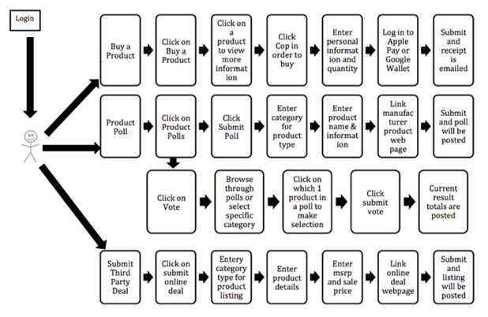

**6.1.3 Use Case Descriptions**

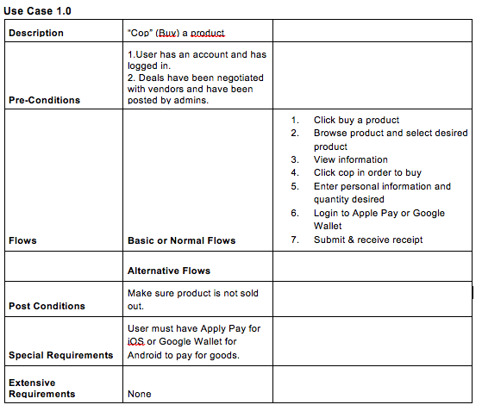

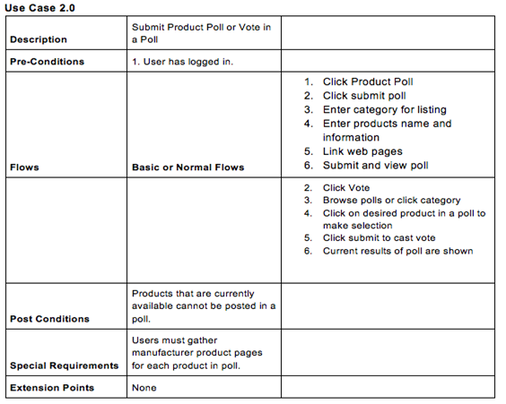

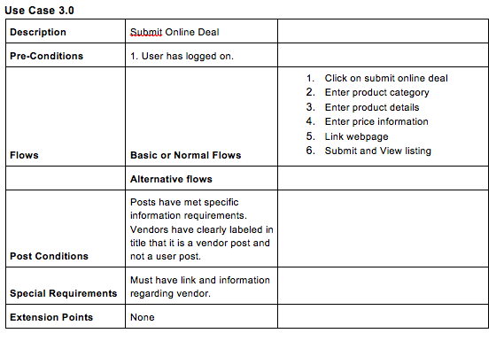

**6.2 USER INTERFACE REQUIREMENTS**

The user interface will use the API’s for Android OS and iOS, respectively. The standard interface will have a login screen and users can click register at the bottom in order to register for the first time. After login, the interface will be simple and minimalistic with three main options. One the second option has a subset of two other options. Once a user clicks an option, the information is displayed. For the first option, to buy a product, product listing are shown and users can click to see more information then buy. For the second option, product polls, the two subset options are to vote or submit poll. The vote option shows polls and users can scroll through, click selection, and submit. The submit poll shows blank categories and user must enter specific information regarding products to be polled. The third option is the submit online deals, which shows category information which user must input along with links. There is a back button on the left hand goes back to the previous page.

**6.3 COMPONENT ARCHITECTURE**

**6.3.1 Component Descriptions**

Login/Logout: A button that allows users to log in to an account, or log out of an account if already logged into one.

ViewCops: A button for viewing all current deals available for purchase

ViewVotes: A button for viewing current deals being voting on and also includes a page to submit a deal

PreferencesButton: A small button which shows the user preferences and the ability to log out

AccountMenu: The menu shown when PreferencesButton is pressed, allowing the user to change info

DropCopServer: The server that stores all account information and stores info about different deals. Order information also stored here.

**6.3.2 Component Architecture Diagram**

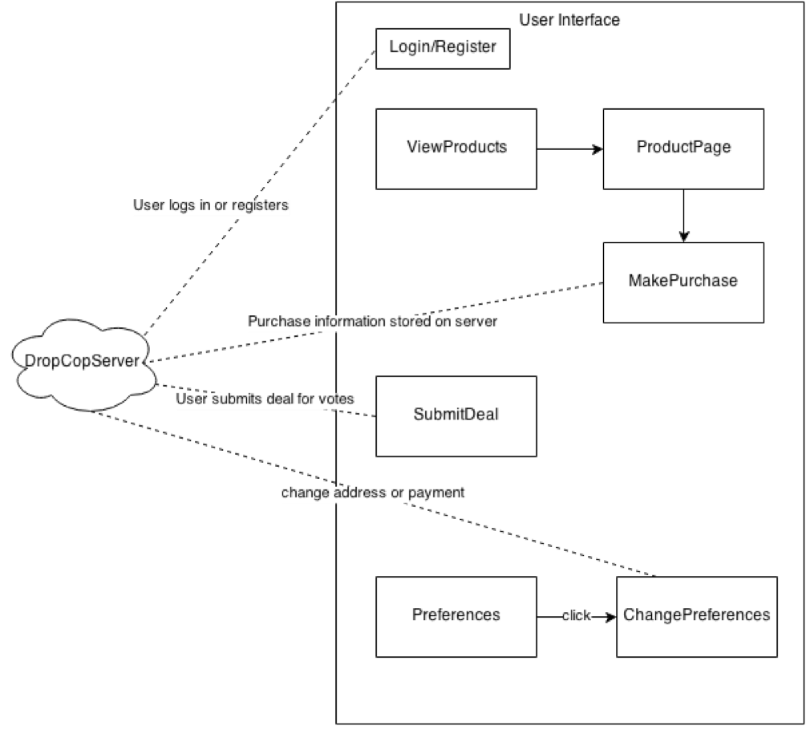

**6.4 CLASS DIAGRAMS**

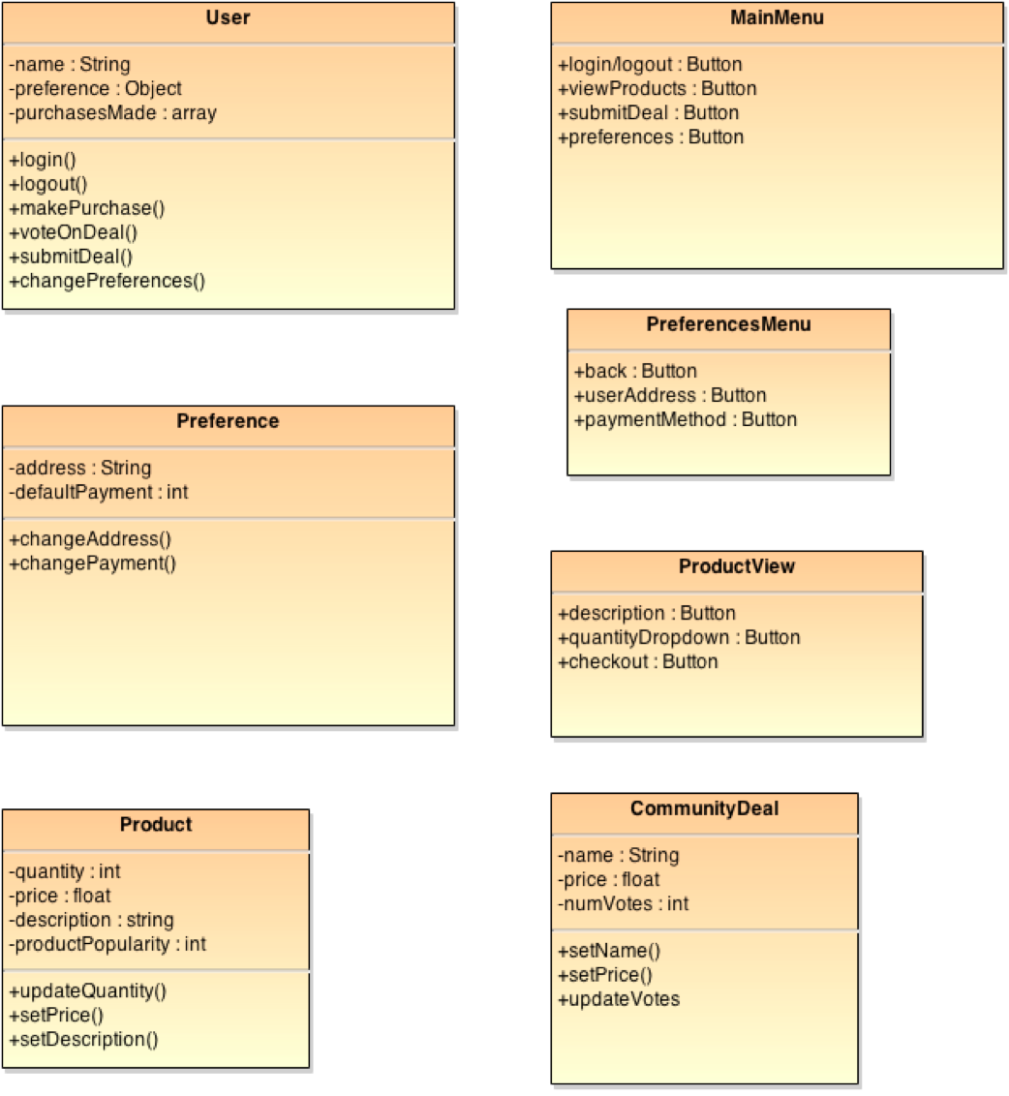

**6.5 CLASS RELATIONSHIP/INTERACTION DIAGRAMS**

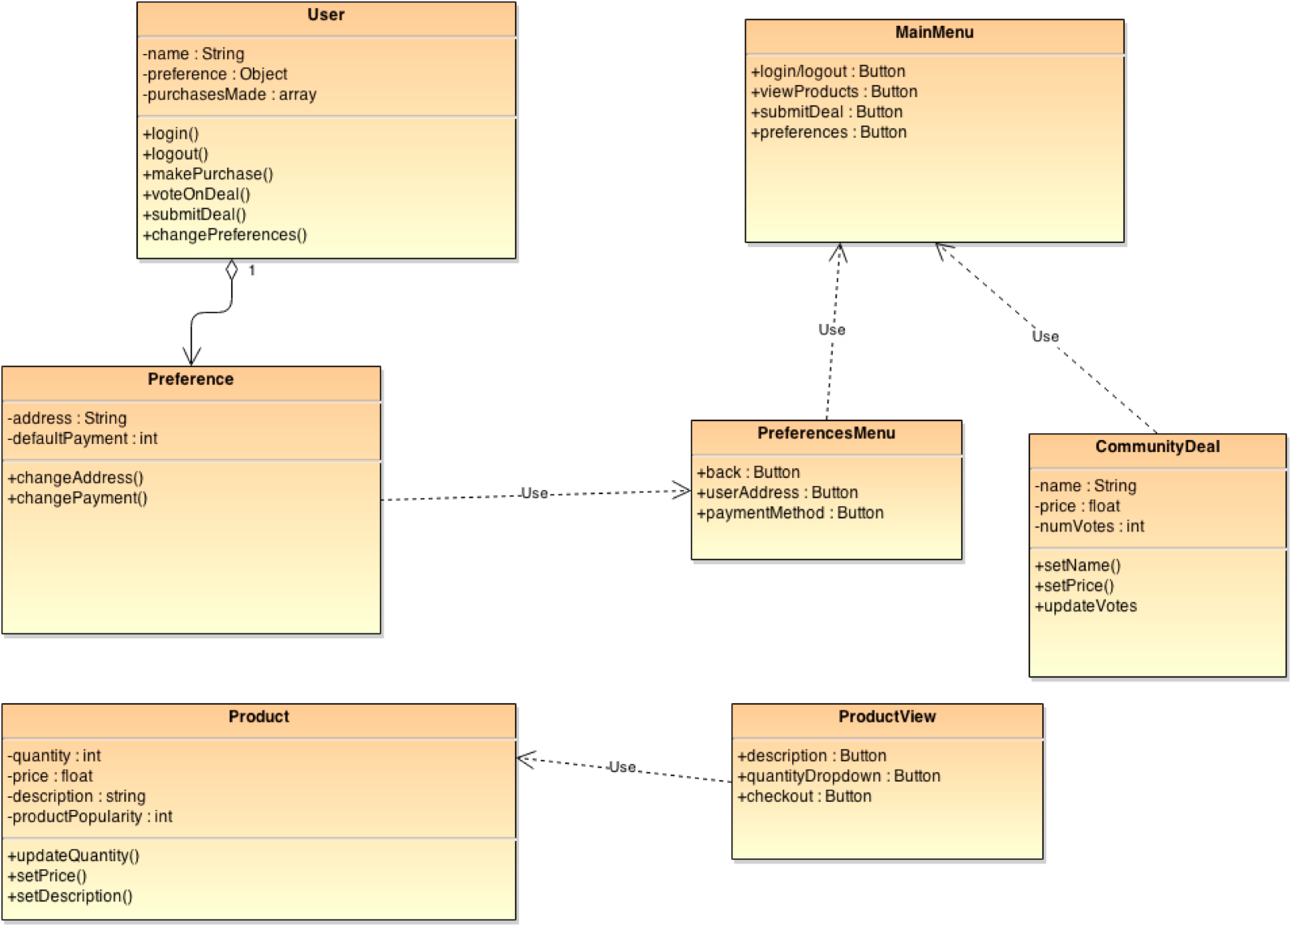

**6.6 Event Section**

**6.6.1 Event Dictionary**

|  |  |
| --- | --- |
| Event | Motive |
| Access Main Menu | Lets user log in or register. Also shows products that may be purchased and allows deal submissions. |
| Login or Register | Authenticate user if account is made already. Or show the registration menu. |
| Change Preferences | Lets user change address or default payment method. |
| View Community Deals | Shows the user deals that are in the voting stage. One can vote or submit deals here. |
| View Products | Shows the user all products available for purchase. |
| Purchase Product | User makes a purchase of desired quantity. |
| Post a new deal | User submits a potential deal for community voting on website. |
| Vote on selected deal | User finds that the deal is good. The vote gauges interest. |

**6.6.2 Event Diagrams**

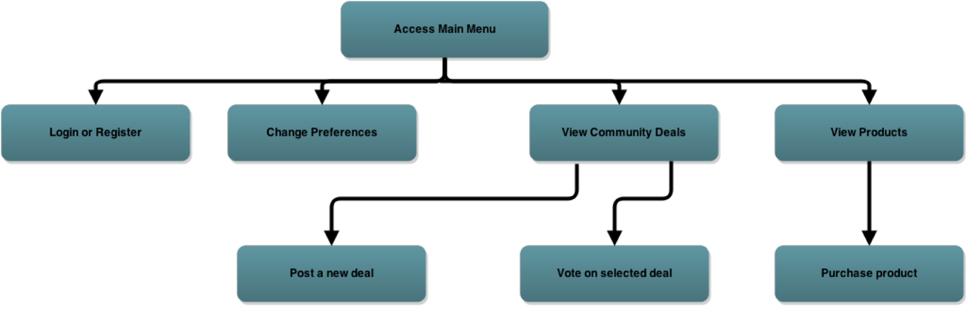

**6.7 Activity/State (Scenario) Section (To be completed in design)**

To be completed in design.

**6.7.1 Activity (Scenario) Diagrams**

To be completed in design.

**6.7.2 Activity (Scenario) Specification**

To be completed in design.

**6.8 Sequence Diagrams**

User Registers and Submits deal

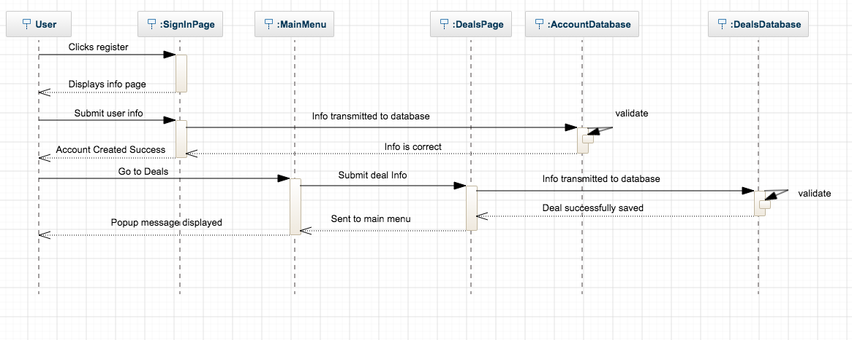

User Votes on Deal

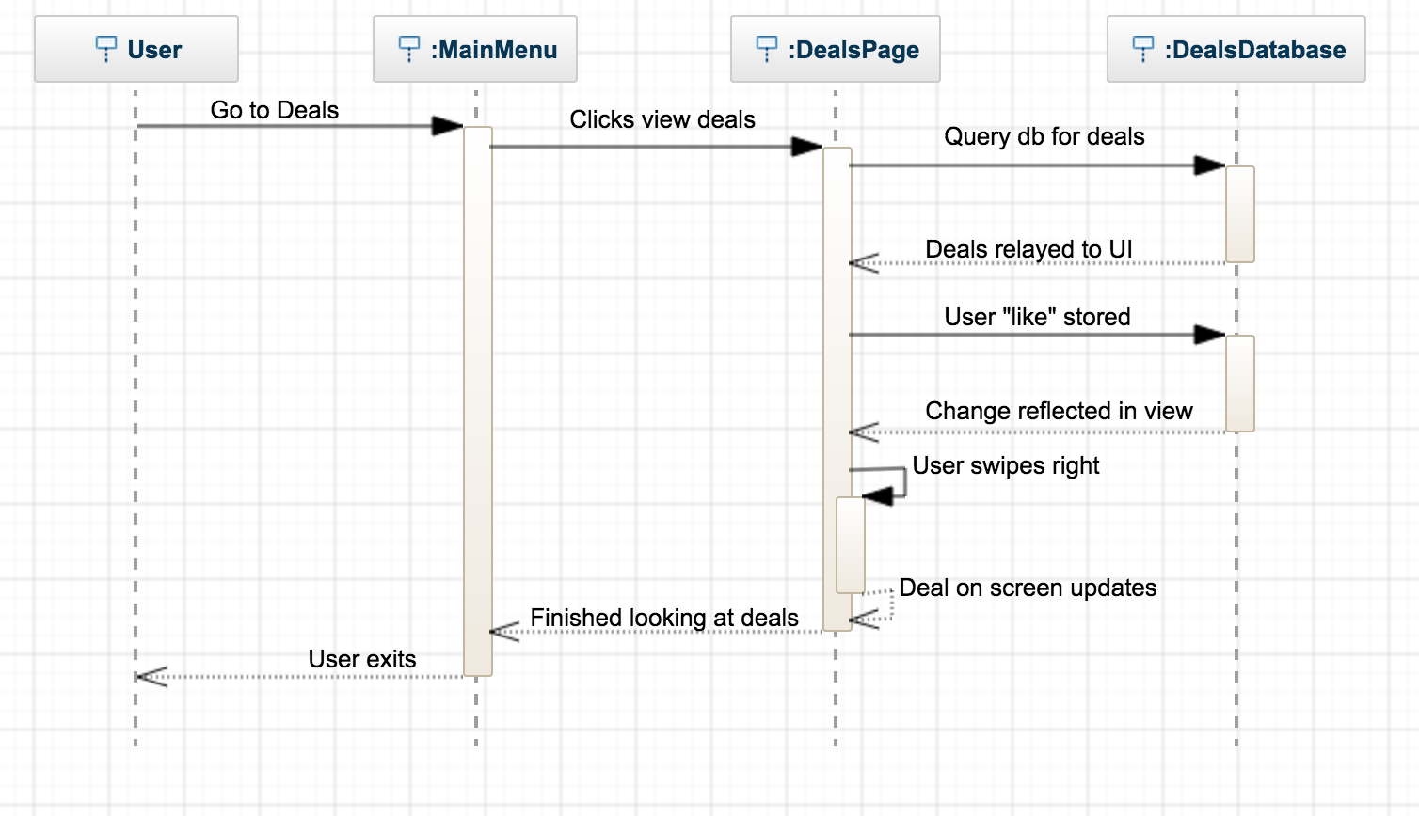

**6.9 Collaboration Diagrams**

To be completed in design.

**6.10 Dictionaries**

Refer to Section 13.1.

**7. NON-FUNCTIONAL/OPERATIONAL REQUIREMENTS**

**7.1 System External Interface Requirements**

The system has to be able to manage the different user inputs. The application will be run on multiple platforms, so the system has to handle communication with different interfaces. It must deal with both iOS and Android devices and manage the user information and application data.

**7.2 Safety Requirements**

Users must be connected to servers in order to vote, buy, or submit. Users will have to enter basic information and verify through email in order to prevent multiple accounts from same user. This helps prevent users from voting more than once. Payments are only accepted through Apple Pay or Google Wallet to ensure security.

**7.3 Security and Privacy Requirements**

The database with user information will be secured with a high level of encryption to prevent user data being exploited. The server itself will also need to be secure to prevent breaches or data being modified. Users cannot see each other nor can they communicate with each other. Everything is done anonymously.

**7.4 System Environment Requirements**

The system will need a network connection in order to operate correctly. If the system does not establish a connection or connection is lost, it will display the login screen. A network connection is necessary to update information and communicate user inputs. This maintains application integrity by syncing information.

**7.5 Computer Resource Requirements**

Note the computer requirements refers to the phone requirements that will be need for the application to run properly.

**7.5.1 Computer Hardware Requirements**

The phone hardware must be capable of handling the supported OS versions. More details will be outline in the design document.

**7.5.2 Computer Hardware Resource Requirements**

The system must be able to use the hardware components on the device such as touch input and network adapter.

**7.5.3 Computer Software Requirements**

The device must be able to run the latest supported versions of the respective operating system. This ensures the application will work the system. The supported versions will be iOS 6 or later and Android 4.0 or later.

**7.5.4 Computer Communications Requirements**

The phone device must have a network connection to communicate with the server.

**7.6 System Quality Factors**

The quality of the system comes down to usage. To be successful, users to be engaged in posting deals, voting in polls, and buying products. The more votes a product gets, the more products we can hopefully bring to the marketplace. The polls submitted must be relevant to the user base; things that interest people. The process of logging in, finding something you want, and checking out should be seamless and quick.

**7.7 Design and Construction Constraints**

Design and Construction Constraints will be set by APIs of iOS and Android.

**7.8 Personnel-Related Requirements**

**■** Google account to access Google Drive

■ Email account and phone number for communication

■ Access to a GitHub account and the GitHub repositories for this project.

■ A laptop capable of running the required software to build this project

**7.9 Training-Related Requirements**

■ Knowledge of the iOS SDK and Android SDK

■ Knowledge of the frameworks and APIs

■ Knowledge of python to script functions

■ Knowledge of programming an application server in C++.

■ Knowledge of databases such as SQL

■ Knowledge of Android OS and iOS to develop the app

**7.10 Logistics-Related Requirements**

**■** The application will need to have a basic guide to show user what is the purpose and capabilities

■ Maintenance and security of the system

**7.11 Packaging Requirements**

Developer licenses will need to be acquired in order to publish the application and get approval from each respective app store. It should be available in both Google’s Play Store and Apple’s App Store.

**7.12 Precedence and Criticality Requirements**

None at this time. N/A

**7.13 Other Requirements**

A lawyer will be required in order to properly abide by commerce laws and deal with any disputes.

**8. SYSTEM TEST PLAN REQUIREMENTS**

The DropCop system has many facets. In order to properly test the functionality of the mobile apps, they must be tested under several circumstances. First, the general case must be tested in which a user on either iOS or Android will browse through and purchase a deal. This will be the most trivial case seeing as to how it is the purpose of the application. There should be no errors within the basic UI of the application. The layout should look the same no matter what the device’s screen resolution is. Also, the robustness/stability of the application server must be tested. Multiple devices will be emulated and the server performance under heavy load will be measured. This will simulate when an extraordinary deal is posted on the site. All transactions should be handled without payment issues. Another scenario will be to make sure that simultaneous orders are handled properly. If an item is about to run out of stock, only one customer should be able to purchase the last item.

**9. QUALIFICATION PROVISIONS**

Two days before each submission date, the document will be reviewed by all three members of the team. The document will be checked for containing all of the proper information. Typos and grammar mistakes are to be avoided to ensure that the purpose of DropCop is conveyed in an easy to read manner. Making sure that everything is in the correct place will also help in case any modifications need to be made in the document. In the future it is likely that a third party will verify that the document is easy to follow.

**10. REQUIREMENTS TRACEABILITY**

1. This section maintains information about the origins of requirements and their traceability both forward and backward. The following is a description of the key requirements and dependencies of DropCop. This section will be used as a reference in case any requirements need to be modified.
2. The software is dependent on the mobile operating systems in use. As of now, the project will be maintained for both iOS and Android. These two variants of the application must be kept up to date with key OS upgrades. DropCop should support any new features that an OS upgrade will bring to the table.
3. The internet connection of mobile devices has a measurable effect on a user’s experience with the application. The application works best with a 4G or WiFi connection. The application’s data transmissions should be kept as small as possible to ensure a good experience with a wide range of devices.
4. As stated previously, Google Wallet and Apple Pay will be the two major payment providers within the application. The cost of these two networks will be monitored and it may be necessary to switch to a lower cost payment processor if market conditions change.
5. The DropCop servers will receive memory dumps from devices whenever the application crashes. The events leading up to application crashes will be recorded in a document. Users may also submit feedback through the application.

**11. RATIONALE**

The application was developed in order to make it possible for a large audience of people to get great deals on items that they want to purchase. By using the economic principle of volume discounts, a large amount of money will be saved and will be kept in consumers’ pockets. It would be great if DropCop is able to convince more consumers to use online shopping. Discounting items further than e-commerce sites such as Amazon and eBay may be the impetus that some consumers may need to purchase items online. The ease of use of the application and also the security provided with the application will draw consumers to purchase items using the complex network of vendors.

The polls of the application will be the social media aspect of the application. People will be able to communicate with each other and see what trends are in the current market. With this data, only the best deals will be provided. The vendors that we work with will also be able to see how their products compare to other options.

The team creators would like it for DropCop to become a household name as large as Amazon or Wal-Mart. DropCop’s network of vendors will be able to penetrate the current online shopping market!

**12. NOTES**

None

**13. APPENDICES**

**13.1 Dictionaries**

|  |  |  |
| --- | --- | --- |
| **Class** | User |  |
| **Parent** | None |  |
|  | **Name** | **Description** |
| **Methods** | login | Log into the DropCop server |
|  | logout | Logs user out from application |
|  | makePurchase | Handles checkout process for user |
|  | voteOnDeal | Lets a user vote on a community deal |
|  | submitDeal | Adds a deal to become available for community voting |
|  | changePreferences | Update database values for user settings |
|  | **Name** | **Description** |
| **Attributes** | name | Full name |
|  | preferences | Object holds user data |
|  | purchasesMade | Shows past orders |

|  |  |  |
| --- | --- | --- |
| **Class** | Product |  |
| **Parent** | None |  |
|  | **Name** | **Description** |
| **Methods** | updateQuantity | Change quantity after purchase or if stock needs to be updated |
|  | setPrice | Change price of the item |
|  | setDescription | Change item description shown on product page |
|  | **Name** | **Description** |
| **Attributes** | quantity | How many units are available |
|  | price | Current price of item |
|  | description | Description of product on site |
|  | productPopularity | Current sales rank on the site |

|  |  |  |
| --- | --- | --- |
| **Class** | CommunityDeal |  |
| **Parent** | None |  |
|  | **Name** | **Description** |
| **Methods** | setName | Updates name of deal |
|  | setPrice | Updates the user submitted price |
|  | updateVotes | Changes how many votes the deal has received |
|  | **Name** | **Description** |
| **Attributes** | name | Name of deal |
|  | price | Price of deal found |
|  | numVotes | Number of votes deal has received |

|  |  |  |
| --- | --- | --- |
| **Class** | Preference |  |
| **Parent** | None |  |
|  | **Name** | **Description** |
| **Methods** | changeAddress | Change address of user |
|  | changePayment | Updates primary payment method |
|  | **Name** | **Description** |
| **Attributes** | address | Address of user |
|  | defaultPayment | Payment method of choice |

|  |  |  |
| --- | --- | --- |
| **Class** | PreferencesMenu |  |
| **Parent** | None |  |
|  | **Name** | **Description** |
| **Methods** |  |  |
|  | **Name** | **Description** |
| **Attributes** | back | Button returns to main menu |
|  | userAddress | Region for user to update address |
|  | paymentMethod | Radio buttons for default payment |

|  |  |  |
| --- | --- | --- |
| **Class** | MainMenu |  |
| **Parent** | None |  |
|  | **Name** | **Description** |
| **Methods** |  |  |
|  | **Name** | **Description** |
| **Attributes** | login/logout | Button allows user to login/logout |
|  | viewProducts | Button shows list of available products |
|  | submitDeal | Button for pop-up interface so user can enter deal |
|  | preferences | Button to access user preferences |

|  |  |  |
| --- | --- | --- |
| **Class** | ProductView |  |
| **Parent** | None |  |
|  | **Name** | **Description** |
| **Methods** |  |  |
|  | **Name** | **Description** |
| **Attributes** | description | Shows product name |
|  | quantityDropdown | Changes amount of product one wants to buy |
|  | checkout | Button starts checkout process pop up window |

**13.2 UML Diagrams**

Not Applicable as they are included in sections 6.1.2 and 6.1.3 of this document.

**13.3 Schedule Tracking**

|  |  |  |  |  |
| --- | --- | --- | --- | --- |
| **Artifact or**  **Deliverable** | **Who (individual**  **or Team)** | **Estimated** | **Actual** | **Difference** |
| RAS | Pavandip Singh | 1 hours | 1 ½ hours | ½ hours |
| RAS | Justin Opraseuth | 2 hours | 1 ½ hours | -½ hours |
| RAS | Mohammed Alam | 1 ½ hours | 1 ½ hours | 0 hours |
|  | Total | 4 ½ | 4 ½ | 0 |

**Cumulative**

|  |  |  |  |
| --- | --- | --- | --- |
| **Who (individual**  **or Team)** | **Estimated** | **Actual** | **Difference** |
| Pavandip Singh | 1 hours | 1 ½ hours | ½ hours |
| Justin Opraseuth | 2 hours | 1 ½ hours | -½ hours |
| Mohammed Alam | 1 ½ hours | 1 ½ hours | 0 hours |
| Total | 4 ½ | 4 ½ | 0 |

**13.4 Defect Tracking**

|  |  |  |  |  |
| --- | --- | --- | --- | --- |
| **Artifact or**  **Deliverable** | **Who (individual**  **or Team)** | **Estimated** | **Actual** | **Difference** |
| RAS | Pavandip Singh | 9 | 14 | 5 |
| RAS | Justin Opraseuth | 8 | 10 | 2 |
| RAS | Mohammed Alam | 10 | 11 | 1 |
|  | Total | 27 | 35 | 8 |

**Cumulative**

|  |  |  |  |
| --- | --- | --- | --- |
| **Who (individual**  **or Team)** | **Estimated** | **Actual** | **Difference** |
| Pavandip Singh | 9 | 14 | 5 |
| Justin Opraseuth | 8 | 10 | 2 |
| Mohammed Alam | 10 | 11 | 1 |
| Total | 27 | 35 | 8 |

**13.5 Updated Gantt Chart**