
A RESEARCH PROPOSAL ON
DESIGNING AND DEVELOPING A SMART DISPATCH AND TRUST-VERIFICATION PLATFORM FOR ON-DEMAND SKILLED TECHNICIANS IN ZAMBIA
Candidate: Arnold Malama
Student ID: 2420996
Programme: Diploma In Information Technology
Supervisor:

A proposal submitted in partial fulfilment of the requirements for the award of
Diploma In Information Technology
September 2026

DECLARATION
I, Arnold Malama, declare that this research project report is my own original work and has not been submitted, in whole or in part, for any other academic award at this or any other institution, except where due acknowledgement has been made in the text.

Signature: __________________________
Date: __________________________

ACKNOWLEDGEMENT
I would like to express my sincere gratitude to my supervisor, Mr. Nkole Ndanji, for the guidance and support extended throughout the course of this project. I also thank the staff and management of Zambia University College of Technology, the technicians and consumers who participated in the interviews and questionnaires, and my family and friends for their continued encouragement.

ABSTRACT
Finding skilled technicians in Zambia is often fragmented, with consumers relying on referrals, Facebook and WhatsApp groups. This makes it difficult to assess technicians’ skills, availability, location and trustworthiness. This study focused on developing Umodzi Connect, a smart dispatch and trust-verification platform that connects consumers with skilled technicians in selected urban areas of Zambia.
The platform is designed as a low-data, mobile-first system incorporating technician profiles, verification, ratings, reviews, geolocation matching, AI-assisted fault classification and automated dispatch. An Agile methodology was used, supported by questionnaires, discussions and observation. A pilot study involving 18 respondents, consisting of 7 technicians and 11 consumers, informed the system requirements. The proposed system uses Next.js, Fastify TypeScript, PostgreSQL and PostGIS.
The findings showed that 72.7% of consumers used Facebook or WhatsApp groups to find technicians, while most participants reported low weekly mobile-data expenditure. Proximity, ratings, reviews, response time and identity verification were also identified as important trust and matching factors.
The study concludes that Umodzi Connect provides a structured approach to technician discovery and matching through trust verification, geolocation, AI-assisted classification and smart dispatch. Further testing is recommended to evaluate its accuracy, fairness, usability and effectiveness.
Keywords: Umodzi Connect, smart dispatch, technician matching, trust verification, geolocation, artificial intelligence, Zambia.

TABLE OF CONTENTS
Contents
DECLARATION 1
ACKNOWLEDGEMENT 2
ABSTRACT 3
TABLE OF CONTENTS 4
CHAPTER ONE: INTRODUCTION 7
1.1 Introduction 7
1.2 Problem Statement 7
1.3 Objectives 8
1.3.1 General Objective 8
1.3.2 Specific Objectives 8
1.4 Research Questions 9
1.5 Scope and Limitation 9
1.5.1 Scope of the Study 9
1.5.2 Limitations of the Study 9
1.6 Significance of the Study 10
1.6.1 Practical Significance 10
1.6.2 Economic Significance 11
1.6.3 Academic Significance 11
1.6.4 Policy and Industry Significance 11
1.6.5 Sustainability Significance 11
1.7 Conceptual Framework 11
Technician Input 11
Consumer Request Input 11
Intelligence Layer 11
Dispatch Engine 12
Outputs 12
Expected Outcomes 12
1.8 Organization of the Report 13
1.9 Summary 14
2.1 Introduction 15
2.2 Related Works 15
2.2.1 Digital Service Marketplaces 15
2.2.2 Trust and Verification 15
2.2.3 Geolocation-Based Matching 16
2.2.4 Low-Data Mobile Design 16
2.2.5 AI-Assisted Fault Classification 16
2.2.6 Informal Technical Services 17
2.2.7 Electronics and ICT Services 17
2.3 Review of Related Works 17
2.4 Proposed System 18
2.5 Summary 19
CHAPTER THREE: RESEARCH METHODOLOGY 20
3.1 Introduction 20
3.2 Software Development Methodology 20
3.3 Requirements Specification 20
3.3.1 Stakeholders 20
3.3.2 Requirements Gathering 21
3.3.3 Requirements Analysis 21
3.3.4 Pilot Survey Findings Used for Requirements 23
3.4 Summary 24
CHAPTER FOUR: SYSTEM DESIGN AND IMPLEMENTATION 25
4.1 Introduction 25
4.2 Architectural Design 25
4.3 Software Design 26
4.3.1 Software Design Tools 26
4.3.2 Component Design 26
4.3.3 Database Design 33
4.4 Software Development 34
4.4.1 Software Development Tools 34
4.4.2 Component Development 35
4.4.3 Evaluation and Testing Techniques 36
4.5 Deployment 37
4.6 Summary 37
CHAPTER FIVE: RESULTS AND DISCUSSION 38
5.1 Introduction 38
5.2 Results 38
5.2.1 Participant Results 38
5.2.2 Technician Survey Results 38
5.2.3 Customer Survey Results 40
5.2.4 Summary of Pilot Findings 42
5.2.5 Functional Testing Results 42
5.2.6 AI Classification Results 43
5.2.7 Dispatch, Usability and Security Results 43
5.2.8 Predictive Analysis 44
5.3 Discussion 45
5.4 Summary 45
CHAPTER SIX: CONCLUSION AND RECOMMENDATIONS 46
6.1 Introduction 46
6.2 Conclusion 46
6.3 Recommendations 46
Expand Technician Verification 46
Integrate Mobile Money 46
Add Local-Language Support 47
Introduce USSD 47
Develop a WhatsApp Channel 47
Introduce Business Accounts 47
Improve Dispatch Fairness 47
Strengthen Data Protection 47
Establish a Controlled Pilot 47
Establish a Sustainable Business Model 47
6.3.1 Future Research and Evaluation 47
6.4 Summary 48
REFERENCES 49

CHAPTER ONE: INTRODUCTION

1.1 Introduction
Digital technology is increasingly influencing how individuals, households and businesses access goods and services. Digital platforms can reduce search costs by bringing service providers and consumers together through online profiles, search tools, location services and communication features.
In Zambia, digital transformation has been identified as an important component of economic development. The World Bank identifies digital infrastructure, digital skills, digital entrepreneurship, digital platforms and digital financial services as important foundations for digital economic transformation in Zambia (World Bank, 2020a). The country has also continued to develop its information and communications technology sector, as reflected in reports published by the Zambia Information and Communications Technology Authority (ZICTA, 2025).
Despite these developments, many consumers still depend on word-of-mouth referrals, personal contacts, Facebook groups and WhatsApp groups when searching for skilled technicians. This is especially common for services such as plumbing, electrical work, automotive repair, appliance repair, electronics repair and ICT support.
The current process is fragmented because information about technician skills, location, availability, previous work and trustworthiness is not usually provided in one structured platform. Technicians may also lose business opportunities because potential customers are unable to discover them easily.
Umodzi Connect is proposed as a smart dispatch and trust-verification platform for connecting consumers with skilled technicians in Zambia. It combines technician profiles, verification information, reviews, geolocation, AI-assisted fault classification and automated dispatch. The system is designed to be mobile-first and low-data so that it can support users with basic or mid-range smartphones and limited mobile-data budgets.

1.2 Problem Statement
In urban Zambia, households and small businesses may experience delays when essential systems fail because there is no centralized and trusted platform for finding available local technicians. Consumers commonly rely on word-of-mouth referrals and scattered social-media posts. This creates information asymmetry because consumers may not know whether a technician is qualified, available, nearby, reliable or experienced in the required type of work.
The existing process also creates difficulties for technicians. A skilled technician may have the necessary practical ability but limited digital visibility. The technician may receive fewer opportunities because services are known only within a small personal network.
Consumers may also need to contact several technicians before finding one who is available. In emergency situations, this delay can result in inconvenience, financial loss or prolonged downtime.
Electronics and ICT technicians face similar challenges. A consumer who requires computer repair, network installation, television repair, satellite installation, mobile-device repair or troubleshooting may not know which technician has the necessary skills.
Umodzi Connect addresses this problem by providing a structured platform where technicians can create profiles, list their skills, indicate service areas and availability, and submit verification information. Consumers can describe faults using ordinary language, receive an AI-assisted category suggestion, provide a location and be matched with an appropriate technician.
The system uses filtering, scoring and cascading dispatch. This means that technicians are first filtered according to eligibility, then ranked according to matching factors, and finally contacted in sequence until one accepts the request.

1.3 Objectives

1.3.1 General Objective
To design and develop a low-data smart dispatch and trust-verification platform that connects consumers with skilled technicians in selected urban areas of Zambia.

Specific Objectives
1.To design and develop an interactive mobile and web application optimized for Zambian connectivity and device constraints.
2.To integrate a community-led vetting, rating and review mechanism to improve trust and professional accountability.
3.To incorporate geolocation services to enable the discovery and matching of technicians according to skill category and location.
4.To design and implement a multi-factor dispatch algorithm that matches service requests with suitable technicians using proximity, skill relevance, availability and trust information.

1.4 Research Questions
- How can a mobile and web platform be designed to connect skilled technicians with consumers in Zambian cities?
- What verification and community-rating mechanisms are required to improve trust and safety in informal technical service delivery?
- How can a multi-factor dispatch algorithm automatically assign service requests to suitable available technicians?
- What requirements do technicians and consumers have concerning mobile-data usage, service discovery, location, trust and language?

1.5 Scope and Limitation

1.5.1 Scope of the Study
- Geographical scope: Kitwe and Ndola in Zambia.
- Target users: Households, consumers, small and medium-sized enterprises, skilled technicians and administrators.
- Technician categories: Plumbers, electricians, mechanics, HVAC technicians, appliance-repair technicians, electronics technicians, ICT technicians and general handymen.
- Functional scope: Technician registration, profiles, skills, service areas, availability, verification, fault-description intake, AI-assisted classification, geolocation-based search, intelligent dispatch, job-status tracking, ratings, reviews, dispute reporting and administration.
- Technology scope: A mobile-first progressive web application using a Next.js frontend, a Fastify TypeScript backend, PostgreSQL, PostGIS and external notification, mapping and AI services.
- Out of scope: Integrated payment gateways, advanced multi-stop routing, full USSD support and complete WhatsApp-based service requests are outside the initial prototype.

1.5.2 Limitations of the Study
- Geographic generalizability: The initial study focuses on Kitwe and Ndola, and therefore the findings may not fully represent technicians and consumers in rural, peri-urban or other parts of Zambia.
- Time constraint: The project is being conducted within a limited academic project period, which restricts the amount of time available for large-scale field data collection, repeated algorithm tuning and longitudinal evaluation.
- Pilot sample size: The currently available questionnaire dataset contains 18 responses, comprising 7 technicians and 11 consumers.
- Sampling method: The current pilot responses were collected primarily for project requirements and feasibility assessment.
- Self-reported outcomes: Information concerning previous jobs, income, waiting time, satisfaction, data expenditure and disputes was self-reported and may be affected by recall or response bias.
- Geographic concentration: The technician responses were from Ndola, while the customer responses were concentrated in Ndola with one response from Kitwe.
- Budget and infrastructure: The use of development or free-tier hosting and a limited number of test devices may not fully represent system performance under all device, network and server conditions.
- Functional boundaries: The initial prototype does not include integrated payment processing, full USSD support or complete WhatsApp-based service requests.
- Language coverage: The initial AI classification approach is primarily evaluated using English-language fault descriptions.
- Verification limitations: Identity verification and community ratings can reduce information gaps but cannot independently guarantee the technical competence or quality of every technician.
- Long-term economic outcomes: The current pilot does not provide sufficient longitudinal evidence to determine whether Umodzi Connect increases technician income or contract volume.

1.6 Significance of the Study

1.6.1 Practical Significance
The proposed platform may reduce the time consumers spend searching for technicians. It may also help consumers compare technicians using structured information such as skills, location, availability, verification status, completed jobs, reviews and ratings.

1.6.2 Economic Significance
Umodzi Connect may increase the digital visibility of informal technicians and create opportunities to access customers beyond personal networks. However, the study does not claim that the platform will increase income. Such a conclusion would require a longitudinal evaluation.

1.6.3 Academic Significance
The project contributes a Zambia-focused case study involving AI-assisted service classification, geospatial matching, trust information and automated dispatch.

1.6.4 Policy and Industry Significance
The study may provide useful evidence for organizations interested in digital inclusion, skills development, trade associations, local authorities and digital entrepreneurship.

1.6.5 Sustainability Significance
Possible future sustainability models include technician subscriptions, customer premium features, institutional accounts, business accounts, service fees and transaction commissions.

1.7 Conceptual Framework
The Smart Dispatch and Trust Ecosystem underlying Umodzi Connect consists of inputs, processing activities, outputs and expected outcomes.

Technician Input
The technician registers, creates a profile, lists skills, identifies a service area, sets availability and submits verification information.

Consumer Request Input
The consumer selects or describes a service, provides a fault description, confirms a location, selects urgency and submits a request.

Intelligence Layer
The AI-assisted classification component analyses the fault description and suggests a service category. If the confidence level is low, the system may request clarification, display alternative categories or use keyword matching.

Dispatch Engine
The dispatch engine filters technicians according to skill, service area, account status and availability. It then calculates a score using factors such as proximity, trust, availability and fairness.
Final Score = w1(Proximity Score) + w2(Trust Score) + w3(Availability Score) + w4(Fairness Factor)

Outputs
- A categorized service request.
- A ranked list of technicians.
- A technician offers.
- A response from the technician.
- A job-status record.
- A customer notification.
- A review after completion.

Expected Outcomes
The expected outcomes include reduced search time, improved information availability, better service matching, improved technician visibility and more structured accountability.
The stages of this framework are illustrated in Figure 1.1 below
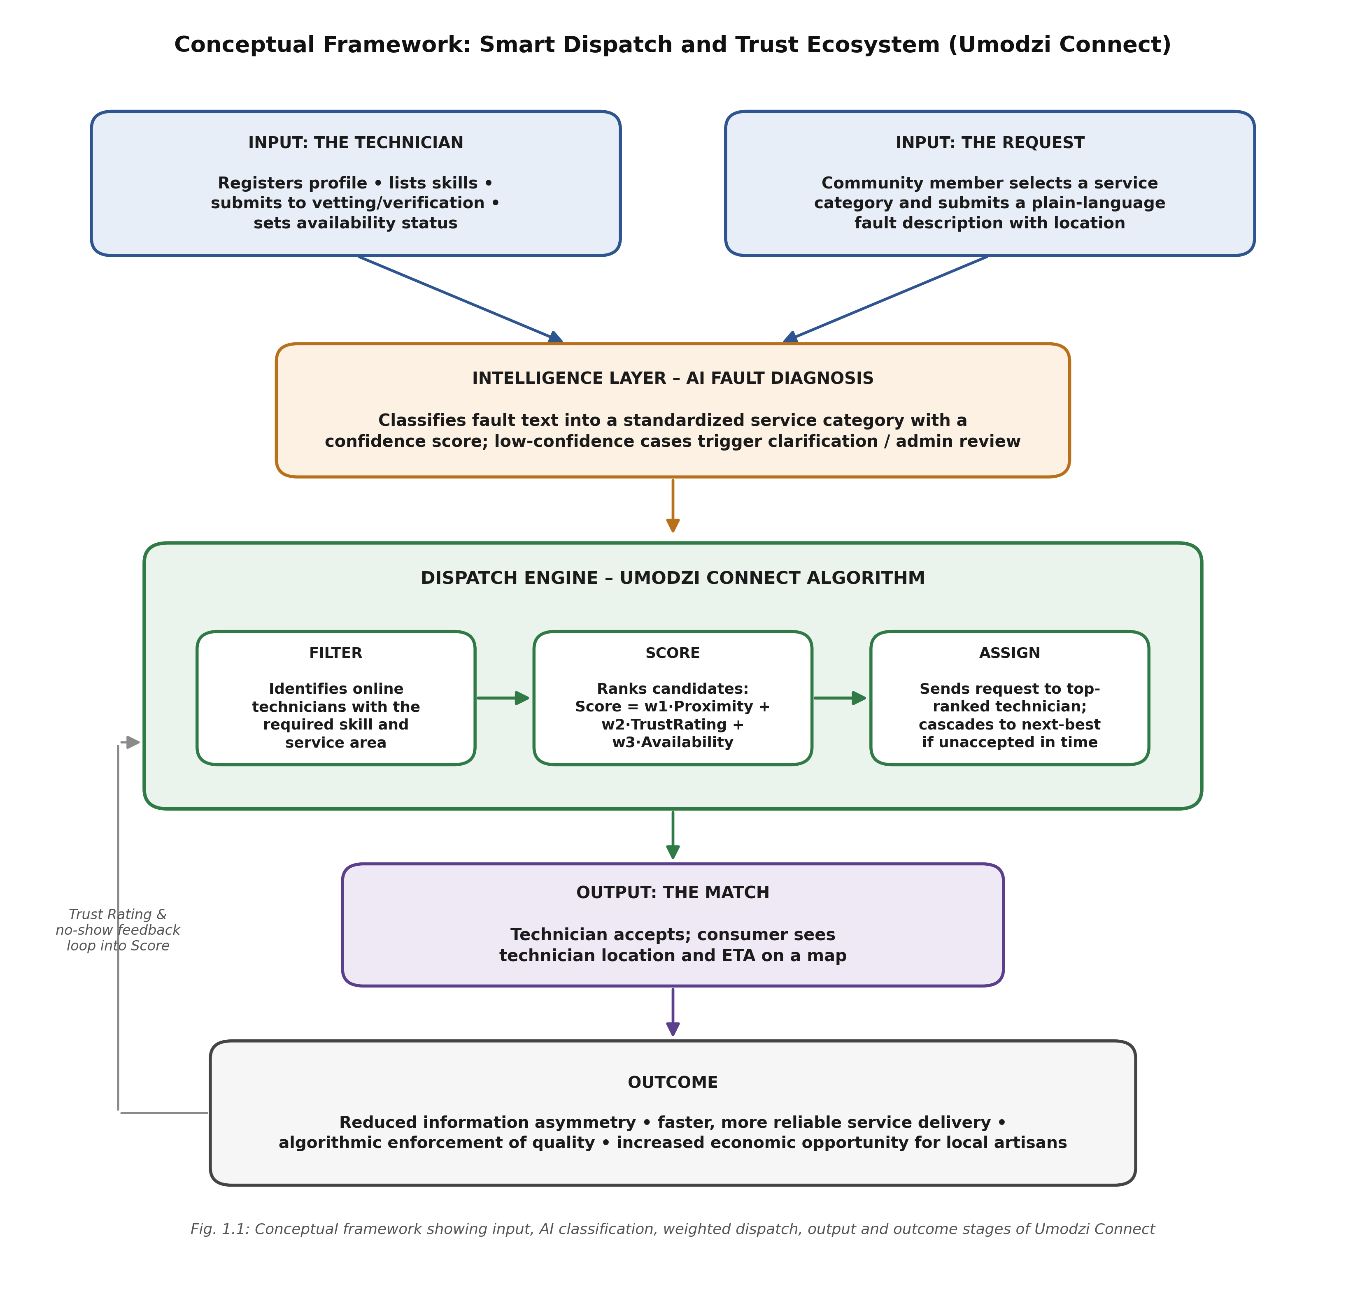

1.8 Organization of the Report
Chapter One introduces the problem, objectives, research questions, scope, limitations, significance and conceptual framework.
Chapter Two reviews related literature concerning digital marketplaces, trust, geolocation, low-data systems and AI-assisted classification.
Chapter Three presents the research methodology, Agile development approach, stakeholders, requirements gathering, pilot findings and requirements analysis.
Chapter Four presents the architecture, diagrams, database design, technologies, components, testing approach and deployment design.
Chapter Five presents the pilot questionnaire results and the technical testing results.
Chapter Six presents the conclusion, recommendations and future research.

1.9 Summary
This chapter introduced the Umodzi Connect project. It described the problem of fragmented technician discovery and presented the objectives, questions, scope, limitations, significance and conceptual framework.
CHAPTER TWO: LITERATURE REVIEW

2.1 Introduction
This chapter reviews literature concerning digital service marketplaces, trust and verification, geolocation-based matching, low-data applications, AI-assisted classification and informal technical services.

2.2 Related Works

2.2.1 Digital Service Marketplaces
Digital service marketplaces connect consumers with service providers through listings, search functions, profiles, reviews and communication tools. These platforms may reduce search costs by making information available in one location.
Digital platforms are also relevant to Zambia's digital transformation. The World Bank identifies digital platforms as one of the five pillars supporting digital economic transformation (World Bank, 2020a).
However, digital platforms may exclude users if they assume high-speed internet, modern devices, formal online payments or continuous connectivity. Umodzi Connect therefore priorities mobile-first and low-data functionality.

2.2.2 Trust and Verification
Trust is an important requirement in service marketplaces. Consumers may need to allow a technician into their home, provide access to valuable equipment or rely on the technician to perform safety-related work.
Possible trust mechanisms include:
- Identity verification.
- Skill or qualification evidence.
- Ratings.
- Written reviews.
- Completed-job history.
- Response time.
- Cancellation history.
- Dispute records.
These mechanisms reduce information gaps but do not guarantee technical competence. A rating can be affected by limited reviews, personal bias or inaccurate reporting.

2.2.3 Geolocation-Based Matching
Geolocation can be used to identify technicians near a consumer. Distance is relevant because technicians have service radii, travel costs and availability limitations.
PostGIS supports geographic distance calculations. The PostGIS documentation explains that geographic distance calculations can return distances in metres when geographic coordinates are used appropriately (PostGIS Project, n.d.).
Geographic matching should not be based on distance alone. A nearby technician may not have the correct skill or may not be available. Umodzi Connect therefore combines proximity with skill, availability and trust information.

2.2.4 Low-Data Mobile Design
Low-data design is important where users may have limited mobile-data budgets or unstable connections. Techniques include:
- Lightweight pages.
- Compressed images.
- Efficient API responses.
- Limited background requests.
- Responsive layouts.
- Caching.
- Simple forms.
- Graceful network-failure handling.
The 18 pilot responses provided requirements-level evidence supporting this approach because most technicians and customers reported weekly data expenditure below K50.

2.2.5 AI-Assisted Fault Classification
AI-assisted classification can analyze a plain-language fault description and suggest an appropriate service category. For example, a description about a leaking pipe may be classified as plumbing.
The classifier should not be treated as a replacement for a professional diagnosis. Its purpose is to support service categorization and matching. The user should be able to confirm or correct the suggested category.
Classification accuracy depends on the quality and language coverage of the dataset. An English-focused model may perform differently when users mix English with Bemba or Nyanja.

2.2.6 Informal Technical Services
Informal technical services are often organized through referrals, personal contacts, advertisements, Facebook pages, WhatsApp groups and direct phone communication.
This system may be convenient but can make it difficult for consumers to compare technicians. It may also restrict technicians to personal networks and reduce access to new customers.

2.2.7 Electronics and ICT Services
Electronics and ICT services include computer repair, mobile-device repair, network installation, television repair, radio repair, printer repair and satellite installation.
These services require clear categorizations because a technician with electrical experience may not necessarily be suitable for ICT or electronics work. Umodzi Connect includes Electronics and ICT service categories.

2.3 Review of Related Works
The literature supports the use of centralized digital platforms, verification, ratings, reviews and geolocation. However, the Zambian context requires special consideration of connectivity, device diversity, mobile-data costs and informal work arrangements.
The World Bank's digital economy assessment identifies progress in Zambia's digital infrastructure, digital platforms and digital financial services, while also identifying continuing gaps in digital skills and digital entrepreneurship (World Bank, 2020a).
The ZICTA 2024 Annual Market Report provides official information about the ICT sector and demonstrates the importance of monitoring connectivity, ICT services and market performance in Zambia (ZICTA, 2024).
The review identifies a gap for a Zambia-focused system that combines:
- AI-assisted service categorization.
- Technician verification.
- Reviews and ratings.
- Geolocation-based filtering.
- Weighted dispatch.
- Low-data design.
- Support for informal technicians.
- Future local-language capability.

2.4 Proposed System
Umodzi Connect addresses the identified gap by providing:
- Technician registration.
- Technician profiles.
- Skill categories.
- Service-radius configuration.
- Availability.
- Verification status.
- Customer reviews.
- Completed-job history.
- AI-assisted fault classification.
- Location-based matching.
- Weighted dispatch.
- Cascading job offers.
- Job-status tracking.
- Dispute reporting.
- Low-data progressive web application design.
The proposed system is not intended to replace professional licensing or government regulation. It is intended to improve service discovery, information availability and structured matching.

2.5 Summary
This chapter reviewed digital service marketplaces, trust mechanisms, geolocation, low-data design and AI-assisted classification. The literature supports the proposed system but also demonstrates the need for local adaptation. Umodzi Connect addresses the identified gap through a low-data and Zambia-focused service-discovery platform.

CHAPTER THREE: RESEARCH METHODOLOGY

3.1 Introduction
This chapter presents the methodology used for the Umodzi Connect project. It explains the Agile development methodology, stakeholder identification, requirements gathering, pilot questionnaire analysis and requirements validation.

3.2 Software Development Methodology
The Agile methodology was selected because it supports incremental development, continuous feedback and frequent testing.
The project follows two-week sprints consisting of:
- Planning.
- Development.
- Testing.
- Review.
- Retrospective.
The planned development progression is:
- Version 0.1: Registration, login and manual matching.
- Version 0.2: Profiles, skills and AI-assisted classification.
- Version 0.3: Geolocation and weighted dispatch.
- Version 0.4: Reviews, verification and job tracking.
- Version 0.5: Administration, security testing and deployment improvement.
Agile is suitable because requirements may change as questionnaire findings, prototype demonstrations and test results become available.

3.3 Requirements Specification

3.3.1 Stakeholders
The main stakeholders are:
- Technicians.
- Consumers.
- Administrators.
- Academic supervisor.
- Future institutional users such as schools, property managers, workshops and small businesses.

3.3.2 Requirements Gathering
Requirements were gathered using semi-structured discussions, questionnaires, contextual observation and analysis of existing service-discovery practices.
The main stakeholder groups were skilled technicians and service consumers. The questionnaire collected information concerning device usage, mobile-data expenditure, technician-discovery methods, trust requirements, service preferences and experiences with technician services.
The current pilot dataset contains 18 responses:
Participant Group | Number of Responses
Technicians | 7
Consumers | 11
Total | 18

The pilot data was used to validate the problem statement, identify requirements and establish practical design priorities. It is not treated as a nationally representative sample.

3.3.3 Requirements Analysis
Questionnaire responses were entered into spreadsheet or CSV format and analyzed using descriptive frequency analysis. Since the pilot dataset is small, counts and percentages are used rather than population-level estimates.
Among the 7 technicians, 5 reported weekly data expenditure below K50 and 2 reported K50-K150. Among the 11 consumers, 8 reported below K50, 2 reported K50-K150 and 1 reported above K150.
Eight of the 11 customers selected Facebook or WhatsApp groups as their main method of finding technicians. Word-of-mouth was the most frequently selected individual method among technicians.
Trust information was also important. Customers selected reviews, response time, ratings and completed jobs. Technicians selected completed jobs and identity verification.

3.3.3.1 Functional Requirements
The system shall:
- Allow account registration.
- Allow secure login.
- Allow technician profile creation.
- Allow skill selection.
- Allow service-radius configuration.
- Allow availability management.
- Allow verification submission.
- Allow administrative verification.
- Allow service requests.
- Allow fault descriptions.
- Suggest service categories using AI assistance.
- Allow users to confirm or correct categories.
- Capture location.
- Filter technicians.
- Rank technicians.
- Send job offers.
- Cascade offers after rejection or timeout.
- Allow technicians to accept or reject.
- Track job status.
- Allow reviews and ratings.
- Allow dispute reporting.
- Store dispatch logs.
- Provide notifications.

3.3.3.2 Non-Functional Requirements
- Performance.
- Usability.
- Security.
- Privacy.
- Reliability.
- Scalability.
- Maintainability.
- Accessibility.
- Low data consumption.
- Compatibility.
- Auditability.

3.3.3.3 Requirements Validation
Requirements are validated through:
- Stakeholder discussions.
- Questionnaire findings.
- Prototype demonstrations.
- Supervisor review.
- Requirement-to-feature traceability.
- Test-case mapping.
- User-acceptance testing.

3.3.4 Pilot Survey Findings Used for Requirements
The pilot questionnaire produced several findings that directly influenced the system design.
First, mobile-data efficiency was identified as an important requirement. Five of the seven technicians and eight of the eleven consumers reported weekly mobile-data expenditure below K50. The system therefore priorities lightweight pages, compressed media, efficient API responses, limited unnecessary background requests and mobile-first design.
Second, technician discovery was highly dependent on informal networks. Eight of the eleven consumers selected Facebook or WhatsApp groups as their main discovery method. This supports the need for a centralized platform where technician information can be presented in a structured manner.
Third, trust information was identified as an important part of technician selection. Customers selected written reviews, ratings, response time and completed jobs. The system therefore provides verification status, completed-job history, ratings and reviews.
Fourth, geographical proximity was important. Four of the seven technicians reported a service radius of 5 km or less, while three reported 6-10 km. This supports service-radius configuration and geospatial filtering.
Finally, mixed-language usage was common. Five of the seven technicians and nine of the eleven consumers selected mixed English and Bemba or Nyanja. This supports clear interface language and future local-language support.

3.4 Summary
This chapter presented the Agile methodology, stakeholders, requirements-gathering methods, pilot survey analysis and requirements-validation process. The findings support low-data operation, trust information, geographic matching, service-radius configuration and future multilingual functionality.

CHAPTER FOUR: SYSTEM DESIGN AND IMPLEMENTATION

4.1 Introduction
This chapter presents the architecture, software design, database design, development tools, implementation approach, testing strategy and deployment architecture of Umodzi Connect.

4.2 Architectural Design
The architecture has five layers:
- Presentation Layer.
- Application Layer.
- Intelligence Layer.
- Data Layer.
- External Services Layer.
The presentation layer is a mobile-first progressive web application for consumers, technicians and administrators.
The application layer handles authentication, profiles, service requests, verification, dispatch, reviews, disputes and administration.
The intelligence layer contains AI-assisted classification, keyword fallback, matching, trust scoring, availability scoring and fairness logic.
The data layer stores users, profiles, skills, requests, locations, reviews, logs, disputes, notifications and verification records.
External services may include AI, maps, geocoding, push notifications and SMS.
Figure 4.1: System Architecture 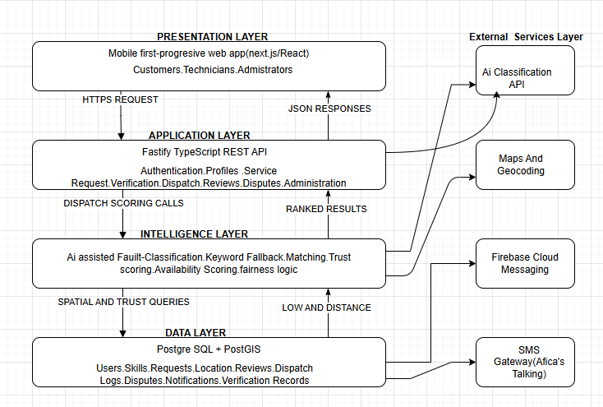

4.3 Software Design

4.3.1 Software Design Tools
- Draw.io.
- Visual Studio Code.
- Git and GitHub.
- PostgreSQL.
- PostGIS.
- Thunder Client or Postman.
- Vitest or Jest.

4.3.2 Component Design

4.3.2.1 Contextual Model
The principal actors are: Customer, Technician, Administrator.
Figure 4.2: Context Diagram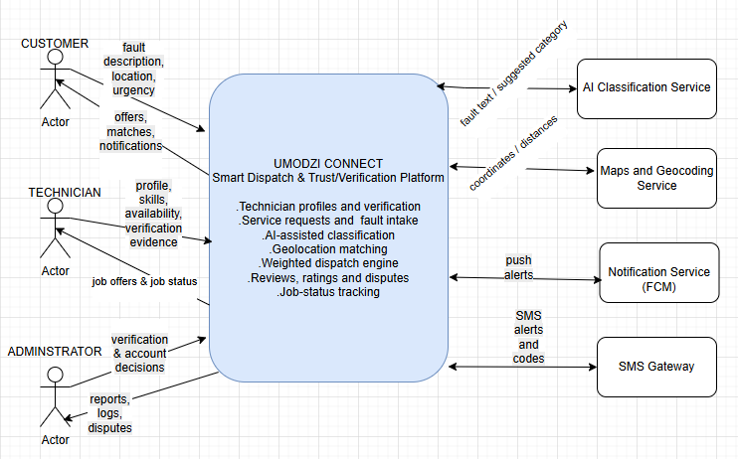

The context diagram shows information exchanged between users, Umodzi Connect, the AI service, maps service, notification service and SMS gateway.

4.3.2.2 Use Case Model
Customer use cases include registration, login, creating requests, describing faults, confirming categories, confirming locations, viewing technicians, tracking jobs, cancelling requests, submitting reviews and reporting disputes.
Technician use cases include registration, login, profile creation, skill management, verification, availability, job acceptance, job rejection, job-status updates and customer reviews.
Administrator use cases include login, verification, account management, category management, dispute management, dispatch-log review and reporting.

Figure 4.3: Use Case Diagram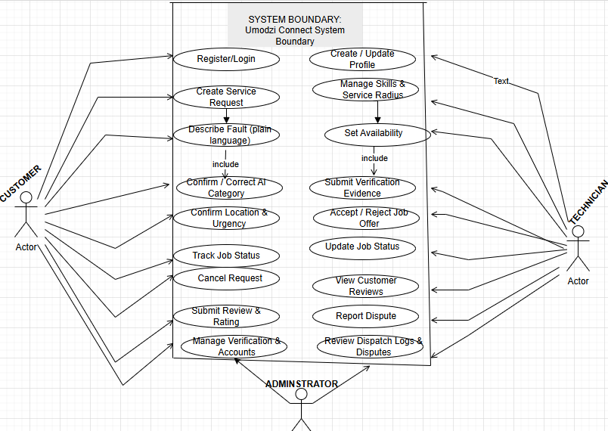

4.3.2.3 Sequence Diagram
The service-request sequence is as follows:
- Customer enters fault description.
- Application sends description to classifier.
- Classifier suggests category.
- Customer confirms category.
- Application capture’s location.
- Matching service retrieves candidates.
- PostGIS calculates geographic distances.
- Dispatch engine calculates scores.
- Technician receives offer.
- Technician accepts or rejects.
- System assigns technician or cascades.
- Customer receives notification.
- Technician performs service.
- Job is completed.
- Customer submits review.

Figure 4.4: Sequence Diagram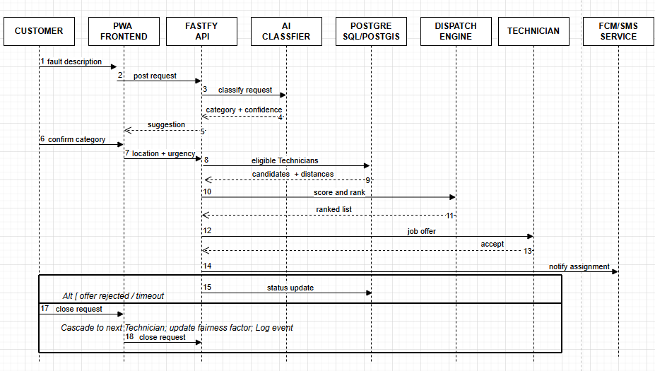

4.3.2.4 State Machine Diagram
Draft ->Submitted -> Classifying -> Classified -> Matching -> Offered -> Accepted -> EnRoute -> InProgress -> Completed -> Reviewed. Alternative states are Cancelled, Expired, Disputed and Resolved.

Figure 4.5: State Machine Diagram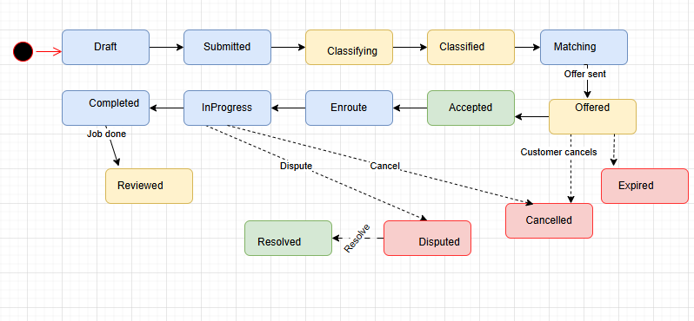

4.3.2.5 Activity Diagram
The activity flow begins with a customer submitting a request and continues through validation, classification, location capture, candidate filtering, scoring, offering, acceptance, job completion and review.

Figure 4.6: Activity Diagram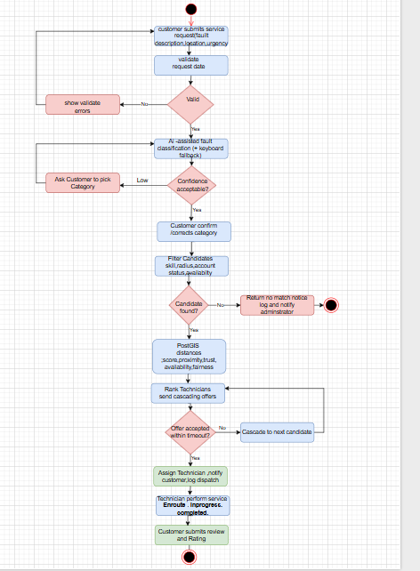

4.3.2.6 Class Diagram
The major classes are:
- User.
- Customer.
- Technician.
- Administrator.
- TechnicianProfile.
- Skill.
- ServiceRequest.
- DispatchLog.
- Review.
- Dispute.
- Verification.
- Notification.

Figure 4.7: Class Diagram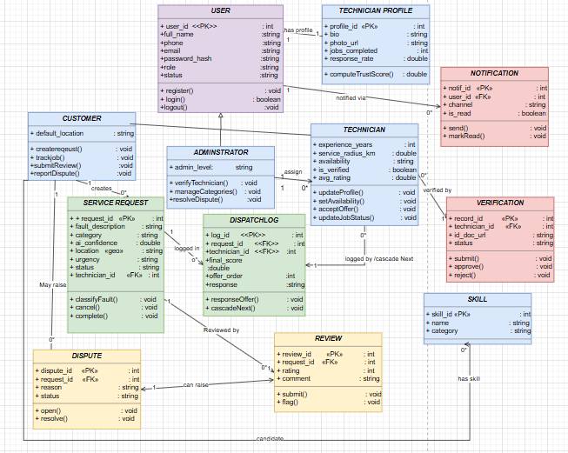

4.3.3 Database Design
The database uses PostgreSQL and PostGIS. Core tables include:
- USERS.
- SKILLS.
- TECHNICIAN_PROFILES.
- TECHNICIAN_SKILLS.
- SERVICE_REQUESTS.
- DISPATCH_LOGS.
- REVIEWS.
- DISPUTES.
- VERIFICATION_RECORDS.
- NOTIFICATIONS.
- SMS_LOGS.

Figure 4.8: Entity-Relationship Diagram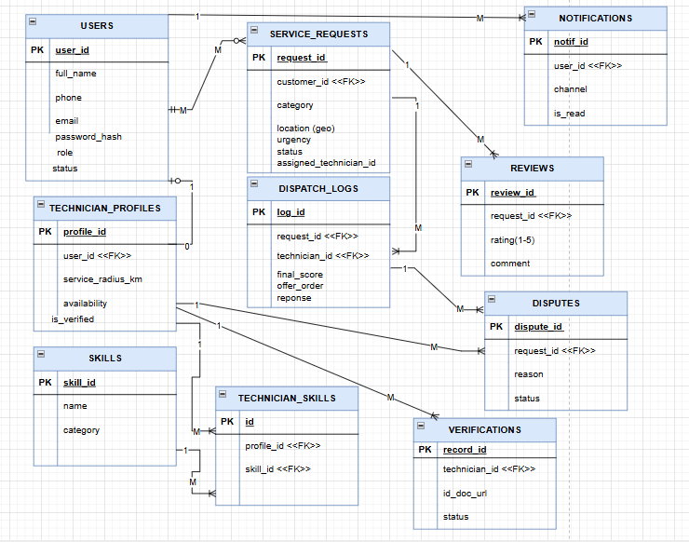

PostGIS supports geographic distance calculations. For geographic data, distance operations such as ST_Distance can return distances in metres, which is useful for service-radius matching (PostGIS Project, n.d.).

4.4 Software Development

4.4.1 Software Development Tools
- Frontend: React and Next.js.
- PWA: Service Worker and Web App Manifest.
- Backend: TypeScript and Factify REST API.
- Database: PostgreSQL.
- Spatial database: PostGIS.
- Authentication: Supabase Auth or equivalent.
- Database security: PostgreSQL Row Level Security.
- AI classification: External AI API with keyword fallback.
- Push notifications: Firebase Cloud Messaging.
- SMS: Africa's Talking or equivalent.
- Testing: Vitest, Jest, Postman and browser tools.
- Hosting: Cloud deployment platform.

4.4.2 Component Development

Authentication Component
The authentication component manages registration, login, sessions, roles, logout and account status.

Technician Component
The technician component manages names, categories, descriptions, experience, service areas, availability, verification and reviews.

Verification Component
The verification component stores identity and skill or experience evidence. Verification reduces information gaps but does not guarantee technical competence.

Service Request Component
The service-request component stores fault description, category, location, urgency, optional photographs, status, assignment and timestamps.

Classification Component
Fault description -> Pre-processing -> AI classification -> Suggested category -> Confidence check -> User confirmation. The classifier categories service requests and does not provide a professional diagnosis.

Dispatch Component
The dispatch component filters, scores, ranks and contacts technicians. Final Score = w1(Proximity Score) + w2(Trust Score) + w3(Availability Score) + w4(Fairness Factor).

Figure 4.9: Smart Dispatch Algorithm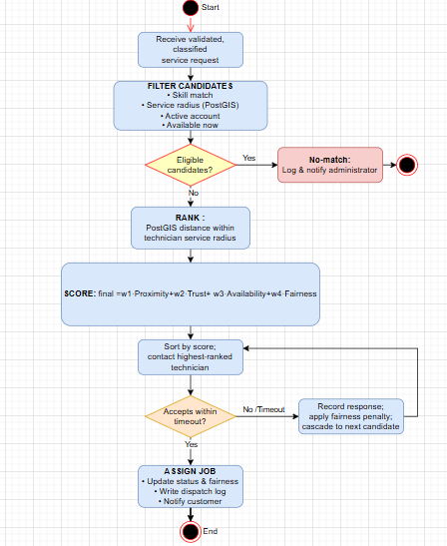

Trust Component
Trust information may include verification, ratings, completed jobs, response rate, cancellation rate and disputes.

4.4.3 Evaluation and Testing Techniques
Functional testing covers authentication, profiles, verification, requests, classification, dispatch, reviews and disputes.
AI classification testing uses accuracy, precision, recall and F1 score.
Dispatch testing measures offer time, acceptance time, match rate, cancellation, distance and fairness.
Usability testing measures task completion, time-on-task, errors, satisfaction and SUS score.
Security testing includes authentication, authorization, input validation, role access, object-level access and session management. OWASP identifies broken object-level authorization and broken authentication among important API risks (OWASP, 2023).

4.5 Deployment
The proposed deployment architecture is: User Browser/PWA -> HTTPS -> Next.js Frontend -> Fastify TypeScript API -> PostgreSQL/PostGIS -> External Services.
The frontend provides presentation and user interaction. The Fastify backend provides the API and server-side business logic.
The backend uses environment variables for secrets and server-side configuration. Sensitive credentials and API keys are not included in client-side code. Administrative operations are restricted to authorized accounts.
The database layer uses PostgreSQL, with PostGIS available for geographic calculations required by technician proximity and service-radius matching.
Security controls should be aligned with the Data Protection Act of Zambia, which provides the legal framework for personal-data protection (Republic of Zambia, 2021).

4.6 Summary
This chapter presented the architecture, software design, database, components, tools, dispatch algorithm, testing techniques and deployment approach. The system combines a mobile-first frontend, Fastify TypeScript backend, PostgreSQL, PostGIS, AI-assisted classification and trust-aware dispatch.

CHAPTER FIVE: RESULTS AND DISCUSSION

5.1 Introduction
This chapter presents results from the pilot questionnaire and the technical testing of the implemented Umodzi Connect system.
The pilot dataset contains 18 responses: 7 technicians and 11 consumers. These responses are preliminary pilot evidence and are not statistically representative of all technicians or consumers in Zambia.

5.2 Results

5.2.1 Participant Results
Participant Group | Number | Percentage
Technicians | 7 | 38.9%
Consumers | 11 | 61.1%
Total | 18 | 100%

The technician responses were collected from Ndola. Ten customers were from Ndola and one was from Kitwe. The results primarily reflect the Copperbelt urban pilot area.

5.2.2 Technician Survey Results

Device Usage
Device Type | Number | Percentage
Desktop/Laptop | 2 | 28.6%
Mid-range Android | 2 | 28.6%
Basic Android | 1 | 14.3%
High-end Android | 1 | 14.3%
iPhone | 1 | 14.3%

Weekly Mobile-Data Expenditure
Expenditure Band | Number | Percentage
Below K50 | 5 | 71.4%
K50-K150 | 2 | 28.6%

Current Method of Finding Customers
Method | Number
Word-of-mouth | 3
Facebook/WhatsApp | 2
Both | 1
Other | 1

Factors Considered When Receiving Jobs
Factor | Number
Proximity | 3
Availability | 1
Trust | 1
Price | 1
Proximity + Trust + Availability + Price | 1

Trust Signals
Completed jobs were selected by 4 technicians. Identity verification was selected by 3 technicians.

Language Preference
Five technicians selected mixed English and Bemba or Nyanja. One selected mostly Bemba or Nyanja and one selected English only.

Type of Service
Six technicians mainly provided on-site services. One provided both on-site and remote services.

Service Radius
Four technicians reported 5 km or less. Three reported 6-10 km.

Paid Jobs During the Previous Month
Jobs | Number
0-2 | 3
3-5 | 3
6-10 | 1

Self-Reported Income
Income Band | Number
Below K1,000 | 3
K1,000-K3,000 | 3
K3,001-K6,000 | 1

No-Shows and Disputes
Three technicians reported such experiences often, two occasionally and two never. Therefore, five technicians reported experiencing at least some level of no-show or dispute.

5.2.3 Customer Survey Results

Respondent Role
Role | Number | Percentage
Household member | 6 | 54.5%
Other | 5 | 45.5%

Device Usage
Device Type | Number | Percentage
High-end Android | 3 | 27.3%
Mid-range Android | 3 | 27.3%
Desktop/Laptop | 2 | 18.2%
Basic Android | 2 | 18.2%
iPhone | 1 | 9.1%

Weekly Mobile-Data Expenditure
Expenditure Band | Number | Percentage
Below K50 | 8 | 72.7%
K50-K150 | 2 | 18.2%
Above K150 | 1 | 9.1%

Current Method of Finding Technicians
Method | Number | Percentage
Facebook/WhatsApp groups | 8 | 72.7%
Word-of-mouth + Facebook/WhatsApp | 1 | 9.1%
Word-of-mouth | 1 | 9.1%
Other | 1 | 9.1%

Factors Used When Choosing a technician
Factor | Number
Proximity | 4
Trust rating | 4
Availability | 3

Preferred Trust Information
Trust Signal | Number
Written reviews | 3
Response time | 2
Average rating | 2
Completed jobs | 2
Other | 1
Multiple/all signals | 1

Language Preference
Nine customers selected mixed English and Bemba or Nyanja. One selected mostly Bemba or Nyanja and one selected English only.

Preferred Service Location
Location | Number
On-site | 6
Both options with price/ETA | 4
Drop-off/remote | 1

Waiting Time
Four respondents had never hired a technician. Among respondents with previous experience, waiting times ranged from less than 30 minutes to more than three hours.

Customer Satisfaction
Eight responses recorded a satisfaction score of 3 out of 5 and three recorded 5 out of 5. Mean of all 11 responses = 3.55 out of 5. Among the seven respondents with previous technician-hiring experience: Approximate mean = 3.86 out of 5.

5.2.4 Summary of Pilot Findings
The pilot findings produced several requirements.
First, low-data operation is important because 71.4% of technicians and 72.7% of consumers reported weekly expenditure below K50.
Second, technician discovery is fragmented because 72.7% of consumers used Facebook or WhatsApp groups.
Third, trust information is important. Customers selected proximity, ratings, reviews, response time and completed jobs.
Fourth, geographic proximity is important. Technicians reported relatively small service radii and customers selected proximity as a main factor.
Fifth, mixed English and Bemba or Nyanja was common. This supports simple language design and future multilingual functionality.

5.2.5 Functional Testing Results
Functional testing was conducted across the core system modules. The pass rate is calculated as: Test Pass Rate = (Number of Passed Tests / Total Number of Tests) x 100.
Test Category | Conducted | Passed | Failed
Authentication
Profiles
Verification
Service requests
Classification
Dispatch
Reviews
Disputes

5.2.6 AI Classification Results
Category | Precision | Recall | F1 Score
Plumbing
Electrical
Automotive
Appliance
Refrigeration
Electronics
ICT
Overall accuracy

5.2.7 Dispatch, Usability and Security Results

Dispatch Results
Metric | Result
Total requests
Requests successfully matched
Match rate | %
Median time to first offer | seconds
Median time to acceptance | seconds
Average candidates contacted
Cancellation rate | %
Average distance | km

Usability Results
Metric | Result
Task completion rate | %
Average task time
Task errors
SUS score
User satisfaction

Security Results
Security Test | Expected | Actual | Status
Customer accesses another customer's request | Denied
Technician accesses private data | Denied
Administrator verification access | Allowed
Unauthenticated API request | Denied
Invalid input | Rejected

5.2.8 Predictive Analysis
The pilot dataset was examined to identify variables for future predictive analysis. However, 18 responses are insufficient for a reliable multivariable predictive model with a large number of predictors.
For customers, a future outcome could be the likelihood of using Umodzi Connect if the service becomes available. Potential predictors include trust importance, proximity importance, availability, current discovery method, mobile-data expenditure, device type, language preference and previous experience.
For technicians, a possible outcome could be the likelihood of registering and accepting jobs through Umodzi Connect. Potential predictors include job volume, income category, service radius, discovery method, availability, mobile-data expenditure, verification preferences and no-show or dispute experience.
Ordinal logistic regression may be suitable where adoption intention is measured on a five-point scale. Binary logistic regression may be suitable where the outcome is genuinely binary.

5.3 Discussion
The pilot findings support the main design assumptions of Umodzi Connect.
The first finding concerns mobile-data constraints. Most respondents reported weekly data expenditure below K50. This supports lightweight pages, efficient API responses, compressed media and limited background requests.
The second finding concerns technician discovery. Customers primarily reported using Facebook and WhatsApp groups, while technicians reported word-of-mouth and social-media channels. This indicates that technician information is distributed across informal networks.
The third finding concerns trust. Customers identified reviews, ratings, response time and completed jobs. Technicians identified completed jobs and identity verification. This supports the combination of verification, review history and service-performance information.
The fourth finding concerns geographic matching. Technicians reported relatively limited-service radii and customers considered proximity important. Geographic filtering and distance scoring are therefore consistent with the pilot requirements.
The results must be interpreted within the limitations of the pilot. The 18 respondents cannot represent all technicians and consumers in Zambia. The results provide requirements-level evidence rather than national statistical estimates.

5.4 Summary
This chapter presented pilot findings from 7 technicians and 11 consumers. The findings support low-data design, structured technician profiles, trust indicators, service-radius configuration, geographic matching and future multilingual support.

CHAPTER SIX: CONCLUSION AND RECOMMENDATIONS

6.1 Introduction
This chapter concludes the study based on the research problem, objectives and pilot findings. It also presents recommendations and areas for future research.

6.2 Conclusion
Umodzi Connect was proposed as a platform for improving the process through which consumers discover and engage skilled technicians in Zambia.
The study identified problems involving fragmented service discovery, limited technician information, uncertainty concerning trust and difficulty matching consumers with available technicians.
The pilot findings showed that most technicians and consumers reported weekly data expenditure below K50. This supports the requirement for a lightweight, mobile-first platform.
Customers frequently used Facebook and WhatsApp groups to find technicians. This supports the problem statement that existing discovery is fragmented.
Customers and technicians identified trust information, completed jobs, reviews, verification and proximity as important. These findings influenced the proposed inclusion of technician profiles, ratings, reviews, verification, geographic filtering and dispatch scoring.
The pilot does not prove that Umodzi Connect will increase technician income, reduce waiting time or improve service quality. Those claims require system testing and longitudinal evaluation.

6.3 Recommendations

Expand Technician Verification
Future versions should consider partnerships with trade schools, professional associations and certification bodies.

Integrate Mobile Money
Mobile-money payment integration may be added after the core service workflow has been validated.

Add Local-Language Support
Future research should develop properly labelled datasets for Bemba, Nyanja and mixed-language fault descriptions.

Introduce USSD
USSD may support users with basic phones and limited smartphone connectivity.

Develop a WhatsApp Channel
A structured WhatsApp service-request channel may be developed subject to privacy and platform-policy requirements.

Introduce Business Accounts
Schools, property managers, shops and other organizations may benefit from recurring maintenance accounts.

Improve Dispatch Fairness
The dispatch system should be tested for possible concentration of jobs among a small number of technicians.

Strengthen Data Protection
The system should apply data minimization, retention controls, encryption, access controls, audit logging and secure identity-document handling. The Data Protection Act provides the relevant legal context in Zambia (Republic of Zambia, 2021).

Establish a Controlled Pilot
The system should be piloted with a controlled group of consumers and technicians in Kitwe and Ndola.

Establish a Sustainable Business Model
Possible models include subscriptions, business accounts, service fees, institutional partnerships and transaction commissions. These models require market validation.

6.3.1 Future Research and Evaluation
Future research should expand the participant sample across additional locations and user groups. A larger study would support stronger statistical analysis of platform adoption and trust.
Future evaluation should collect system telemetry, including:
- Request-to-offer time.
- Offer-to-acceptance time.
- Number of candidates contacted.
- Successful match rate.
- Cancellation rate.
- Geographic distance.
- Dispatch fairness.
- Classification performance.
- System response time.
- Usability scores.
A longitudinal study could compare technician job volume and income before and after platform adoption. This would provide stronger evidence concerning whether digital visibility and automated dispatch are associated with changes in technician economic outcomes.

6.4 Summary
Umodzi Connect represents a Zambia-focused application of digital technology to a practical service-discovery problem. Its main contribution is the combination of technician verification, trust information, AI-assisted service classification, geospatial matching and automated dispatch within a low-data platform.

REFERENCES
Afrobarometer (2022) Zambia: 78% of labour force in informal sector. Available at: https://www.afrobarometer.org/wp-content/uploads/2022/02/afrobriefno135.pdf (Accessed: 30 September 2026).
Bank of Zambia (2026) Zambia FinScope 2025 survey: topline findings. Lusaka: Bank of Zambia.
Centers for Disease Control and Prevention (2024) Field epidemiology manual: study design and sample size considerations. Atlanta: CDC.
Chigbu, B.I. (2026) 'Algorithmic management in the global gig economy', Frontiers in Sociology, 11, article 1743445.
DataReportal (2026) Digital 2026: Zambia. Available at: https://datareportal.com/reports/digital-2026-zambia.
FinScope (2025) FinScope Zambia survey 2025. Available at: https://www.boz.zm/sites/default/files/2026-04/Zambia%20Finscope%202025%20survey%20topline%20findings.pdf.
Google (2026) Firebase Cloud Messaging documentation. Available at: https://firebase.google.com/docs/cloud-messaging.
Grand View Research (2024) On-demand home services market size, share and trends analysis report, 2024-2030. Available at: https://www.grandviewresearch.com/industry-analysis/on-demand-home-services-market.
Ministry of Technology and Science (2023) National digital transformation strategy 2023-2027. Lusaka: Government of the Republic of Zambia.
Mozilla Developer Network (2026) Progressive web apps reference. Available at: https://developer.mozilla.org/en-US/docs/Web/Progressive_web_apps.
OWASP (2023) OWASP API Security Top 10: 2023. Available at: https://api-security.owasp.org/editions/2023/en/0x11-t10/.
PostGIS Project (n.d.) ST_Distance. Available at: https://postgis.net/docs/ST_Distance.html.
Republic of Zambia (2021) The Data Protection Act, 2021, No. 3 of 2021. Lusaka: Government Printer.
Supabase (2026a) Row level security. Available at: https://supabase.com/docs/guides/database/postgres/row-level-security.
Supabase (2026b) Database documentation. Available at: https://supabase.com/docs/guides/database/overview.
Trade.gov (2026) Zambia: digital economy. Available at: https://www.trade.gov/country-commercial-guides/zambia-digital-economy (Accessed: 30 September 2026).
UCLA Institute for Digital Research and Education (2026) Logistic regression and ordinal logistic regression. Los Angeles: University of California.
Vercel (2026) Next.js documentation. Available at: https://nextjs.org/docs (Accessed: 30 September 2026).
World Bank (2020a) Accelerating digital transformation in Zambia: digital economy diagnostic report. Washington, DC: World Bank.
World Bank (2020b) Zambia's digital transformation journey: strides made, but key gaps remain. Washington, DC: World Bank.
Zambia Information and Communications Technology Authority (2024) 2024 annual market report for the information and communication technologies sector. Lusaka: ZICTA.
Zambia Information and Communications Technology Authority (2025) ICT sector market performance report. Lusaka: ZICTA.

