**Module ICT3715**

## Year 2020

**INFORMATION AND COMMUNICATION TECHNOLOGY**

**ASSIGNMENT 2**

**DUE DATE: 30 APRIL 2020**

|  |  |  |  |  |  |  |  |  |  |
| --- | --- | --- | --- | --- | --- | --- | --- | --- | --- |
| STUDENT NUMBER (Student completes) | | | | | | | | | |
| 5 | 8 | 2 | 3 |  | 1 | 6 | 7 |  | 6 |

|  |  |  |  |  |  |  |  |  |  |  |  |  |
| --- | --- | --- | --- | --- | --- | --- | --- | --- | --- | --- | --- | --- |
| **IDENTITY NUMBER (Student completes)** | | | | | | | | | | | | |
| **9** | **6** | **0** | **9** | **1** | **3** | **5** | **2** | **6** | **7** | **0** | **8** | **5** |

*No handwritten assignments will be accepted.*

**INSTRUCTIONS:**

**Instructions for the student:**

*Complete this front page (page 1).*

*Complete the Plagiarism Pledge (page 3). Your assignment will not be assessed without this.*

*After you’ve completed the front page with your information, the plagiarism pledge and section A, save the document as a PDF. Keep a copy of the original should there be problem with the upload.*

**Instructions for the marker:**

*Marker indicate the marks obtained by the student for each component of the assignment on page 2. Refer to the Criteria Document that you’ve received for the detailed description and requirement for each component. Comments are made in the document itself and/or page 2.*

|  |  |  |  |  |
| --- | --- | --- | --- | --- |
| System component (Marker completes) | **Marks** | | | |
| **Markers** | | | |
|  | | **Comments From Marker** | |
|  | Max | Stud |  | |
| ***SECTION A Exporting and importing of data [20 marks]*** | | | | |
| Exporting and importing of data from spreadsheets to tables.  (Refer to Section A in the Assignment and follow the process. You are required to export the database, tables and imported data to a SQL file. Combine the SQL file with this document (in PDF) format and ZIP it together as one file) | 20 |  |  | |
| ***SECTION B – Creating of Reports [30 marks]*** | | | | |
| Day-to-day Report 1  Unpaid Invoices | 5 |  |  | |
| Day-to-day Report 2  Birthdays | 5 |  |  | |
| Day-to-day Report 3  Supplements below stock level | 5 |  |  | |
| MIS Report 1  Top 10 clients (frequency) | 5 |  |  | |
| MIS Report 2  Month report | 5 |  |  | |
| MIS Report 3  Client Contact report | 5 |  |  | |
| MARKER (SIGNATURE) |  | |  |  |

**PLAGIARISM PLEDGE BY THE STUDENT**

1. I have read Unisa’s plagiarism policy.
2. I understand Unisa’s plagiarism policy.
3. I agree to abide by Unisa’s plagiarism policy.
4. I have read the direct copying, plagiarism, and “patch-writing” document.
5. I understand what direct copying, plagiarism, and “patch-writing” is.
6. I undertake to avoid copying directly, plagiarism and patch writing.
7. All academic work, written or otherwise, that I submit is expected to be the result of my own skill and labour.
8. I understand that, if I am guilty of the infringement of breach of copyright/plagiarism or unethical practice, I will be subject to the applicable disciplinary code as determined by Unisa.
9. The marker has the right to refuse to assess the assignment and the system if plagiarism is detected.

Student name and Surname: ____John-Jacques Malan_________________

Student number: ___58231676___________________

Jmalan

___________________________ 14/04/2020_

Student signature: Date:

SECTION A

Please see the attached SQL-file as requested.

SECTION B

***Day-to-day Report 1 Unpaid Invoices***

***SQL***:

SELECT tblClientInfo.Client_id AS "CLIENT ID", tblClientInfo.C_name||tblClientInfo.C_surname AS "CLIENT", tblInv_Info.Inv_Num AS "INVOICE NUMBER", tblInv_Info.Inv_date AS "INVOICE DATE"

FROM tblClientInfo, tblInv_Info

WHERE tblClientInfo.Client_id = tblInv_Info.Client_id AND tblInv_Info.Inv_Paid != 'Y' OR tblClientInfo.Client_id = tblInv_Info.Client_id AND tblInv_Info.Inv_Paid IS NULL AND tblInv_Info.Inv_date < '12/31/2019'

ORDER BY tblInv_Info.Inv_date;

***Day-to-day Report 1 Unpaid Invoices***

***Report (complete – all the data returned by your SQL must be displayed. Either make a screen dump or copy and paste from the query results)***

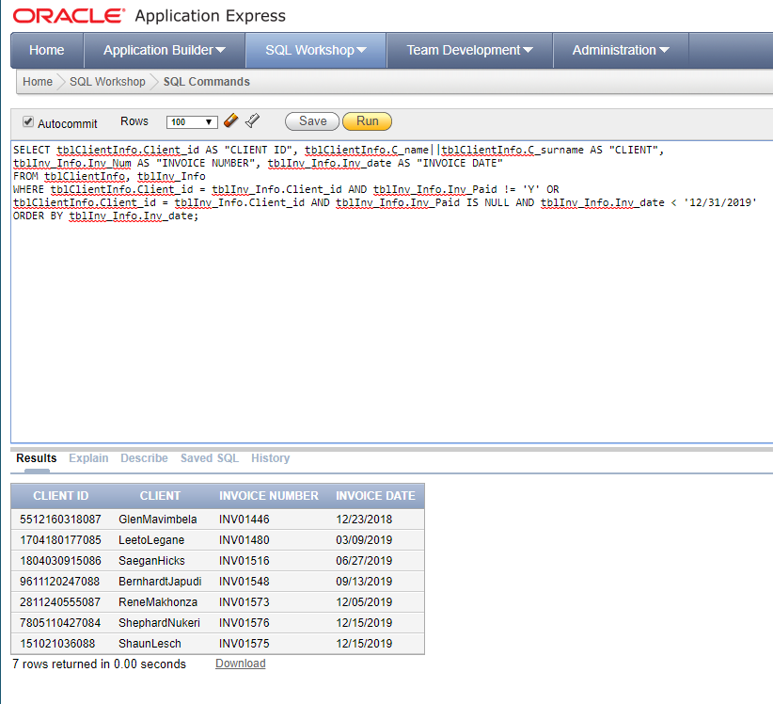

***Day-to-day Report 2 Birthdays***

***SQL***:

SELECT tblClientInfo.Client_id AS "CLIENT ID", tblClientInfo.C_name||' '||tblClientInfo.C_surname AS "CLIENT NAME"

FROM tblClientInfo

WHERE SUBSTR(tblClientInfo.Client_id, 3, 4) = SUBSTR(TO_CHAR(CURRENT_DATE,'yymmdd'), 3, 4);

***Day-to-day Report 2 Birthdays***

***Report (complete – all the data returned by your SQL must be displayed. Either make a screen dump or copy and paste from the query results)***

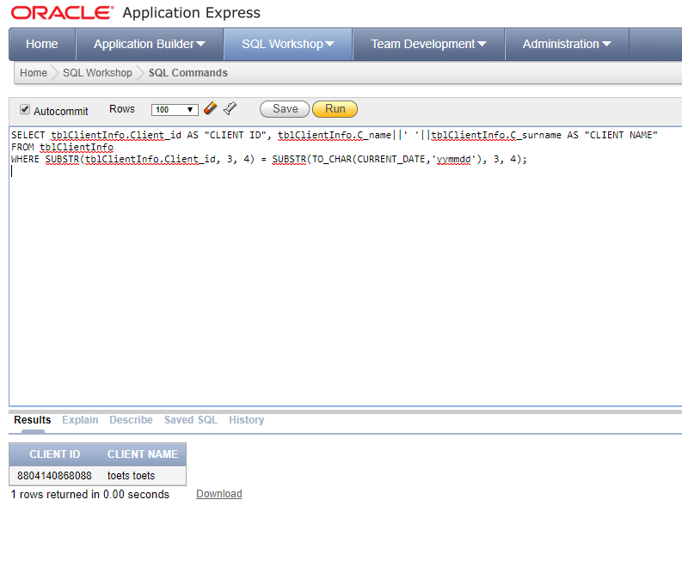

***Day-to-day Report 3 Supplements below stock level***

***SQL***

SELECT tblSupplements.Supplement_id AS "Supplement",

tblSupplier_Info.Supplier_ID||' '||tblSupplier_Info.Contact_Person||' '||tblSupplier_Info.Supplier_Tel AS "Supplier Information",

tblSupplements.Min_levels AS "Min Levels", tblSupplements.Current_stock_levels AS "Current Stock"

FROM tblSupplements, tblSupplier_Info

WHERE tblSupplier_Info.Supplier_ID = tblSupplements.Supplier_ID AND tblSupplements.Min_levels > tblSupplements.Current_stock_levels

ORDER BY tblSupplier_Info.Supplier_ID;

***Day-to-day Report 3 Supplements below stock level***

***Report (complete – all the data returned by your SQL must be displayed. Either make a screen dump or copy and paste from the query results)***

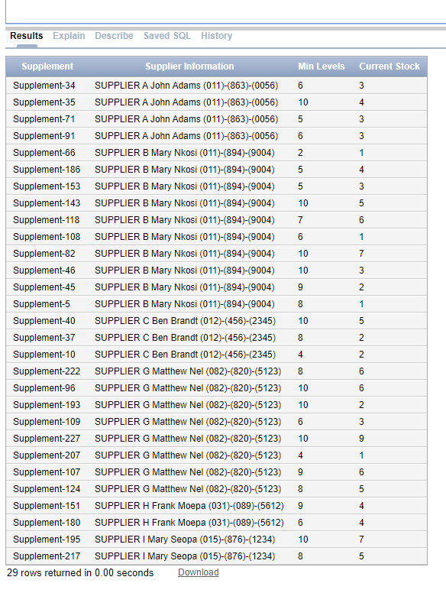

***MIS Report 1 Top 10 clients (frequency)***

***SQL***

SELECT DISTINCT TblClientInfo.Client_id||' '||TblClientInfo.C_name||' '||TblClientInfo.C_surname AS "Client",COUNT(tblInv_Info.Client_id) AS "Frequency"

FROM TblClientInfo, tblInv_Info

WHERE TblClientInfo.Client_id = tblInv_Info.Client_id

GROUP BY tblInv_Info.Client_id, TblClientInfo.Client_id, TblClientInfo.C_name, TblClientInfo.C_surname

ORDER BY "Frequency" DESC;

***MIS Report 1 Top 10 clients (frequency)***

***Report (complete – all the data returned by your SQL must be displayed. Either make a screen dump or copy and paste from the query results)***

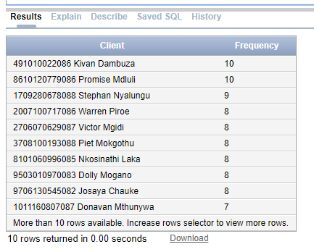

***MIS Report 2 Month Report***

***SQL***

SELECT COUNT(tblInv_Info.Inv_Date) AS "NUM OF PURCHASES", SUBSTR(TO_CHAR(tblInv_Info.Inv_Date,'yyMONTHdd'), 3, 3) AS "MONTH"

FROM tblInv_Info

GROUP BY SUBSTR(TO_CHAR(tblInv_Info.Inv_Date,'yyMONTHdd'), 3, 3)

ORDER BY "NUM OF PURCHASES" DESC;

***MIS Report 2 Month Report***

***Report (complete – all the data returned by your SQL must be displayed. Either make a screen dump or copy and paste from the query results)***

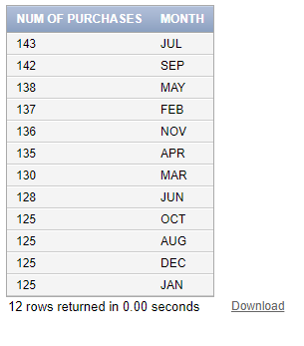

***MIS Report 3 Client Contact Report***

***SQL***

SELECT TblClientInfo.Client_id AS "CLIENT", TblClientInfo.C_Tel_H AS "HOME", TblClientInfo.C_Tel_W AS "WORK", TblClientInfo.C_Tell_Cell AS "CELL", TblClientInfo.C_Email AS "E-MAIL"

FROM TblClientInfo

WHERE TblClientInfo.C_Tell_Cell IS NULL AND TblClientInfo.C_Email IS NULL

ORDER BY TblClientInfo.Client_id;

***MIS Report 3 Client Contact Report***

***Report (complete – all the data returned by your SQL must be displayed. Either make a screen dump or copy and paste from the query results)***

