**SENTIMENT ANALYSIS**

**A PROJECT REPORT**

***Submitted by,***

**MALANI PRINCE [20BEIT30046] PATEL AARYA[20BEIT30060] PATEL KEYUR [20BEIT30077] DESAI DHWANI [20BEIT30025]**

***In fulfillment for the award of the degree Of***

### BACHELOR OF ENGINEERING

**In INFORMATION TECHNOLOGY**



**LDRP INSTITUTE OF TECHNOLOGY AND RESEARCH, GANDHINAGAR**

### Kadi SarvaVishwa Vidyalaya, Gandhinagar

**SEPTEMBER-2023**

## LDRP Institute of Technology and Research

Information Technology Department



**CERTIFICATE**

This is to certify that the Project Work entitled **“Sentiment Analysis”** has been carried out by **Malani Prince[20BEIT30046]** under my guidance in fulfilment of the degree ofBachelor of Engineering in Information Technology (7th Semester) of Kadi Sarva Vishwavidyalaya University, Gandhinagar during the academic year 2023-24.

## LDRP Institute of Technology and Research

Information Technology Department



**CERTIFICATE**

This is to certify that the Project Work entitled **“Sentiment Analysis”** has been carried out by **Patel Aarya[20BEIT30060]** under my guidance in fulfilment of the degree ofBachelor of Engineering in Information Technology (7th Semester) of Kadi Sarva Vishwavidyalaya University, Gandhinagar during the academic year 2023-24.

## LDRP Institute of Technology and Research

Information Technology Department



**CERTIFICATE**

This is to certify that the Project Work entitled **“Sentiment Analysis”** has been carried out by **Patel Keyur[20BEIT30077]** under my guidance in fulfilment of the degreeof Bachelor of Engineering in Information Technology (7th Semester) of Kadi Sarva Vishwavidyalaya University, Gandhinagar during the academic year 2023-24.

## LDRP Institute of Technology and Research

Information Technology Department



**CERTIFICATE**

This is to certify that the Project Work entitled **“Sentiment Analysis”** has been carried out by **Dhwani Desai[20BEIT30025]** under my guidance in fulfilment of the degreeof Bachelor of Engineering in Information Technology (7th Semester) of Kadi Sarva Vishwavidyalaya University, Gandhinagar during the academic year 2023-24.

**Presentation-II for Project-II**

|  |  |
| --- | --- |
| **1. Name & Signature of Internal Guide** |  |
| **2. Comments from Panel Members** |  |
| **3. Name & Signature of Panel Members** |  |

**PROJECT PROFILE**

|  |  |
| --- | --- |
| **Project Title:** | **Sentiment Analysis** |
| **Goal of System:** | Provide personalized content recommendations to users based on their emotions, preferences, and past interactions with the platform. |
| **Project Duration:** | 3 months |
| **Team Size:** | 4 persons |
| **Internal Project Guide:** | Prof. Yogesh Vaghela |
| **Technology:** | Python, Flask, Jupyter Notebook |
| **Front End Tool:** | HTML, CSS |
| **Back End Tool:** | Python, Flask |

**ACKNOWLEDGEMENT**

With immense pleasure I would like to present this report on my topic “Sentiment Analysis”. We thankful to all that have helped us a lot for successful completion of our project and providing us encourage for completing the work.

We are thankful to our Head of the Department Dr. MEHUL BAROT and my internal faculty guide Prof. YOGESH VAGHELA, for providing guidance throughout my work giving us their valuable time.

At last, we would like to thank my parents and friends who have directly or indirectly helped me in making the project work successfully.

##### Prince Malani

(20BEIT30046)

##### Aarya Patel

(20BEIT30060)

##### Keyur Patel

(20BEIT30077)

##### Dhwani Desai

(20BEIT30025)

### ABSTRACT

Over-The-Top (OTT) platforms have revolutionized the way users consume media content by providing personalized video, audio, and other forms of entertainment directly over the internet. The success of these platforms relies on delivering content recommendations that cater to users' preferences and emotional responses. This project presents an OTT recommendation system using sentiment analysis to enhance the user experience by offering emotionally relevant content suggestions.

The proposed system leverages natural language processing and machine learning techniques to analyze user sentiments expressed through reviews, comments, and interactions with content. By understanding users' emotional responses to specific shows, movies, or genres, the recommendation system can provide highly personalized content recommendations. This personalization leads to increased user engagement, longer viewing sessions, and higher user satisfaction rates.

### LIST OF FIGURES

|  |  |  |
| --- | --- | --- |
| **NO** | **NAME** | **PAGE NO** |
| 1 | Use Case Diagram-System | 15 |
| 2 | ER Diagram | 16 |
| 3 | Activity Diagram | 17 |
| 4 | DFD Level 0 | 18 |
| 5 | DFD Level 1 | 19 |

**TABLE OF CONTETS**

|  |  |  |
| --- | --- | --- |
| **Sr.** | **CHAPTER NAME** | **PAGE NO** |
|  | **Project Profile** | **i** |
|  | **Acknowledgement** | **ii** |
|  | **Abstract** | **iii** |
|  | **List Of Figures** | **iv** |
|  | **Table Of Contents** | **v** |
| **1** | **Introduction** | **1** |
|  | **1.1** Introduction | **2** |
|  | **1.2** Scope | **2** |
|  | **1.3** Project Purpose | **3** |
|  | **1.4** Problem Definition | **3** |
| **2** | **Technology and Literature Review** | **5** |
|  | **2.1** User Characteristic | **6** |
|  | **2.2** Hardware Configuration | **7** |
|  | **2.2.1** Client Side | **7** |
|  | **2.2.2** Server Side | **7** |
|  | **2.3** Software Requirement | **7** |
|  | **2.3.1** Client Side | **7** |
|  | * 1. Tools and Technology   2. Project Development Approach | **8**  **10** |
|  | **2.6** Constrain | **11** |
| **3** | **Analysis and Design** | **13** |
|  | **3.1** Analysis | **14** |
|  | **3.2** Design and Introduction | **14** |
|  | **3.3** UML Diagram | **14** |
|  | **3.4** Use Case Diagram | **15** |
|  | **3.5** ER Diagram | **16** |
|  | **3.6** Activity Diagram | **17** |
|  | **3.7** DFD Diagram | **18** |

|  |  |  |
| --- | --- | --- |
| **4** | **Implementation and System Testing** | **20** |
|  | **4.1** Basic | **21** |
|  | **4.2** System Testing | **21** |
|  | **4.3** Unit Testing | **21** |
|  | **4.4** Integration Testing | **22** |
|  | **4.5** Testing Plan | **22** |
|  | **4.5.1** Functional Testing | **22** |
|  | **4.5.2** Usability Testing | **23** |
|  | **4.5.3** Interface Testing | **24** |
| **5** | **Evaluation** | **25** |
|  | **5.1** Graphical User Interface (GUI) | **26** |

|  |  |  |
| --- | --- | --- |
| **6** | **Limitation and Future Enhancements** | **29** |
|  | **6.1** Limitation | **30** |
|  | **6.2** Future Enhancement | **31** |
| **7** | **Conclusion and Bibliography** | **32** |
|  | * 1. Conclusion   2. Bibliography | **33**  **34** |

# Introduction

## Introduction

* 1. **Scope**

## Project Purpose

* 1. **Problem Definition**

#### Introduction:

In recent times, over-the-top (OTT) platforms have experienced a remarkable surge, fundamentally transforming the manner in which we access and enjoy media content. These online platforms provide video, audio, and various forms of entertainment directly through the internet, establishing themselves as an essential part of contemporary media consumption patterns. One of the primary reasons behind their triumph is their capacity to provide personalized content suggestions that effectively keep users interested and content.

In the fiercely competitive OTT industry, delivering customized content suggestions has become increasingly vital. While conventional recommendation systems rely on collaborative filtering or content-based techniques, they may not fully grasp the emotional dimensions of user preferences. It is equally important to comprehend how users emotionally connect with particular content and genres to provide a genuinely captivating and personalized experience.

This paper introduces an innovative approach to enhancing OTT recommendation systems by incorporating sentiment analysis. By leveraging natural language processing and machine learning techniques, the proposed system aims to analyze user sentiments expressed through reviews, comments, and interactions with content. By gaining insights into users' emotional responses to specific shows, movies, or genres, the recommendation system can deliver content suggestions that go beyond simple content relevancy.

The primary goal of the OTT recommendation system using sentiment analysis is to offer emotionally relevant and captivating content recommendations to users. By understanding users' emotions, the system can curate personalized content queues that align with individual preferences, leading to increased user engagement and longer viewing sessions.

#### Scope:

The primary scope of the system is to provide personalized content suggestions that align with users' emotional preferences. By understanding how users feel about specific shows, movies, or genres, the system can curate content queues tailored to individual tastes. The system's scope includes facilitating content discovery for users. By suggesting emotionally aligned content, users are encouraged to explore new shows, movies, or genres that match their preferences

#### Project Purpose:

The purpose of an OTT recommendation system using sentiment analysis is to enhance the user experience and engagement on Over-The-Top (OTT) platforms by providing emotionally intelligent and personalized content recommendations. By leveraging sentiment analysis techniques, the system aims to understand users' emotional responses to specific shows, movies, or genres, and use this knowledge to curate content suggestions that resonate with individual preferences.

#### Problem Definition:

The problem addressed by the OTT recommendation system using sentiment analysis is to improve the accuracy and personalization of content recommendations on Over-The-Top (OTT) platforms. The traditional recommendation systems often rely on collaborative filtering or content-based approaches, which may not fully capture the emotional aspects of user preferences. To overcome this limitation, the proposed system aims to leverage sentiment analysis techniques to understand users' emotional responses to specific shows, movies, or genres.

#### The key components of the problem are as follows:

**User Emotional Understanding:** The primary challenge is to accurately analyze and interpret users' emotional responses expressed through reviews, comments, and interactions with content. Sentiment analysis techniques must be applied to extract emotional insights from user-generated data.

**Emotion-driven Personalization**: The system must use the emotional understanding of users to offer personalized content recommendations. The challenge is to curate content queues that resonate with individual preferences, taking into account emotional inclinations.

**Relevance and Engagement**: Ensuring that the recommended content is relevant and engaging is essential. The system must accurately match users' emotions with content that elicits positive responses, leading to increased user engagement and satisfaction.

**Ethical Considerations**: An important aspect is to handle user emotional data ethically and responsibly. The system must maintain user privacy and ensure transparent data handling throughout the sentiment analysis process.

**Continuous Learning**: The system should be capable of learning and adapting over time. As users' emotional responses evolve, the recommendation engine must update its understanding and improve the accuracy of future content suggestions.

# Technology and Literature Review

## User Characteristic

* 1. **Hardware Configuration**

## Software Requirement

* 1. **Tools and Technology**

## Project Development Approach

* 1. **Constrain**

## User Characteristic:

Analyzing user characteristics is an important aspect of any project. It allows us to clearly define and focus on who the end users are for the project. Also, it allows checking the progress of the project to ensure that we are still developing the system for the end users.

### The user must have following characteristics:

* + - User must have basic knowledge of Computers.
    - User should understand the use of all modules.
    - User can easily interact with the proposed system.
    - User must know the technical terms used in the company for performing different task specially related to call logs, payment details, transportation details and report retrieval User should be also being aware about the running process of the system.
    - The way users interact with the platform, such as using search, browsing categories, or clicking on recommended content, provides valuable data for refining the sentiment- based recommendations.

## Hardware Configuration

### client Side:

|  |  |
| --- | --- |
| RAM | 512 MB |
| Hard disk | 10 GB |
| Processor | 1.0 GHz |

* + 1. **Server Side:**

|  |  |
| --- | --- |
| RAM | 4 GB |
| Hard disk | 20 GB |
| Processor | 4.0 GHz |

## Software Requirement:

**2.3.1 client Side:**

|  |  |
| --- | --- |
| Web Browser | Google Chrome, Microsoft Edge, etc. |
| Operating System | Windows, Mac, Parrot, Linux, etc. |

## TOOLS AND TECHNOLOGY:

##### PYTHON:

Python stands out as a versatile and interpreted programming language with a high-level nature, renowned for its readability and simplicity. Guido van Rossum is the mastermind behind its creation, with the initial release dating back to 1991. The language places a strong emphasis on writing code that is both clear and concise, making it accessible and easily understandable. This beginner-friendly and intuitive syntax has played a significant role in its widespread use across diverse fields like web development, data analysis, artificial intelligence, machine learning, scientific computing, automation, and other domains.

##### HTML:

HTML (Hypertext Markup Language) is the bedrock of web page creation, providing a standard markup language to structure and organize content. Its significance lies in defining the layout and components displayed on web browsers. By employing tags, HTML encompasses a wide range of elements such as headings, paragraphs, images, links, forms, and tables, ensuring proper presentation and functionality. Beyond its foundational role, HTML also plays a vital semantic function, enabling better comprehension for search engines and assistive technologies, thereby enhancing accessibility and SEO. Evolving in tandem with technology, HTML has undergone updates to cater to modern web development needs, often complemented by CSS and JavaScript for added interactivity. As a universally adopted language, HTML continues to empower developers in creating informative, interactive, and engaging websites, solidifying its indispensable position in the realm of web development.

##### CSS:

CSS (Cascading Style Sheets) plays a pivotal role as a style sheet language, crucial for describing the presentation and layout of HTML (Hypertext Markup Language) documents. In perfect harmony with HTML, CSS empowers developers by providing them with unparalleled control over the appearance and formatting of web pages, effectively segregating the content from its visual representation. By skillfully leveraging CSS, web designers can effortlessly apply a myriad of styles, encompassing captivating colors, attractive fonts, precise margins, padding, and exact positioning, ultimately culminating in the creation of visually stunning, cohesive, and harmonious web pages.

##### JUPYTER NOTEBOOK:

Jupyter Notebook is an open-source web-based interactive computing environment used for data analysis, data visualization, machine learning, and scientific computing. It is part of the larger Jupyter Project, which was originally developed as a spin-off of the IPython project.

##### Key features of Jupyter Notebook include:

**Notebook Interface**: Jupyter Notebook provides a web-based notebook interface that allow users to create and share documents called "notebooks." These notebooks can contain live code, equations, visualizations, text, and multimedia elements.

**Support for Multiple Programming Languages**: While Jupyter Notebook was initially designed for Python (hence the name "Jupyter" - a combination of Julia, Python, and R), it supports many other programming languages, including R, Julia, Scala, and more. This makes it a versatile tool for various data analysis and scientific computing tasks.

**Code Execution**: Users can execute code directly within the notebook cells. Each code cell can be run independently, allowing for interactive data analysis and experimentation.

##### FLASK:

Flask is a lightweight and flexible web framework for Python, designed to make it easy to build web applications quickly and with minimal boilerplate code. It is classified as a micro- framework because it does not include many built-in features found in larger frameworks. Instead, Flask provides the essential tools needed to build web applications, allowing developers to choose and integrate additional libraries as needed.

## Project Development Approach

##### Week 1-2: Milestones & Deliverable

|  |  |
| --- | --- |
| **Milestones** | **Deliverable** |
| Study about our application requirement, planning | Analysis Report |
| Understand project definitions and basic terms and logic forParameter Evaluation. |
| Gathering the requirements of the project using different fact finding techniques. |
| Still Continue with Requirement’s study. |

**Week 3: Milestones & Deliverable**

|  |  |
| --- | --- |
| **Milestones** | **Deliverable** |
| System analysis. | Analysis Report |
| System design including Activity diagram. | SRS |

##### Week 4-5: Milestones & Deliverable

|  |  |
| --- | --- |
| **Milestones** | **Deliverable** |
| Designing flow of application | Designing |
| Designing User Interface of Application | Designing |
| Setting of User Authentication | Coding |

**Week 6: Milestones & Deliverable**

|  |  |
| --- | --- |
| **Milestones** | **Deliverable** |
| Setting up Database. | Coding |

|  |  |
| --- | --- |
| Setting up backend. | Coding |
| Making and testing of APIs. | Coding/Testing |

**Week 7: Milestones & Deliverable**

|  |  |
| --- | --- |
| **Milestones** | **Deliverable** |
| Integration of Backend with Frontend. | Coding |
| Testing of API on Frontend. | Testing |
| Finishing of the App. | Final App |

## Constrain

### Reliability Requirements:

Reliability requirements of the system are one of the prime ones in the list. The system is needed to be highly reliable in terms of performance and capable of delivering robust performance. If the reports are generated within 5 seconds, then the system is said to be reliable.

### Criticality of the Application:

The system can stop working on computers with very low internet connection. Other than that there won’t be any issues. Apart from these the system should be able to make updates at regular time intervals.

### Safety and Security:

Consideration Safety and security too are other major concerns of any system. It is necessary to provide safety and security as the system is web application and might be intrude by security threats from the internet. Thus, the code needs to be encrypted and any transaction needs to be done securely.

### Hardware Limitations:

Hardware Limitations are other constraint of the system. Hardware Limitations should be overcome for better performance of the system. This can be achieved by using minimum and only necessary hardware.

### Regulatory Policies:

Regulatory policy is about achieving organization’s objectives using regulations, laws, and other instruments to deliver better economic and social outcomes and thus enhance the life of business. Thus, the system should be developed by using these regulations to provide better outcome to the company.

### General Constraints:

The service provided by consultants of Educe is 24*7 to its client companies. Hence the oracle database server as well as the web application needs to be up 24*7. Internet availability is the major requirement for all the end users to successfully access the application. As well as being a live application security enforcement needs to be tight else there are chances of hacking or intrusion.

# Analysis and Design

## Analysis

* 1. **Design Introduction**

## UML Diagram

* 1. **Use Case Diagram**
  2. **ER Diagram**

## Activity diagram

## Analysis:

Designing a database is a multifaceted task that offers valuable learning experiences. During this process, we face various challenges, including integrating real-world objects, defining entities and attributes, normalizing the schema, and analyzing functional dependencies. Efficient data retrieval is a crucial aspect throughout. A well-defined database model is essential for accurately representing the functionalities of any front-end application. In the case of our "Sentiment Analysis system," the database will play a pivotal role in effectively capturing and managing real-time anomalies.

## Design and Introduction:

Design is the initial step in developing techniques and principles to define a device, process, or system with enough detail for physical realization. Software design involves design, coding, implementation, and testing to build and verify the software. Design decisions in this phase impact the software's success, maintenance, reliability, and maintainability. It is the process of translating customer requirements into finished software. The OTT recommendation system aims to use sentiment analysis to provide emotionally relevant content suggestions, enhancing user engagement and viewing time.

## UML Diagram:

A UML diagram is a powerful visual representation tool based on the Unified Modeling Language (UML) used in software engineering and system design. Its primary purpose is to visually depict complex systems, including their structure, behavior, interactions, actors, roles, actions, artifacts, or classes. By providing a clear and intuitive graphical view of the system, UML diagrams enable software developers, architects, analysts, and stakeholders to better understand the system's architecture, identify potential design flaws, optimize performance, and enhance overall system efficiency.

They serve as a blueprint for system development and maintenance, facilitating effective communication and collaboration among team members. With various types of UML diagrams available, such as class diagrams, use case diagrams, sequence diagrams, activity diagrams, and state machine diagrams, they offer a comprehensive means to comprehend, analyze, and document information about intricate systems

## Use Case Diagram:

Use case diagrams model behavior within a system and helps the developers understandof what the user require. The stick man represents what is called an actor. Use case diagram can be useful for getting an overall view of the system and clarifying thatcan do and more importantly what they can’t do. Use case diagram consists of use cases and actors and shows the interaction between the usecase and actors. The purpose is to show the interactions between the use case and actor. To represent the systemrequirements from user’s perspective.

An actor could be the end-user of the system or an external system. A Use case is a description of set of sequence of actions. Graphically it is rendered as an ellipse with solid line including only its name. Use case diagram is a behavioral diagram that shows a set of use cases and actors and their relationship. It is an association between the use cases and actors. An actor represents real-world object. Primary Actor – Sender, Secondary Actor Receiver.

### Diagram:

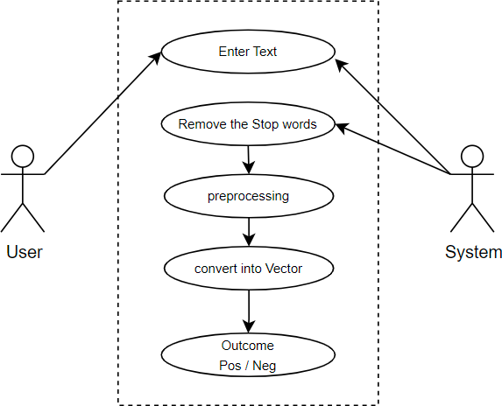

**Figure : 1**

## ER-Diagram:

ER diagrams use various notations for representing data objects, and there is no standardized approach. The original notation by Chen is common in academic texts but less so in non- academic publications and CASE tools. Other widely used notations include Bachman, crow’s- foot, and IDEFIX. All these styles depict entities as labeled rectangles and relationships as lines connecting the boxes. Specific symbols are used to represent cardinality in connections. This document follows Martin's notation, where entities are labeled rectangles (singular nouns), relationships are solid lines (verb names), and attributes, if present, are listed inside the entity rectangle. Identifiers are underlined. Cardinality of "many" is denoted by a crow's foot, while omission of the crow's foot signifies a cardinality of one. Existence is represented by a circle or a perpendicular bar on the line, indicating mandatory or optional existence, respectively.

### Diagram:

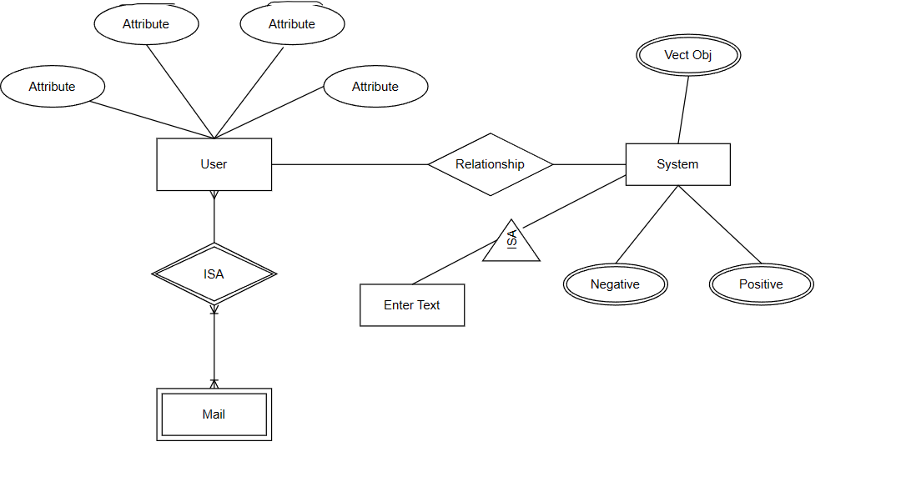

**Figure : 2**

## Activity Diagram:

An activity diagram visually presents a series of actions or flow of control in a system similar to a flowchart or a data flow diagram. Activity diagrams are often used in business process modelling. They can also describe the steps in a use case diagram. Activities model can be sequential and concurrent. Activity diagrams show the workflow from a start point to the finish point detailing the many decision paths that exist in the progression of events contained in the activity. They may be used to detail situations where parallel processing may occur in the execution of some activities.

### Diagram:

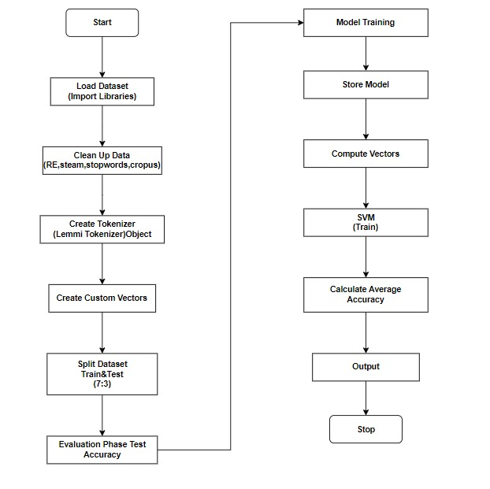

**Figure : 3**

## Data Flow Diagram (DFD):

A data flow diagram (DFD) is a graphical or visual representation using a standardized set of symbols and notations to describe a business's operations through data movement. They are often elements of a formal methodology such as Structured Systems Analysis and Design Method (SSADM).

There are two types of DFDs — logical and physical. Logical diagrams display the theoretical process of moving information through a system, like where the data comes from, where it goes, how it changes, and where it ends up.

DFDs make it easy to depict the business requirements of applications by representing the sequence of process steps and flow of information using a graphical representation rather than a textual description. When used through an entire development process, they first document the results of business analysis. Then, they refine the representation to show how information moves through, and is changed by, application flows. Both automated and manual processes are represented.

#### What are the different DFD levels and layers?

Levels or layers are used in DFDs to represent progressive degrees of detail about the system or process. These levels include:

* + - Level 0: Also known as a "context diagram," this is the highest level and represent is very simple, top-level view of the system being represented.
    - Level 1: Still a relatively broad view of the system, but incorporates sub processes and more detail.

**Diagram:**

##### Level: 0

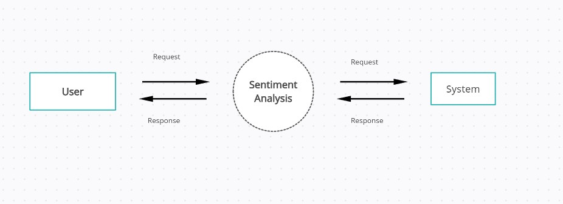

**Figure : 4**

##### Level: 1

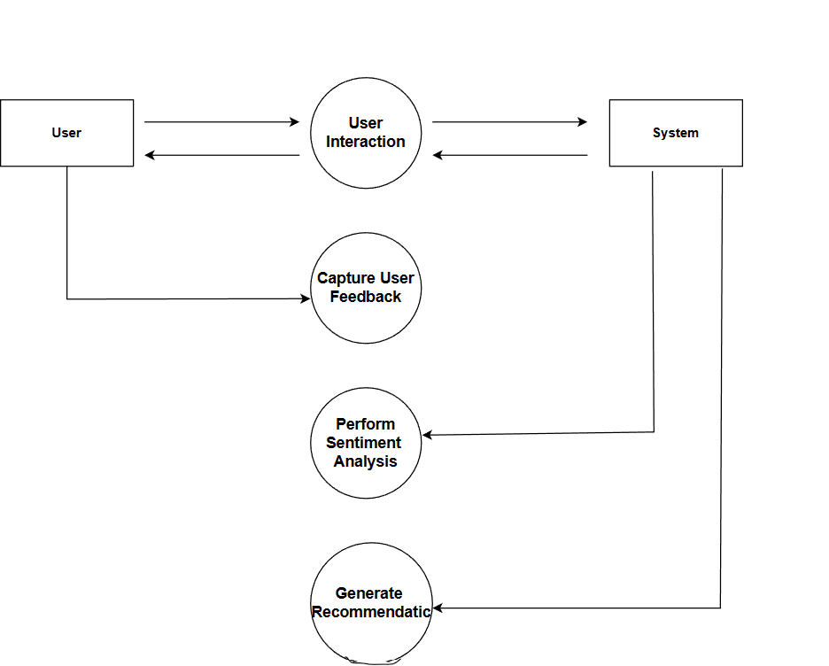

**Figure : 5**

# Implementation and System Testing

## Basics

* 1. **System Testing**

## Unit Testing

* 1. **Integration Testing**

## Testing Plan

* 1. **Basics:**

After all phase have been perfectly done, thesystem will be implemented to the server and the system can be used. A method of software testing that examines the functionality of an application without peeringinto its internal structures or workings. This method of test can be applied to virtually every level of software testing: unit, integration, system and acceptance.

## System Testing:

The primary objective of the system testing process was to identify any faults or defects in our project. We subjected the program to a series of test inputs and carefully analyzed the outcomes to determine if the program functioned as expected. Our project underwent two levels of testing: system testing and integration testing. System testing, also known as system-level tests or system-integration testing, involved the evaluation of how different components of the application interacted with each other within the complete integrated system or application. The QA team played a crucial role in this process to ensure the overall quality and functionality of the project.

## Unit Testing:

Unit testing is commenced when a unit has been created and effectively reviewed. In order to test a single module, we need to provide a complete environment i.e., besides the section we would require. This ensures that the unit's functionality is isolated and rigorously examined, helping to identify and address potential issues early in the development process. By conducting unit testing in a controlled environment, developers can gain confidence in the reliability and correctness of the module, leading to a more robust and stable overall system.

* + - The procedures belonging to other units that the unit under test calls.
    - Testing admin login form-T his form is used for login of administrator of the system In this form we enter the username and password if both are correct administration pagewill open otherwise if any of data is wrong it will get redirected back to the login page and again ask the details.
    - Non local data structures that module accesses
    - A procedure to call the functions of the unit under test with appropriate parameters
    - Report Generation: admin can generate report from the main database.

## Integration Testing:

In The Integration testing we test various combination of the project module by providing the input. The primary objective is to test the module interfaces in order to confirm that no errors are occurring when one module invokes the other module.

level of the software testing process comes after unit testing. In this testing, units or individual components of the software are tested in a group. The focus of the integration testing level is to expose defects at the time of interaction between integrated components or units.

## Testing Plan:

1. Functionality Testing
2. Usability testing
3. Interface testing

### Functional Testing:

Unit testing is carried out once a unit has been meticulously created and undergone a thorough review process. To effectively test a single module, it is imperative to provide a complete and well-prepared environment, encompassing all the required dependencies and supporting components. This ensures that the unit's functionality is isolated and rigorously examined, helping to identify and address potential issues early in the development process. By conducting unit testing in a controlled environment, developers can gain confidence in the reliability and correctness of the module, leading to a more robust and stable overall system.

##### Some Parameters

* + - * Test the outgoing links from all the pages from specific domainunder test.
      * Test the outgoing links from all the pages from specific domain under test.
      * Test all internal links.
      * Test links jumping on the same pages.
      * Test links used to send the email to admin or other users from web pages.

**Test forms in all pages:**

Forms are the integral part of any web site. Forms are used to get information from users and to keep interaction with them.

* + - * First check all the validations on each field.
      * Check for the default values of fields.
      * Wrong inputs to the fields in the forms.
      * Options to create forms if any, form delete, view or modify the

### Usability Testing:

#### Test for navigation:

Navigation is a critical aspect of how users explore web pages, involving various controls such as buttons, boxes, and links to seamlessly navigate through different sections of a website. Usability testing encompasses several essential factors to ensure a user-friendly experience. A well-designed website should offer effortless usability, allowing users to navigate and interact with ease. Clear and concise instructions are vital to guide users effectively, ensuring that they can accomplish their tasks smoothly. Testing the accuracy and relevance of the provided instructions is crucial in determining whether they serve their intended purpose.

Furthermore, a consistent main menu should be present on every page, facilitating easy access to key sections of the website and improving overall navigation efficiency. Consistency in design and layout across different pages contributes to a cohesive user experience, promoting familiarity and reducing cognitive load. By conducting comprehensive usability testing, web developers can identify and address potential pain points, leading to an intuitive and user- centric website that fosters engagement and customer satisfaction.

#### Content:

Content should be logical and easy to understand. Check for spelling errors. Use of dark colors annoys users and should not be used in site theme. You can follow some standards that are used for web page and content building. These are common accepted standards like as I mentioned above about annoying colors, fonts, etc. Content should be meaningful. Allthe anchor text links should be working properly. Images should be placed properly with proper sizes. These are some basic standards that should be followed in web development. Your task is to validate all for UI testing.

##### Other user information for user help:

Like search option, sitemap, help files etc. Sitemap should be present with all the links in web sites with proper tree view of navigation. Check for all links on the sitemap. “Search in the site” option will help users to find content pages they are looking for easily and quickly. These are all optional items and if present should be Validated.

### Interface Testing:

The main interfaces are:

* + - * Web server and application server interface
      * Application server and Database server interface.
      * Check if all the interactions between these servers are executed properly. Errors are handled properly. If database or web server returns any error message for any query by application server then If database or web server returns any error message for anyquery by application server then application server should catch and display these error messages appropriately to users.

# Evaluation

## Graphical User Interface (GUI)

**5.1 Graphical User Interface (GUI):**

1. **Home Page**



1. **Login Page**

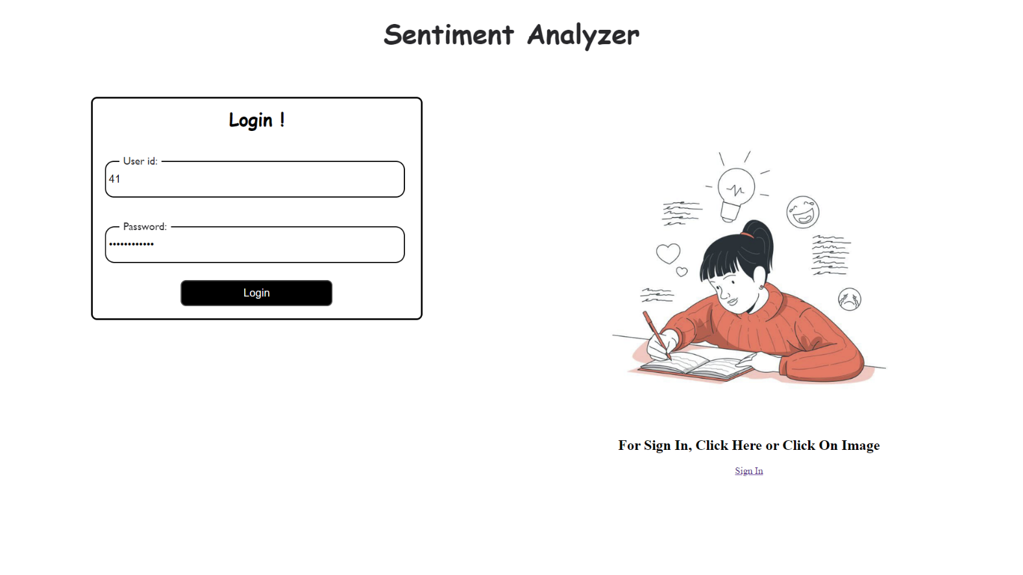

1. **Signup Page**

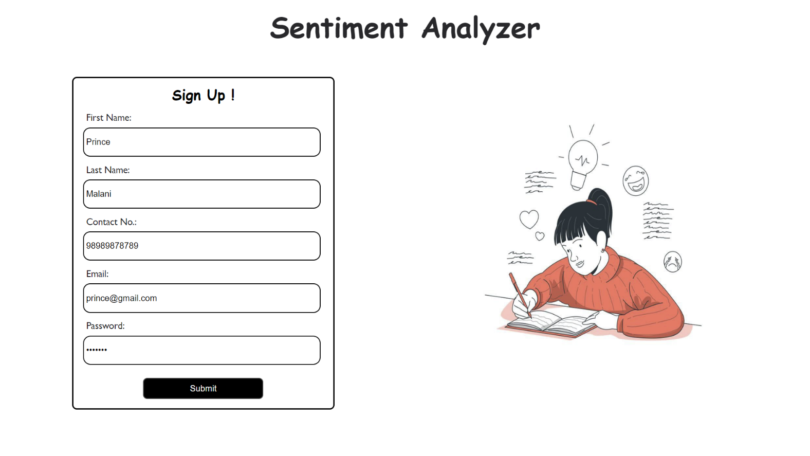

1. **User Details**

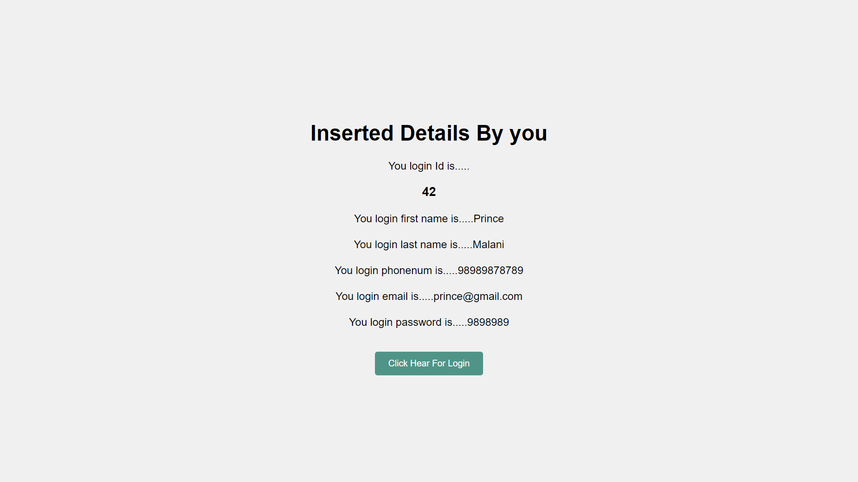

1. **Main Page**

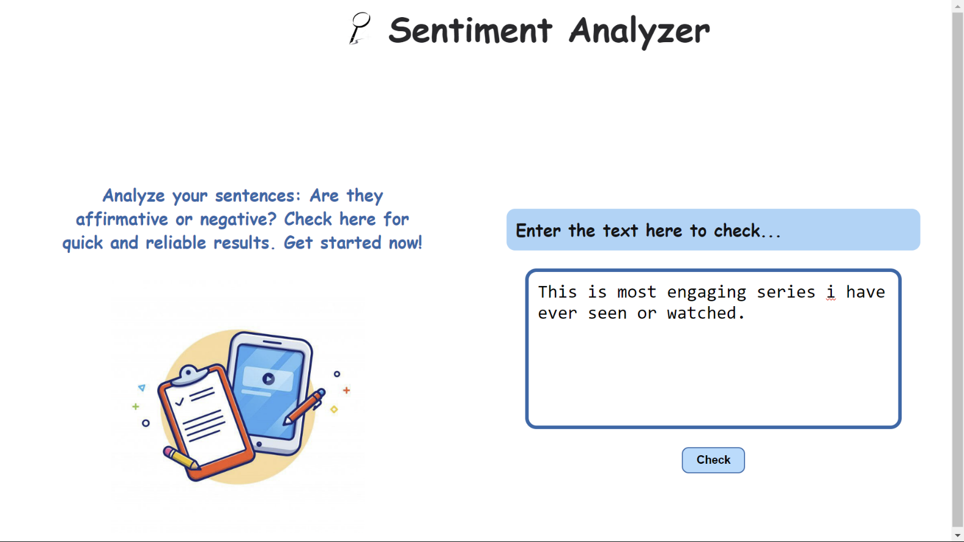



1. **Result page**



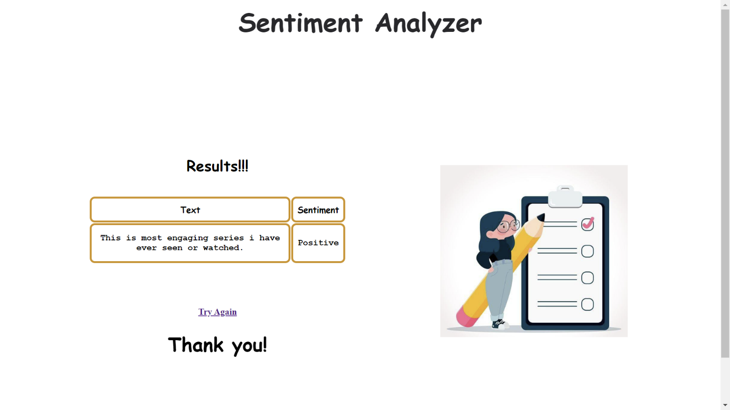

# Limitation and Future Enhancements

## Limitation

* 1. **Future Enhancement**

## Limitation:

While recommendation systems made using sentiment analysis offer several benefits, they also have some limitations that need to be considered. Here are some key limitations:

### Subjectivity and Ambiguity:

Sentiment analysis relies on natural language processing algorithms, which may struggle to interpret the subtleties and nuances of human emotions. The same content may evoke different emotions in different users, leading to subjective and ambiguous sentiment analysis results.

### Limited Data Sources:

The effectiveness of sentiment analysis depends on the availability and quality of user- generated data, such as reviews and comments. In some cases, the amount of emotional data may be limited, leading to less accurate recommendations.

### Emotion Complexity:

Human emotions are complex and can change rapidly, making it challenging to capture all emotional aspects accurately. The system may not always reflect the full emotional spectrum of users' experiences.

### Privacy Concerns:

Implementing sentiment analysis raises privacy concerns related to user emotional data. Users may be reluctant to share personal emotional responses, leading to limited data availability

## Future Enhancement:

The future scope of recommendation systems made using sentiment analysis is promising and likely to expand significantly due to advancements in technology and the increasing importance of personalized user experiences. Here are some key areas where the future of sentiment-based recommendation systems holds great potential:

### Multimodal Sentiment Analysis:

Current sentiment analysis mainly focuses on textual data, but the future will see the integration of multimodal data, including images, audio, and video. This will enable recommendation systems to capture emotions expressed through various modalities and provide even more nuanced and accurate recommendations.

### Emotion Prediction and Real-time Response:

Advanced machine learning models may be developed to predict users' emotions in real-time during their interactions with the platform. This can lead to dynamic and adaptive recommendations that respond to users' changing emotional states instantly.

### Context-Aware Recommendations:

Future systems may incorporate context-aware sentiment analysis, considering factors like time, location, and social context when making recommendations. This will further enhance the relevance and accuracy of suggested items.

### Domain-specific Sentiment Analysis:

Recommendation systems may employ domain-specific sentiment analysis models, tailored to industries such as healthcare, finance, or education. This will allow for more accurate and specialized recommendations in different sectors.

# Conclusion and Bibliography

## Conclusion

* 1. **Bibliography**

## Conclusion:

In conclusion, a recommendation system made using sentiment analysis represents a powerful and evolving approach to enhancing user experiences and engagement across various industries and platforms. By leveraging natural language processing and machine learning techniques to understand users' emotions and sentiments, these systems offer a more personalized and empathetic approach to making recommendations.

The advantages of such systems are numerous. They provide personalized recommendations that align with individual preferences and emotional inclinations, leading to increased user satisfaction and engagement. Users are more likely to explore and discover relevant content, products, or services that resonate with their emotions, resulting in enhanced user retention and loyalty.

Furthermore, sentiment-based recommendation systems have the potential to drive business success by increasing conversion rates and facilitating more emotionally intelligent marketing campaigns. Understanding user sentiments can also lead to improved customer support experiences, as the system can recommend tailored solutions that address users' emotional needs.

## Bibliography:

### Web Resources:

* + - [www.w3cschools.com](http://www.w3cschools.com/)
    - <https://www.javatpoint.com/flask-tutorial>
    - <https://docs.jupyter.org/en/latest/>

### Books:

* + - Object Oriented Modelling and Design with UML (second edition) by Michael Blaha and James Rambaugh.