PHASE 1
Employee Data Spreadsheet
The employee data is prepared in Excel with fields such as Employee ID, Employee Name, Email, Department and Location.
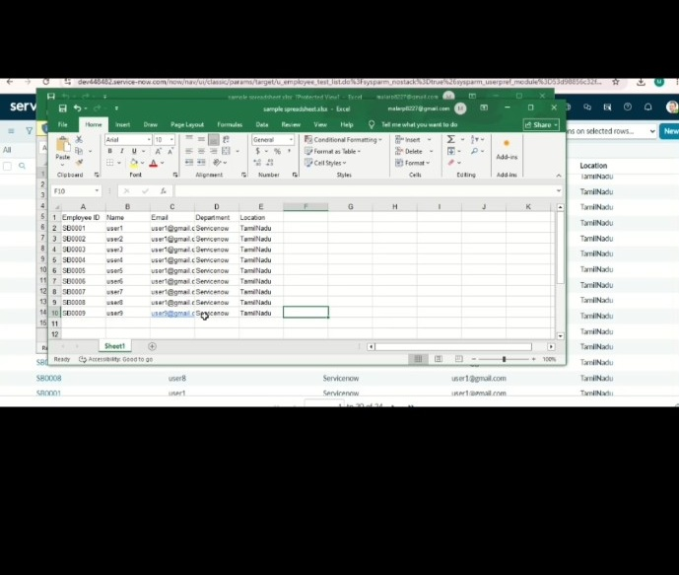
ServiceNow – Import Data using Transform Maps (Spreadsheet)

