PHASE 2
Load Data / Import Set
The Employee Import staging table is selected and the spreadsheet is loaded into ServiceNow.
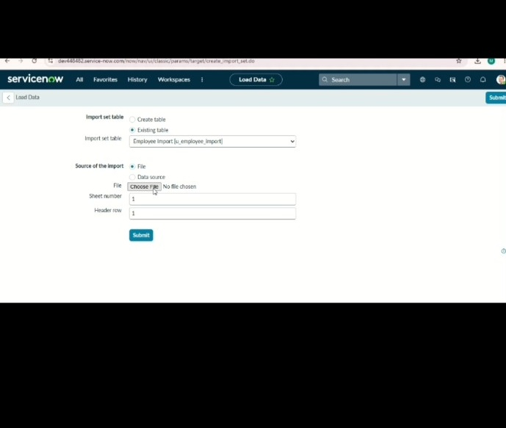
ServiceNow – Import Data using Transform Maps (Spreadsheet)

