PHASE 3
Import Set Configuration
The ServiceNow import configuration and field information are shown before processing the employee data.
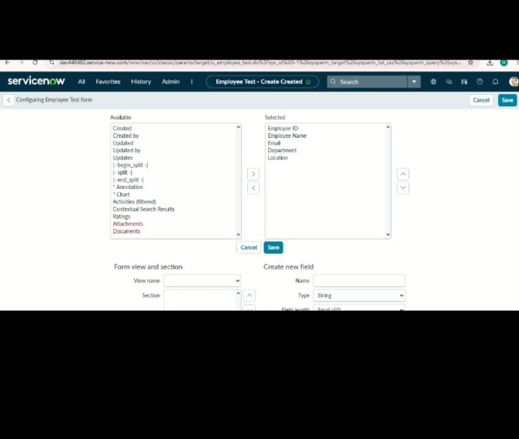
ServiceNow – Import Data using Transform Maps (Spreadsheet)

