PHASE 4
Employee Test Table
The imported employee records are displayed in the Employee Test table.
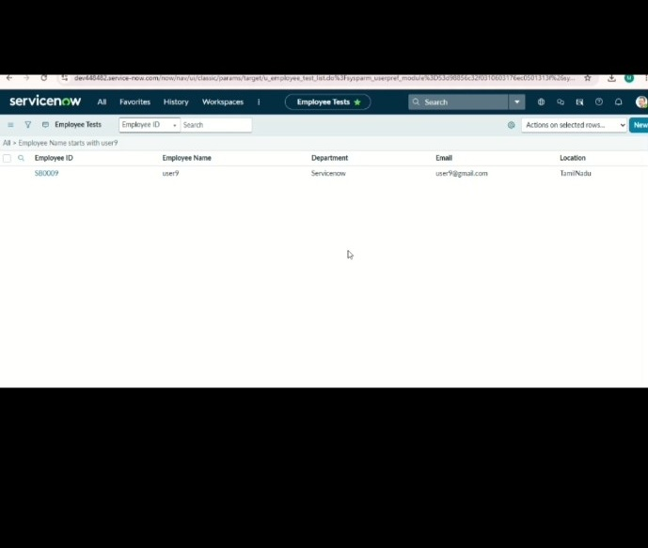
ServiceNow – Import Data using Transform Maps (Spreadsheet)

