PHASE 5
Transform Completion
The transform process completes successfully and ServiceNow provides the next-step links.
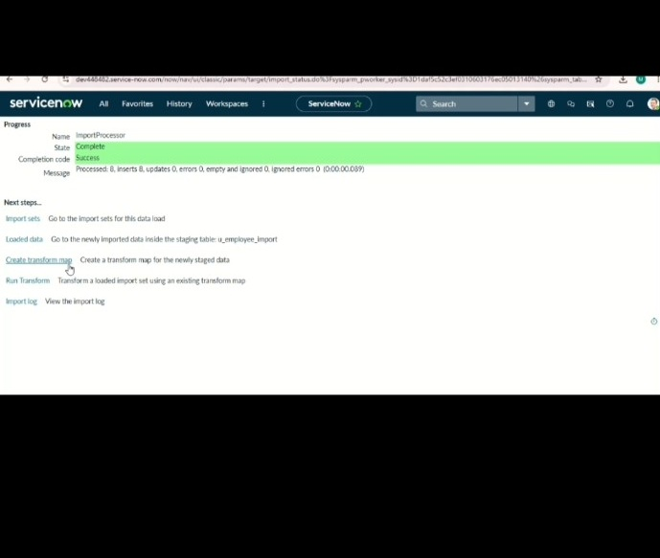
ServiceNow – Import Data using Transform Maps (Spreadsheet)

