PHASE 6
Transform / Import Result
The transformation result is shown with a successful completion status.
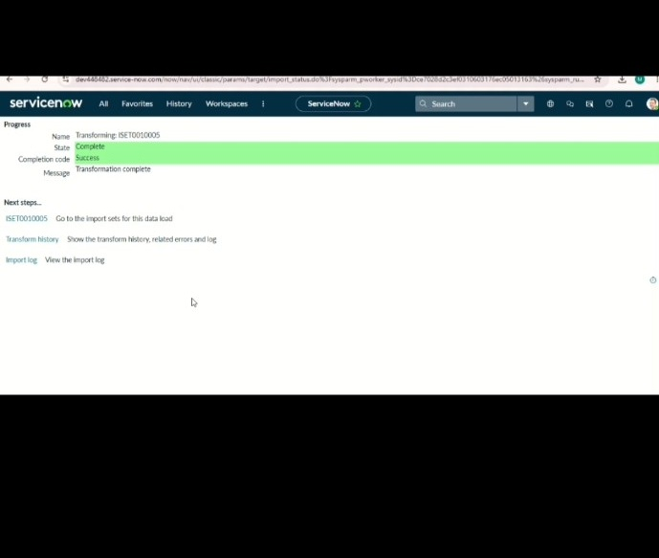
ServiceNow – Import Data using Transform Maps (Spreadsheet)

