PHASE 7
Employee Records Validation
The Employee Test table is checked to verify the imported employee records.
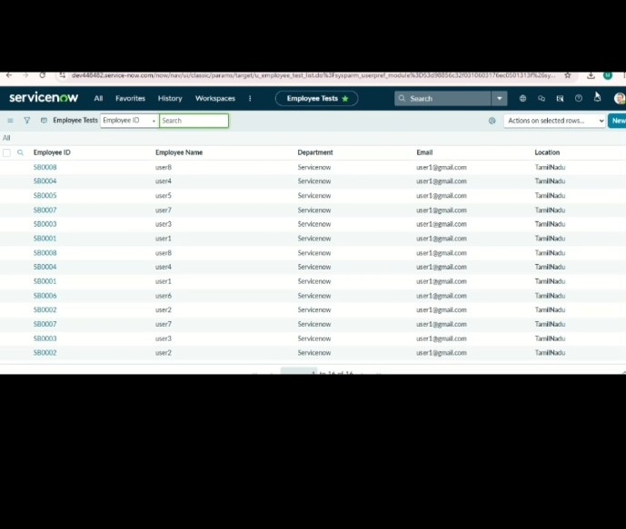
ServiceNow – Import Data using Transform Maps (Spreadsheet)

