PHASE 8
Employees by Department Report
A pie-chart report named Employees by Department is created from the Employee Test table.
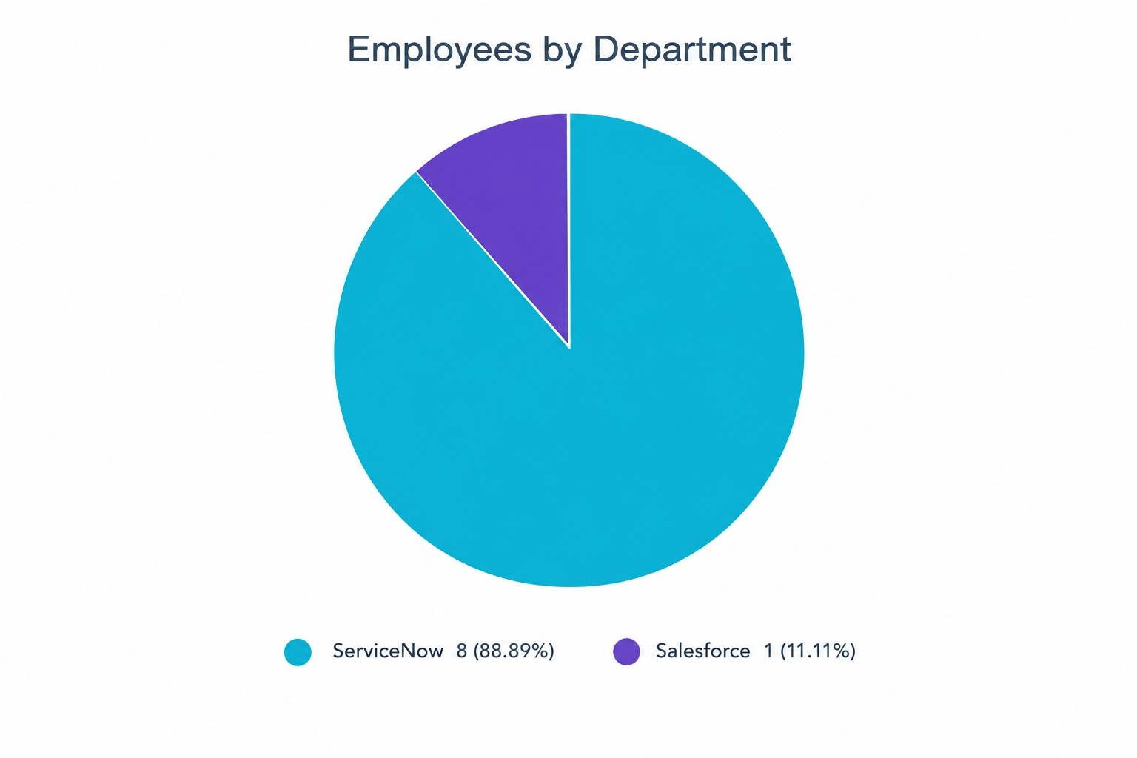
ServiceNow – Import Data using Transform Maps (Spreadsheet)

