

Interview Assignment

**ReadMe**

By: Malarvizhi Sugunaraj

Date: 09-09-2018

**TABLE OF CONTENTS**

Contents

**1.** **Scope Description** 3

**2.** **Requirements** 3

**3.** **Implementation Approach** 3

**4.** **GitHub Repository Details** 4

**5.** **Repository Folder Hierarchy** 4

**6.** **Pre-Requisites** 5

**7.** **Instructions to Run the Test** 5

**8.** **Test Cases and Results** 7

## **Scope Description**

The assignment is to automate all possible test scenarios for the User Sign Up API that takes 6 fields as input and determine the execution status based on the responses from API. Any available automation Tool can be used to complete this assignment

## **Requirements**

The API tests should be run against a mock test harness that is not hooked up to any database. All test cases should be documented with the test results. Code should be submitted using Github and repository link should be provided. Readme should be included to provide the steps to setup and run the tests.

Valid criteria/fields for signup (all fields are required):

* Username
  1. must be greater than 2 characters
* First Name
  1. Alpha characters + spaces + apostrophes are valid - nothing else
* Last Name
  1. Alpha characters + spaces + apostrophes are valid - nothing else
* ​Password
  1. greater than 6 characters
  2. less than 20 characters
  3. must contain at least 1 upper case letter
  4. must contain at least 1 lower case letter
  5. must contain at least 1 number
  6. must contain at least 1 special character
* Email
  1. must be a valid email address
* Phone Number
  1. must be a valid phone number - (acceptable format xxx-xxx-xxxx)

## **Implementation Approach**

For the given requirements and the scope, I have automated the test scenarios/cases using the below approach

* Used Java as the source code for automating this requirement, referenced all libraries using maven repository by providing the required dependencies.
* Stored the environment details in config.properties file and used the code to read and frame the URLs
* Developed json utility and excel reader utility to read the inputs from the TestData.xlsx and frame the JSON payload to be sent with POST call. Referenced the json, Jackson and apache poi libraries for the same
* Developed the RestClient > POST method referencing httpclient and httpcore libraries
* Developed the test class PostAPITest.java that extends the base class and referencing the other libraries/utils to run all test cases.

## **GitHub Repository Details**

The source code is checked into the below repository in GitHub

<https://github.com/malar2301/assignment>

## **Repository Folder Hierarchy**

The source code is available in the below hierarchy

* + assignment
    - src/main/java
      * com.onforce.interview.assignment
        + BaseAPI.java
      * com.onforce.interview.assignment.client
        + RestClient.java
      * com.onforce.interview.assignment.config
        + config.properties
      * com.onforce.interview.assginment.data
        + Users.java
        + TestData.xlsx
        + Users.json
      * com.onforce.interview.assignment.data
        + ExcelReader.java
        + TestUtil.java
    - src/test/java
      * com.onforce.interview.assignment.test
        + PostAPITest.java
    - pom.xml

**src/main/java** – Contains Base class, config files, data files required to run for different user signups and util files for reading inputs from excel and forming JSON object from user inputs

**src/test/java –** This folder has the test class that uses the libraries, utils and data from src/main/java. Running this test class will trigger all API requests and print the results in the console

**pom.xml** – includes all dependencies to include the respective libraries (testing, json, Jackson, httpclient, httpcore, etc) for running the test

**TestData.xlsx** – All combination of user signup details are provided in this sheet

**config**.**properties** – Used this config file to provide the environment details

## **Pre-Requisites**

Below tools/plugins should be installed and available for the test to run

* JDK 8
* Eclipse IDE
* Maven Integration for eclipse - plugin
* TestNG for eclipse

## **Instructions to Run the Test**

**STEP 1:** Download/Clone the repository from GitHub using the link to your local: <https://github.com/malar2301/assignment>

**STEP 2:** Import the project “assignment” to eclipse as mentioned in the below screen shots:

1. **Choose File > Import > Maven > Existing Maven Projects**

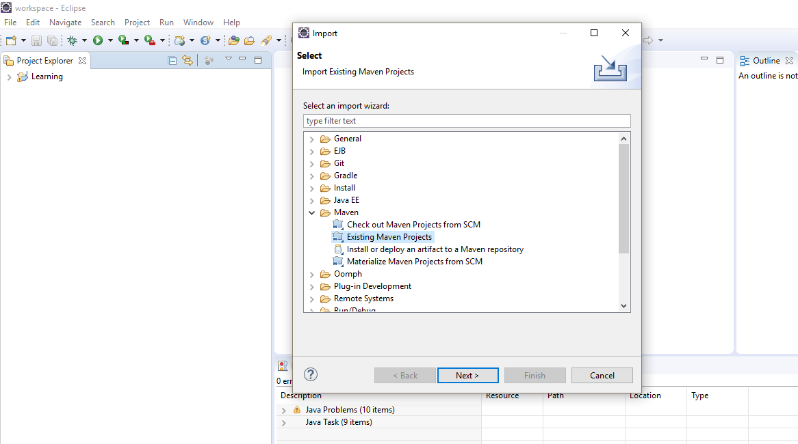

1. **Browse and choose “assignments” project** (check for Maven Dependencies folder for the required jars)

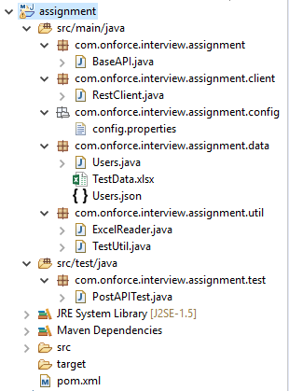

**STEP 3:** Navigate to **assignment/src/test/java/com.onforce.interview.assignment.test**

**STEP 4:** Run PostAPITest.java using

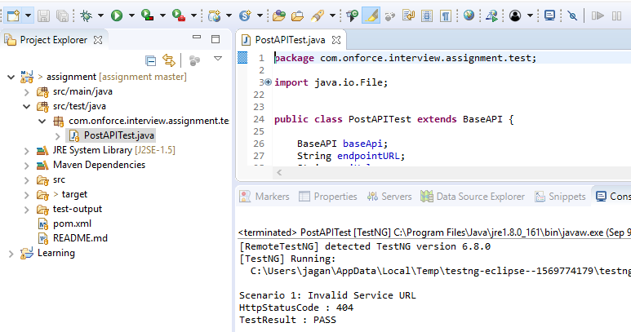

**STEP 5:** Check for the results in the console

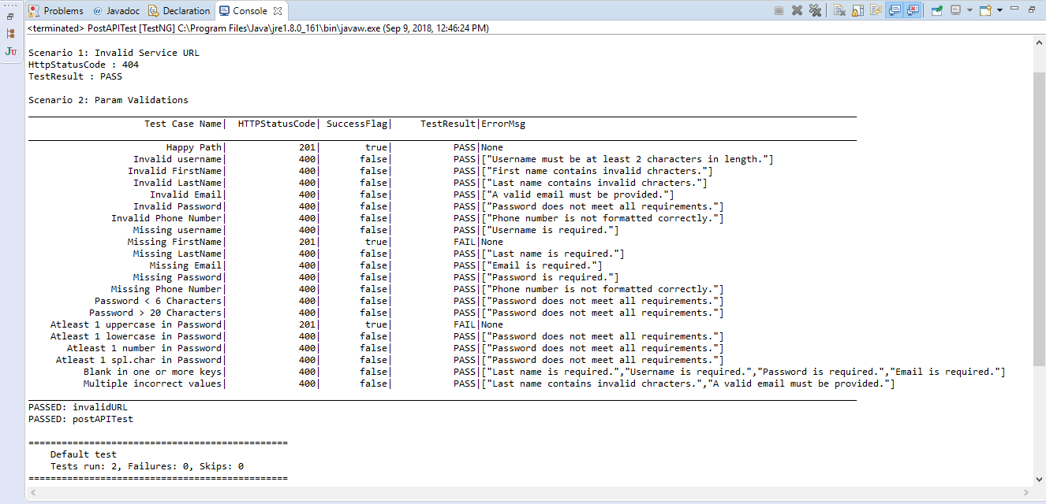

STEP 6: The test can be run for different set of test data using /**assignment/src/main/java/com.onforce.interview.assignment.data > TestData.xlsx**

## **Test Cases and Results**

Test cases along with the results are document in the excel:

**TestCases_WorkMarket_InterviewAssigment.xlsx**

