Background Paper for
The Shared Homeland Paradigm Project:
Making Common Place
in Israel-Palestine:
Lessons from Northern Ireland
Frank Gaffikin
March 2026

The views expressed in this publication are those of the author(s) and do not necessarily reflect the position of the Shared Homeland Paradigm project.
Introduction
No two conflicts are the same. While this paper concentrates on Northern Ireland, it poses the question as to whether its experience in recent decades of pursuing the formal policy of creating a more shared society bears any relevance for Israel-Palestine. In doing so, it acknowledges the many differences between both places. There are, however, some apparent resemblances. Both have long histories, allowing for generations of ancestral grievance around disputed conquest and heritage. The central feature of each is a contest over identity, territory and sovereignty. That macro struggle plays out in micro clashes over access to consecrated ground, layered over time with shrines and rituals. Behind the oversimplification of a binary battle between two pre-eminent groupings, lies a complicated differentiation: in Northern Ireland, alongside those who identify themselves as of Protestant or Catholic background, are secularists, atheists, and ethnic newcomers, whose political alignment is fluid; in Israel, the Mizrahim and Haredim are distinguishable from fellow Jews, and splits among Palestinians can be religious and in the case of Hamas and Fatah, political. In both places, the conflict has been theorized in terms of ethno-nationalism and settler colonialism. The cycle of violence generates atrocities, which in turn father the next atrocities. Violence itself accentuates polarization, physically manifest in barriers, separatism, and spatial segregation. There can be a correspondence between the most segregated, most violent, and most deprived areas. Demography can be seen as destiny in a contest where the traditionally dominant party believes itself to be in an existential struggle. Presently, in Northern Ireland, Catholics are approximately equal in number to their Protestant counterparts, while in Israel-Palestine, at around 7 million, Jewish Israelis are broadly equal to their Palestinian counterparts. Such ‘tight’ numbers make issues like new housing settlements very contentious. In both places, there is a sense of a zero-sum game, rather than prospect of mutual gain. Thus, fatalism and designations of heroes and villains dominate respective narratives. These and related factors help shape the contours of the conflict.
But there are many dissimilarities. The scale and intensity of the violence in Israel-Palestine is greater, as is the geo-political significance. While both places have a religious dimension, it is much starker in Israel-Palestine, where claims of divinely chosen people and eschatological and apocalyptic prophecies bestow doomsday scenarios. In the Irish context, the historical battlelines for republicans centre on the British Empire, whereas in the case of Israel-Palestine, dispute can be traced through multiple Empires, including, Babylonian, Persian, Roman, Ottoman, and British. While militias have operated in both places, in recent decades the military force exercised by the British state to what it perceives as insurrection is far outweighed by the disproportionate violence undertaken by the Israeli state. Similarly, in that recent time frame, the level of repression and discrimination experienced by the proclaimed subjugated group is much greater in Israel-Palestine. These and other features mark pronounced differences between the two conflicts.
Within these qualifications, this paper seeks to explore the role of planning in both places in addressing contested space. It proceeds to offer case studies of attempts to create shared space in Northern Ireland that may offer some models for greater mutual accommodation in Israel-Palestine in the spirit of reciprocal recognition and partaking in a common homeland. It concludes with an assessment of the challenges posed by such an agenda.
The Role of Planning
But what has all this to do with planning? Surely it is a detached, rational, technical and apolitical activity? Well, no, it’s not. Even in its most narrow definition, it concerns zoning and land use. And these issues are tied into property rights and settlement patterns that beset the Israel-Palestine dispute. In its more expansive framework, planning’s role in place-making concerns the social making and mediating of space. As such, it is highly political. In its quest for a built environment that is permeable and fluid and celebrates connectivity and hybridity, it's also at odds with segregated settlement patterns that divide housing and labour markets, embolden use of sectarian motifs and wall murals that mark territory, and cause severance and separation over integration. Proactive comprehensive planning that is inclusive in its engagement with residents seeks a bonded physical representation of the social cohesion that visionary plans foster. Rather than facilitating border lines that demarcate opposing communities, it designs publicly accessible spaces that are unfortified and hospitable. Rather than silo developments, it seeks synergies. Rather than duplication of facilities for each side of a divided society, it seeks a commonwealth of services and amenity. Rather than physical infrastructures like roads that dismember the urban fabric and isolate and insulate, it seeks those that append and darn neighbourhoods together.
Socially Engineered Division
A familiar criticism of this interventionist approach is that it taints planning as a covert social engineering project, thereby embroiling it in the conflict. This is disingenuous. A divided society is predisposed to spatial fissures. For instance, in Northern Ireland in October 1970, just over a year into what came to be known as ‘the Troubles’, the then Unionist-led government established a Joint Working Party, comprising government, civil servant, and security personnel, to examine planning and design in areas marked by public disturbance. Its eventual recommendations included the idea that the comprehensive plan for Belfast, then getting underway, should use the proposed major motorway as a ‘cordon sanitaire’, separating out the West of the city, the site of significant unrest and violence. Across the region, road realignment should be deployed to detach ‘difficult areas’ from each other.

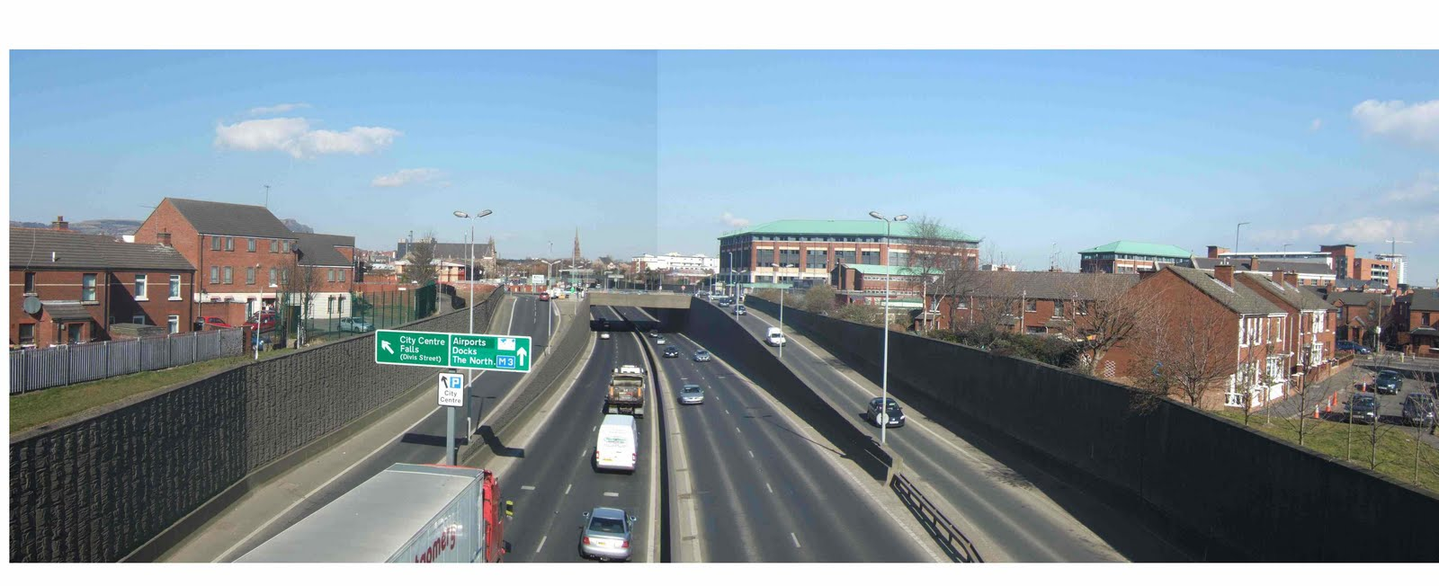
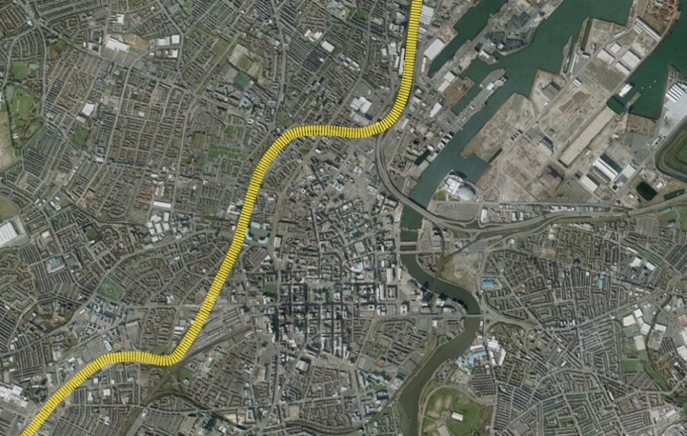 | Figure 1: ‘Westlink’ motorway, a permanent infrastructure separating the west of the city.
Beyond such infrastructural interventions, major plans involving housing and commerce should, where necessary, provide opportunity for consultation with the security forces and other government departments. This general counter-insurgency strategy of ‘engineering’ partition between warring factions and physically containing areas assessed to be sources of subversion, meant that statutory planning should be secretly influenced by security perspectives. Such a strategy was comfortable with increasing residential segregation, and using new build factories, warehouses and business parks to form buffer zones between the two protagonist communities.
Many decades later, in 2015, new plans for Belfast acknowledged how inapt roadbuilding had ruptured the urban fabric, thereby creating mental and physical impediments between the city centre and adjacent neighbourhoods. Interestingly, an opposing voice on the committee came from the Office of the United Kingdom in Northern Ireland. He saw it as resignation to persistent separation, constructed by bricks and mortar, confining selected communities in a way that could cradle far-reaching agitation. And indeed planning and policy proceeded to be conducive to spatial containment.
At the same time, a counter strategy that affirms the efficacy of ‘designing’ for peace amid conflict can be worthy, yet naïve, as the following proposition by Berg demonstrates:
When a city is built to separate conflicting groups or to fortify buildings against bombings—something that can be seen from Belfast to Baghdad—those separations are tacitly encouraged and the bombings expected. Allowing designers into the discussions earlier provides an understanding of the dynamics of urban spaces, and it can lead to the development of precise interventions to instill stability, functionality, and, eventually, peace.
While this general declaration represents an over-stated faith in the reconciling power of urban design, Berg gives the example of two Tel-Aviv based urbanists, Bar-Sinai and Greenfield-Gilat, who posit the connectivity that could be flexibly built into a design that accommodates a current reality of disunion, while facilitating a future reality of greater compromise and understanding. They take the case of the railway in Jerusalem and offer this prospect:
Two separate train lines—one serving East Jerusalem, the other West Jerusalem—would run parallel along the border and lead to the same two-in-one transit hub straddling a border destination. The hub in East Jerusalem would mirror the one in West Jerusalem, both featuring elevated train platforms, market areas, and parks. Before integration, the train station would serve the populations separately: The lines would bring riders from the two populations close, but they would still be separated by a transparent border device between the two train platforms. The catch would be to design and build the terminal in such a way that, upon a peace agreement, the wall could be removed, and the markets, parks, and train platforms could be desegregated almost instantly.
Other examples are presented, such as a shared community peace park flanking between the Gilboa Regional Council, north of Jerusalem and the Palestinian city of Jenin, a joint project that would include a water treatment capacity for the adjoining polluted river, demonstrating the mutual benefit from collaboration. In developing such schemes, what lessons can be drawn from Northern Ireland?
Examples of Shared Space Initiatives in Northern Ireland
Shankill Women’s Centre
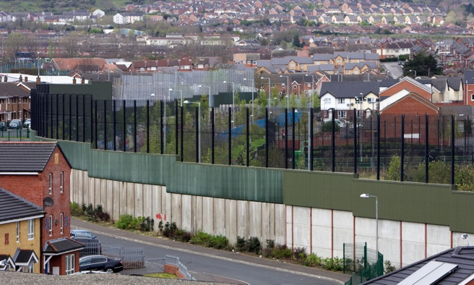
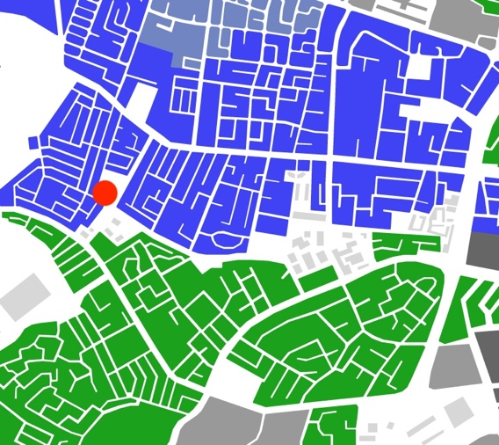
The Shankill area of Belfast is the city’s emblematic Protestant/Unionist neighbourhood, as the Falls Road nearby is for the Catholic/Nationalist community. Both are working-class areas that have suffered significantly from militarist violence during three decades of the Troubles. Opening in 2024, the Shankill Shared Women's Centre is a £7.79 million multipurpose-built shared space for women and their families. Located near the interface area on Lanark Way, adjacent to the largest ‘Peace Wall’ in Belfast, it aims to create ‘a welcoming, safe and accessible shared space for women and their families from all communities’.
Figure 2: Site selection of shared Women’s Centre – situated on historical Falls-Shankill ‘peacewall’.
The project involves collaboration with a group on the other side of the divide, the Clonard Women’s Group, and its associated Neighbourhood Development Partnership, operating in a prominent district within the Falls Road. Together, they provide services that include education, empowering young women, good relations/peacebuilding, training and health awareness, all supported by childcare.
In the case of the Shankill team, they can trace their origin and purpose back over 30 years, a durability that enhances their roots and credibility in the area. They have comprised particular leading figures with a profile in cross-community organisations like the trade union movement, which has an established anti-sectarian stance. The standing of both partner bodies helped secure the substantial funding. This came in part from the European Union’s PEACE IV Programme, managed by the Special EU Programmes Body (SEUPB). Amongst other objectives of reconciliation, this Programme aspires to create a more cohesive society through an increased provision of shared spaces and services. Match-funding came from the combined source of Belfast City Council and central government in Northern Ireland and the Irish Republic.
It offers itself as an inclusive centre that seeks to deliver needed services in a secure and convivial space, while also helping build friendly relations across a sensitive interface. Purposeful contact among women participants is designed to be both socially consequential and sustained. This scope for great impact has been recently recognised by the European Commission’s RegioStars Awards, which select EU-funded projects on the basis of development excellence, innovation and social impact, including inclusivity. The project won the ‘Europe Closer to Citizens’ category in 2025.
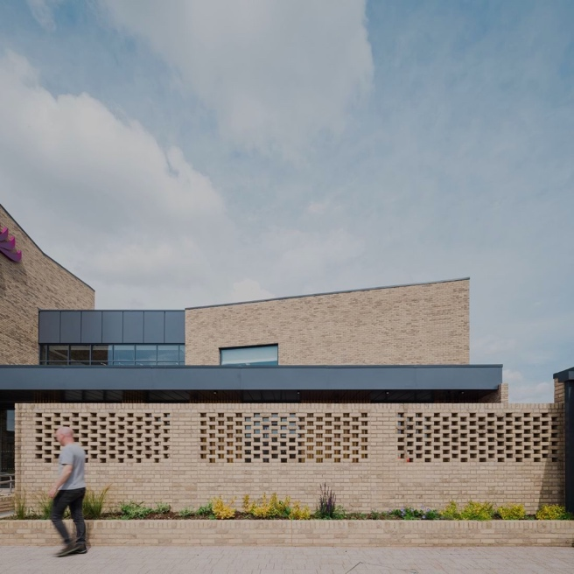
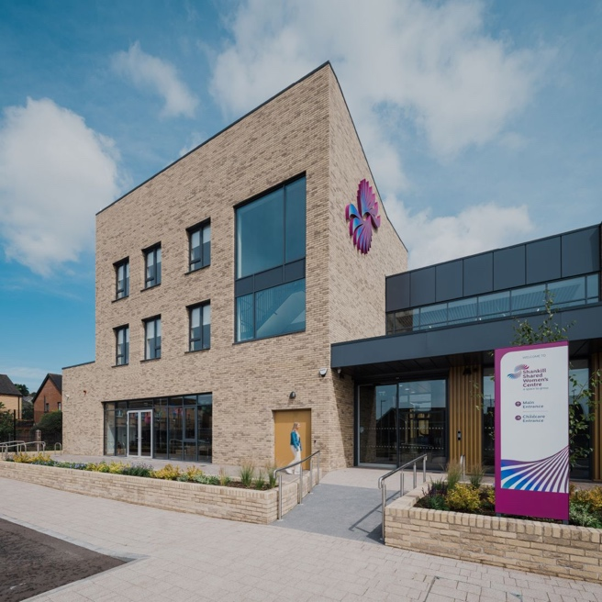
Figure 3: Street views of of Shared Women’s Centre, opened in June 2024
How did such a substantial resource in a deprived conflict-torn environment come about, with women across the divide coming together for mutual lifechanging benefit? First, it has strong community roots, with organisations well versed in both service delivery and project management. They went for an ambitious capital spend to achieve a quality building, and impressive provision of such distinction can attract people from all communities. The imposing 2,700 sqm building was designated Social/Community Project of the Year at the CEF Construction Excellence Awards 2024.
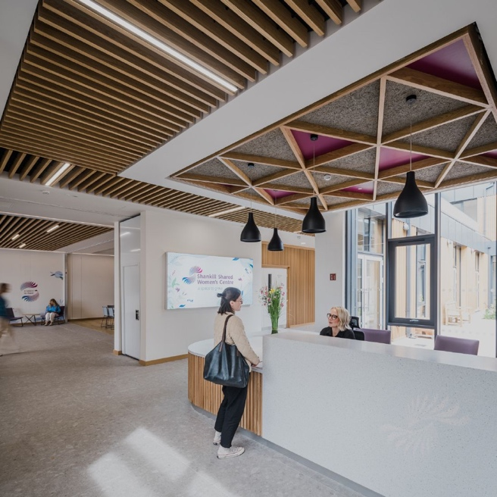
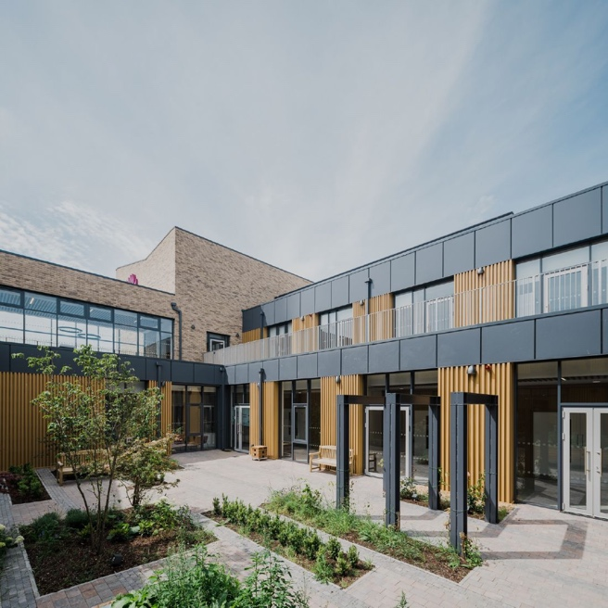
Figure 4: Images of Shared Women’s Centre, all spaces revolve around shared central courtyard.
It is on a site that has experienced layers of contention over the years. Once occupied by mills, its dereliction at one point testified to the deindustrialisation and loss of strategic economic base in the wider area. The subsequent brownfield site became a bonfire ground, and bonfires in Northern Ireland are traditional rituals of partisan commemoration. Future use was itself subject to some contest, with one possibility being usage for much needed social housing in the city. Given these past imprints and current disputes about its settlement, the project’s location was not without deliberation. Remaking old landmark sites in a form that suggests a liberation from the worst legacies of a troubled past has striking appeal for domestic and international funders. The centre’s advocates attained government backing in both parts of Ireland, together with the European peace programme, a feat that takes astute navigation and negotiation. It explicitly targets women, the empowering of whom is a societal issue that can transcend other political and cultural identities.
Together with a token annual registration fee, activities are free at the point of use, making participation financially manageable for all incomes. The courses cover a comprehensive range of life skills, employability training, conflict resolution expertise, civic literacy, and volunteering proficiencies, thereby offering participants continual opportunity to upgrade. Beyond the specific courses, there is deliberate intent to foster an informal curriculum based on values such as people humanising and respecting each other. In being open to ‘all communities’, it is offering a reach beyond the two traditional sides to those who do not necessarily identify with either – like newcomers or the LGBTQ community.
Although located in the Shankill, it near enough borders with the Falls to be accessible to partakers from there. For some, this instance of bridging Shankill and Falls – the two renowned heartlands of loyalism and republicanism – holds special meaning for progress toward a more shared society. Others may say that organisations like the Falls Women’s Centre have long offered care and community-based education for women, regardless of categories like nationality and religious belief.
Not dissimilar schemes for interface facilities reaching out to both main communities include the Black Mountain Shared Space project, situated at a conflict-sensitive interface area in Belfast of Ballygomartin and Springfield Roads. It has seen a £7 million new mixed-use building, intended as shared cross-community facility, opened in September 2024. While the local group behind the initiative has been operating for 15 years, the project was backed by the Belfast City Council and entailed removal of 30 metres of ‘peace wall’. Underway since October 2024, phase two will create 8 new community-use office units. Funders include the EU Peace programme, Belfast City Council, the International Fund for Ireland, and the Northern Ireland Departments for Communities and Justice.
Greenway Development
Another way to extend public space accessible to all involves systematic development of ‘greenways’, open linear corridors offering paths to pedestrians and cyclists, often routed along riverbanks or towpaths or other natural habitats, or reclaimed land, or linking parks, or connecting parks to nearby hills. Whereas the built environment in contested societies can be about enclosure, ghettoisation and defensive space, the central idea of greenways is to open out built-up areas. The idea is to eradicate physical and psychological barriers that partition the urban fabric, separating, isolating, or insulating communities from each other. Instead of dissection, there is intersection. Indeed, it is a multi-purpose enterprise, at once improving urban ecology by fusing the built and natural environment; enhancing the healthy city by promoting well-being and recreation; freeing people from the congested traffic of motorised transport; facilitating protected zones for wildlife; and, at the same time, offering secure space for all publics. Granted that the concept of ‘secure space’ here is problematic and relative. It is secure to the degree that patently public spaces that are not legible in traditional terms of the conflict, that offer new amenities that can be seen to bring mutual benefit to contesting parties, and that are planned, managed and safeguarded in ways that protect users can come to be widely regarded as safe for all sides.
Many examples of these have been progressed across Northern Ireland, designed to connect people and place. In Belfast, the Connswater Community Greenway is a £40 million transformative investment, supported and funded by Belfast City Council in alliance with EastSide Partnership and Northern Ireland Rivers Agency. It covers a 9km linear park and a wider catchment of 16km interconnected pathways, encompassing three rivers – the Connswater, Loop and Knock. Apart from its role in enhancing biodiversity, achieving cleaner rivers, and ensuring better flood resilience, it has brought physical, visual and social coherence and initiated various community interactivities. Linking the various components of the greenway are seven new steel bridges and two wooden ones, thereby networking greenery, pond and glen and local parks like Victoria and Orangefield. But to make the greenway an animated space, it is brought alive by public sculptures, visitor centre, refreshment amenity, observation area, play park, and importantly, by regular events. All this, together with basics like good signposting, gateways and lighting complete the quality scheme. This shows that the creation of places for public gathering is insufficient. They require effective ongoing management. This project has a professional staff team, augmented by volunteer Greenway Leaders, who act as project ‘ambassadors’, promoting its dynamic use, and an engaged local community setup of volunteer support.
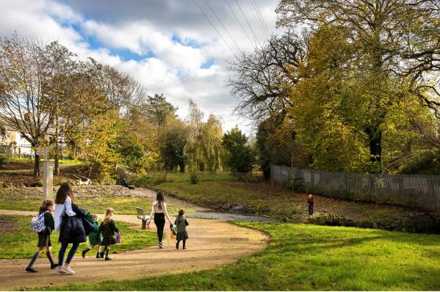
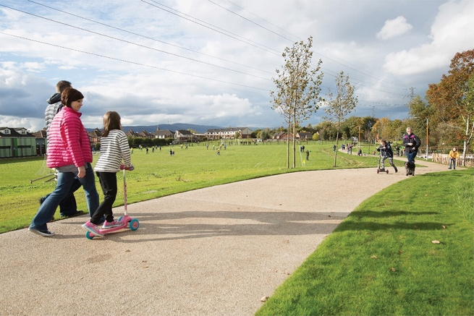
Figure 5: Connswater Community Greenway
Among other examples is the Forth Meadow Community Greenway, a £6.2 million EU Peace Programme funded project, extending 12km from Clarendon Playing Fields to the new city centre transport hub. In common with other greenways, it involves new surfacing of trails, new planting and street furniture, insertion of public art, and linkage with existing parks like Springfield. This greenways movement is gaining momentum for similar initiatives in Sydenham, Lagan Gateway, Shankill, Bog Meadows, and Carryduff, among others. Such impetus is prompting the case for a strategic plan to extend this programme and build a Greenway Network that will allow some of these greenways to start linking near each other. Importantly, some will aim to link into the city centre, thereby opening areas that were long cut off, not only from each other but also from the urban core.
Successful efforts to realise such projects share certain features: cross-party political backing; an engaged public; well-based local organisations with considered proposals; bold ambitious plans capable of transformative intervention; multiple sources of funding; and quality design. Dedicated spaces of uncontested public purpose can secure widespread approval because their promise of more open recreational space, or protection against flooding, or routes that permit wheelchair access and car-free mobility can cut across different communities. Again, sustainable projects understand that it is insufficient to provide new facility without ongoing organisation of ‘happenings’ to attract consistent public use and familiarity. The purpose is to make these common places commonplace.
At the same time, open design and principles of equal access do not guarantee against informal segregations within the greenways, based on traditional territorial affinity and sense of safe boundary held by different communities.
Shared Housing
In the experience of this author, difficult as it is to develop shared social and cultural facilities in troubled areas with long legacies of decline, dereliction, deprivation and division, the most sensitive issue around which there is the most contentious dispute is housing. In good part, this is because housing allocation can change the demographic and electoral arithmetic. Despite apparent public backing for mixed neighbourhoods, evidenced in longitudinal studies like the Life and Times Survey, public policy moves to break down deeply embedded residential segregation, particularly in social housing, have been tentative and slow. The majority of Northern Ireland’s social housing estates are single identity communities, segregated on the basis of religious background. Yet, the Northern Ireland government formally affirms shared housing, and as part of its Shared Housing Development Programme, now known as Housing for All, the relevant department seeks to annually build 200 shared housing units.
Shared neighbourhood schemes are seen as a pivotal part of the government’s strategy known as Together: Building a United Community (TBUC), which envisions:
A united community, based on equality of opportunity, the desirability of good relations and reconciliation - one which is strengthened by its diversity, where cultural expression is celebrated and embraced and where everyone can live, learn, work and socialise together, free from prejudice, hate and intolerance.
The Housing Executive, Northern Ireland’s regional housing authority, is working with 11 local Housing Associations on 85 sites for shared housing, amounting to a total of 2925 homes. Of these, 49 sites have been completed, with 36 in process or soon to commence. These initiatives are complemented by 5-year Good Relations Plans, which contain ‘bonding’ programmes to develop a sense of shared neighbourliness within each new development, and ‘bridging’ programmes to help develop connection between new ‘shared’ residents and inhabitants of nearby communities. For instance, the Belfast City Council has a Belfast Agenda, setting out a plan to make the city a ‘welcoming safe, fair and inclusive’ place for all. Currently, Belfast has 4 new shared housing developments. But new integrated residential settlements have encountered problems. For instance, in Belfast in 2017, four Catholic families fled their homes in the shared housing area of Cantrell Close due to paramilitary intimidation, and in 2025 there were intimidatory incidents in North Belfast’s Annalee and Alloa Streets. Paramilitaries have long ‘gatekept’ territory, and ‘shared housing’ blurs boundaries.
An example of an early cross-community attempt to create shared housing is the Delaware project, which started in 2010. It involved the acquisition of an old commercial building, located on a disputatious interface site on Belfast’s Limestone Road between Catholic Newington and Protestant Tiger’s Bay. Two local Housing Associations, each mainly associated with each main community, collaborated in consultation with local communities, in designing residential accommodation to be shared by people from different community backgrounds. It has been supported by a forum comprising residents, police and interface workers, and the intra-community cooperation continues through the Duncairn Community Partnership. Interestingly, this project has had a relatively low profile, perhaps to prevent it drawing the wrong attention from potential opponents.
Since residential segregation is particularly marked in social housing estates, and there have been funding constraints on building new social housing, despite significant housing demand, potential for new shared housing schemes is restricted. Some argue that the priority should be meeting housing need, and that therefore reconciliation and cohesion should not take precedence over inclusion and equality. Indeed, from this perspective, genuine reconciliation is dependent on achieving equality. Moreover, given that territory continues to be marked in many parts by partisan flags and wall murals, and paramilitary coercion is still a menacing factor, the jeopardy felt by some in taking a chance on this kind of shared living is likely to remain.
Outside public and community housing initiatives, market-driven habitat schemes in Belfast’s new waterfront development of Laganside and Titanic quarter have regenerated old dockland areas into more cosmopolitan spaces that intentionally try to be legible outside traditional sectarian terms. The vibe of waterfront living, adjacent to café, museum, commercial, entertainment and leisure facility, seemingly attracts a mix of people, such as young professionals, at ease with diversity. A recent example is a mixed tenure scheme of 778 housing units, known as Loft Lines, on a brownfield site within the Titanic quarter, led by a private developer, with Clonmil Housing Association contributing the affordable component. The immediate hinterland offers the ambience associated with riverside walkways. By such means, the private sector, driven by commercial rather than social policy interest, may inadvertently be effective in creating shared spaces, that might be looked upon by some as politically motivated if led by the public sector.
In general, whatever the local benefits of specific projects, funded under the auspices of developing peace and shared space, sceptics suggest that their process is largely transactional. In other words, community interests on both sides know that they have a better chance of attaining ‘peace programme’ money if they apply as a cross-community partnership. So, sceptics claim that some at least use this as a flag of convenience, rather than as a platform to develop sustainable reconciliation with the other side. For those critics, it is less a matter of developing ‘shared space’ as much as ‘shared out space’, whereby each side agrees to the resource allocation for the other provided the corollary is that they get the same in return. The extent to which the substantial peace-making funds have achieved their purpose is difficult to determine. Evaluation studies of their impact concede that it is easier to determine their outputs rather than outcomes. This is partly because the baseline data on the pre-existing condition before intervention, together with viable measurement of the change categories, are often insufficiently robust. The ‘tick-box’ culture prizes what can be counted, not necessarily what counts.
Summary Considerations
Any summary lessons from Northern Ireland’s intricate experience of planning for shared space risks being cursory. The first thing to note is that the region’s violent conflict and its collateral agony, pale in scale and intensity, relative to the recent catastrophe in Israel-Palestine, following the Hamas-led massacre in October 2023, and the subsequent destruction of Gaza. In Northern Ireland, one reason presented for slow progress in peace and reconciliation following the 1998 Good Friday/Belfast Agreement is the legacy of inter-generational trauma inflicted by the violence. This argument portends a pessimistic outcome for Israel-Palestine. On the other hand, despite being subject to two devastating nuclear attacks by the US in World War 11, Japan was in trading and diplomatic cooperation with America within a decade, following the Treaty of San Francisco coming into effect in 1952, reestablishing Japanese sovereignty and developing new security cooperation. Change has a cadence dependent on political will, public sentiment, and the favourable economic support that motivates all sides to experience a ‘peace dividend’ of better life opportunities.
In Northern Ireland, multiple public documents have affirmed the objective of creating a shared society post 1998, and the subsequent ‘Agreements’ at St. Andrews (2006) and Stormont House (2014). These have included: A Shared Future (2005); Cohesion, Sharing and Integration (2010); and Together: Building a United Community (2013). Local government Councils have ‘good relations’ strategies to promote better exchanges across the sectarian divide, and these are implanted into their Local Development Plans. These strategies have been underpinned by an EU Peace Programme, which since 1995 up to the end of the current phase in 2027 will have seen Euro 3.7 billion spent to support cross-community projects designed to embed the peace. Other philanthropic money augments this spending. For instance, the International Fund for Ireland has invested £780 million across the island on peacebuilding projects since its inception in 1986. Chuck Feeney’s foundation, Atlantic Philanthropies, donated around Euro 2 billion throughout Ireland, with nearly half billion to projects in Northern Ireland. Alongside all this, the Shared Education Act (NI) 2016 provides the basis for collaborative learning opportunities among students of different religious faiths and socio-economic status, with the goal of promoting good relations, community cohesion, equality of opportunity, and respect for diversity.
Despite all these policies and the substantial funding that buttresses them, the dial has not shifted significantly on some fundamentals of division and separation. Though systematic organised violence has notably decreased, paramilitary power in some working-class neighbourhoods remains. Between 1998 and early 2023, there were 3,260 ‘punishment’ assaults, with 63.3% undertaken by loyalists and 36.7% by republicans. Research from the Northern Ireland Housing Executive has found that 90% of social housing areas are segregated on ethno-religious lines, and there is a close correspondence in places like Belfast between those parts suffering multiple deprivation, segregation, and legacies of past violence.
Whereas in 2024, two-thirds of young people had been involved in shared education with another school, just 8% approximately of children in Northern Ireland are educated in integrated schools, set up first in 1981 to purposefully bring together children from different religious, cultural and social backgrounds. Despite this, two-thirds of people say that they would prefer to send their children to a mixed religion school. While 76% of people say that they would prefer to live in a mixed religion neighbourhood, only 31% perceive their neighbourhood as mixed. In terms of public spaces in their area, over 90% regard leisure centres, parks, libraries and shopping centres as ‘shared and open’ to both main communities. Yet, 59% think Protestants and Catholics use different shops and services, like the local GP, in their area, while just over a quarter think that this is not the pattern. All told, less than half (47%) of adults and over one third (37%) of young people think that relations between Protestants and Catholics have improved relative to five years ago.
Conclusion: Steps Forward
In this context, the following are some of issues that planning faces in addressing ‘shared space’.
- The need to consider a spatial typology in places of conflict. There is ethnic space, where the presence and/or influence of one side predominates. There is neutral space, where all communities can feel safe and welcomed. There is shared space, where there is capacity for people to meet and mix across divides in candid but respectful exchange about their difference. Shared space has to be dialogic space. There is cosmopolitan space, which transcends local political identity in favour of a more international affinity and embrace of global diversity. And there is dead space, which can be a buffer zone or ‘no man’s land’ or abandoned derelict area, of which no side to the conflict claims ownership. While these types may be contested, there is need for greater definitional clarity.
- Given the links between deprivation, segregation and sites of the most intense violence, regeneration and reconciliation are twin processes. Yet, redistributive initiatives can unintentionally amplify division when rival communities compete over resources. In fostering greater pluralism and equity, while challenging dominant power and discrimination, terms like need, equality, and inclusion are part of the contest, and they need to be considered alongside others, such as assets, opportunity, responsibility, and rule of law.
- This approach is tied to civic, not ethnic priorities — that transcend tribal enclaves and empower planners to act as ‘border-crossers’, seeking win-win over zero sum outcomes – to get beyond the charge that says that if your side is gaining, my side must be losing.
- Old style planning that was based on the ‘predict and provide’ model needs replacing with a proactive and participative strategy that openly identifies power relations -- who gets access to land and resources at what cost and benefit to whom?
- Physical development and creative planning and design are necessary but insufficient. Development of places needs development in places. This involves building capacity to challenge unjust power, enhancing trust and connection for alliances of progressive change. This soft infrastructure is at least as important.
- In turn, this process demands multi-disciplinary teams of planners, residents, educationalists, economic developers, etc operating robust evidence-based analysis and critical thinking about power structures. It involves tackling institutional amnesia, which can erase the lessons to be learned from past best practice, thereby reinventing wheels rather than scaling up and disseminating good impact outcomes from previous interventions.
- Reconnecting fragmented and partitioned places, scarred by segregation and inequality, planning must move from 3P (parcel, parse, portion) to 3S (stitch, scale, scope):Stitch cities and areas together as one coherent whole; Scale investment to match the scale of the challenge, redefining “local” to embrace cross-community populations; Scope development to include both needs and assets, aligning public, private, and voluntary resources behind a shared vision.
- In teamwork and workshop dialogue with residents it is useful to engage around principles and values. For instance, there is a beneficial discourse around propositions such as no group has exclusive preserve on access to the public city; the city as a whole should be shared space, creating a pluralist place for a pluralist people; sustainable places should accommodate mixed use, mixed income and mixed publics; development of marginalized and interface areas needs to be done within a framework of wider regeneration that connects them to wider social and economic opportunity; planners should not don the mantle of the technocrat, but rather advocate equity planning in favour of the most dispossessed; though the term ‘community’ has a positive cordial connotation, ‘community’ in deeply divided societies can often be a refuge for tribal solidarity rather than inclusive belonging; planning should provoke against entrenched thinking, while avoiding inflaming a delicate situation; appealing to people’s practical needs often achieves more than appealing to their abstract goodwill; can planning make progress in contested states without macro change that shifts from ethnic (based on kinship and cultural affinity) to civic (based on citizenship and shared rights) nationalism? civic values—equity, diversity, and cohesion—should supersede sectarian loyalties; Yet, in contexts like Northern Ireland and Israel-Palestine, where the concept of citizenship is fragile, and where sovereignty itself is contested, appeals to shared citizenship are problematic; is there not a contradiction in Liberal democracies, which celebrate diversity yet claim, at least, to support universal equality, producing tension between group recognition and individual rights? Do structural inequalities—class, gender, race— not undermine the promise of equal opportunity? How do you unpack historic injustices, which have imprinted themselves in layers of spatial discrimination and containment? Effort to redress inequality can breed resentment. In divided contexts, parity of treatment is not uniformity—those in greater need require greater support. Yet unequal resource allocation easily fuels accusations of bias, entwining peacebuilding with the very conflict it seeks to resolve; how do you confront inequality while aiming to create a unified social fabric where difference coexists with shared purpose? Are strategies for inclusion invariably at odds with strategies for cohesion in contested states? Such questions don’t have definitive answers. Rather, they’re intended to stimulate debate and challenge conventional ideas about planning being apolitical.
- In working to align social and spatial policy, avoid proliferation of plans and strategies, a feature that bedevils Northern Ireland, whereby their nesting in terms of authority, hierarchy and accountability causes confusion in the move from launch to implementation. Delivery mechanisms – timelines, funding, agency responsibility, and impact measures – must be built into the plans from the start.
- Challenge euphemisms. Peace Walls in Northern Ireland are really segregation walls. The ‘peace process’ is a blanket term that can be abused to cast legitimate disagreement in terms of pro and anti-peace. The concept of ‘shared future’ suggests integrated living and working across the main divide, rooted in principles of equity, interdependence and diversity. What of those who argue that such liberal sentiment underplays persistent divisions based on class, gender and other structural discriminations? ‘Collateral damage’ is a shameful way of talking about fatalities, dehumanising victims of violence. ‘Communities in Transition’ is a term used in Northern Ireland to refer to those areas still living in the shadow of the gunman, from which they are trying to emerge. The idea is to provide them with special funding that supports this process. But spatially targeting extra resources to areas plagued by violence can inadvertently ‘reward’ violence.
A fundamental consideration of the interventions outlined here to promote ‘mutual understanding’ is that they are premised on a flawed anti-prejudice contact model, which posits that increasing cross-community engagement reduces animosity. However, as Freud’s ‘narcissism of small difference’ postulates, greater inter-group familiarity can amplify minor dissimilarities, bolstering rather than ameliorating discord. Moreover, the contact model tends to see prejudice and bigotry as individual-level concerns, attributable to ignorance, and correctable by systematic contact with the other, improved interpersonal relations and individual behavioural change rather than system transformation. Herrault addresses this in Northern Ireland examples like the shared housing policy, which he sees as moralising what constitutes a balanced community, and as operating regulatory procedures like ‘good neighbour’ charters, instead of focusing on redistributive priorities that redress historic discrimination and violent displacement and remedy housing need. Structural inequality is demoted in favour of a managerialist approach to community relations within spatially engineered areas. In largely using binary identities --- Protestant and Catholic – it airbrushes other identities. The sectarian signature on space takes precedence over the class one, spatialising rather than socialising public problems and largely discounting relations of domination.​ ​

With maps, photos and visuals from Clare Mulholland
Department of Environment (N.I.) (2015) Belfast Metropolitan Area Plan (BMAP) Part 4; Vol. 2; 23.
Cunningham, T. (2025) Human Rights and the Architecture of Conflict. London & New York. Routledge.
Berg, A. (September/October 2014) Diplomacy by Design. Foreign Policy No 208. pp. 66-71. 68.
Ibid. 69.
Morrison, J. F. (2024) The Violence of Peace: Post Good Friday Agreement Paramilitary Vigilantism in Northern Ireland. Terrorism and Political Violence. 37(6) 727-748.
‘Segregated’ housing area is defined as one in which 80% or more of the residents comes from one community/religious background.
These opinion data are from the most recent Tbuc report: Northern Ireland Good Relations Indicators 2024 Report (October 2025) Executive Office. Northern Ireland Statistics and Research Agency. The data largely derive from the Life and Times Survey, which has annually monitored the attitudes and behaviour of Northern Ireland people on social policy issues since 1998.
These suggestions come from long-standing work with colleagues, Maeliosa Hardy, Chris Karelse, Mike Morrissey, Malachy Mc Eldowney, Clare Mulholland, and Ken Sterrett. They are elaborated in reports such as: Planning for Spatial Reconciliation Group (2016) Making Space for Each Other: Civil Place-Making in a Divided Society. EU Peace 111 Programme & Queen’s University Belfast. They also owe debt to Mark Hackett from the Forum for an Alternative Belfast.
Hadrien Herrault (June 2022) The Invention of ‘Shared Space’ in Northern Ireland. From Contact Theory to Controlling the Distribution of Social Housing Residents. SJSJ. https://www.jssj.org/wp-content/uploads/2022/07/JSSJ_17_Herrault_EN.pdf.

