Project Development Phase
Performance Test
Date | 30 September 2026
Team ID | SWTID-2026-5397
Project Name | Import Data using Transform Maps (Spreadsheet)
Team Size | 5
Team Leader | LAVANYA S
Maximum Marks / Team Members | 10 Marks / KAVIYA P, KEERTHANA J, LITHIKA P, MADHUMITHA R

Model Performance Testing:
Project team shall fill the following information in model performance testing template.
S.No. | Parameter | Screenshot / Values
1. | Data Rendered | Imported spreadsheet records are displayed in the target table.  Example: 500 source records loaded and made available for verification.  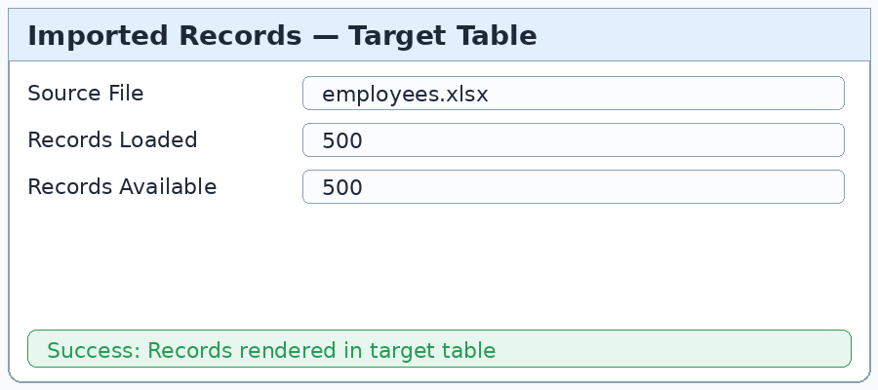
2. | Data Preprocessing | Validate column headers, mandatory fields, data formats, duplicates, and empty values before transformation.  Example: 2 duplicate rows removed before import.  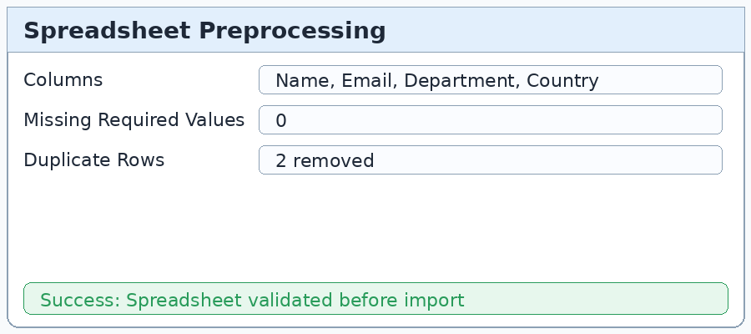
3. | Utilization of Filters | Use filters to inspect successful/failed imports, departments, batches, and validation status.  Example: Status = Successful; Department = IT.  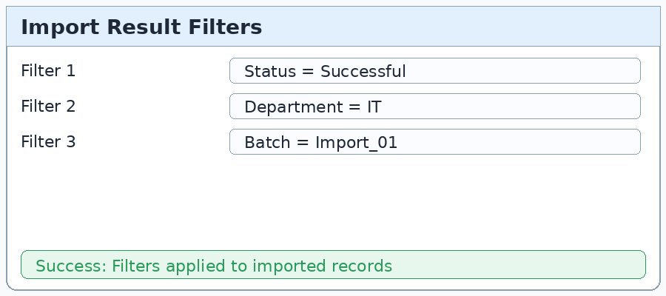
4. | Calculation fields Used | For this Transform Map project, calculation logic is implemented through field mappings and transform rules rather than Tableau calculated fields.  Example: Trim text, convert date format, derive Import Status.  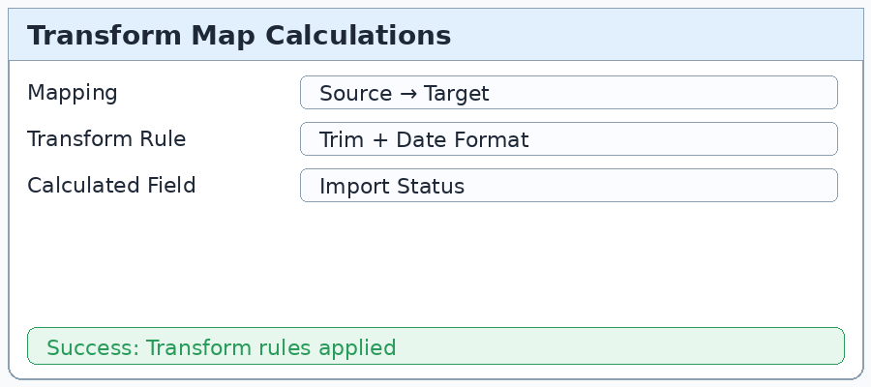
5. | Dashboard design | Import summary view can display total records, successful records, failed records, and success rate for quick monitoring.  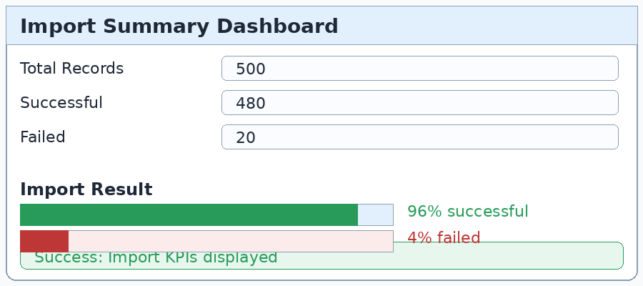
6. | Story Design | Process story documents the complete flow: Spreadsheet Upload → Field Mapping → Transform & Validate → Target Table Verification.  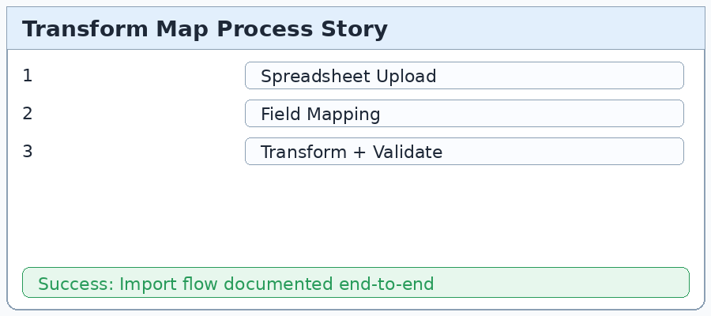

Note: The embedded screenshots are topic-related illustrative UI images. Replace them with actual project screenshots if your submission requires execution evidence.

