User Acceptance Testing (UAT) Template
Date | 30 September 2026
Team ID | SWTID-2026-5397
Project Name | Import Data using Transform Maps (Spreadsheet)
Maximum Marks | 10 Marks
Team Details | Leader: LAVANYA S | Members: KAVIYA P, KEERTHANA J, LITHIKA P, MADHUMITHA R

Project Overview:
Project Name: Import Data using Transform Maps (Spreadsheet)
Project Description: Import spreadsheet data into a target ServiceNow table using an Import Set and Transform Map, with field mapping, transformation, validation, and error handling.
Project Version: 1.0
Testing Period: 30 September 2026
Testing Scope:
• Spreadsheet upload and Import Set creation
• Source-to-target field mapping and Transform Map configuration
• Data transformation, validation, mandatory-field checks, and duplicate handling
• Import execution, error handling, and target-table record verification
Testing Environment:
URL/Location: ServiceNow project instance / development environment
Credentials: Project-provided credentials (not included in document)
Test Data: Spreadsheet (.xlsx) containing representative records

Test Cases:
Test Case  ID | Test  Scenario | Test Steps | Expected  Result | Actual  Result | Pass/Fail
TC-001 | Spreadsheet Upload | 1. Open the Import Set module.  2. Select the prepared spreadsheet.  3. Start the import. | Valid spreadsheet is accepted and an import set is created. | To be recorded during execution | Pass/Fail
TC-002 | Transform Map Field Mapping | 1. Open the Transform Map.  2. Verify source fields.  3. Verify target field mappings. | Required fields are mapped to the correct target fields. | To be recorded during execution | Pass/Fail
TC-003 | Data Transformation | 1. Configure transformation rules.  2. Run the transform.  3. Inspect transformed values. | Configured transformations are applied consistently to imported records. | To be recorded during execution | Pass/Fail
TC-004 | Validation and Error Handling | 1. Include invalid/missing values.  2. Run the transform.  3. Review import/transform errors. | Invalid rows are identified and valid rows are processed without corrupting target data. | To be recorded during execution | Pass/Fail
TC-005 | Target Record Verification | 1. Open the target table.  2. Search for imported records.  3. Compare key fields with the source spreadsheet. | Imported records match the expected source values and appear in the target table. | To be recorded during execution | Pass/Fail
TC-006 | Duplicate Record Handling | 1. Import data containing an existing record.  2. Execute the Transform Map.  3. Review the result. | Duplicate/coalesced records are handled according to the configured Transform Map behavior. | To be recorded during execution | Pass/Fail

Bug Tracking:
Bug ID | Bug Description | Steps to reproduce | Severity | Status | Additional feedback
BG-001 | Record mapping or transformation mismatch | 1. Upload test data  2. Run transform  3. Compare source and target fields | Low/Medium/High | Open/In Progress/Closed | Capture screenshot and error details
BG-002 | Invalid row handled incorrectly | 1. Add invalid value  2. Run transform  3. Review transform result | Low/Medium/High | Open/In Progress/Closed | Record affected row and message

UAT Evidence / Screenshots:
Test Area | Related Screenshot
Spreadsheet upload / Import Set | 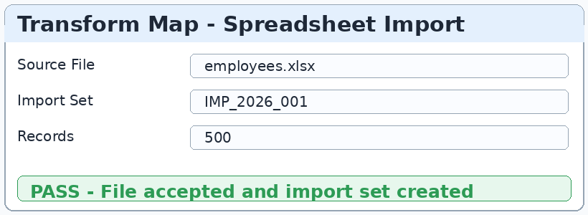
Transform Map field mapping | 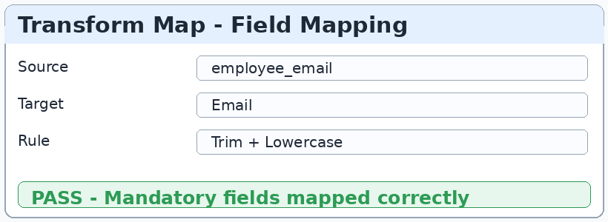
Target table verification | 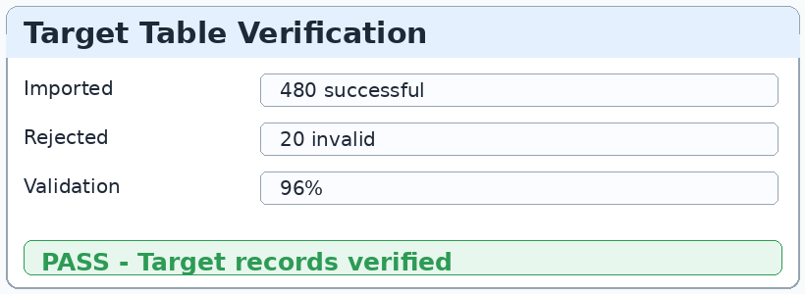

UAT Sign-off:
UAT Result | Accepted / Accepted with Changes / Not Accepted
Team Leader | LAVANYA S
Date / Signature

