IMPORT DATA USING TRANSFORM MAPS
Spreadsheet Data Import into ServiceNow

PROJECT DOCUMENTATION

Team ID : SWTID-2026-5397
Team Size : 5

Team Leader : LAVANYA S
Team Member : KAVIYA P
Team Member : KEERTHANA J
Team Member : LITHIKA P
Team Member : MADHUMITHA R

ServiceNow – Import Set & Transform Map

PROJECT OVERVIEW
This project demonstrates the process of importing employee data from an Excel spreadsheet into ServiceNow using an Import Set and Transform Map. The source material provided for this document uses an Employee Import table, an Employee Test target table, field mapping, transformation, validation, coalesce, and report creation.
Project Flow
- Prepare Excel employee data
- Create the Import Set table using Load Data
- Create the Transform Map
- Map source and target fields
- Transform the imported data and validate the result
- Enable Coalesce to avoid duplicate records
- Verify the Employee Test table and arrange fields
- Create reports on the Employee Test table
Team
Role | Name
Team Leader | LAVANYA S
Team Member | KAVIYA P
Team Member | KEERTHANA J
Team Member | LITHIKA P
Team Member | MADHUMITHA R

PHASE 1 & PHASE 2 : PROJECT PREPARATION
The supplied source screenshots begin from Phase 3 (Import Set Table). Therefore, the exact instructions and screenshots for Phases 1 and 2 are not present in the provided material and are not recreated here.
Available project preparation context
- The project uses employee data maintained in an Excel spreadsheet.
- The destination used in the supplied material is the Employee Test table.
- The import process is performed through ServiceNow Import Set and Transform Map functionality.
- The source material later uses Coalesce to avoid duplicate employee records.
Source evidence
The following pages reproduce the supplied screenshots as supporting evidence for the documented phases.

PHASE 3 : IMPORT SET TABLE
Navigation: In Application Navigator → Load Data.
Click on Load Data and create an import table. Fill the details as shown in the source:
- Label: Employee Import
- Name: u_employee_import (auto populated)
The source screenshot shows the Load Data page where the import table is created and the Employee Import label is entered.
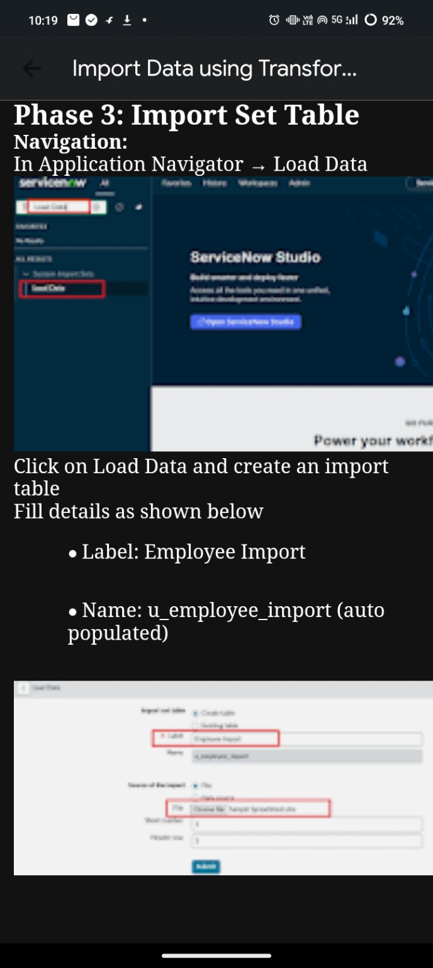

PHASE 4 : CREATE TRANSFORM MAP
In this phase, create the Transform Map by clicking the Create Transform Map button.
Inputs shown in the supplied material:
- Name: Sample Spreadsheet Import
- Source Table: Employee Import (auto-populated)
- Target Table: Employee Test – created earlier
- Click Auto Map to match fields.
The source also instructs to use Mapping Assist to map fields between the Source and Target tables, then click Save.
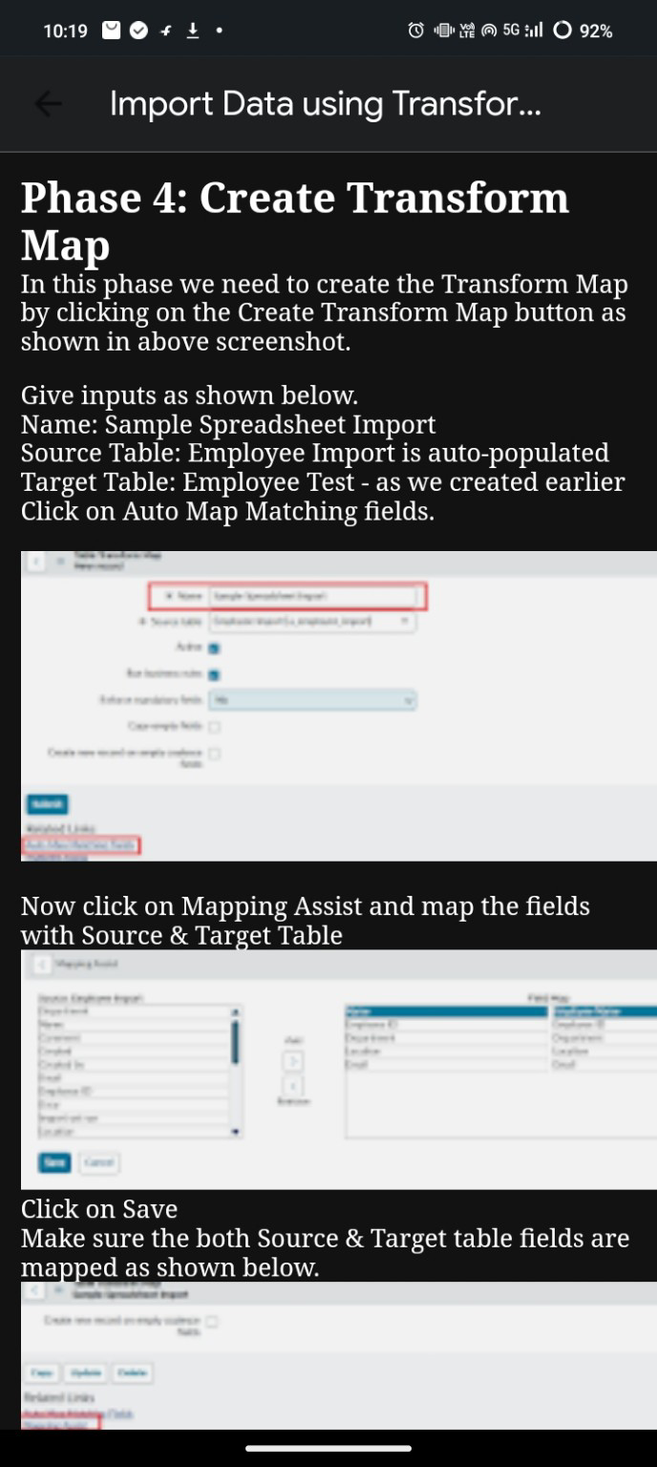

PHASE 4 : FIELD MAPPING
After creating the Transform Map, use Mapping Assist to map the fields with the Source and Target Table. The source material instructs the user to click Save and make sure both Source and Target table fields are mapped.
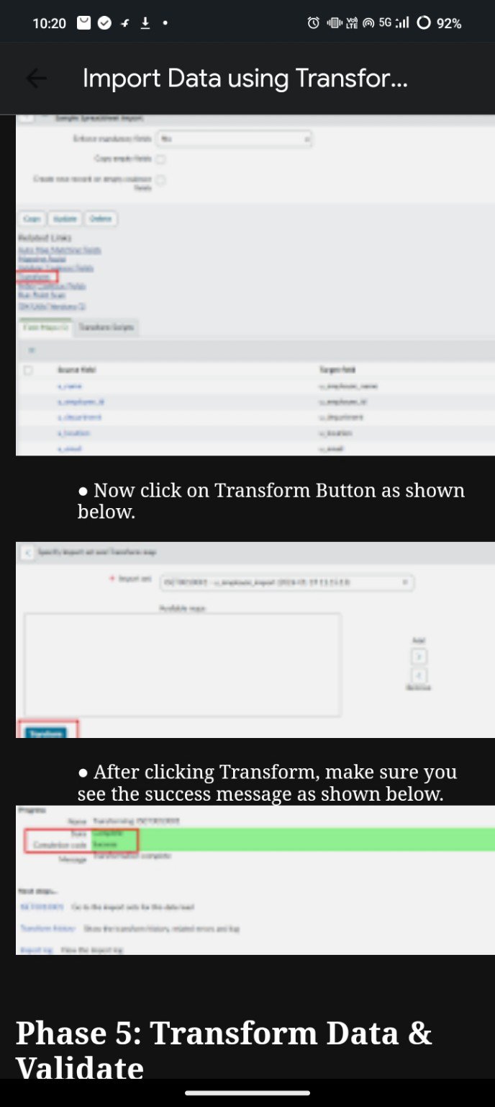
The screenshot is retained as supplied so that the project record shows the mapping stage used in the workflow.

PHASE 5 : TRANSFORM DATA & VALIDATE
After the field mapping is completed, click the Transform button as shown in the source.
- Click on Transform Button.
- After clicking Transform, make sure the success message is displayed.
The supplied material then proceeds to Transform Data & Validate. The transformation result is checked before moving to the next phase.
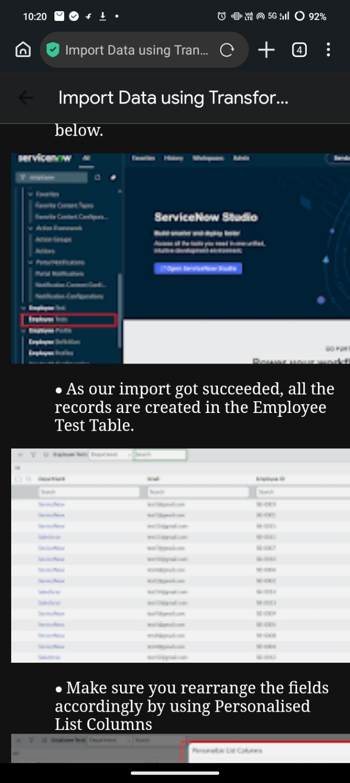

PHASE 5 : TRANSFORM RESULT & VALIDATION
The supplied screenshots show the transformation interface and the success state after the Transform action.
Validation is performed by checking the transformation status and the resulting records. The source material continues from this stage into the duplicate-record prevention step.
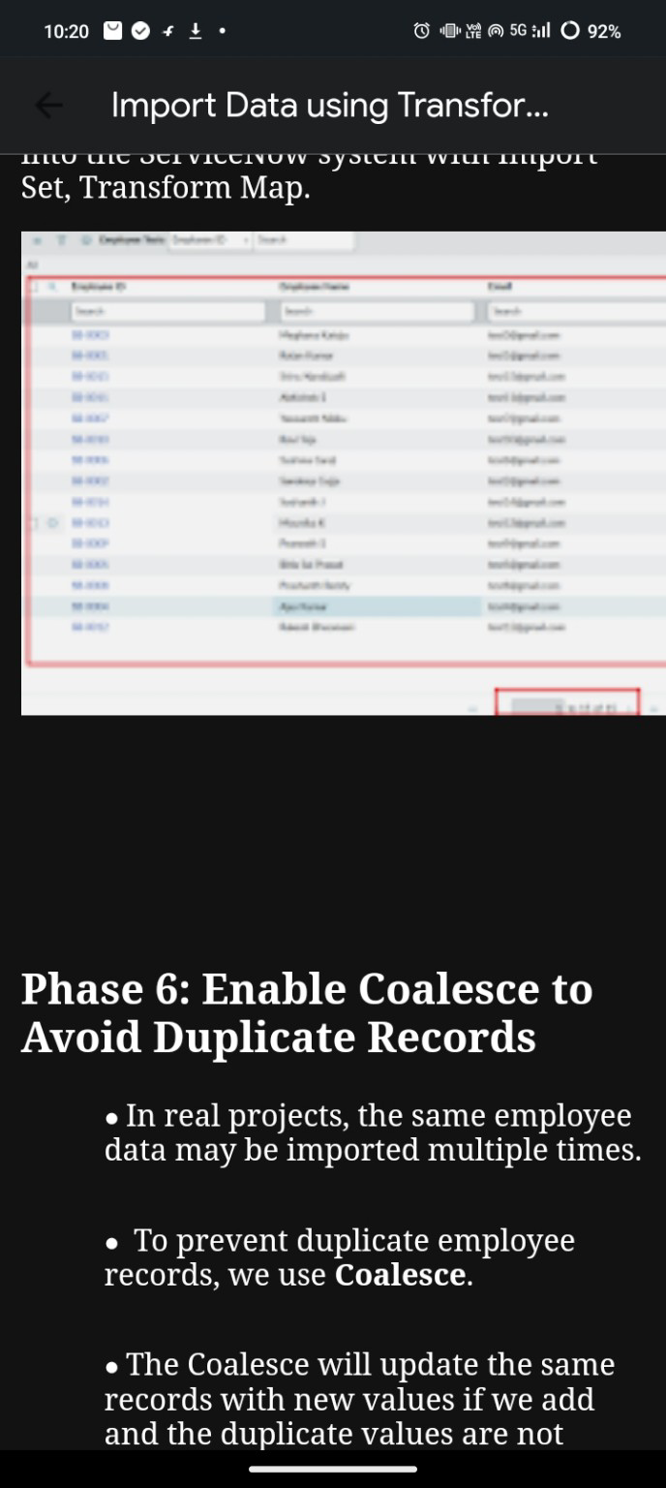

PHASE 6 : ENABLE COALESCE TO AVOID DUPLICATE RECORDS
- In real projects, the same employee data may be imported multiple times.
- To prevent duplicate employee records, we use Coalesce.
- The source explains that Coalesce will update the same records with new values when the matching value is found, rather than creating duplicate records.
The supplied material also shows the Employee Test table after a successful import and instructs the user to rearrange the fields using Personalised List Columns.
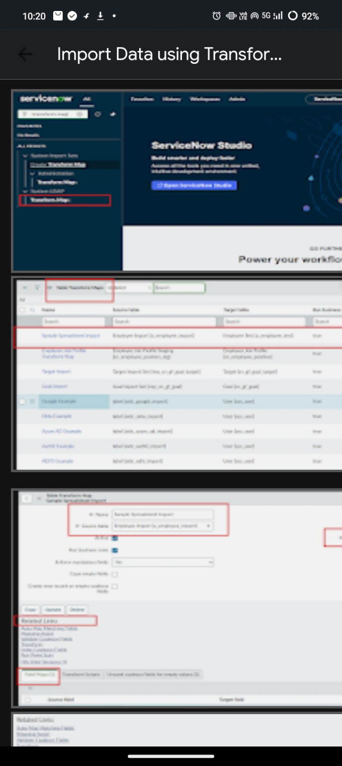

PHASE 7 : VERIFY IMPORTED EMPLOYEE DATA
After the import succeeds, the records are created in the Employee Test Table. The source material shows the imported employee records and instructs the user to make sure the fields are arranged appropriately using Personalised List Columns.
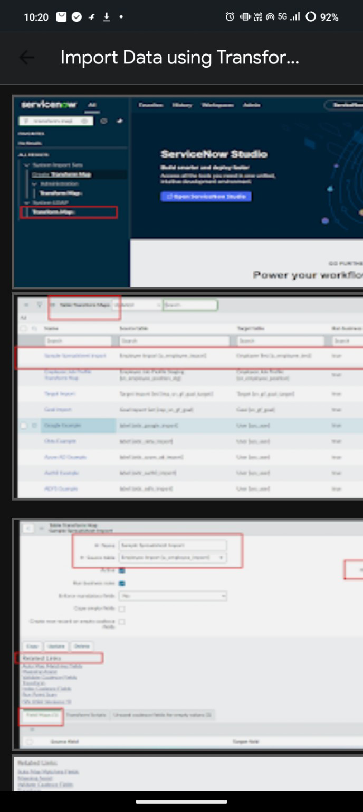
Verification should be performed against the spreadsheet values used for the import.

PHASE 8 : CREATE REPORTS ON EMPLOYEE TEST TABLE
Navigation Steps:
- Open All menus and search for Reports.
- Under Usage and governance, select Reports.
- Click the New button to create a new report.
- Create 3 Reports as described in the source.
Report 1 : Employees by Department
- In Data
- Report name: Employees by Department
- Source Type: Table
- Table: Employee Test, then click the Next button.
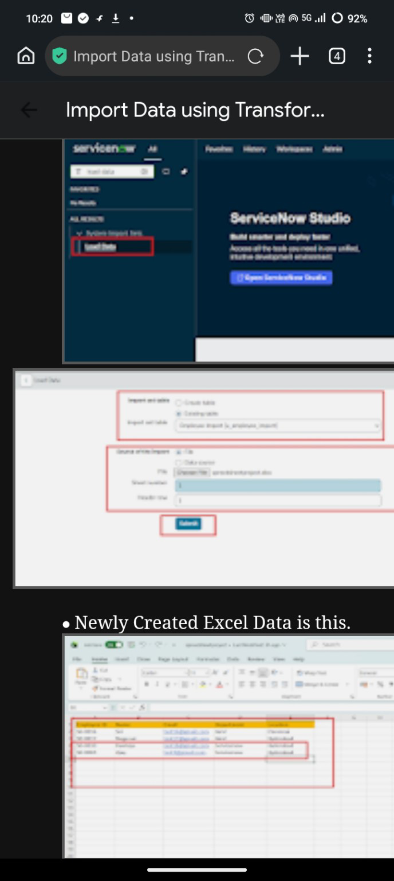

PHASE 8 : TRANSFORM HISTORY & REPORTING
The supplied source shows the Transform History result and then the reporting stage. It states that the transformation completes successfully and that Transform History shows the newly added data along with Inserted and Skipped values.
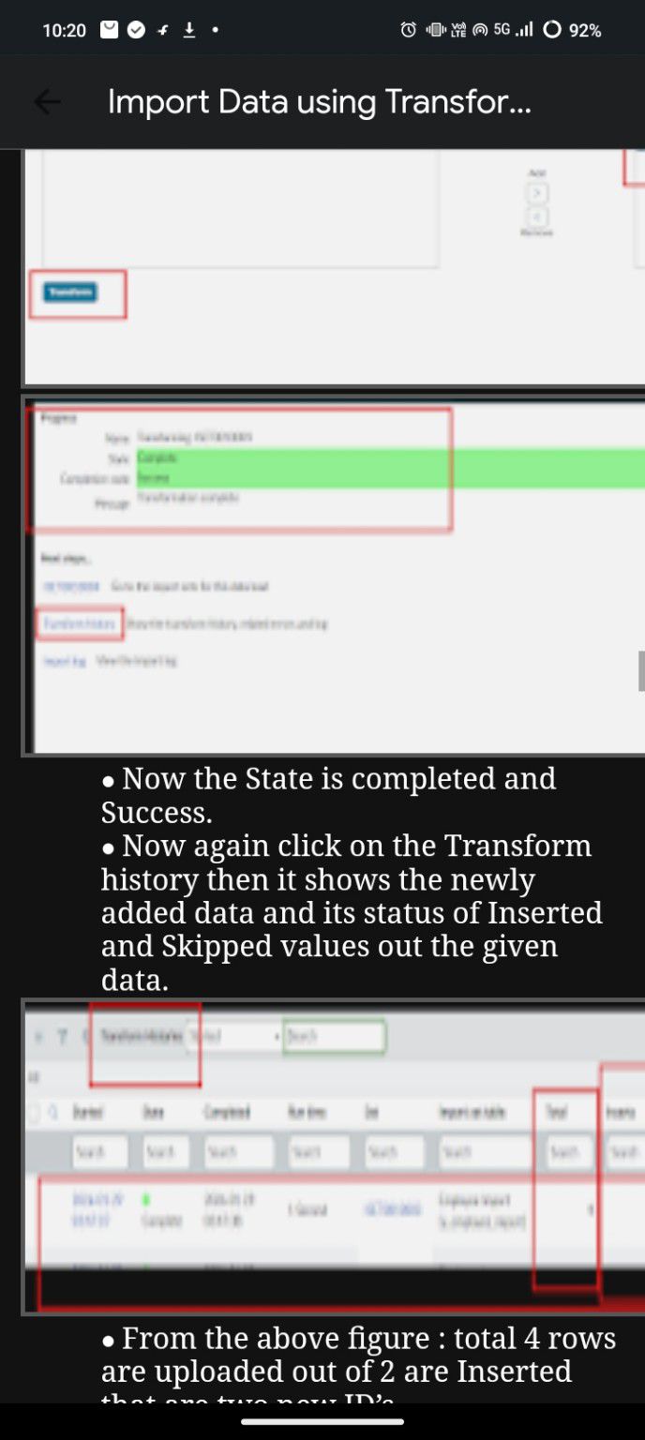
The source also shows the Employee Test report configuration and the imported Excel data used for the project.
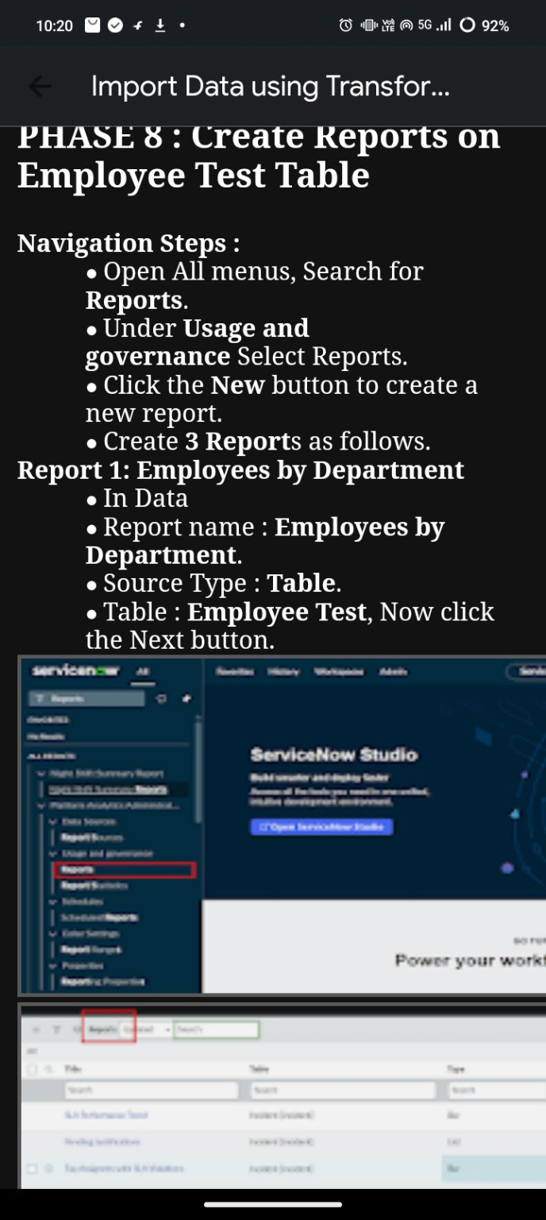

PROJECT CONCLUSION
The supplied project material demonstrates an end-to-end ServiceNow spreadsheet import process. Employee data is loaded through Load Data into an Import Set table, connected to the Employee Test target table through a Transform Map, mapped between source and target fields, transformed, validated, and protected against duplicate records through Coalesce. The final stage uses the Employee Test table for reporting.
Key Components Used
- Excel spreadsheet – source employee data
- Import Set / Employee Import – staging data
- Transform Map – source-to-target transformation
- Mapping Assist / field mapping – source and target field connection
- Transform – data processing
- Coalesce – duplicate prevention / matching
- Employee Test – target table
- Reports – reporting on the imported employee data
Team Details
SWTID-2026-5397 | Team Size: 5
LAVANYA S • KAVIYA P • KEERTHANA J • LITHIKA P • MADHUMITHA R

