Project Design Phase-II
Technology Stack (Architecture & Stack)
Date | 30 September 2026
Team ID | SWTID-2026-5397
Project Name | Import Data using Transform Maps (Spreadsheet)
Team Size | 5
Team Leader | LAVANYA S
Team Member | KAVIYA P
Team Member | KEERTHANA J
Team Member | LITHIKA P
Team Member | MADHUMITHA R
Maximum Marks | 4 Marks
Technical Architecture:
The solution uses ServiceNow Import Sets and Transform Maps to load spreadsheet data into a target table. The spreadsheet is uploaded through the ServiceNow interface, staged in an Import Set table, transformed using field mappings and optional transform scripts, validated, and finally inserted or updated in the target table.
Example: Importing employee, incident, asset, or other business records from an Excel/CSV spreadsheet into ServiceNow.
Reference: ServiceNow Import Sets and Transform Maps platform functionality.
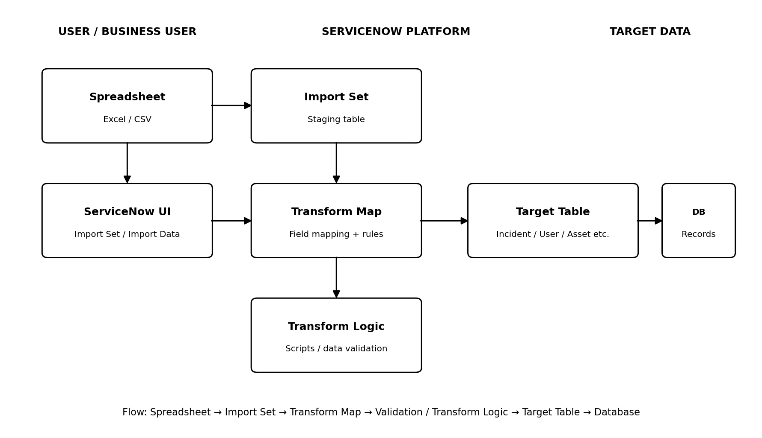
Guidelines:
• Include the complete data-import process from spreadsheet upload to target-table record creation.
• Show the separation between the user interface, ServiceNow platform components, and stored target data.
• Identify the Import Set staging table and Transform Map as the main application-processing blocks.
• Show field mapping, coalesce/update logic, validation, and transform scripts where applicable.
• Indicate the target table and ServiceNow platform database as the data-storage components.

Table-1 : Components & Technologies:
S.No | Component | Description | Technology
1 | User Interface | Interface used to upload the spreadsheet and start the import process. | ServiceNow UI, Import Data / Import Set
2 | Application Logic-1 | Receives spreadsheet data and creates staging records before transformation. | ServiceNow Import Set
3 | Application Logic-2 | Maps source spreadsheet fields to fields in the destination table. | ServiceNow Transform Map
4 | Application Logic-3 | Applies validation, default values, data conversion and conditional processing. | Transform Scripts / Field Mapping
5 | Database | Stores imported business records in ServiceNow tables. | ServiceNow Platform Database
6 | Cloud Database | Managed cloud data layer used by the ServiceNow platform. | ServiceNow Cloud Platform
7 | File Storage | Temporary/source spreadsheet file used for the import operation. | Excel / CSV file; ServiceNow attachment storage
8 | External API-1 | Not required for the basic spreadsheet import workflow. | Not Applicable
9 | External API-2 | Not required for the basic spreadsheet import workflow. | Not Applicable
10 | Machine Learning Model | No machine-learning model is required for standard Transform Map import. | Not Applicable
11 | Infrastructure (Server / Cloud) | Hosts the application, import engine, Transform Maps and target tables. | ServiceNow Cloud / SaaS
Import Process Summary:
Step | Process | Description
1 | Prepare Spreadsheet | Create an Excel/CSV file with column headers and source data.
2 | Upload Data | Use ServiceNow Import Set / Import Data to upload the spreadsheet.
3 | Create Import Set | ServiceNow loads the spreadsheet rows into a staging/import-set table.
4 | Configure Transform Map | Map source fields to target fields and configure coalesce/update behavior.
5 | Transform & Validate | Run field transformations, validation rules and optional transform scripts.
6 | Load Target Table | Create new records or update existing records in the selected ServiceNow target table.

