PROJECT DOCUMENTATION
Import Data using Transform Maps (Spreadsheet)
PHASE 1 – PLANNING & REQUIREMENTS
Date | 01 October 2026
Team ID | SWTID-2026-5397
Project Name | Import Data using Transform Maps (Spreadsheet)
Maximum Marks | 1 Mark

Objective
This phase defines the spreadsheet import requirement, identifies the source and target data, documents the Transform Map rules, and prepares the test data and workflow needed to import records into ServiceNow.
Team & Responsibility
Team Member | Responsibility
LAVANYA S | Team Lead / Planning & Coordination
KAVIYA P | Requirement Analysis
KEERTHANA J | ServiceNow Configuration
LITHIKA P | Transform Map & Field Mapping
MADHUMITHA R | Testing & Documentation

Requirements
S.No | Requirement | Priority
1 | Import data from a structured spreadsheet into a ServiceNow target table. | High
2 | Create or use an Import Set Table to stage spreadsheet records. | High
3 | Create a Transform Map and map source fields to target fields. | High
4 | Use a coalesce field to identify existing records and avoid unwanted duplicates. | High
5 | Validate successful, failed, updated and inserted records after transformation. | Medium

Planned Workflow
Step | Planned Activity | Expected Output
1 | Prepare spreadsheet with valid column headers and sample records. | Clean source data ready
2 | Load the spreadsheet into an Import Set / staging table. | Import Set records available
3 | Create Transform Map and define field mappings / coalesce. | Transformation rules documented
4 | Run Transform and review inserted, updated and error records. | Import result verified
5 | Prepare positive and negative test scenarios. | Test data ready

Source Spreadsheet Requirements
Field | Example Value | Validation
Employee ID | EMP1001 | Mandatory; unique for coalesce
Name | Kaviya P | Text; not blank
Email | kaviya@example.com | Valid email format
Department | IT | Allowed department value
Location | Chennai | Text / reference as configured

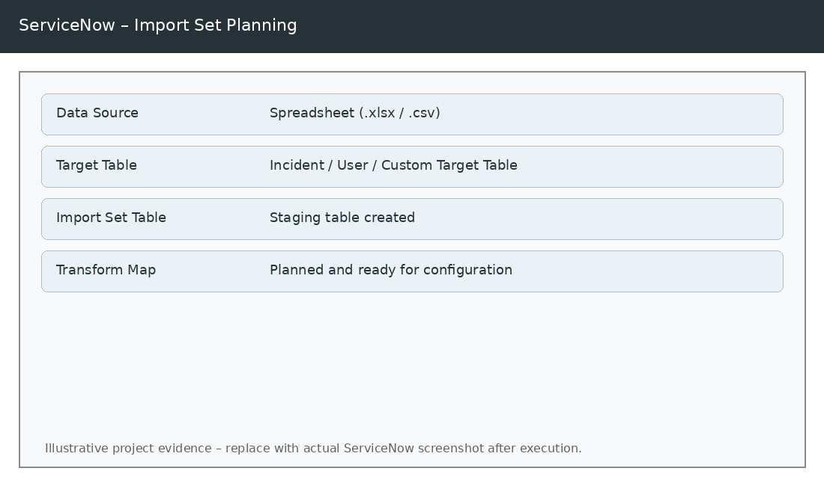
Figure 1 – Planned spreadsheet-to-Import Set workflow (illustrative).
Phase 1 Completion
Item | Status
Requirements identified | Completed
Source and target fields identified | Completed
Transform Map rules planned | Completed
Test data requirements defined | Completed

