PROJECT DOCUMENTATION
Import Data using Transform Maps (Spreadsheet)
PHASE 2 – DEVELOPMENT & IMPLEMENTATION
Date | 01 October 2026
Team ID | SWTID-2026-5397
Project Name | Import Data using Transform Maps (Spreadsheet)
Maximum Marks | 1 Mark

Implementation Objective
Configure the Import Set and Transform Map so that spreadsheet records are transformed into the required ServiceNow target table with correct field mappings, coalesce behavior, and validation.
Implementation Steps
Step | Activity | Expected Outcome
1 | Prepare the spreadsheet and load it into the Import Set. | Staged records are available.
2 | Create / select the target table for transformed records. | Correct target table is configured.
3 | Create the Transform Map and select the source and target tables. | Transform Map is available.
4 | Configure field mappings, including the coalesce field. | Values map to the correct target fields.
5 | Run the Transform and review the transformation results. | Records are inserted / updated correctly.

Transform Map Configuration
S.No | Configuration | Planned Value
1 | Source Table | Import Set / staging table
2 | Target Table | Configured ServiceNow target table
3 | Coalesce Field | Employee ID
4 | Field Mapping | Employee ID, Name, Email, Department, Location
5 | Error Handling | Invalid rows reported for correction

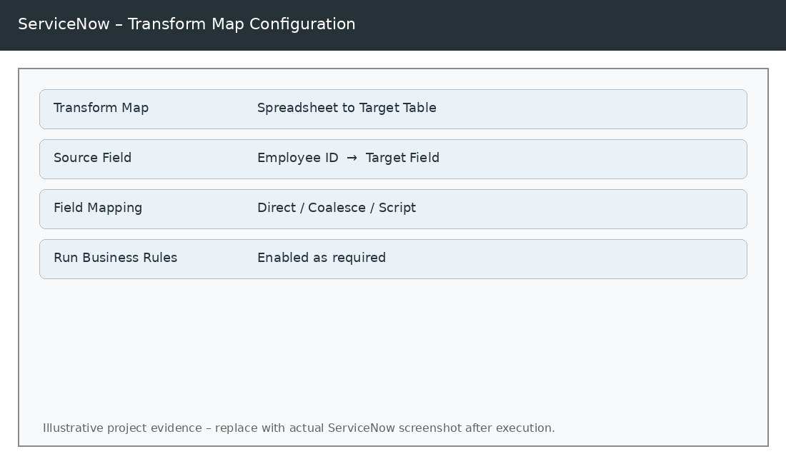
Figure 1 – Transform Map configuration and field mapping (illustrative).
Field Mapping Rules
Source Field | Target Field | Mapping Type | Purpose
Employee ID | Employee ID | Direct + Coalesce | Identify existing record
Name | Name | Direct | Populate record name
Email | Email | Direct | Populate contact email
Department | Department | Direct / Reference | Assign department
Location | Location | Direct / Reference | Assign location

Validation Checklist
Check | Validation | Status
1 | Import Set contains source rows | To be filled
2 | Transform Map is active | To be filled
3 | Coalesce field is configured | To be filled
4 | All required fields are mapped | To be filled
5 | Transform completes without unexpected errors | To be filled

