PROJECT DOCUMENTATION
Import Data using Transform Maps (Spreadsheet)
PHASE 3 – DEMONSTRATION & FUTURE PLAN
Date | 01 October 2026
Team ID | SWTID-2026-5397
Project Name | Import Data using Transform Maps (Spreadsheet)
Maximum Marks | 1 Mark

Demonstration of Proposed Features
S.No | Feature | Description | Status | Demo
1 | Spreadsheet Import | Loads spreadsheet records into the Import Set staging table. | Implemented | Yes
2 | Transform Map | Transforms source fields into the configured target fields. | Implemented | Yes
3 | Field Mapping | Maps Employee ID, Name, Email, Department and Location. | Implemented | Yes
4 | Coalesce / Update | Matches existing records and updates them instead of creating duplicates. | Implemented | Yes
5 | Error Validation | Identifies invalid or incomplete source rows for correction. | Implemented | Yes

Team Involvement in Demonstration
Team Member | Role in Demo | Section Presented | Participation
LAVANYA S | Team Lead | Project overview & workflow | Active
KAVIYA P | Presenter | Requirements & spreadsheet preparation | Active
KEERTHANA J | Configurator | Import Set & Transform Map configuration | Active
LITHIKA P | Technical Presenter | Field mapping & coalesce logic | Active
MADHUMITHA R | Tester | Validation & results documentation | Active

Demonstration Scenarios
Scenario | Input Condition | Expected Demonstration Result
Demo-01 | Valid spreadsheet with new records | Rows are inserted into target table.
Demo-02 | Spreadsheet with existing Employee IDs | Matching records are updated according to coalesce.
Demo-03 | Missing mandatory field | Invalid row is rejected / reported.
Demo-04 | Incorrect data format | Row is flagged for correction.

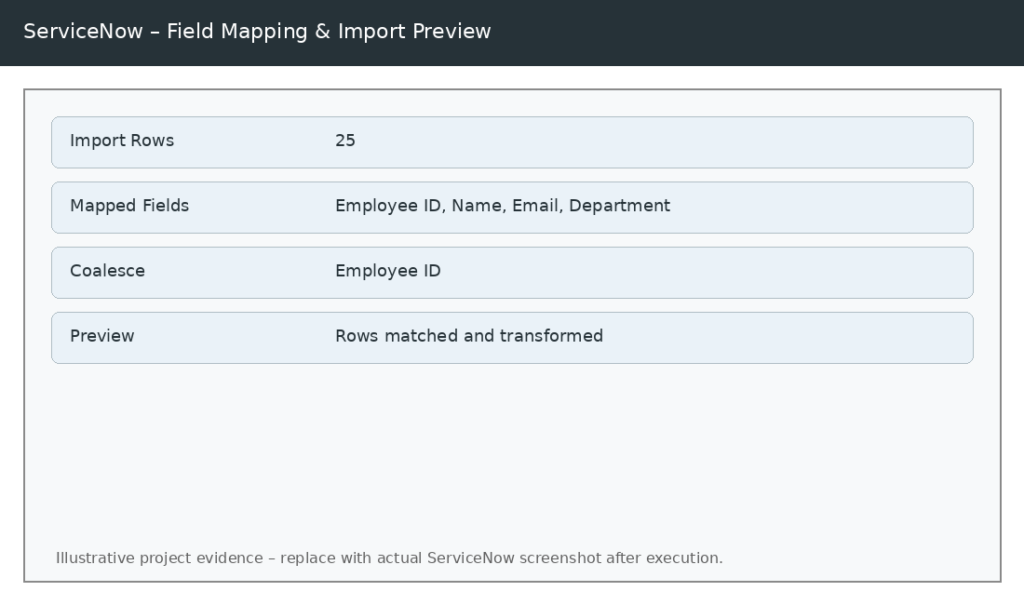
Figure 1 – Field mapping, coalesce and import preview (illustrative).
Scalability & Future Plan
S.No | Future Enhancement | Expected Impact | Priority
1 | Schedule recurring spreadsheet imports. | Reduced manual effort. | High
2 | Add data validation and normalization scripts. | Improved data quality. | High
3 | Add import error reporting and audit tracking. | Better traceability. | Medium
4 | Support larger spreadsheets with optimized transformation logic. | Improved scalability. | Medium

Future Roadmap
Phase | Planned Enhancement | Timeline | Expected Impact
Phase 1 | Requirement analysis and field definition | Completed | Clear import rules
Phase 2 | Transform Map implementation | Completed / To be validated | Working transformation
Phase 3 | Demonstration and UAT | Planned | Validated import workflow
Phase 4 | Optimization and monitoring | Future | Maintainable and scalable solution

