Work flow:

Order microservice
1. Create order and place order giving specifications order id created inserted in mongo db using post
2.Using order id confirm order id using PUT and send that message to kafka for topic “order-events” –only producer part implemented

Shipping microservice.
3.Post “CONFIRM” status, kafka consumer listener is configured for topic name “order-events” –only consumer part implemented
.Poll those meaage which are having status confirmed and change the status as “SHIPPED”
4.After api call to update status as “DELIVERED”

Creating order:
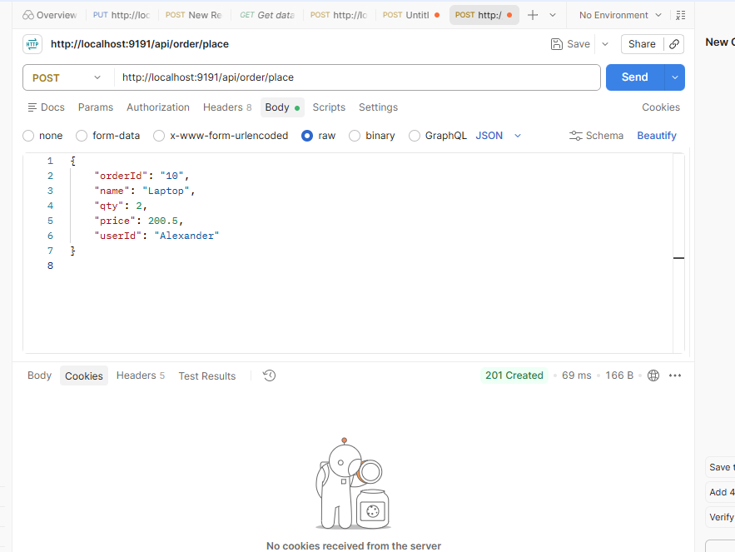

http://localhost:9191/api/order/place
{
"orderId": "10",
"name": "Laptop",
"qty": 2,
"price": 200.5,
"userId": "Alexander"
}

1.Db mongo:
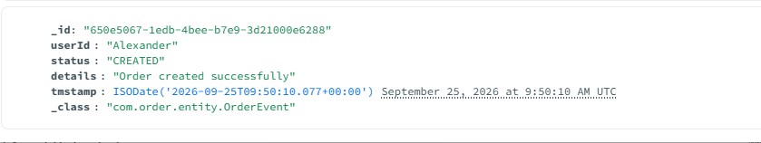
2.Confirm order:v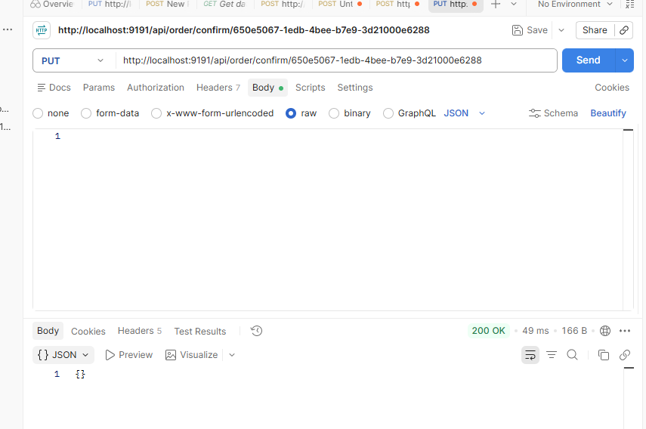
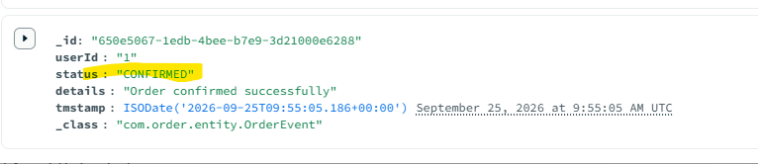

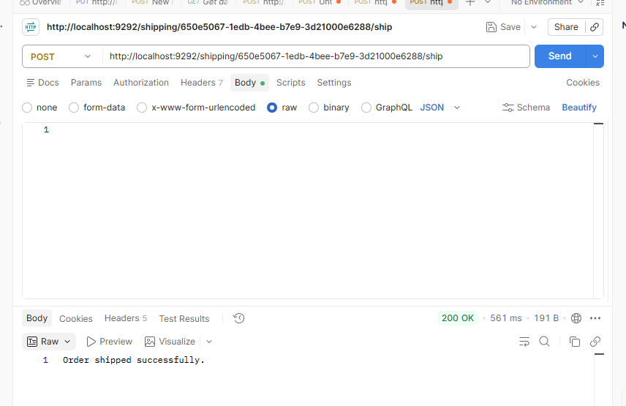

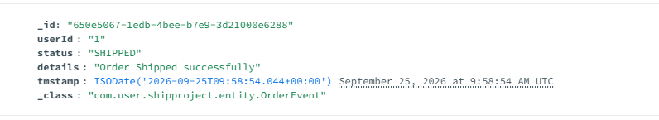
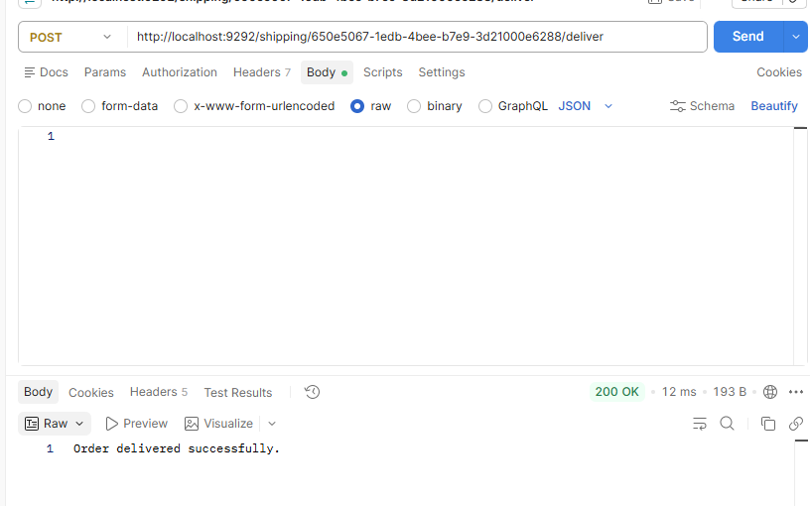
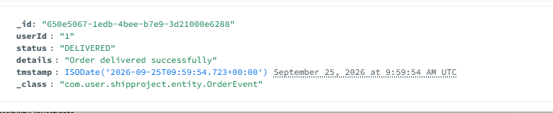

Kafka:
Consumer with status shipped
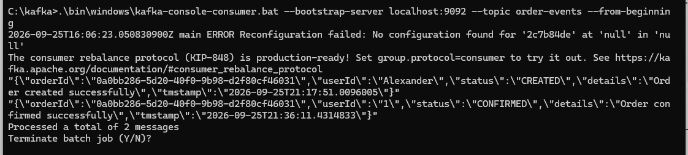

Actuator:
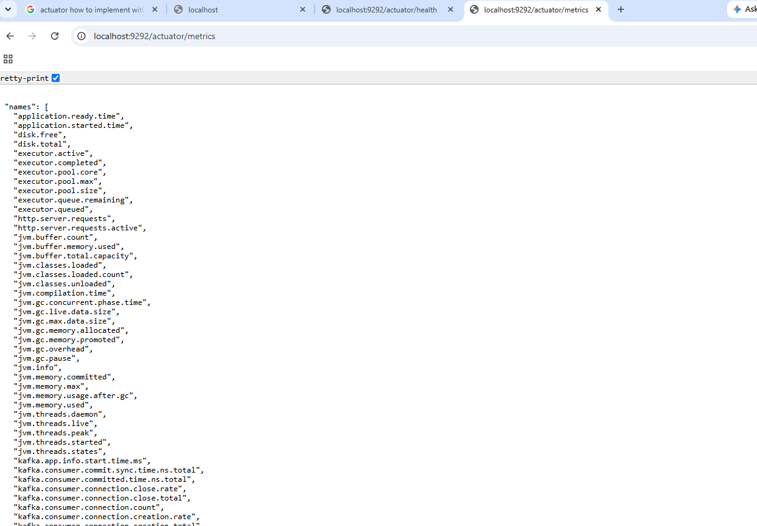
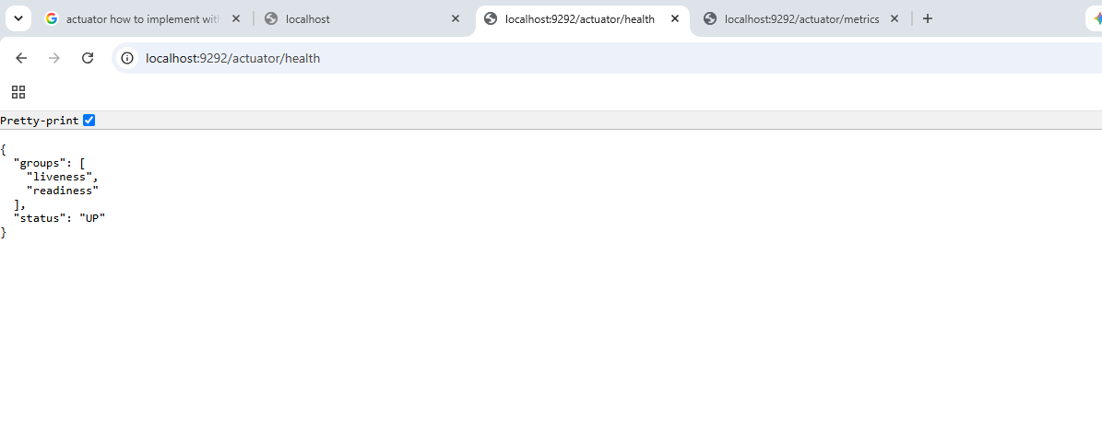

Issues face in kafka configuration: new version 4.3.1
Kraft: no zookeeper
C:\kafka>bin\windows\kafka-storage.bat random-uuid

bin\windows\kafka-storage.bat format --standalone -t EbOdMOy7TIOmdOwqYH6AeA -c config\server.properties

.\bin\windows\kafka-server-start.bat .\config\server.properties | To start
bin\windows\kafka-topics.bat --create --topic test-topic --bootstrap-server localhost:9092 --partitions 1 --replication-factor 1 | Create topic
bin\windows\kafka-console-producer.bat --topic test-topic --bootstrap-server localhost:9092 | producer
bin\windows\kafka-console-consumer.bat --topic test-topic --from-beginning --bootstrap-server localhost:9092 | consumer
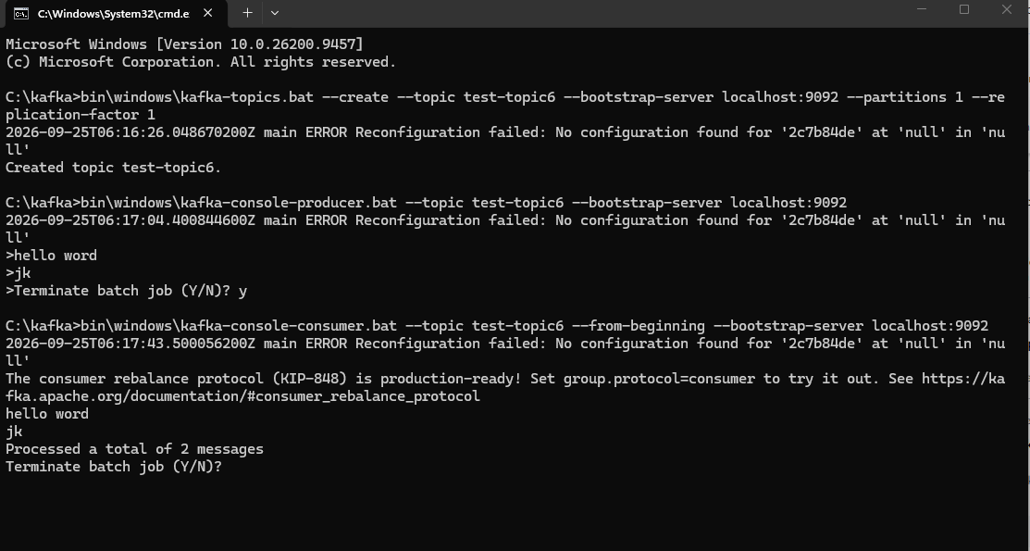

Wmic not recognized

bin\windows\kafka-server-start.bat config\server.properties

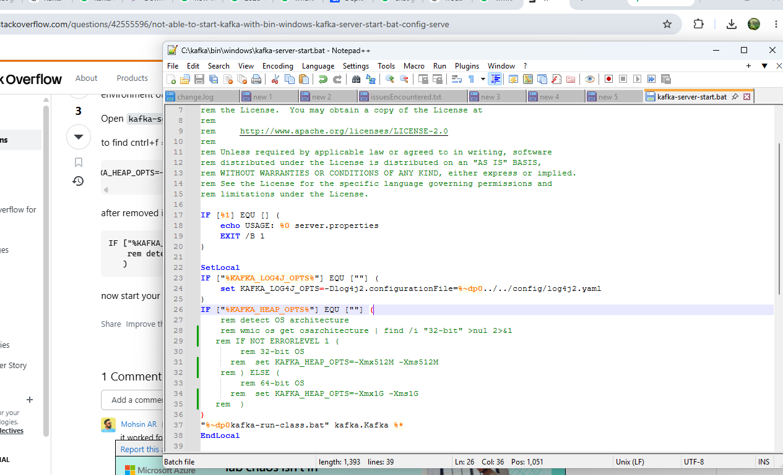

This log message is completely normal during the first few seconds of a Kafka 4 KRaft node startup. It means the metadata engine is initializing and waiting to establish connection with the cluster's controller(s) to determine the latest state. [1, 2]
However, if this message keeps printing endlessly and never stops, it means the node is stuck because it cannot establish a quorum with the controller voters. [1, 3]
Here is how to fix it depending on your setup:
Scenario A: If you are running a Single-Node Local Cluster
If this is a local development instance on Windows, the issue is almost always a network configuration mismatch in server.properties. [3]
- Verify your controller.quorum.voters setting:
Open your configuration file (config/kraft/server.properties) and look for controller.quorum.voters. Ensure it matches the node ID and port you are using: [3]
- node.id=1
- controller.quorum.voters=1@localhost:9093
- Fix localhost vs 127.0.0.1 mismatches:
Windows sometimes struggles to map localhost over IPv4 correctly for Kafka network listeners. Try switching localhost to explicit loopback IP addresses in your configuration: [3]
- listeners=PLAINTEXT://127.0.0.1:9092,CONTROLLER://127.0.0.1:9093
- advertised.listeners=PLAINTEXT://127.0.0.1:9092
- controller.quorum.voters=1@127.0.0.1:9093
- Re-format the Storage Directory:
If you changed the configuration files after formatting, the cluster ID mapping might be broken. Clear out your logs and re-format:
  - Delete the folder you configured in log.dirs (e.g., C:\kafka\kraft-combined-logs).
  - Generate a new random UUID:
  - bin\windows\kafka-storage.bat random-uuid
  - Re-run the format command:
  - bin\windows\kafka-storage.bat format -t <NEW_UUID> -c config\kraft\server.properties

Scenario B: If you are running a Multi-Node Cluster
If you are deploying a cluster with multiple nodes or controllers: [1]

- The controllers aren't all online yet: KRaft requires a strict majority (quorum) to start. If you have a 3-controller setup, this log will repeat endlessly on node 1 until you actually boot up node 2 and node 3. Once the majority of controllers are online, they will elect a leader, establish the high watermark, and the error will stop. [1, 2]
- Firewall blocks: Ensure that Windows Firewall or your cloud security groups are not blocking traffic on your controller port (typically 9093).

Let me know:

- Is the log stuck repeating infinitely, or did the server eventually crash?
- Can you share the listeners and controller.quorum.voters lines from your server.properties file?
You can install and run Apache Kafka version 4 on Windows in KRaft mode (without ZooKeeper) by downloading the binaries from the Apache Kafka Downloads page. [1, 2, 3]
Starting with Kafka 4.0, ZooKeeper is completely removed, and Kafka uses KRaft (Kafka Raft Metadata mode) for cluster management. [2]

Step 1: Install Java Development Kit (JDK)
Kafka requires Java to run. [1]
- Download and install Java JDK 17 or higher.
- Set up the JAVA_HOME environment variable and add its bin directory to your system PATH.
- Verify the installation by opening Command Prompt and running:
- java -version
Step 2: Download and Extract Kafka 4
- Go to the Apache Kafka Downloads page and download the latest Kafka 4 binary release (e.g., kafka_2.13-4.x.x.tgz or .zip).
- Extract the contents using a tool like 7-Zip or WinRAR.
- Move the extracted folder to a short path in your root directory to avoid Windows maximum path length limitations (e.g., C:\kafka). [1, 3, 4]
Step 3: Configure KRaft Mode
- Open your Kafka configuration folder at C:\kafka\config\kraft\ (or C:\kafka\config).
- Open the server.properties file in a text editor.
- Locate and update the log directory path (use forward slashes or escaped backslashes):
- log.dirs=C:/kafka/kraft-combined-logs
- Ensure the node/controller properties are set appropriately for a single-node local setup:
- controller.quorum.voters=1@localhost:9093
Step 4: Generate a Cluster ID and Format Storage
Kafka 4 in KRaft mode requires a unique cluster ID and formatted storage before it can start. [1, 5]
- Open Command Prompt (cmd) and navigate to your Kafka installation path:
- cd C:\kafka
- Generate a random UUID/Cluster ID:
- bin\windows\kafka-storage.bat random-uuid
- Copy the generated UUID string output from the terminal.
- Format the storage directory using that UUID (replace <your-cluster-id> with the copied UUID):
- bin\windows\kafka-storage.bat format -t <your-cluster-id> -c config\kraft\server.properties
(Note: If your configuration file is located directly in config\server.properties based on your specific package structure, adjust the -c path accordingly). [1, 6, 7, 8, 9]
Step 5: Start the Kafka Server
- In your Command Prompt window, start the Kafka broker:
- bin\windows\kafka-server-start.bat config\kraft\server.properties
- Leave this Command Prompt window open. Kafka is now running locally on port 9092. [1, 7]
Step 6: Test Your Installation
Open a new Command Prompt window, navigate to C:\kafka, and run the following commands to verify operation: [7, 9]
- Create a topic:
- bin\windows\kafka-topics.bat --create --topic test-topic --bootstrap-server localhost:9092 --partitions 1 --replication-factor 1
- Start a console producer (type messages and press Enter):
- bin\windows\kafka-console-producer.bat --topic test-topic --bootstrap-server localhost:9092
- Start a console consumer (in another new terminal window to view messages):
- bin\windows\kafka-console-consumer.bat --topic test-topic --from-beginning --bootstrap-server localhost:9092
If you'd like, let me know:
- Are you running into any specific error messages (such as path length or batch script failures)?
- Would you prefer setting this up using Docker Desktop instead of a native installation?
I can provide the exact troubleshooting steps or docker configuration.

