1. Upload the Encompass Plugin through the Input Form Builder. For more information consult Encompass documentation.
2. Relaunch Encompass and login with an account that has the “Super Administrator” persona.
3. 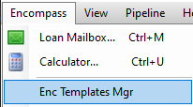Click “Encompass” in the menu bar and select “Enc Templates Mgr” from the dropdown.
4. 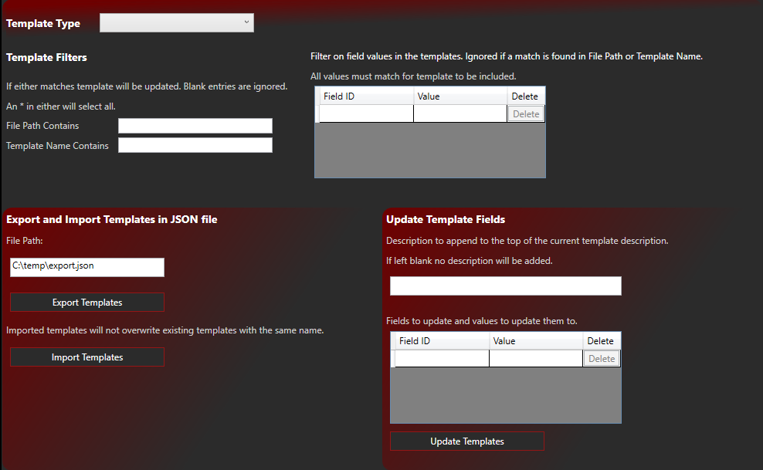This will open the Template Manager window.
5. Select a Template Type in the top dropdown. As of this writing, only Loan Programs, Data Templates and Closing Cost Templates are supported.
6. Enter filter data. If filters are left blank, no templates will be included in the following actions.
   1. The filters apply in order. 1st the File Path, 2nd the Template Name, and 3rd field values within the Template.
   2. If a Template matches any filter value it will be included.
   3. An \* in either the File Path filter or Template Name filter will include ALL Templates.
   4. To filter on field values in the Templates enter the Field ID in the left column and the expected value in the right column.
      1. Click the Enter key to add additional rows.
      2. Click the Delete button to remove rows.
      3. Empty rows will be ignored.
      4. For a template to be included all Fields entered must match.
7. Export Templates
   1. Templates can be exported for later import.
   2. Ensure you have a Filter applied.
   3. Enter a File Path where the JSON file will be exported, including the file name.
   4. Click the Export Templates button.
   5. This operation can take some time depending on how many Templates are in the system.
8. Import Templates
   1. Once you have a JSON file of exported Templates they can be imported into another Encompass instance.
   2. Ensure you have a Filter applied. Remember you can use \* in either File Path or Template Name to include all.
   3. Click the Import Templates button.
   4. This operation can take some time depending on how many Templates are in the system.
   5. The file hierarchy will be replicated as well as the Templates.
9. Update Templates
   1. Existing Templates can be bulk updated.
   2. Ensure you have a Filter applied.
   3. Recommended: Enter a description to append to the existing Template Description to track your changes.
   4. In the Field Update Grid enter in the Field ID to update in the left column and the value to update to in the right column.
   5. If the Field ID does not exist in the Template it will be ignored.
   6. Click the Update Templates button.
   7. This operation can take some time depending on how many Templates are in the system.