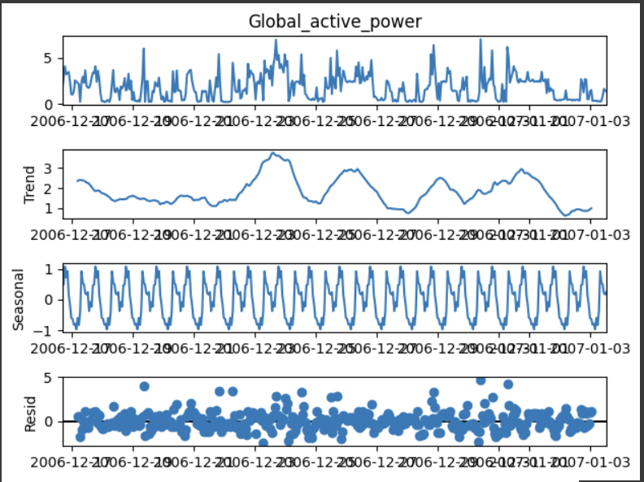

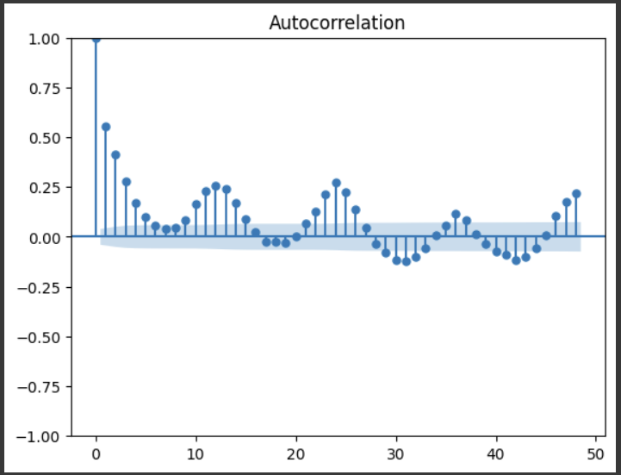

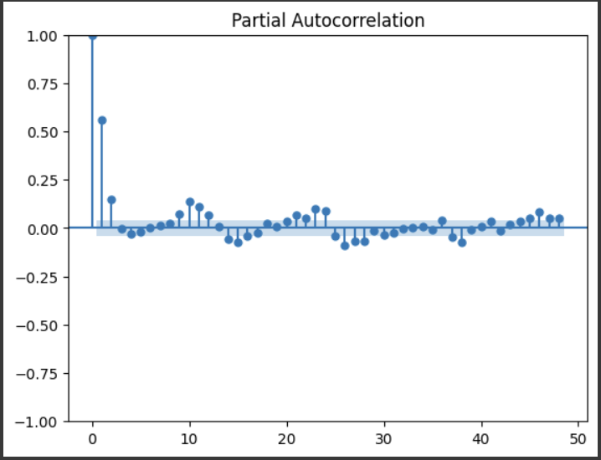

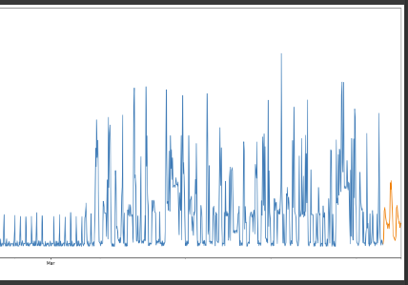

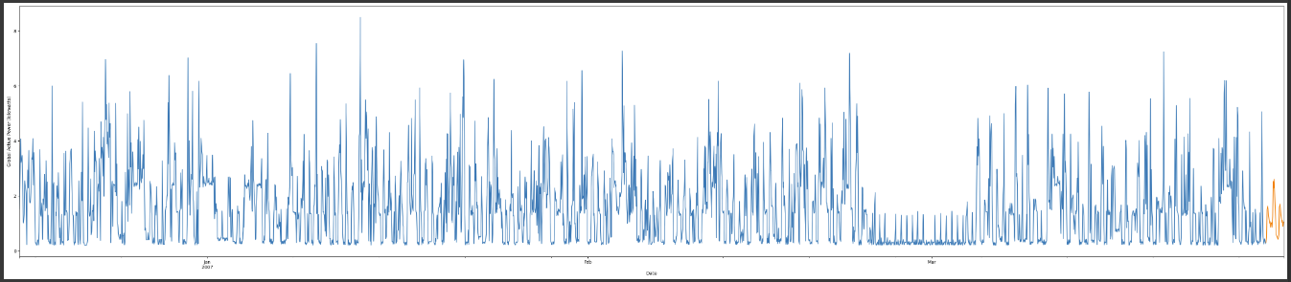

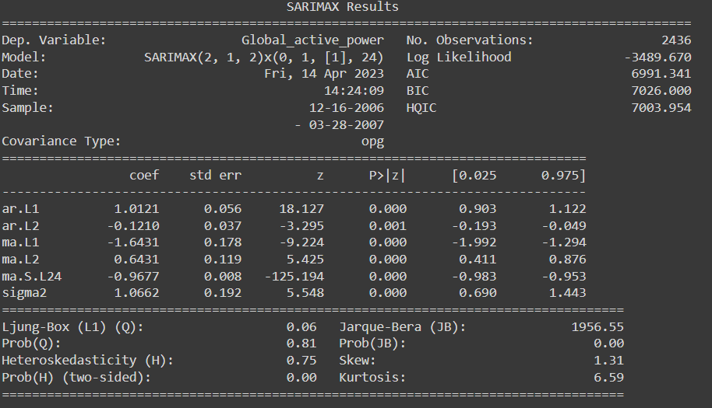

**Data Set Source:**

<https://archive.ics.uci.edu/ml/datasets/Individual+household+electric+power+consumption>

**Data Set Information:**

This archive contains 2075259 measurements gathered in a house located in Sceaux (7km of Paris, France) between December 2006 and November 2010 (47 months).  
Notes:  
1.(global_active_power*1000/60 - sub_metering_1 - sub_metering_2 - sub_metering_3) represents the active energy consumed every minute (in watt hour) in the household by electrical equipment not measured in sub-meterings 1, 2 and 3.  
2.The dataset contains some missing values in the measurements (nearly 1,25% of the rows). All calendar timestamps are present in the dataset but for some timestamps, the measurement values are missing: a missing value is represented by the absence of value between two consecutive semi-colon attribute separators. For instance, the dataset shows missing values on April 28, 2007.

**Attribute Information:**

1.date: Date in format dd/mm/yyyy  
2.time: time in format hh:mm:ss  
3.global_active_power: household global minute-averaged active power (in kilowatt)  
4.global_reactive_power: household global minute-averaged reactive power (in kilowatt)  
5.voltage: minute-averaged voltage (in volt)  
6.global_intensity: household global minute-averaged current intensity (in ampere)  
7.sub_metering_1: energy sub-metering No. 1 (in watt-hour of active energy). It corresponds to the kitchen, containing mainly a dishwasher, an oven and a microwave (hot plates are not electric but gas powered).  
8.sub_metering_2: energy sub-metering No. 2 (in watt-hour of active energy). It corresponds to the laundry room, containing a washing-machine, a tumble-drier, a refrigerator and a light.  
9.sub_metering_3: energy sub-metering No. 3 (in watt-hour of active energy). It corresponds to an electric water-heater and an air-conditioner.

**About The Data Set:**

The dataset was collected using Internet of Things (IoT) devices. Specifically, it was collected from a single house located in Sceaux, France, between December 2006 and November 2010 using a set of sensors that measured various electrical quantities (voltage, current, power, etc.) at a frequency of 1 minute.