Analysis of Social Networks

A social network is a group made of individuals, companies, which are connected by some characteristics based on some associations, friendly relationship, family connections, similar tastes in arts, literature, likes and dislikes of beliefs and knowledge. Such a network can be made of web pages, citations, collaborations, neurons, proteins and DNA sequences. Participants in many Social Networking Sites not necessarily want to look out for connecting to new people. But they want to communicate with people who are a part of their enlarged social network earlier.So by giving importance to this articulating feature these sites are named as Social Network Sites Ramsey theorem says at any party with at least six people, there are three people who are all either mutual acquaintances or mutual strangers.

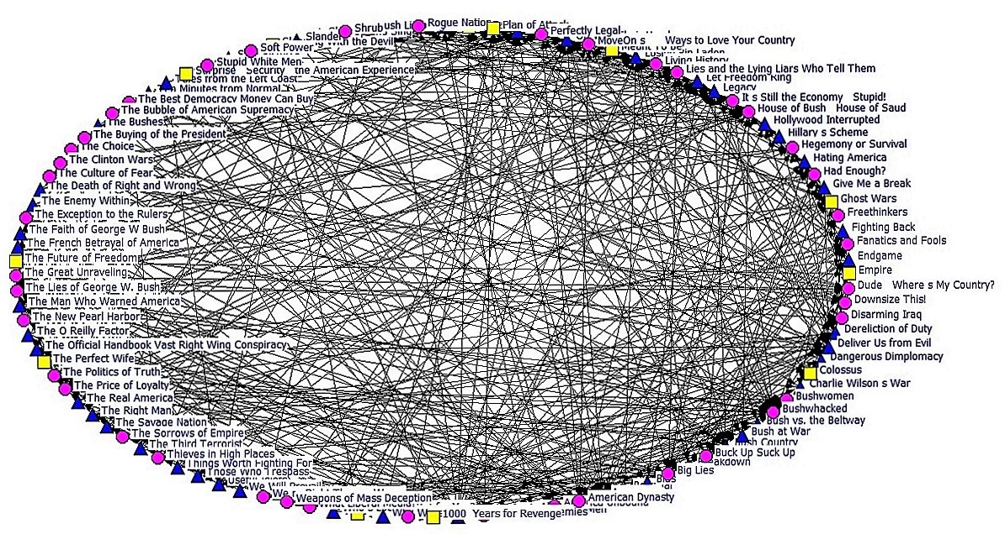Visualization of a Sample Social Network

Different entities and their relationships among them form a network and that can be drawn as a graph. There are millions of people socializing over internet finding other people with common interests in hobbies, religion, or politics. They socialize on sites by reading the profile pages of other members and possibly even contacting them. Social networks can be drawn as graphs. Further networks can be formed from protein folding, combination of genes, citations, there are neural networks when nodes represent neurons, worldwide web networks when nodes represent uniform resource locators, collaboration networks when node represents individual actor. Whatever may be the network it can be analysed with the help of graphs. A graph is a set of nodes(vertices)and edges(links or ties). Each node may represent individual, state, organization, work group and household.  Social Network Analysis (SNA) helps in perceiving and investigating these relationships through visual and mathematical procedures. Organizations utilize these relationships and make use of them to find out insights and take better decisions. They find out the number of individuals in a network, their bonding with other individuals in the network. Based on the results, metrics such as individuals who are mostly connected with others, the people who are influential and people who are prominent in a network can be obtained. Twitter, Facebook and Linkedinare some of the prominent social networks.

Visual Analysis of a network of books, based on US politics is shown in the above figure. This network called Polbooks is a co-purchasing book network. These books were published in the year 2004 and sold by amazon.com. These books are based on US politics and got published when presidential election was going on. Each node denotes a political book and there is an edge between two books if purchased by the same person. There are about one hundred and five nodes and eight hundred and eightytwo edges.

Different colors and shapes are used to distinguish the three types of books in the data namely, liberal, conservative and neutral.

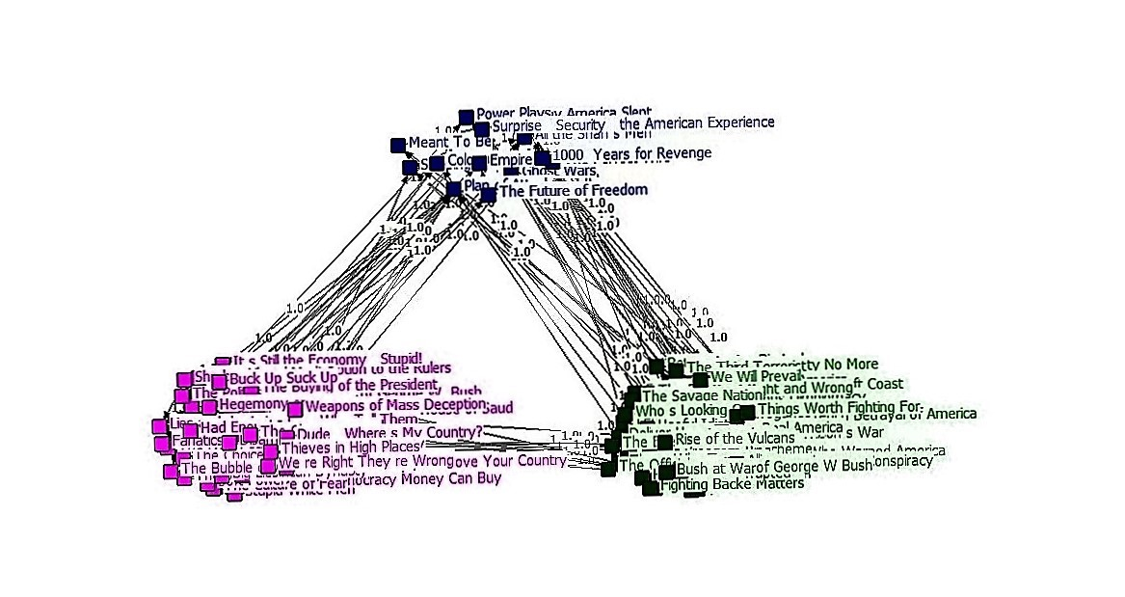Categorical Representation of Data

The figure above, shows these three types of categories. The links connecting the nodes show the weights associated with the connections and are assigned equally unit value.

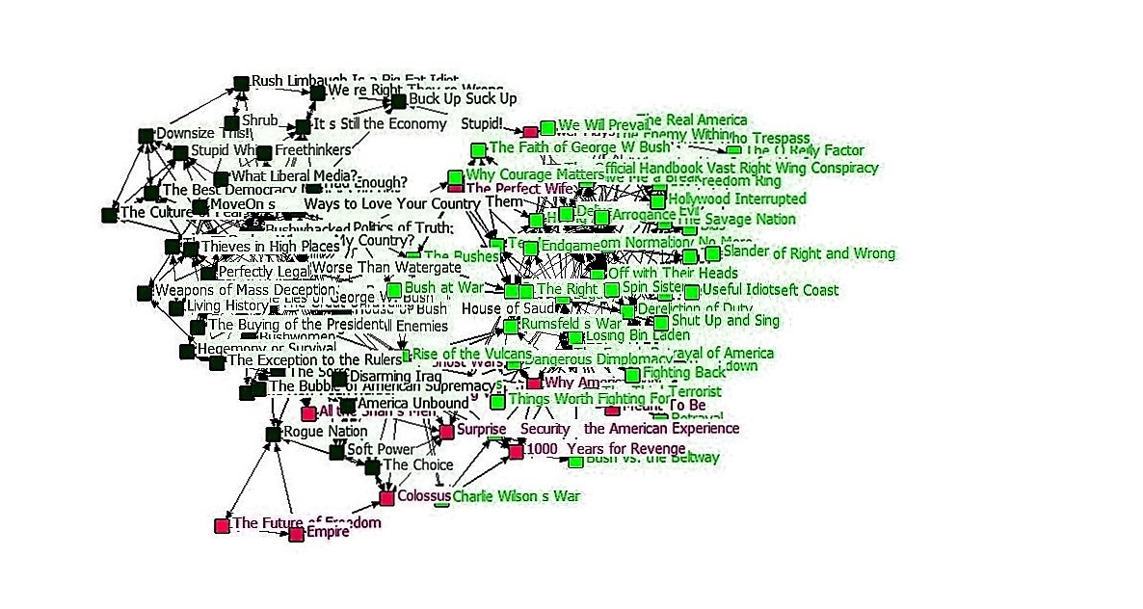Geodesic distance representation of the network.

The above figure, represents the geodesic distance representation of the network. Geodesic distance in the field of mathematical graph theory, is the distance between two nodes in a shortest path connecting them.

**Centrality Measures for Social Networks**

Centralities of individual nodes in the network provide information about the individual’s status in the network. The relationship between the nodes in the network can divulge much details about the overall network composition.

***Degree Centrality:***  Social network researchers identify network activity for a node by using the concept of degrees.

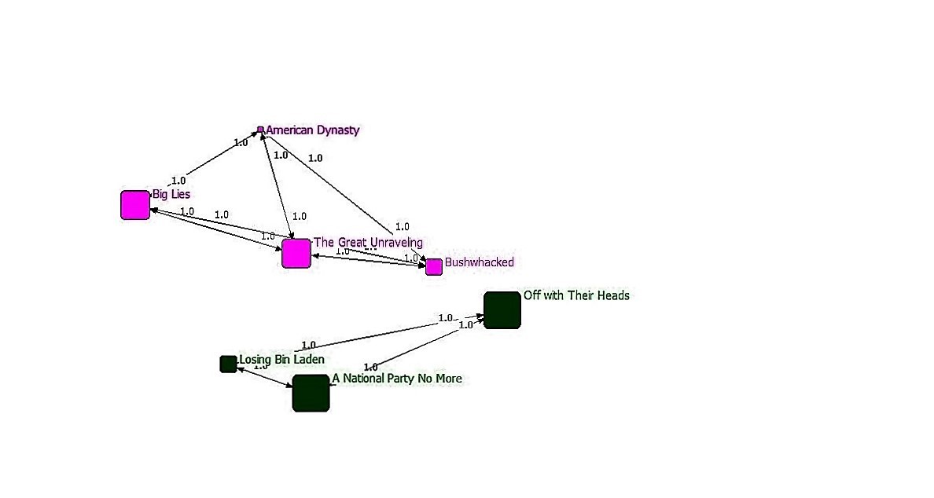

Degree Centrality

Degree can be indegree, the number of incoming connections a node has, or it can be outdegree, the number of outgoing connections. This figure shows degree centrality of books, which have a degree more than twenty. In this book network, the book ‘A National Party no more’ and ‘Off with their heads’ has a degree of 25 and is given a shape of square with bigger size.

***Betweenness Centrality:***Persons who act as brokers are those who bridge holes. Holes are nothing but absence of connections. These brokers are at an advantageous position and highly influential in the society.

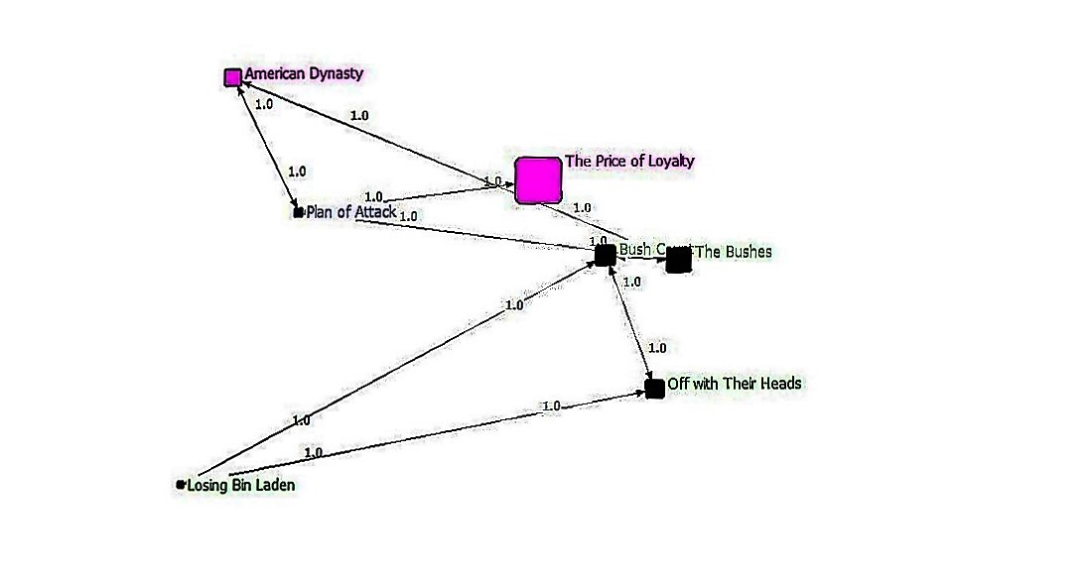

Betweenness Centrality

In this analysis, related to PolBooks, while the book ‘Off with their heads’ has many direct ties, ‘The Price of Loyalty’ has lesser ties. But it is at one of the best position in the network. It lies between two important communities. The figure above shows that this book acts as an intermediary role in the network.

The brighter side is that it plays an authoritative role in the network. The adverse thing is that it is unique and acts as a single node of breakdown. Without that broker node, many nodes would be cut off from the book network. A node with high betweenness is predominant over other nodes in the network. So, location is important in the network.

***Eigen vector centrality:*** This measure is an alternative metric of degree centrality. Degree is the number of neighbors connected to a node and it says relative influence of that node. But it does not say the relevance of neighbors connected to a node. For example, two nodes A and B may have same degrees. If neighbors of B have more neighbors than with respect to A, then B is said to be more influential. Google’s page rank is based on the variant of Eigenvector.

***Software used:*** Netdraw is a software bundled with Ucinet to read and display network visualizations. Ucinet file format can be used with many analysis and visualization platforms. It is widely used by network consultants for network analysis. Ucinet is suitable for constructing small networks but not suited for importing larger datasets in which data is not arranged in an adjacency matrix.

This work has been published in <http://ieeexplore.ieee.org/document/7779440/>